


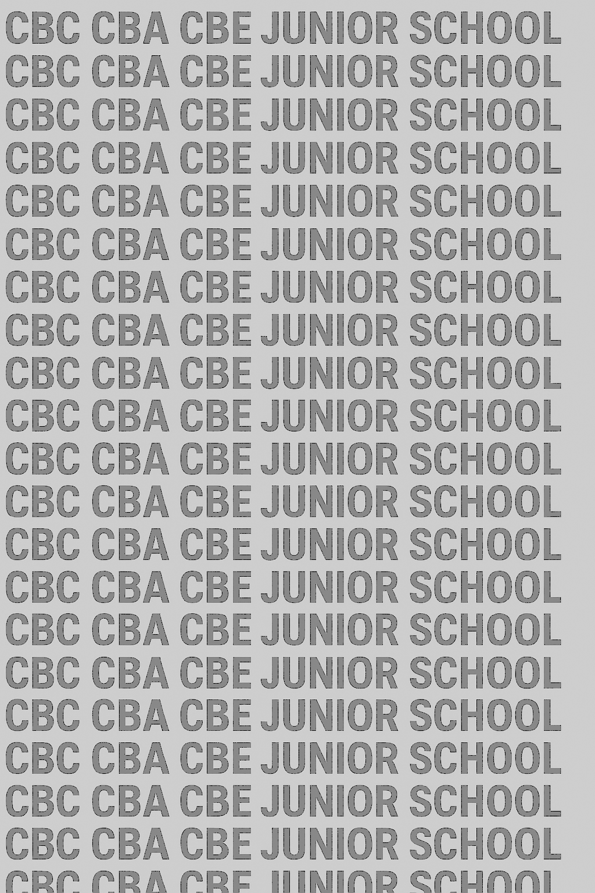
KENYA JUNIOR SCHOOL EDUCATION ASSESSMENT
GRADE 8 TERM 1 FEBRUARY 2026
ENGLISH PAPER 2 CKEAB 002

(Composition and Literary Analysis)

Time - 1 hour 45 minutes

LEARNER’S DETAILS
Name: ________________________________________________. School: _____________________________________
Assessment Number: _____________________________. Date: ______________________________.
School Code: ____________________________. Signature: ____________________________.
INSTRUCTIONS TO LEARNERS
- Write your name and assessment number in the spaces provided.
- Write the name and code of your school in the spaces provided.
- Write the date of the assessment and sign in the spaces provided.
- This question paper consists of two sections: A and B.
- Answer ALL questions in this paper.
- Write ALL the answers in the spaces provided in this question paper.
- Do NOT remove any page from this question paper.
- Answer the questions in English.
For official use only

TASK  -ENGLISH- -002- - Paper Code 901/2- | Maximum Score | Learner's Score
A
Task 1 (Composition) | 15
B
Task 2 (Oral Literature) | 14
Task 3 (Poetry) | 11
Task 4 (Novella) | 10
Total | 50

This paper consists of 8 printed pages. Candidates should check the question paper to ascertain that all the pages are printed as indicated and that no questions are missing.

This paper has 16 printed pages. Please check out to ensure all pages are printed
Turn over

SECTION A: COMPOSITION (15 Marks)

TASK 1: EXPOSITORY COMPOSITION
Topic:
The Importance of Developing a Reading Culture Among Young People.
………………………………………………………………………………………………………………………………………………………………………………………………………………………………………………………………
………………………………………………………………………………………………………………………………………………………………………………………………………………………………………………………………
………………………………………………………………………………………………………………………………………………………………………………………………………………………………………………………………
………………………………………………………………………………………………………………………………………………………………………………………………………………………………………………………………
………………………………………………………………………………………………………………………………………………………………………………………………………………………………………………………………
………………………………………………………………………………………………………………………………………………………………………………………………………………………………………………………………
………………………………………………………………………………………………………………………………………………………………………………………………………………………………………………………………
………………………………………………………………………………………………………………………………………………………………………………………………………………………………………………………………
………………………………………………………………………………………………………………………………………………………………………………………………………………………………………………………………
………………………………………………………………………………………………………………………………………………………………………………………………………………………………………………………………
………………………………………………………………………………………………………………………………………………………………………………………………………………………………………………………………
………………………………………………………………………………………………………………………………………………………………………………………………………………………………………………………………
………………………………………………………………………………………………………………………………………………………………………………………………………………………………………………………………
………………………………………………………………………………………………………………………………………………………………………………………………………………………………………………………………
………………………………………………………………………………………………………………………………………………………………………………………………………………………………………………………………
………………………………………………………………………………………………………………………………………………………………………………………………………………………………………………………………
………………………………………………………………………………………………………………………………………………………………………………………………………………………………………………………………
………………………………………………………………………………………………………………………………………………………………………………………………………………………………………………………………
………………………………………………………………………………………………………………………………………………………………………………………………………………………………………………………………
………………………………………………………………………………………………………………………………………………………………………………………………………………………………………………………………
………………………………………………………………………………………………………………………………………………………………………………………………………………………………………………………………
………………………………………………………………………………………………………………………………………………………………………………………………………………………………………………………………
………………………………………………………………………………………………………………………………………………………………………………………………………………………………………………………………
………………………………………………………………………………………………………………………………………………………………………………………………………………………………………………………………
………………………………………………………………………………………………………………………………………………………………………………………………………………………………………………………………
………………………………………………………………………………………………………………………………………………………………………………………………………………………………………………………………
………………………………………………………………………………………………………………………………………………………………………………………………………………………………………………………………
………………………………………………………………………………………………………………………………………………………………………………………………………………………………………………………………
………………………………………………………………………………………………………………………………………………………………………………………………………………………………………………………………
………………………………………………………………………………………………………………………………………………………………………………………………………………………………………………………………
………………………………………………………………………………………………………………………………………………………………………………………………………………………………………………………………
………………………………………………………………………………………………………………………………………………………………………………………………………………………………………………………………
………………………………………………………………………………………………………………………………………………………………………………………………………………………………………………………………
………………………………………………………………………………………………………………………………………………………………………………………………………………………………………………………………

SECTION B: ORAL LITERATURE (14 Marks)

TASK 2: FABLE

“The Talking Drum of Kitui”
Long ago, in a dry land called Kitui, there lived a wise chief named Mzee Mutua. His people loved him because he always listened before judging. In the centre of the village stood a large drum made from the skin of an elephant. It was called Ngoma ya Ukweli — The Drum of Truth.
Whenever there was a disagreement in the village, the chief would beat the drum three times. It would then “speak” — not with words, but by giving a sign. If the accused person was guilty, the drum would sound dull and heavy. If innocent, the sound was sharp and clear.
For many years, the drum kept the people honest. But one day, a greedy merchant named Ndege sold fake salt to the villagers. When he was caught, he went to the drum and said loudly, “Ngoma ya Ukweli, I am innocent!” The drum remained silent.
Fearful, Ndege decided to trick the drum. At night, he poured animal fat on its surface so that it would produce no sound. The next morning, when the chief called the people, the drum refused to speak at all. The whole village was worried.
Mzee Mutua realized something was wrong. “The drum speaks only when the people are truthful,” he said. “Someone among us has broken that bond.” The people confessed their wrongs one by one, but Ndege kept quiet. Then, a little shepherd boy stepped forward and said, “I saw Ndege touch the drum last night.”
When Ndege was brought forward, he fell on his knees and admitted his deceit. The chief forgave him but ordered him to clean and repair the drum. That evening, the drum sounded again — deep, clear, and strong. From that day, the people of Kitui swore never to lie again, for the drum reminded them that truth cannot be silenced.

Questions (14 marks)
- What was special about the drum in Kitui village? (2 marks)
………………………………………………………………………………………………………………………………………………………………………………………………………………………………………………………………
- How did the drum help the chief to rule his people? (2 marks)
………………………………………………………………………………………………………………………………………………………………………………………………………………………………………………………………
- What wrong did Ndege commit against the villagers? (2 marks)
………………………………………………………………………………………………………………………………………………………………………………………………………………………………………………………………
- How did Ndege try to trick the drum? (2 marks)
………………………………………………………………………………………………………………………………………………………………………………………………………………………………………………………………
- What role did the little shepherd boy play in the story? (2 marks)
………………………………………………………………………………………………………………………………………………………………………………………………………………………………………………………………
- Identify two lessons we learn from this story. (2 marks)
………………………………………………………………………………………………………………………………………………………………………………………………………………………………………………………………

- State two features of oral narratives used in this fable. (2 marks)

………………………………………………………………………………………………………………………………………………………………………………………………………………………………………………………………

SECTION C: POETRY (11 Marks)

TASK 3: ENVIRONMENTAL POEM
When the Earth Weeps
By Peter Amadi
The earth weeps beneath our feet,
Its forests fallen, its rivers dry.
We build our towers high and proud,
Yet forget the ground that bears us all.
The wind whispers warnings in vain,
Oceans rise and storms reply.
But we are deaf to nature’s cry,
Busy chasing wealth and gain.
Children cough beneath smoky skies,
Fish die where oil flows like tears.
The farmer prays for rain in dust,
As seasons lose their faithful tune.
Still, hope lives in the seed we plant,
In every hand that spares a tree.
For when we heal the wounded earth,
It smiles again — and so do we.

Questions (11 marks)
- What is the main message of the poem? (2 marks)

………………………………………………………………………………………………………………………………………………………………………………………………………………………………………………………………

- Identify two environmental problems mentioned in the poem. (2 marks)

………………………………………………………………………………………………………………………………………………………………………………………………………………………………………………………………

- Explain the meaning of the line
“We build our towers high and proud, yet forget the ground that bears us all.” (2 marks)

………………………………………………………………………………………………………………………………………………………………………………………………………………………………………………………………

- What does the poet mean by the line “Fish die where oil flows like tears”? (2 marks)

………………………………………………………………………………………………………………………………………………………………………………………………………………………………………………………………

- Identify two poetic devices used and give examples. (2 marks)

………………………………………………………………………………………………………………………………………………………………………………………………………………………………………………………………

- According to the poem, what brings hope to the earth? (1 mark)

………………………………………………………………………………………………………………………………………………………………………………………………………………………………………………………………

SECTION D: CLASS READER EXTRACT (10 Marks)

TASK 4:
The rain poured heavily as Naliaka and her classmates waited in the school hall for the results of the national science fair. For weeks they had worked late into the night designing a simple but effective solar-powered water purifier. The principal had encouraged them, saying, “Innovation is born from curiosity and persistence.”
When the results were announced, the announcer paused dramatically. “The winner of this year’s fair is... Green Valley Junior School!” The hall erupted in cheers. Naliaka could hardly believe it. She looked at her friends, who were laughing and crying at the same time.
Later that evening, Naliaka’s teacher called her aside. “Do you see now what teamwork can do?” he asked. Naliaka nodded, her eyes bright with pride. “Yes, sir. We almost gave up when our project failed to work, but each failure taught us something new.”
That night, she wrote in her journal:
“Success is not the end of the journey, but proof that determination always bears fruit.”

Questions (10 marks)
- What project had Naliaka and her classmates worked on? (2 marks)
………………………………………………………………………………………………………………………………………………………………………………………………………………………………………………………………
- How did Naliaka’s principal encourage the learners? (2 marks)
………………………………………………………………………………………………………………………………………………………………………………………………………………………………………………………………
- What lesson did Naliaka learn from her experience? (2 marks)
………………………………………………………………………………………………………………………………………………………………………………………………………………………………………………………………
- Identify one theme and one moral value in the extract. (2 marks)
………………………………………………………………………………………………………………………………………………………………………………………………………………………………………………………………

- Suggest a suitable title for this passage. (2 marks)

………………………………………………………………………………………………………………………………………………………………………………………………………………………………………………………………

©2026
All rights reserved
©COMPETENCE KENYA EXAMINATION AND ASSESSMENT BOARD
This is the last printed page

