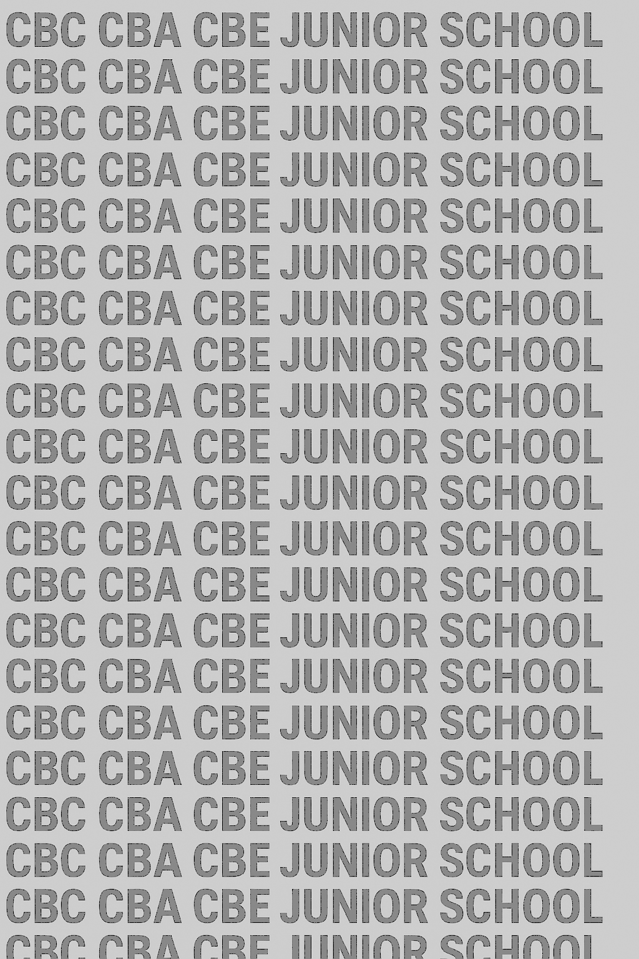
KENYA JUNIOR SCHOOL EDUCATION ASSESSMENT
GRADE 8 TERM 1 FEBRUARY 2026
CREATIVE ARTS AND SPORTS CKEAB 002

LEARNER’S DETAILS
Name: _______________________________________________________________________________________.
School: ______________________________________________________________________________________.
Assessment Number: ________________________________. Date: __________________________________.
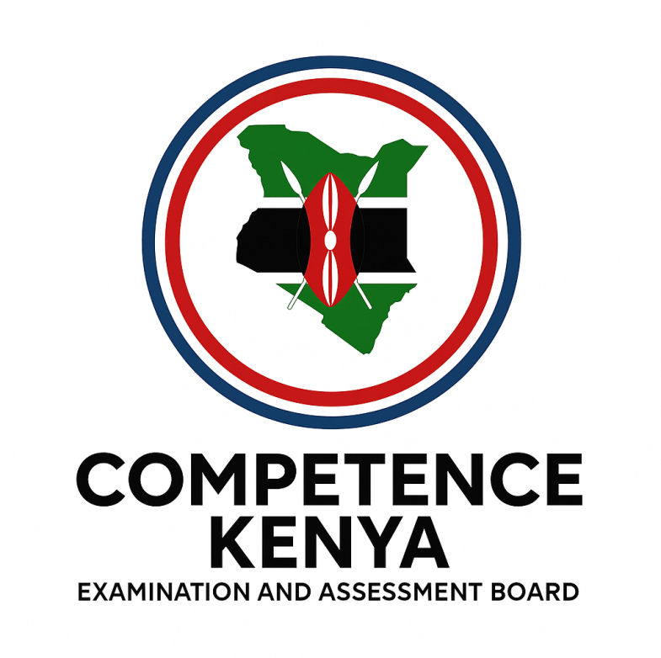
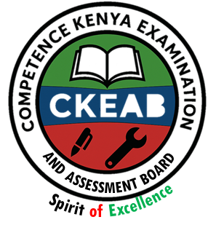
School Code: _______________________________. Signature: ________________________________.

INSTRUCTIONS TO LEARNERS
- Write your Name and Assessment Number in the spaces provided.
- Write the Name and Code of your School in the spaces provided.
- Sign and write the date of the assessment in the spaces provided above.
- This question paper consists of two sections: A and B.
- Section A contains multiple-choice questions numbered 1 to 40.
- Section B contains structured questions numbered 41 to 45.
- Answer all questions in Section A on the separate answer sheet provided.
- Answer all questions in Section B in the spaces provided in this question paper.
- Do NOT remove any page from this question paper.
- Answer all questions in English.

SECTION A: MULTIPLE CHOICE QUESTIONS (40 Marks)
Question Number | 1 | 2 |  | 3 | 4 |  | 5 | 6 | 7 |  | 8 | 9 | 10 | 11 | 12 | 13 | 14 | 15 | 16 | 17 | 18 | 19 | 20 | 21 | 22
Maximum Score | 1 | 1 |  | 1 | 1 |  | 1 | 1 | 1 |  | 1 | 1 | 1 | 1 | 1 | 1 | 1 | 1 | 1 | 1 | 1 | 1 | 1 | 1 | 1
Candidate’s Score |  | -CREATIVE ARTS AND SPORTS- -002- - Paper Code 911-
Question Number | 23 |  | 24 |  |  | 25 |  | 26 |  | 27 |  | 28 | 29 | 30 | 31 | 32 | 33 | 34 | 35 | 36 | 37 | 38 | 39 | 40 | TT
Maximum Score | 1 |  | 1 |  |  | 1 |  | 1 |  | 1 |  | 1 | 1 | 1 | 1 | 1 | 1 | 1 | 1 | 1 | 1 | 30 | 1 | 1 | 40
Candidate’s Score

SECTION B: STRUCTURED QUESTIONS. (60 Marks)
Section | Questions |  | Maximum Score |  | Candidate’s Score | Performance Scale
Section A | 1–40 |  | 40
Section B | 41–65 |  | 60
GRAND TOTAL |  |  | 100
Level | Level | % Range |  | Points | Learner’s score | Remarks
Exceeding (EE) | EE1 | 90–100% |  | 8 |  | Exceptional mastery; exceeds expectations
 | EE2 | 75–89% |  | 7 |  | Very strong performance
Meeting (ME) | ME1 | 58–74% |  | 6 |  | Solid understanding
 | ME2 | 41–57% |  | 5 |  | Partial achievement
Approaching (AE) | AE1 | 31–40% |  | 4 |  | Limited achievement
 | AE2 | 21–30% |  | 3 |  | Very limited
Below (BE) | BE1 | 11–20% |  | 2 |  | Poor performance
 | BE2 | 1–10% |  | 1 |  | Extremely weak

This paper consists of 8 printed pages. Candidates should check the question paper to ensure that all pages are printed as indicated and no questions are missing. TURN OVER

SECTION A: (40 MARKS)
Answer all the questions. Choose the correct answer for each.

- Which of the following is NOT a component of Creative Arts and Sports?
A. Visual Arts B. Music C. Handball D. Chemistry
- The relationship among categories of Creative Arts and Sports includes:
A. Audience, themes, attire
B. Weather, population, culture
C. Science, language, history
D. Nutrition, hygiene, reading
- A chart showing categories of Creative Arts and Sports should include:
A. Music, athletics, visual arts
B. Biology, chemistry, physics
C. Geography, history, civics
D. None of the above
- Which of the following illustrates the appreciation of Creative Arts and Sports?
A. Critiquing performances and artworks
B. Memorizing science formulas
C. Solving arithmetic problems
D. Conducting chemistry experiments
- In Visual Arts, the principle of rhythm refers to:
A. Movement and repetition of elements
B. Colour mixing only
C. Drawing geometric shapes
D. Singing songs
- Which of these is an element of a story?
A. Plot B. Pass C. Dribble D. Tempo
- Coordination and strength in physical fitness can be improved by:
A. Practising exercises with music B. Sleeping all day
C. Watching TV D. Reading novels
- The main purpose of creating a rhythmic pattern in music is to:
A. Organize sounds in time B. Count numbers
C. Draw pictures D. Write essays
- The principle of balance in Visual Arts refers to:
A. Even distribution of visual weight
B. Number of pages in a book
C. Speed of running
D. Weight of a javelin
- When demonstrating fitness activities, one should mainly focus on:
A. Coordination, strength, and safety
B. Memorization of notes
C. Reading skills
D. Storywriting
- A quaver represents how many beats in music?
A. ¼ B. ½ C. 1 D. 2
- The treble staff is used to:
A. Write high-pitched notes
B. Measure weight
C. Draw visual arts
D. Record athletic scores
- Which of the following is a quality of a good melody?
A. Has identifiable shape and symmetry
B. Has no rhythm
C. Has only one note
D. Cannot be sung
- When composing a four-bar melody, one must consider:
A. Pitch, rhythm, and time B. Distance and speed
C. Colour and paint D. Story plot
- The major 2nd interval in a melody refers to:
A. Two notes separated by one step
B. Two identical notes
C. Two notes separated by 5 steps
D. Silence
- Sight-reading a melody allows learners to:
A. Perform music without prior rehearsal
B. Throw a javelin correctly
C. Dribble a ball
D. Draw sketches
- The French rhythm name Taa-aa-aa-aa represents:
A. Semibreve B. Quaver C. Minim D. Crotchet
- Repetition of note values in music is important because it:
A. Creates rhythm
B. Breaks the melody
C. Confuses the performer
D. None of the above
- Variation of note values and rests helps to:
A. Add interest and expression to music
B. Write longer essays
C. Measure strength
D. Build a handball net
- A warm-up routine with music helps to:
A. Improve coordination and strength
B. Learn story writing
C. Mix colours
D. Compose four-bar melodies
- The first phase of a javelin throw is:
A. Carry B. Release C. Follow-through D. Approach
- Carving a javelin requires attention to:
A. Shape, length, thickness, and safety
B. Colour only
C. Writing a story
D. Singing
- A good javelin thrower should:
A. Follow the five phases of throwing
B. Only throw with strength
C. Only carve the javelin
D. Ignore safety rules
- Observing others’ effort in javelin throwing helps to:
A. Give feedback and appreciate skills
B. Win by cheating
C. Ignore others
D. None of the above
- Physical fitness exercises that enhance coordination include:
A. Marching to rhythm B. Sleeping
C. Reading D. Watching videos
- Strength in athletics can be demonstrated by:
A. Jumping, throwing, and lifting B. Only drawing
C. Singing softly D. Storytelling
- A jump shot in handball is performed after:
A. Dribbling the ball B. Drawing a card
C. Composing melody D. Carving a javelin
- The side pass in handball is mainly used to:
A. Move the ball to a teammate B. Throw a javelin
C. Sing a song D. Draw a sketch
- Dribbling a handball requires:
A. Hand-eye coordination B. Visual arts principles
C. Composing a melody D. Writing a story
- Safety in athletics and handball is demonstrated by:
A. Following rules and using proper equipment
B. Running carelessly
C. Ignoring others
D. Singing loudly
- The element of colour in Visual Arts is used to:
A. Communicate emotions and beauty
B. Pass the ball
C. Compose a melody
D. Throw javelin
- Tone or value in Visual Arts refers to:
A. Lightness or darkness of a colour
B. Strength of a ball throw
C. Pitch in music
D. Time signature
- A plot in a story refers to:
A. Sequence of events B. Colour choices
C. Melody pattern D. Fitness exercise
- The theme of a story communicates:
A. Central idea B. Rhythm of music
C. Athletic rules D. Sketching techniques
- The character in a story:
A. Drives the action of the plot
B. Throws javelin
C. Dribbles handball
D. Chooses colours
- Balance, rhythm, and movement are principles of:
A. Visual Arts B. Handball
C. Melody D. Fitness
- When collecting samples of artworks, learners identify:
A. Elements and principles of Visual Arts
B. Handball nets
C. Javelin phases
D. Melodies
- Appreciation of artwork can be shown by:
A. Discussing and critiquing
B. Ignoring the art
C. Only drawing
D. Only composing music
- Elements of a story include:
A. Character, setting, plot, and theme
B. Melody, rhythm, pitch
C. Dribbling, passing, shooting
D. Balance, tone, colour
- Movement in Visual Arts and Sports demonstrates:
A. Coordination and rhythm B. Only pitch
C. Story writing D. Sketching

SECTION B (60 MARKS)
Answer all questions in the spaces provided

PART I: PERFORMING ARTS (22 Marks)
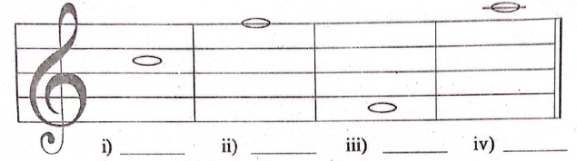
- Write the letter name of the notes as shown on the staff. (4 marks)

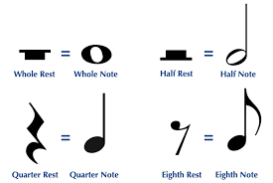
- Write the notes of the following rests. (4 marks)

i) _________________ ii) ___________________ iii) ___________________ iv) __________________
- Combine the following rhythms to create a rhythmic pattern. (3 marks)
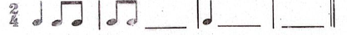
- Look at the diagram below of a musical instrument:
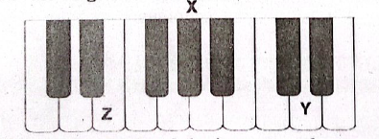
a) Name of the instrument: ___________________ (1 mark)
b) How are the black keys arranged? _______________ (1 mark)
c) Identify the keys marked: (3 marks)
i) Z – ___________________
ii) X – __________________
iii) Y – _________________
d) What is the interval from Z to X?
_____________________________________________________ (3 marks)
- Grade 8 learners discussed the importance of performing arts in society. Suggest four points they might have discussed. (4 marks)
a) ______________________________________________________________________________________.
b) ______________________________________________________________________________________.
c) ______________________________________________________________________________________.
d) ______________________________________________________________________________________.

PART II: PHYSICAL EDUCATION AND SPORTS (14 Marks)
SECTION A – Answer ALL Questions
- Name two types of sprint techniques practiced by Grade 8 learners. (2 marks)
a) ______________________________________________________________________________________.
b) ______________________________________________________________________________________.
- Identify the sprint start technique:
a) Toes of rear foot level with heel of front foot. _______________________________ (1 mark)
b) Both feet placed well behind the starting line. _______________________________ (1 mark)
- In handball, what is the technique called when the player bounces the ball on the ground once or repeatedly? _____________________________________________ (1 mark)
- Mention one dribbling technique in handball. ____________________________ (1 mark)
- Indicate whether the following statements are TRUE or FALSE: (2 marks)
a) Dodging can only be done with a ball.
TRUE FALSE

b) Shooting is throwing the ball into the opponent’s goal to score.
TRUE FALSE

- Mention one safety measure when performing a javelin throw.
__________________________________________________________________________. (1 mark)
- Identify one quality of a good marker in netball.
__________________________________________________________________________. (1 mark)
- Name another pass performed in netball besides the chest pass. ________________________ (1 mark)
- Mention one finishing technique in a sprint relay race. ___________________________________ (1 mark)
- Swimming: Mention two unsafe ways of entering or exiting a swimming pool. (2 marks)
i) _____________________________________________________________________.
ii) _____________________________________________________________________.
- During interclass, learners performed Nyama-Nyama. State two ways this game can be performed. (2 marks)
i) _____________________________________________________________________.
ii) _____________________________________________________________________.

PART III: VISUAL ARTS (10 Marks)
- Complete the career pathway diagram:
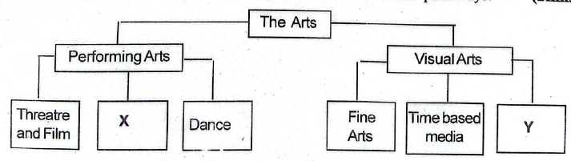
i) X represents: _____________________________________________.
ii) Y represents: _____________________________________________.
- Describe analogous colours and complementary colours. (2 marks)
a) Analogous colours: __________________________________________________________________________________________________________________________________________________________________________________________
b) Complementary colours: __________________________________________________________________________________________________________________________________________________________________________________________
- Value gradation strip shows colour changing in lightness or darkness. Name two ways to change the value of a colour. (2 marks)
a) _________________________________________________________________________________________
b) _________________________________________________________________________________________
- Mention two ways of decorating a clay item. (2 marks)
a) _________________________________________________________________________________________
b) _________________________________________________________________________________________
- State two differences between jewellery and ornaments. (2 marks)
 | Jewellery | Ornaments
i
ii

©2026
All rights reserved
©COMPETENCE KENYA EXAMINATION AND ASSESSMENT BOARD
THIS IS THE LAST PRINTED PAGE

