
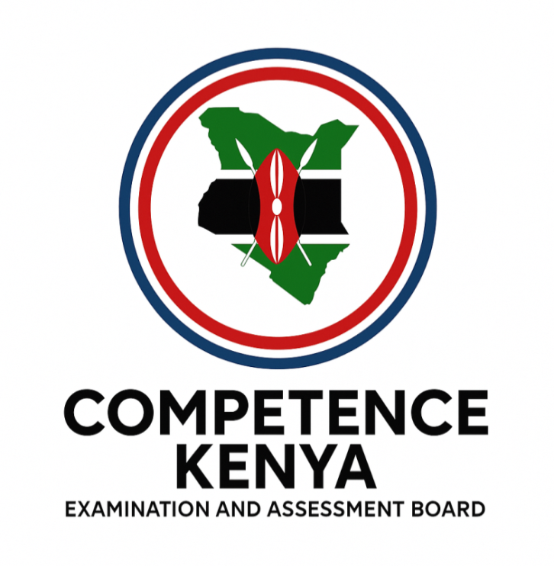
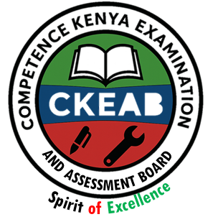
KENYA JUNIOR SCHOOL EDUCATION ASSESSMENT

GRADE 8 TERM 1 FEBRUARY 2026
✝
CHRISTIAN RELIGIOUS EDUCATION
CKEAB 002

Time - 1 hour 45 minutes

LEARNER’S DETAILS
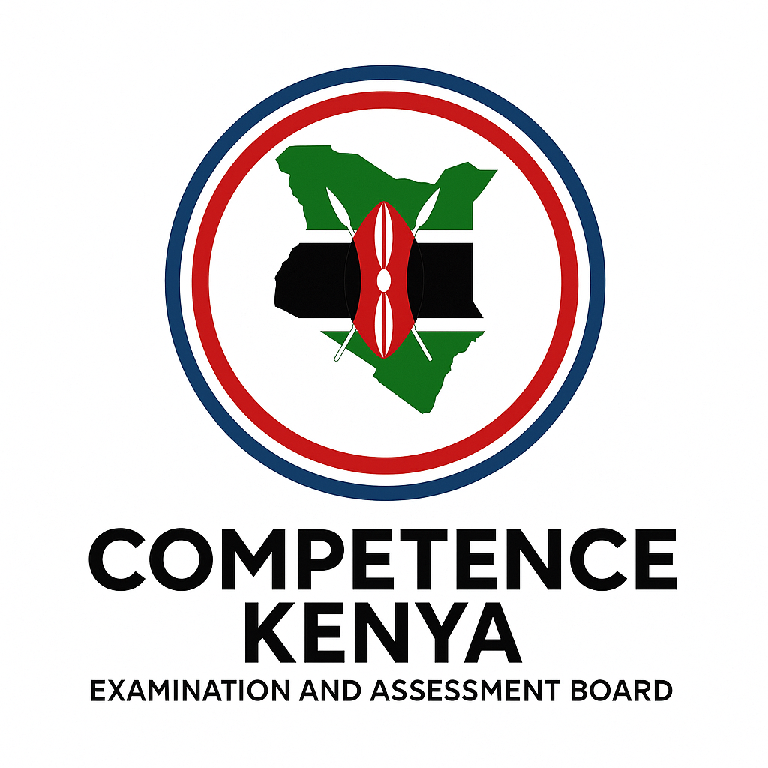
Name: ________________________________________________. School: _____________________________________
Assessment Number: _____________________________. Date: ______________________________.
School Code: ____________________________. Signature: ____________________________.
INSTRUCTIONS TO LEARNERS

- Write your name and assessment number in the spaces provided.
- Write the name and code of your school in the spaces provided.
- Write the date of the assessment and sign in the spaces provided.
- This question paper consists of two sections: A and B.
- Answer ALL questions in this paper.
- Write ALL the answers in the spaces provided in this question paper.
- Do NOT remove any page from this question paper.
- Answer the questions in English.

For official use only
SECTION A: MULTIPLE CHOICE QUESTIONS (20 Marks)
-CRE- -FORMATIVE ASSESSMENT- -002- - Paper Code 908-
Question No. | 1 | 2 | 3 | 4 | 5 | 6 | 7 | 8 | 9 | 10 | 11 | 12 | 13 | 14 | 15 | 16 | 17 | 18 | 19 | 20 | TOTAL
Max Score | 1 | 1 | 1 | 1 | 1 | 1 | 1 | 1 | 1 | 1 | 1 | 1 | 1 | 1 | 1 | 1 | 1 | 1 | 1 | 1 | 20
Candidate’s Score
SECTION B: STRUCTURED QUESTIONS (60 Marks)
Task | Qn Nos. | Max Marks | Candidate's Score  GRAND TOTAL
SECTION A | 20 | 20
SECTION B | 8 | 80
TOTAL | 28 | 100
Level |  | Level | % Range | Points | Learner’s score | Remarks
Exceeding (EE) |  | EE1 | 90–100% | 8 |  | Exceptional mastery; exceeds expectations
 |  | EE2 | 75–89% | 7 |  | Very strong performance
Meeting (ME) |  | ME1 | 58–74% | 6 |  | Solid understanding
 |  | ME2 | 41–57% | 5 |  | Partial achievement
Approaching (AE) |  | AE1 | 31–40% | 4 |  | Limited achievement
 |  | AE2 | 21–30% | 3 |  | Very limited
Below (BE) |  | BE1 | 11–20% | 2 |  | Poor performance
 |  | BE2 | 1–10% | 1 |  | Extremely weak
This paper consists of 8 printed pages. Candidates should check the question paper to ascertain that all the pages are printed as indicated and that no questions are missing. Turn over

SECTION A: (20 MARKS)
Answer all questions by choosing the correct answer

- Jane tells a lie to escape punishment for breaking a school rule.
This act of disobedience is primarily a violation of the Christian teaching on:
A. Forgiveness B. Sin
C. Redemption D. Fasting
- When facing overwhelming stress, a young person starts abusing alcohol to forget their problems.
This cause of substance abuse is best classified as:
A. Social pressure
B. Emotional escape
C. Economic necessity
D. Environmental factor
- The first biblical account of creation (Genesis 1) describes God creating light by speaking the command. This shows that God is:
A. Holy
B. Merciful
C. Omnipotent (All-Powerful)
D. Just
- A farmer who practices crop rotation and avoids chemical fertilizers to protect the soil demonstrates:
A. Ownership
B. Sustainability
C. Selfishness
D. Dominance
- A Christian reading the book of Prophets to understand God’s warnings shows that the Bible is a source of:
A. Personal entertainment
B. Historical and prophetic record
C. Scientific data
D. Secular law
- Missionaries translating the Bible into local dialects aim to promote:
A. Literary criticism
B. Accessibility and understanding
C. Cultural assimilation
D. Linguistic analysis
- Ann feels obligated to seek her friend’s permission before meeting others. This shows:
A. Christian fellowship
B. An unhealthy relationship
C. Mutual respect
D. Healthy boundaries
- Tom uses his lunch money to participate in a chance-based competition. This activity is:
A. Investment risk
B. Gambling
C. Saving
D. Business venture
- A student who posts hurtful comments online is engaging in:
A. Trolling
B. Cyberbullying
C. Networking
D. Self-expression
- After killing an Egyptian, Moses fled to Midian where he learned:
A. Military combat techniques
B. Patience and reliance on God
C. Egyptian court protocol
D. Wealth management
- The prophecy that the Messiah would be born of a virgin (Isaiah 7:14) points to:
A. Judging the nations
B. Redemption through Jesus Christ
C. Establishing a new temple
D. Restoring the monarchy
- After the Fall, God’s promise to put enmity between the woman’s seed and the serpent (Genesis 3:15) shows His:
A. Anger B. Love and initiative
C. Silence D. Vengeance
- Abraham’s willingness to sacrifice Isaac demonstrated:
A. Wealth B. Obedience
C. Faith D. Humility
- A Christian’s firm belief in the Lord’s return gives them:
A. Legal precedent
B. Hope for the future
C. Economic gain
D. Social isolation
- Genesis 2 focuses mainly on:
A. The creation of light
B. The creation of man in detail
C. The creation of the heavens
D. The separation of waters
- A Christian who sincerely apologizes and changes behavior shows:
A. Justification
B. Temptation
C. Repentance
D. Fasting
- The Christian teaching on marriage emphasizes that it is a:
A. Contract B. Covenant
C. Partnership D. Agreement
- When a student resists the urge to steal, they demonstrate:
A. Courage B. Diligence
C. Integrity D. Loyalty
- The book of Hebrews is part of the New Testament division called:
A. The Gospels
B. The Epistles/Letters
C. The Law
D. The Prophecy
- A group that dedicates a day to prayer and abstaining from food is practicing:
A. Sacrifice
B. Fasting
C. Confession
D. Almsgiving

SECTION B: (80 Marks)
Answer all questions in complete sentences.
- All humans are affected by sin, yet God offered reconciliation.
(a) Explain three causes of sin or temptation among youth today. (3mks)

- _______________________________________________________________________________________
- _______________________________________________________________________________________
- _______________________________________________________________________________________

(b) Describe four ways God showed His love immediately after the Fall of Man. (4mks)
- _______________________________________________________________________________________
- _______________________________________________________________________________________
- _______________________________________________________________________________________
- _______________________________________________________________________________________
(c) Discuss three importance of redemption to a Christian. (3mks)
- _______________________________________________________________________________________
- _______________________________________________________________________________________
- _______________________________________________________________________________________
- The Bible must be understood and applied.
(a) State four functions of the Bible in guiding Christian life. (4mks)

- _______________________________________________________________________________________
- _______________________________________________________________________________________
- _______________________________________________________________________________________
- _______________________________________________________________________________________
(b) Explain three reasons for translating the Bible into different languages. (3mks)
- _______________________________________________________________________________________
- _______________________________________________________________________________________
- _______________________________________________________________________________________
(c) Outline three ways Christians misuse the Bible today. (3mks)

- _______________________________________________________________________________________
- _______________________________________________________________________________________
- _______________________________________________________________________________________

- God created humanity to manage the earth responsibly.
(a) Differentiate between Genesis 1 and Genesis 2 creation accounts. (4mks)
(b) List three responsibilities God gave man over creation. (3mks)

- _______________________________________________________________________________________
- _______________________________________________________________________________________
- _______________________________________________________________________________________
(c) Suggest three ways to care for God’s creation in school. (3mks)
- _______________________________________________________________________________________
- _______________________________________________________________________________________
- _______________________________________________________________________________________
- Abraham’s faith is a model for believers.
(a) Identify four ways Abraham demonstrated faith in God. (4mks)

- _______________________________________________________________________________________
- _______________________________________________________________________________________
- _______________________________________________________________________________________
- _______________________________________________________________________________________
(b) List six promises God made to Abraham. (6mks)
- _______________________________________________________________________________________
- _______________________________________________________________________________________
- _______________________________________________________________________________________
- _______________________________________________________________________________________
- _______________________________________________________________________________________
- _______________________________________________________________________________________
- Youth often face pressure to engage in unhealthy relationships.
(a) Define human sexuality from a Christian view. (3mks)
_______________________________________________________________________________________
_______________________________________________________________________________________
_______________________________________________________________________________________
(b) Describe three causes of unhealthy relationships among youth. (3mks)

- _______________________________________________________________________________________
- _______________________________________________________________________________________
- _______________________________________________________________________________________

(c) Suggest four Christian teachings on marriage that guide healthy living. (4mks)
- _______________________________________________________________________________________
- _______________________________________________________________________________________
- _______________________________________________________________________________________
- _______________________________________________________________________________________
- Drug abuse continues to threaten the youth.
(a) Define:
i. Drug (1mk)
__________________________________________________________________________________________________________________________________________________________________________________________
ii. Drug abuse (1mk)
__________________________________________________________________________________________________________________________________________________________________________________________
(b) Explain four reasons young people abuse drugs today. (4mks)
- _______________________________________________________________________________________
- _______________________________________________________________________________________
- _______________________________________________________________________________________
- _______________________________________________________________________________________
(c) Describe four ways to help youth avoid drug abuse. (4mks)
- _______________________________________________________________________________________
- _______________________________________________________________________________________
- _______________________________________________________________________________________
- _______________________________________________________________________________________
- Moses’ leadership and the Church’s mission show examples of service.
(a) Describe the stages of God’s preparation of Moses for leadership. (4mks)

- _______________________________________________________________________________________
- _______________________________________________________________________________________
- _______________________________________________________________________________________
- _______________________________________________________________________________________
(b) Identify three barriers to effective church mission today. (3mks)
- _______________________________________________________________________________________
- _______________________________________________________________________________________
- _______________________________________________________________________________________
(c) Outline three contributions of the Church to the health sector. (3mks)
- _______________________________________________________________________________________
- _______________________________________________________________________________________
- _______________________________________________________________________________________

- Youth misuse technology and engage in gambling.
(a) Define gambling and list two types. (3mks)
Meaning:
__________________________________________________________________________________________________________________________________________________________________________________________
Types
- _______________________________________________________________________________________
- _______________________________________________________________________________________
- _______________________________________________________________________________________
(b) Explain three negative effects of gambling on a student’s academic life. (3mks)
- _______________________________________________________________________________________
- _______________________________________________________________________________________
- _______________________________________________________________________________________
(c) State four positive uses of social media for learning and growth. (4mks)
- _______________________________________________________________________________________
- _______________________________________________________________________________________
- _______________________________________________________________________________________
- _______________________________________________________________________________________

©2026
All rights reserved
©COMPETENCE KENYA EXAMINATION AND ASSESSMENT BOARD
This is the last printed page

