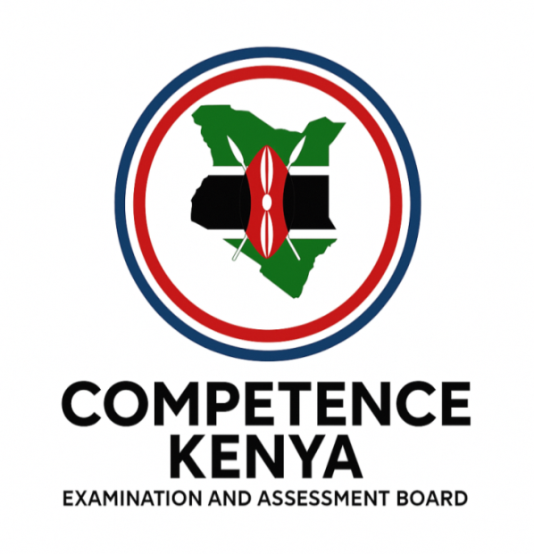
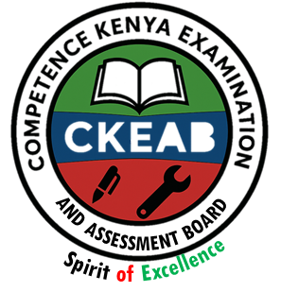

COMPETENCY-BASED EDUCATION (CBE)

SCHOOL-BASED ASSESSMENT CKEAB 002

GRADE 5 – MIDTERM ASSESSMENT (TERM 1, 2026)
Learner’s Name: ___________________________School Name: ______________________________
Assessment Number: ___________________________ Date: _______________________________

SOCIAL STUDIES ACTIVITIES ASSESSMENT
SCORE GRID: FOR FACILITATORS USE
TOTAL SCORE | 50
LEARNERS SCORE
PERFORMANCE LEVEL

SOCIAL STUDIES ACTIVITY ASSESSMENT

ANSWER ALL QUESTIONS
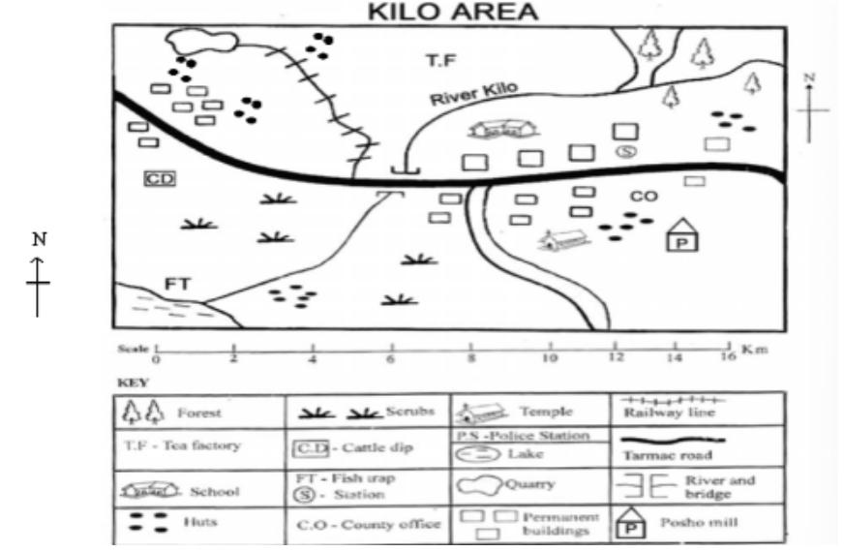
Study the map of Kilo area and answer the question:

- Which of the following economic activities is not practiced in Kilo area?
A. Fishing B. Mining
C. Cattle keeping D. Tourism
- What is the direction of the quarry from the posh mill?
A. North East B. South East
C. North West D. South West
- The population distribution in the North Western part of Kilo area can be described as:
A. Densely populated B. Linear settlement
C. Sparsely populated D. Clustered settlement
- Who is the most senior officer in Kilo area?
A. Police officer B. Chief
C. Governor D. President
- Which of the following pairs of rivers drain their water into the lake Turkana?
A. R. Ewaso Nyoro and R. Tana
B. R. Turkwel and R. Kerio
C. R. Athi and R. Galana
D. R. Mara and R. Nzoia
- Joshua was asked to state the elements of weather. Which of his responses is not an element of weather?
A. Temperature B. Rainfall
C. Altitude D. Sunshine
- Grade 5 pupils visited a local cultural centre. Which of the following items were they not likely to see?
A. Traditional earthen pots
B. Traditional hunting equipment
C. Traditional attires
D. Plastic water containers
- During a discussion, learners listed several communities in Kenya. Which of these belong to the Cushitic language group?
A. Agikuyu, Nandi, Dahalo
B. Watavetu, Aembu, Sanye
C. Maasai, Luo, Abaluhya
D. Borana, Somali, Gabbra
- Gabriel watched a video clip on African traditional education. Which of the following methods was he not likely to see?
A. Riddles B. Poems
C. Proverbs D. Radio
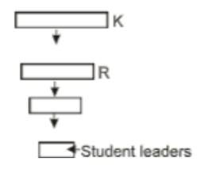
- A pupil drew the following school administrative chart.

What are the titles of the officers in the slots labelled K and R respectively?
A. Principal and senior teacher
B. Headteacher and deputy headteacher
C. Senior teacher and director
D. Class teacher and principal
- During a Social Studies lesson, Tr. Ruth asked learners to define population density. Who gave the correct definition?
A. Janet - The number of people living in a place
B. Shine - The number of people in an area at a particular time
C. Trevor - The number of people per square kilometer
D. Teresia - The number of people in a place over a certain period of time
- Grade 4 learners defined democracy. Which definition is correct?
A. Freedom to express our ideas
B. Freedom to make own decisions
C. Ability to make choices
D. Freedom to choose our leaders
- Felix and Gloria listed members of the county assembly. Who among the listed is not a member of the county assembly?
A. Governor B. Speaker
C. Police D. Youth representatives
- Helen discussed economic activities in the county. Which of the following activities leads to land destruction?
A. Fishing B. Tourism C. Trading D. Mining
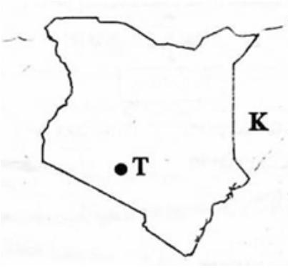
- Study the following map of Kenya.

The country marked K is:
A. Tanzania B. Somalia
C. Uganda D. South Sudan
- Which historical built environment is found at the part marked T?
A. Vasco da Gama Pillar
B. Fort Jesus
C. Gedi ruins
D. Jomo Kenyatta Monument

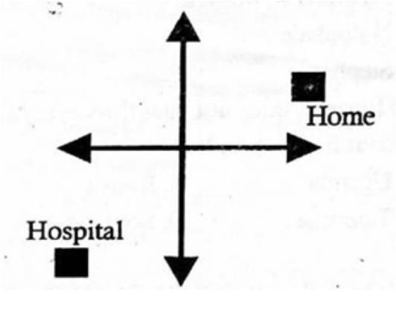
- A Grade 5 learner is planning to visit a doctor for a medical checkup.

Which route will the learner follow from home to the hospital?
A. North East B. South West
C. North West D. South East
- Grade 4 learners drew different features of the land. Which feature appeared on a long, flat, raised area?
A. Plateau B. Swamp C. Valley D. Ocean
- Elements of a map help interpret features and symbols. Which element contains the symbols and signs used on a map?
A. Frame B. Title C. Scale D. Legend
- Which product is correctly matched with the industry where it is made?
A. Basket – carving B. Milk - baking
C. Rope - weaving D. Cement - creamery
- Learners at Upendo School listed ways people depend on one another. Which is an importance of interdependence?
A. People lack each other's support
B. There is unity
C. It encourages tribalism
D. Leads to dense population
- Mr. Juma allows learners to choose activities during cultural day. By doing this, he allows learners to practice:
A. Democracy B. Freedom
C. Nepotism D. Interaction
- Grade 4 learners wrote down aspects of culture. Which group consists only of aspects of culture?
A. Food, dressing, religion
B. Climate, festivals, carvings
C. Housing, sports, food
D. Ceremonies, dances, beadwork
- Who among the members of the county government is a member of the county assembly?
A. Deputy Governor
B. M.C.A
C. Deputy Governor
D. Executive committee member
- A good citizen should be able to:
A. Be boastful to others
B. Be helpful to others
C. Be a good friend to the rich
D. Be selfish to others
- What do we call the weather condition of a place recorded for a very long time?
A. Weather B. Altitude
C. Relief D. Climate
- Choose a country that does not border Kenya:
A. Tanzania B. Sudan
C. Rwanda D. Uganda
- We can practice democracy in a school by:
A. Learners choosing their leaders
B. Learners choosing the subjects they like
C. Learners doing whatever they want
D. Teachers teaching better
- Who among the following is a Kenyan citizen?
A. A tourist who loves Kenya
B. Somebody from a neighbouring country
C. A five-year-old child in Kenya but parents are not known
D. Anybody who wants to be a Kenyan
- Which of the following is the largest country in Eastern Africa?
A. Rwanda B. Sudan
C. Uganda D. Eritrea
- In African traditional education, children were taught through all the following except:
A. Copying notes B. Using riddles
C. Storytelling D. Observation
- Which of the following is not a man-made lake?
A. Kiambura B. Nyumba ya Mungu
C. Naluubale D. Stephanie
- Kenya covers the total area of?
A. 582646km² B. 582000km²
C. 47km² D. 50000km²
- The element of a map that is also called legend is?
A. frame B. title C. scale D. key
- Grade five learners went for an educational tour to the Bomas of Kenya. Their Social Studies teacher asked them to identify the type of built environment they were at. Which response did they give?
A. Monument
B. Museum
C. Cultural centre
D. Historic site
- Grade 5 learners were asked to identify ways of conserving historic built environment. Which response was not correct?
A. Cleaning them
B. Putting fences around them.
C. Protecting them from destruction.
D. Destroying them.
- Grade 5 learners went for an educational tour to Nairobi National Museum. Which of the items is not one of the traditional artefacts they saw?
A. Calabash
B. Gourd
C. Spear
D. Laptop
- Which group is made up of the Bantu speakers in Kenya?
A. Nandi, Maasai, Kipsigis
B. Akamba, Ameru, Wataita
C. Rendille, Borana, Somali
D. Luo, Abagusii, Abakuria
- Debates in the county assembly are controlled by the?
A. speaker B. teacher
C. governor D. senator
- Identify the largest lake in Kenya
A. L. Victoria
B. L. Nakuru
C. L. Baringo
D. L. Turkana
- Which of these rivers drains into Lake Turkana?
A. River Yala B. River Nzoia
C. River Nyando D. River Kerio
Use the map of Kenya below to answer questions 42 – 45
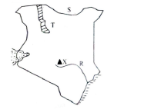
- Identify the lake marked T.
A. Lake Turkana B. Lake Victoria
C. Lake Baringo D. Lake Bogoria
- The river marked R is?
A. R. Tana
B. R. Athi
C. R. Nile
D. R. Gucha
- The country that neighbours Kenya marked S is?
A. Sudan
B. Ethiopia
C. Somalia
D. Rwanda
- The mountain labeled X is?
A. Mt. Kenya
B. Mt. Elgon
C. Mt. Longonot
D. Mt. Marsabit
- John sells his flowers to Britain. Which means of transport does he use to transport the flowers from Kenya to Britain?
A. Road
B. Air
C. Railway
D. Water
- The head of the county executive committee is the?
A. speaker
B. senator
C. governor
D. MCA
- Grade 5 learners were asked to state the elements of weather. Which response was wrong?
A. Rainfall
B. Wind
C. Temperature
D. Soil
- Law and order is maintained by the?
A. governor
B. police officers
C. chief
D. president
- Learners in a boarding school were asked to pay for a trip to Mombasa. Which is the best means of communication that the headteacher should have used to pass the message to all the parents quickly and at the same time?
A. Letters
B. Sending emails
C. Calling using mobile phone
D. Announcing over the radio

©2026
All rights reserved
©COMPETENCE KENYA EXAMINATION AND ASSESSMENT BOARD
This is the last printed page

ANSWERS
- D
- C
- D
- C
- B
- C
- D
- D
- D
- B
- C
- D
- C
- D
- B
- D
- B
- A
- D
- C
- B
- A
- D
- B
- B
- D
- C
- A
- C
- B
- A
- D
- A
- D
- C
- D
- D
- B
- A
- A
- D
- A
- A
- B
- A
- B
- C
- D
- B
- C

