


COMPETENCY-BASED EDUCATION (CBE)

SCHOOL-BASED ASSESSMENT CKEAB 002

GRADE 5 – MIDTERM ASSESSMENT (TERM 1, 2026)
Learner’s Name: ___________________________School Name: ______________________________
Assessment Number: ___________________________ Date: _______________________________

SCIENCE AND TECHNOLOGY ACTIVITIES ASSESSMENT
SCORE GRID: FOR FACILITATORS USE
Q. No. | 1 | 2 | 3 | 4 | 5 | 6 | 7 | 8 | 9 | 10 | 11 | 12 | 13 | 14 | 15 | 16 | 17 | 18 | 19 | 20 | 21 | 22 | 23 | 24 | 25 | 26 | 27 | 28 | 29 | 30 | TOTAL
Score per Qn | 1 | 1 | 1 | 1 | 1 | 1 | 1 | 1 | 1 | 1 | 1 | 1 | 1 | 1 | 1 | 1 | 1 | 1 | 1 | 1 | 1 | 1 | 1 | 1 | 1 | 1 | 1 | 1 | 1 | 1 | 50
Learner Score
Performance Level
Q. No. | 31 | 32 | 33 | 34 | 35 | 36 | 37 | 38 | 39 | 40 | 41 | 42 | 43 | 44 | 45 | 46 | 47 | 48 | 49 | 50
Score per Qn | 1 | 1 | 1 | 1 | 1 | 1 | 1 | 1 | 1 | 1 | 1 | 1 | 1 | 1 | 1 | 1 | 1 | 1 | 1 | 1
Learner Score
Performance Level
Answer all the questions

- The following picture was taken by a learner during a study on identification of fungi.
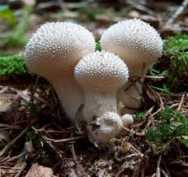
The picture shows a:
A. Mould B. Yeast C. Puffball D. Mushroom
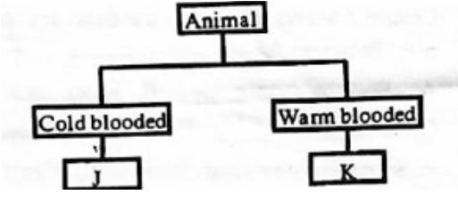
- The following chart was drawn by a learner to show classification of animals.

Which animals should the learner correctly use at point J and K?
A. Duck - Toad B Fish - Rabbit C. Snake - Lizard D. Crocodile - Turtle
- Learners listed the following characteristics of clouds:
i. Irregular in shape
ii. Resembles bundles of cotton wool
iii. Covers the whole sky
iv. Appears in layers
Which of the listed characteristics are for nimbus clouds?
A. iv and ii B. i and iii C. i and ii D. iii and iv
- Which of the following is a safety precaution to be observed when handling harmful plants?
A. Smelling plants before picking them B. Putting on protective clothing C. Destroying harmful plants D. Washing hands with soap and water when handling harmful plants
- The following are examples of levers which make work easier. Which one is not?
A. Beam balance B. Hammer C. Wheelbarrow D. Chair
- Grade 4 learners identified items made using good conductors of heat. Which is correct?
A. Cooking pan B. Sweater C. Plastic plate D. Kettle handles
- During a lesson on reflection of sound, a learner dropped a nail and everybody in the class turned back to where the sound came from. This shows that sound:
A. Travels in a straight line B. Can be reflected easily C. Travels in all directions D. Travels in one direction
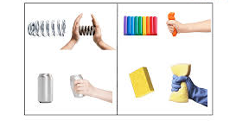
- The pictures above show that force can:

A. Stop a moving object B. Change the shape of an object C. Make an object move D. Push an object away
- During a class discussion, learners stated ways they can make a floater sink in a bucket full of water. Which is correct?
A. Reducing the water level in bucket B. Dropping the floater on water using force C. Tying a heavier material on it D. Increasing the water level in a bucket
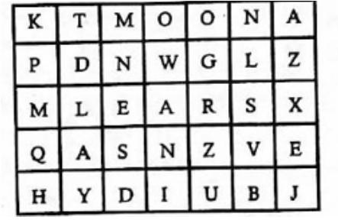
- A teacher asked learners to find different names of parts of the body. Which one did they find in the puzzle below?

A. Head B. Liver C. Ears D. Nose
- Which part of a desktop computer will a learner use to connect it to its hardware?
A. Cables B. Monitor C. Mouse D. Processor
- Most learners from Bidii School walk to their homes after school. In which of the following places are they not likely to find polluted water?
A. Watering troughs B. Old containers by the roadside C. Open pits D. Closed tanks
- Which of the following is an effect of air pollution on living things near your home area?
A. Slaughterhouses B. Proper disposal of waste C. Poor growth of plants D. Sprinkling water on dusty grounds
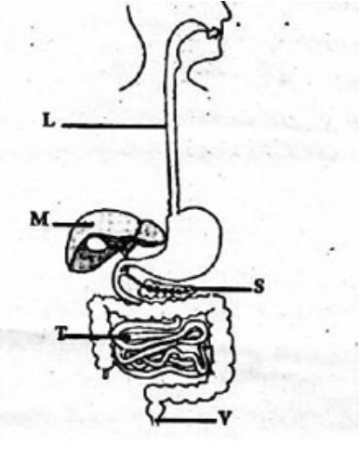
Study the diagram below and answer questions 14 and 15.

- The parts marked L and S are:
A. Rectum - Stomach B. Large intestine - Liver C. Anus - Small intestine D. Esophagus - Pancreas
- In which part will the food eaten by a child be absorbed after being digested?
A. T B. S C. M D. V

- The picture above shows that animals:
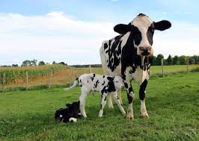
A. Move B. Feed C. Remove waste D. Reproduce
- Learners were grouping living and non-living things in the environment. Which group did they group non-living things only?
A. Flowers, Pen B. Water, Soil C. Tree, Vehicle D. Sawdust, Bee
- During a class discussion, learners listed some characteristics of reptiles. The following are characteristics they listed about reptiles except:
A. Their body is covered with scales B. They live on land only C. Breathe through lungs D. Cold-blooded
- Which of the following plants collected by Grade 5 learners during an outdoor activity is non-flowering?
A. Sodom Apple B. Pawpaw C. Maize D. Ferns
- A shopkeeper was having difficulties in calculating the total amount of sales in his shop. Which digital device would you advise him to use?
A. Television B. Calculator C. Wall clock D. Camera
- Which of the following is a safety precaution Grade 4 learners should observe when handling animals?
A. Running near animals B. Playing with their young ones C. Being alert when around them D. Feeding them
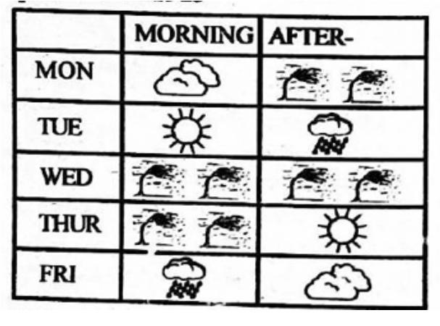
Study the weather chart below and answer questions 22 and 23.

- Which was the best day for winnowing?
A. Friday B. Wednesday C. Tuesday D. Monday
- On which day did learners carry umbrellas while heading to school?
A. Friday B. Tuesday C. Thursday D. Wednesday
- Learners put water in different containers as shown below.

The activity above shows that liquids:
A. Have fixed volume B. Flow C. Have a fixed shape D. Take the shape of the container
- Which is the best practice learners can carry out to reduce air pollution at their homes?
A. Using ventilated improved pits B. Proper disposal of waste C. Sprinkling water in pit latrines D. Wearing safety clothes when in an air-polluted place
- A learner observed a seedling grow towards light. Which process is this an example of?
A. Phototropism B. Geotropism C. Hydrotropism D. Chemotropism
- Which material is a poor conductor of heat?
A. Aluminium B. Copper C. Wood D. Steel
- A learner wants to test which liquid flows faster. Which property of liquids is being investigated?
A. Viscosity B. Density C. Conductivity D. Volume
- Which of the following animals is a herbivore?
A. Lion B. Cow C. Crocodile D. Eagle
- Which part of the human body helps in pumping blood?
A. Lungs B. Heart C. Liver D. Kidney
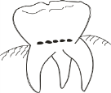
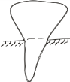
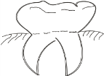
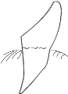
- Which among the following types of teeth is used for cutting and biting?

A. B. C. D.

Animals with a backbone are called
A. mammals B. invertebrates
C. vertebrates D. living things

Which of the following animals should not be in this group?
A. Elephant B. Antelope C. Crocodile D. Wasp

Most digested food in the human body is absorbed in the—
A. mouth B. stomach
C. small intestine D. large intestine

Which one of the following is not a solid?
A. Stone B. Water C. Wood D. Metal
- During a nature walk, a Grade 6 learner observed a plant that was green but did not produce flowers. Which plant was it?
A. Maize B. Pawpaw C. Fern D. Tomato
- The following are ways to protect ourselves when handling poisonous plants except wearing
A. Gloves B. Goggles C. Masks D. Necklaces
- Kirwa displayed a picture of fungi in her class. What is the name of the fungi?
A. Toadstool B. Bread molds
C. Puffballs D. Mushrooms
- The school chef made dough for preparing mandazi during prayer day. Apart from flour and water, which ingredient was also in the dough?
A. Flour B. Yeast C. Mucus D. Lichens
- The table below shows groups of vertebrates. Which group is correctly matched with animals belonging to it?
A. Mammals – Toad B. Reptiles – Lizard
C. Fish – Whale D. Amphibians – Kite
- The following are characteristics of a certain animal:
i. Body covered with scales
ii. They lay eggs
iii. Breathe through lungs
iv. Body temperature changes with environment
Which animal has these characteristics?
A. Newt B. Frog C. Snake D. Goat
- Kelvin matched the following sense organs with their uses. Which one was correctly matched?
A. Eyes – Listening B. Nose – Tasting
C. Skin – Hearing D. Tongue – Tasting
- Which of the following cleaning tools is safe for cleaning the ear?
A. Matchstick B. Ear bud
C. Sticks D. Handkerchief
- A learner was identifying parts of the human skeleton. Which part is located above the stomach?
A. Backbone B. Ribcage C. Limbs D. Head
- An IT technician installed a word processor on his computer. Which of the following is NOT a use of the application?
A. Creating a file B. Editing a document
C. Printing D. Taking photos
- Ben heated water in a sufuria. What happened when the water was heated for a long time?
A. The water cooled
B. The water evaporated
C. The sufuria expanded
D. The water remained the same
- Grade 5 learners were investigating materials that turn red litmus paper blue. Which material was most appropriate?
A. Ash B. Toothpaste
C. Lemon juice D. Water
- One day when Klemo was walking home, he felt rain droplets falling on him. What caused the droplets to fall?
A. Gravity B. Energy
C. Speed D. Density
- Kihunga Market has experienced noise pollution for a long time. What is the best measure to control it?
A. Relocate the market
B. Use hearing protective devices
C. Government to make policies
D. Avoid listening to loud music
- Wambui washed her blouse and placed it on a hanging line. How did the heat from the sun reach the cloth?
A. Conduction
B. Convection
C. Radiation
D. Heating

©2026
All rights reserved
©COMPETENCE KENYA EXAMINATION AND ASSESSMENT BOARD
This is the last printed page
Answers
- C
- A
- B
- B
- D
- A
- C
- B
- C
- C
- A
- D
- C
- D
- A
- D
- B
- B
- D
- B
- C
- B
- A
- D
- B
- A
- C
- A
- B
- B
- B
- C
- D
- C
- B
- C
- D
- B
- B
- B
- C
- D
- B
- B
- D
- B
- A
- A
- B
- C

