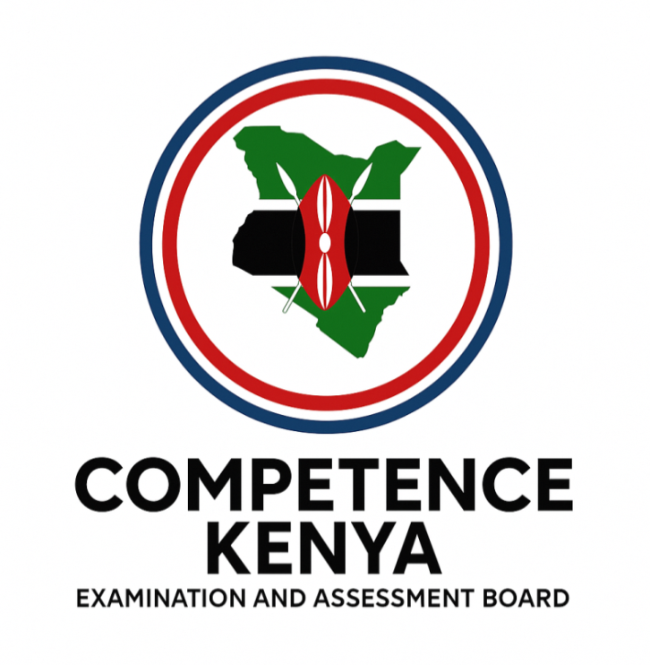
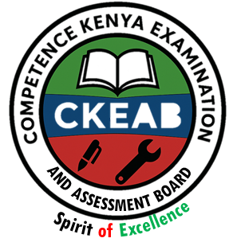

COMPETENCY-BASED EDUCATION (CBE)

SCHOOL-BASED ASSESSMENT CKEAB 002

IRE ACTIVITY ASSESSMENT

GRADE 5 – MIDTERM ASSESSMENT (TERM 1, 2026)
Learner’s Name: ___________________________School Name: ______________________________
Assessment Number: ___________________________ Date: _______________________________

IRE ACTIVITIES ASSESSMENT
SCORE GRID: FOR FACILITATORS USE
Question Number | 1 | 2 | 3 | 4 | 5 | 6 | 7 | 8 | 9 | 10 | 11 | 12 | 13 | 14 | 15 | 16 | 17 | 18 | 19 | 20 | 21 | 22 | 23 | 24 | 25 | 26 | 27 | 28 | 29 | 30 | TOTAL
Score per Question | 1 | 1 | 1 | 1 | 1 | 1 | 1 | 1 | 1 | 1 | 1 | 1 | 1 | 1 | 1 | 1 | 1 | 1 | 1 | 1 | 1 | 1 | 1 | 1 | 1 | 1 | 1 | 1 | 1 | 1 | 30
Learner Score

ANSWER ALL QUESTIONS

- “Whiter than milk, sweeter than honey…” refers to Surah
A. Aadiyat B. Asr C. Naas D. Kawthar
- To protect oneself from evil men and jinns, a Muslim should recite Surah
A. Maun B. Kawthar C. Asr D. Naas
- Which one is NOT a lesson from Surah Al-Maun? We should not
A. Encourage feeding the poor
B. Show off in ibadah
C. Pray on time
D. Be kind to orphans
- The story of Abrahah is mentioned in Surah
A. Fiyl B. Asr C. Tiyn D. Maun
- Six children of Prophet Muhammad (SAW) were from Khadijah except
A. Qassim B. Ibrahim
C. Abdullah D. Ruqqayyah
- The only pillar of Islam given in the heavens was to be performed how many times a day?
A. 7 B. 5 C. 50 D. 99
- The dua “Bismillahi tawakkaltu ‘alallah…” is said when
A. Entering the house
B. Leaving the house
C. Entering the market
D. Entering the mosque
- Which is a correct description of a male’s clothing?
A. Should cover whole body
B. Should cover between navel and knees
C. Should be long enough
D. Should not be attractive
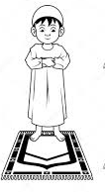
- The posture shown in the diagram is

A. Qiyaam B. Sujuud
C. I’tidal D. Smartul

- Which eating etiquette was NOT taught by the Prophet?
A. Say Bismillah B. Eat with right hand
C. Eat what is in front D. Eat using a spoon
- The social media symbol shown represents

A. Twitter B. Instagram
C. Skype D. Google
- Which attribute of Allah appears in both Surah Fatiha and Surah Naas?
A. Al-Malik B. Ar-Rahmaan
C. Ar-Rahiim D. Al-Aziz
- Who identified the correct Ulul Azm prophets?
A. Kawthar – Nuh, Ibrahim, Isa, Musa, Muhammad
B. Mariam – Isa, Yusuf, Adam, Idris, Muhammad
C. Hawa – Muhammad, Musa, Isa, Yusuf, Adam
D. Kassim – Yusuf, Idris, Isa, Ismail, Ishaaq
- Which one is NOT among the five things we will be questioned about?
A. Wealth B. Life
C. Knowledge D. Work
- Another name for Surah Al-Fatiha is
A. Thulithil Qur’an B. Qalbul Qur’an
C. Sabaul Mathani D. Saratul Ahad
- Allah calls Himself all these names in Surah Naas except
A. Khaaliki Naas B. Rabbi Naas
C. Maliki Naas D. Ilaahi Naas
- Surahs Naas and Falaq are called Al-Muawwidhatayn because they are Surahs of
A. Guidance B. Sleep
C. Protection D. Medicine
- Surah Al-Masad was revealed to warn
A. Abrahah and his elephants
B. Abu Lahab and his wife
C. Taif chiefs
D. Kafirun
- Prophet Muhammad (SAW) is an example of all these except
A. Jealousy B. Kindness
C. Trustworthiness D. Truthfulness
- “Bismillahi awwalahu wa akhirahu” is said when you forget
A. To wash hands
B. To eat with right hand
C. To say Alhamdulillah
D. To say Bismillah
- Allah is “The Source of Peace” and is praised as
A. As-Saami’u B. As-Salaam
C. Al-Baswiir D. Ar-Rahmaan
- Number of prophets mentioned in the Qur’an is
A. 15 B. 40
C. 25 D. 36
- A baby boy below two years produces Najis Mukhaffafa when he passes
A. Vomit B. Stool
C. Saliva D. Urine
- It is Sunnah to perform Wudhu
A. Before eating
B. Before travelling
C. Before bathing
D. Before sleeping
- Qiblah direction in Kenya is towards
A. South B. West C. North D. East
- One finishes Swalah by
A. Turning right then left
B. Raising right hand
C. Saying Ameen
D. Reciting a dua
- Clothing made from _____ is forbidden for Muslim males.
A. Silk B. Khaki C. Cotton D. Polyester
- The dua “Bismillahi tawakkaltu…” is recited when
A. Leaving a bus B. Leaving a house
C. Entering a bus D. Entering a house
- Which one is NOT true about the first call to prophethood?
A. He was in Cave Hira
B. He was 40 years old
C. He was asked to read
D. He was migrating to Madina
- The Quran contains ______ surahs.
A. 100 B. 200 C. 114 D. 124

©2026
All rights reserved
©COMPETENCE KENYA EXAMINATION AND ASSESSMENT BOARD
This is the last printed page

IRE ANSWERS
- D
- D
- B
- A
- B
- C
- B
- B
- A
- D
- B
- A
- A
- D
- C
- A
- C
- B
- A
- D
- B
- C
- D
- D
- C
- A
- A
- B
- D
- C

