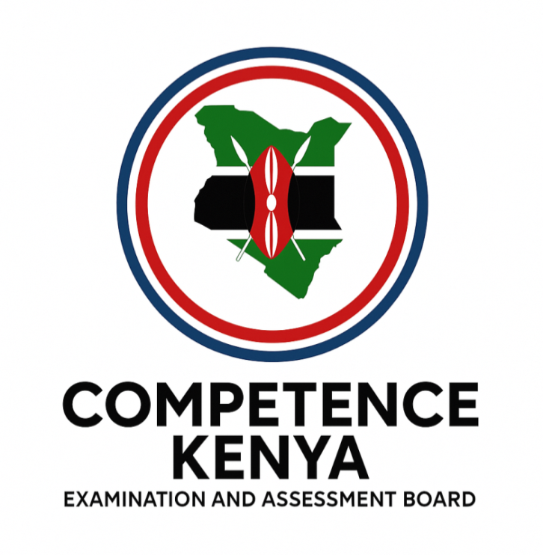
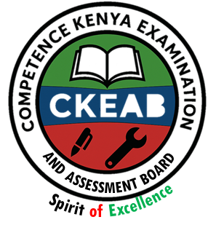

COMPETENCY-BASED EDUCATION (CBE)

SCHOOL-BASED ASSESSMENT CKEAB 002

GRADE 5 – MIDTERM ASSESSMENT (TERM 1, 2026)
Learner’s Name: ___________________________School Name: ______________________________
Assessment Number: ___________________________ Date: _______________________________

CREATIVE ARTS ACTIVITIES ASSESSMENT
SCORE GRID: FOR FACILITATORS USE
Question Number | 1 | 2 |  | 3 | 4 |  | 5 | 6 | 7 |  | 8 | 9 |  | 10 |  | 11 |  | 12 |  | 13 |  | 14 |  | 15 |  | 16 |  | 17 |  | 18 |  | 19 |  | 20 |  | 21 |  | 22 |  | 23 |  | 24 |  | 25
Score per Question | 1 | 1 |  | 1 | 1 |  | 1 | 1 | 1 |  | 1 | 1 |  | 1 |  | 1 |  | 1 |  | 1 |  | 1 |  | 1 |  | 1 |  | 1 |  | 1 |  | 1 |  | 1 |  | 1 |  | 1 |  | 1 |  | 1 |  | 1
Learner Score
Question Number | 26 |  | 27 |  |  | 28 |  | 29 |  | 30 |  |  | 31 |  | 32 |  | 33 |  | 34 |  | 35 |  | 36 |  | 37 |  | 38 |  | 39 |  | 40 |  | 41 |  | 42 |  | 43 |  | 44 |  | 45 |  | 46 |  | 47 |  | 48 | 49 | 50 | TOTAL
Score per Question | 1 |  | 1 |  |  | 1 |  | 1 |  | 1 |  |  | 1 |  | 1 |  | 1 |  | 1 |  | 1 |  | 1 |  | 1 |  | 1 |  | 1 |  | 1 |  | 1 |  | 1 |  | 1 |  | 1 |  | 1 |  | 1 |  | 1 |  | 1 | 1 | 1 | 50
Learner Score

Questions and Answers

- The following are non-melodic percussion instruments used in music except:
A. Kayamba B. Shakers
C. Kigamba D. Adongo
- A Grade 4 class was asked to draw a picture of fruits placed on a table.
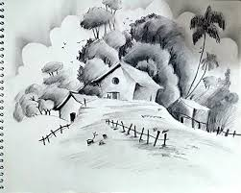

Which drawing technique would they most likely use?
A. Smudge technique B. Still life drawing
C. Crayon etching D. Cross hatching
- While making charcoal sticks for an art project, learners followed safety measures. Which of the following is NOT a safety measure?
A. Peeling off the backs of sticks
B. Cutting the sticks into small sizes
C. Properly placing the tin on fire to turn
D. Cooling the charcoal sticks
- During a netball lesson, the teacher demonstrated a certain type of pass.

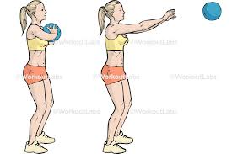

Which type of pass is this?
A. Overhead skill B. Underarm skill
C. Chest pass skill D. Double handed skill
- When playing percussion instruments, learners used several techniques. Which one is not a correct technique?
A. Hitting B. Shaking
C. Striking D. Fingering
- While preparing materials to make charcoal sticks, which of the following was not necessary?
A. Panga B. Tin kiln
C. Pliers D. Green sticks
- During a music lesson, learners clapped the beats of a French rhythm shown on the board.
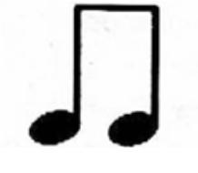

How many beats did they clap?
A. Half beat B. Two beats
C. Four beats D. One beat
- Learners were asked to identify primary colours from a group of colours. Which group contains only primary colours?
A. Red, Blue, Green
B. Purple, Yellow
C. Violet, Orange, Green
D. Red, Blue, Yellow
- A learner played a note on a descant recorder shown in a diagram.
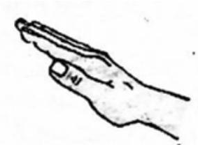

Which note did they play?
A. m B. d C. v D. f
- After completing their still life drawings, learners displayed them at the front of the class. What was the main reason for this?
A. For easy labelling
B. To improve its appearance
C. For critique by other learners
D. To make it last long
- During a tie-and-dye activity using primary colours, learners were told to dry the fabric under shade after untying it. Why?
A. Remove the starch in the fabric
B. Prevent the colour from fading
C. To remove excess dye
D. To make it last long
- During a dance performance, what safety measure should learners observe?
A. Maintaining the same rhythm
B. Making different formations
C. Using the props carefully
D. Dancing on a slippery floor
- A group of learners performed a folk song during a church ceremony. Which type of folk song were they most likely performing?
A. Initiation folk song B. Worship folk song
C. Naming folk song D. Work folk song
- The teacher showed a part of a descant recorder to learners.

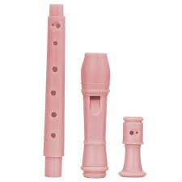
Which part was it?
A. Middle joint B. Window
C. Foot joint D. Head joint
- During gymnastics, a learner was performing a side roll.

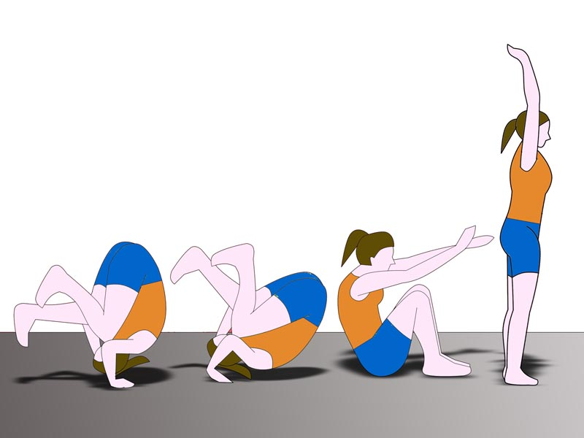

Which stage is being demonstrated in the image?
A. Stance B. Spotting
C. Rolling D. Compilation
- When singing the National Anthem, which practice helps others hear the words clearly?
A. Accuracy in tune
B. Observing good etiquette
C. Observing proper tempo
D. Proper pronunciation
- Learners were asked to make a shaker. Which material is most suitable?
A. Resonator B. Bottletops
C. Strings D. X-shaped stick
- How many players are in a standard netball team?
A. 12 B. 7 C. 14 D. 8
- When using the chest pass in netball, what is the correct technique?
A. Hold the ball at shoulder level
B. Throw the ball to a teammate at chest level using two hands
C. Stand facing an unintended receiver
D. Keep distance from the receiver at least 5m
- Which is a safety measure for performing a standing surface dive during swimming?
A. Chewing gum when diving
B. Swimming in the correct costumes
C. Diving on the deep end of the pool
D. Performing warm-up activities after the dive
- In drawing, which element is created by shading some areas dark and others light?
A. Texture
B. Tonal value
C. Proportion
D. Balance
- The wind instrument shown belongs to which community?
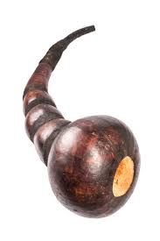
A. Luhya B. Agikuyu C. Teso D. Luo
- Which statement about smudge technique in drawing is correct?
A. Involves rubbing crayons on a surface
B. Is done by smearing colour on a surface
C. Shows dark tones
D. Cannot be done by rubbing pencil horizontally
- Why should crayon etching compositions not be done under hot sun?
A. White surfaces may appear
B. Sharp tools may damage the surface
C. Waxed surface fades
D. Wax may melt
- When creating a montage composition, which material can be used as a base?
A. Plywood
B. Razor
C. Natural glue
D. Pictures of different foods
- Which digital device is NOT suitable for taking photos of learners during warm-up exercises?
A. Smartphone B. Television
C. Tablet D. Camera
- A learner performed a gymnastic activity going backwards in reverse. Which activity is this?
A. Backward roll B. Crab balance
C. Side roll D. Head balance
- Which material is most suitable for improvising a soccer ball?
A. Prepared clay B. Dry sticks
C. Plastic bags D. Rubber bands
- Learners identified play equipment used in soccer. Which is correct?
A. Bat B. Marking cones
C. Whistle D. Baton
- Why is it important to take care of a wind instrument after use?
A. Make it produce good tunes
B. Improve its appearance
C. Make storage easy
D. Make it last long
- Skills used in handball include catching, passing, and dribbling. Which is NOT a skill?
A. Catching
B. Two-hand rim catch
C. Passing and receiving
D. Dribbling
- Which parts of the body can be used to tackle a player in handball?
A. Hands and chest
B. Head and chest
C. Stomach and legs
D. Hands and head
- How many players are in a volleyball team?
A. 12 B. 10 C. 6 D. 8
- For youth aged 1–12 years, which size of ball should be used in sports?
A. 3 B. 5 C. 4 D. 2
- How many finishes does a standard athletics track have?
A. Two B. Many
C. Four D. One common
- Which are elements of a good pass?
A. Curved, fast, stoppable
B. Fast, straight, not intercepted
C. Accurate, fast, not intercepted
D. Accurate, moderate, not intercepted
- Which is NOT a benefit of making healthy food choices during games and sports?
A. To get energy and help us grow fat
B. To help fight diseases
C. To help get nutrients for muscle development
D. To help our bodies fight diseases
- Which of the following is NOT a track event?
A. Drop finish B. Bunch start
C. Backstroke D. Shoulder shrug
- The field drawn in the diagram is suitable for which game?
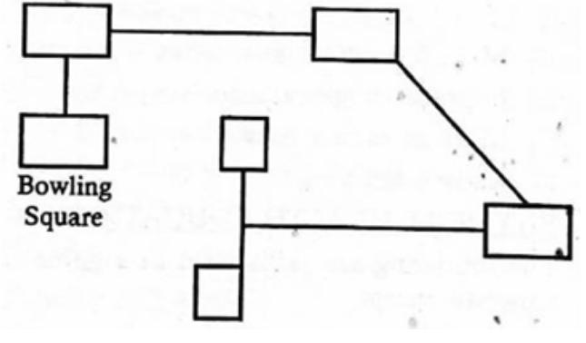

A. Athletics B. Rounders
C. Volleyball D. Soccer
- Scissors technique is applied in which game?
A. High jump B. Kabaddi
C. Softball D. Soccer
- Partner work is best applied in which activity?
A. Swimming B. Athletics
C. Soccer D. Ropework
- The first-aid item shown is used to:

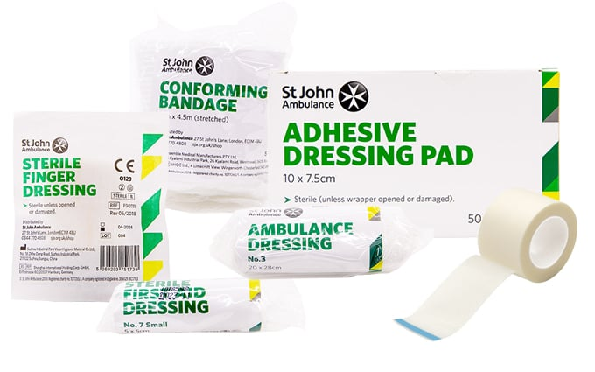
A. Straighten a bone
B. Cover stains of blood
C. Dress a wound
D. Kill pain
- In first-aid, ABC stands for different steps. What does ‘B’ represent?
A. Break B. Breathing
C. Bone D. Back
- Choose the necessary equipment for a volleyball game from the diagram:
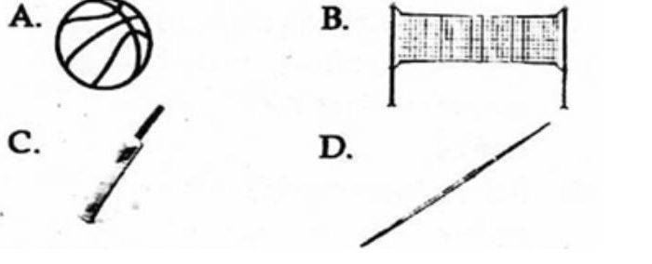

- Smitts are used to protect:
A. Eyes
B. Head
C. Knees
D. Hands
- Which cannot be used to improvise a volleyball ball?
A. Pieces of cloth
B. Papers
C. Pebbles
D. Old socks
- Which is NOT a cause of nose bleeding?
A. Sitting in a shade
B. A blow to the nose
C. Blowing the nose hard repeatedly
D. Picking the nose
- Front crawl is a skill practiced in:
A. Javelin
B. Swimming pool
C. Volleyball pitch
D. Shotput
- The person who officiates a football match is called:
A. Referee
B. Linesman
C. Umpire
D. Coach
- Why is first-aid necessary in sports?
A. To show that no one can get hurt
B. So that medicines are used in the field
C. So that no one ever gets injured
D. To help the injured before treatment

©2026
All rights reserved
©COMPETENCE KENYA EXAMINATION AND ASSESSMENT BOARD
This is the last printed page

Answers
- D
- B
- A
- C
- D
- C
- C
- D
- B
- C
- B
- C
- B
- D
- C
- D
- B
- B
- B
- B
- B
- D
- B
- D
- A
- B
- A
- C
- B
- D
- B
- A
- C
- A
- D
- C
- A
- C
- B
- A
- D
- C
- B
- B
- A
- C
- A
- B
- A
- D

