
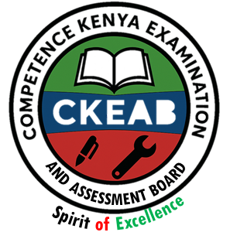

COMPETENCY-BASED EDUCATION (CBE)

SCHOOL-BASED ASSESSMENT CKEAB 002

GRADE 5 – MIDTERM ASSESSMENT (TERM 1, 2026)
Learner’s Name: ___________________________School Name: ______________________________
Assessment Number: ___________________________ Date: _______________________________

AGRICULTURE AND NUTRITION ACTIVITIES ASSESSMENT
SCORE GRID: FOR FACILITATORS USE
Q. No. | 1 | 2 | 3 | 4 | 5 | 6 | 7 | 8 | 9 | 10 | 11 | 12 | 13 | 14 | 15 | 16 | 17 | 18 | 19 | 20 | 21 | 22 | 23 | 24 | 25 | 26 | 27 | 28 | 29 | 30 | TOTAL
Score per Qn | 1 | 1 | 1 | 1 | 1 | 1 | 1 | 1 | 1 | 1 | 1 | 1 | 1 | 1 | 1 | 1 | 1 | 1 | 1 | 1 | 1 | 1 | 1 | 1 | 1 | 1 | 1 | 1 | 1 | 1 | 50
Learner Score
Performance Level

AGRICULTURE AND NUTRITION ACTIVITIES ASSESSMENT

Answer all questions

- The compost manure shown is important to crops because it
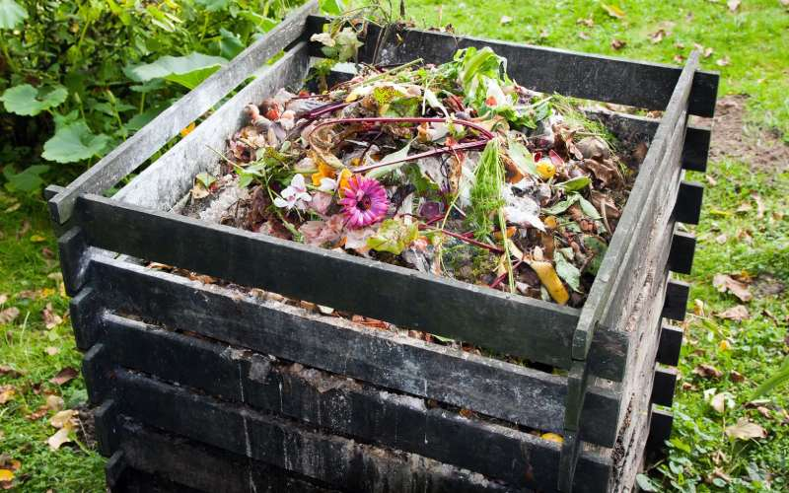
A. Makes them grow slowly
B. Provides the nutrients for them
C. Reduces crop production
D. Destroys soil structure
- Which of the following materials is suitable for making the compost manure above?
A. Paper waste
B. Sugarcane cuttings
C. Artificial fertilizers
D. Chicken droppings
- Which animal is most likely to be kept off by a scarecrow?
A. Elephant B. Moles
C. Weaverbird D. Monkeys
- The scarecrow should be placed
A. Away from the crops
B. At a corner of the farm
C. In the middle of the farm
D. On the path to the farm
- Learners listed places to obtain fruit seeds. Which answer is correct?
A. From natural seed fall B. Climbing up trees
C. Shaking the tree D. Local nurseries
- All the crops below produce tiny seeds except
A. Pawpaw plant B. Avocado plant
C. Lemon plant D. Passion plant
- Which farm tool is suitable for leveling a seedbed for tiny seeds?
A. Rake B. Slasher
C. Garden trowel D. Watering can
- Which fuel can be conserved by using energy-saving jikos in a hotel?
A. Gas B. Kerosene
C. Electricity D. Charcoal
- Which is a benefit of oxen on the farm?
A. Transporting people
B. Ploughing the land
C. Source of eggs
D. Provision of security
- Who took a balanced meal?
A. Tom: Chapati, cheese, bread
B. Ann: Lemons, bananas, oranges
C. Ken: Peas, Irish potatoes, ripe bananas
D. Rilly: Greengrams, chicken meat, sweet potatoes
- Which should NOT be done when boiling an Irish potato?
A. Peeling before boiling
B. Adding some salt
C. Poking to check if cooked
D. Slicing into smaller pieces before boiling
- Which type of surface is most likely cleaned using: floor cloth, warm water, scrubbing brush, soap?
A. Tiled floor B. Cemented floor
C. Glass surface D. Plain wooden surface
- Which item is personal protective equipment?
A. Gumboots B. Handkerchief
C. Walking stick D. Towel
- A piece of land lost its topsoil. Which process took place?
A. Runoff B. Soil erosion
C. Soil recovery D. Soil deposition
- Why are even tacking stitches used when repairing garments?
A. To make the garment fit well
B. To maintain its shape
C. To lose its colour
D. To make it more appealing
- Soil with large particles
A. Is best for growing crops
B. Holds little water
C. Is sticky when wet
D. Holds a lot of water
- After sowing tiny seeds, which practice conserves water?
A. Weeding B. Fencing
C. Irrigation D. Mulching
- Mrs. Rose cooks eggs by shallow frying. Which is NOT a step she follows?
A. Frying until brown
B. Washing the egg before breaking
C. Pouring little cooking oil
D. Poking the egg to check if cooked
- Which is an importance of soil to plants?
A. It is a home for small living things
B. It affects the growth of plants
C. Weeds grow on it
D. It provides nutrients to plants
- Which is the wrong way of conserving water in the farm?
A. Cover cropping B. Shading
C. Use of sprinklers D. Mulching
- Which material can be used to make organic waste in a pit?
A. Sugarcane trash B. Old tyres
C. Wood pallets D. Pebbles
- Which is a safe way of using a needle?
A. Staying close to each other
B. Keeping the needle in a scissors case
C. Wearing a thimble to protect fingers
D. Tying needles with a rubber band
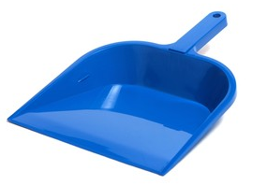
- Eunice used the equipment shown below to perform daily tasks

How is the cleaning equipment shown above likely to be used?
A. Sweeping the floor B. Scrubbing the walls
C. Removing stains D. Collecting dirt
- Why put old newspapers in canvas shoes after cleaning?
A. To make them airy
B. To prevent losing shape
C. To remove dust
D. To remove excess water
- Which substance in food helps our bodies grow and stay healthy?
A. Nutrients B. Diet
C. Meals D. Nutrition

©2026
All rights reserved
©COMPETENCE KENYA EXAMINATION AND ASSESSMENT BOARD
This is the last printed page

Answers
1-B
2-D
3-D
4-C
5-D
6-B
7-A
8-D
9-B
10-C
11-D
12-B
13-A
14-B
15-D
16-B
17-D
18-B
19-D
20-C
21-A
22-C
23-D
24-D
25-A

