
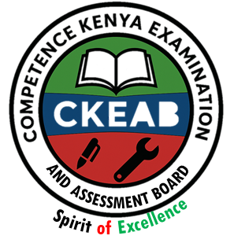

COMPETENCY-BASED EDUCATION (CBE)

SCHOOL-BASED ASSESSMENT CKEAB 002

GRADE 4 – MIDTERM ASSESSMENT (TERM 1, 2026)
Learner’s Name: ___________________________School Name: ______________________________
Assessment Number: ___________________________ Date: _______________________________

SOCIAL STUDIES ACTIVITIES ASSESSMENT
SCORE GRID: FOR FACILITATORS USE
Question Number | 1 | 2 |  | 3 | 4 |  | 5 | 6 | 7 |  | 8 | 9 |  | 10 |  | 11 |  | 12 |  | 13 |  | 14 |  | 15 |  | 16 |  | 17 |  | 18 |  | 19 |  | 20 |  | 21 |  | 22 |  | 23 |  | 24 |  | 25
Score per Question | 1 | 1 |  | 1 | 1 |  | 1 | 1 | 1 |  | 1 | 1 |  | 1 |  | 1 |  | 1 |  | 1 |  | 1 |  | 1 |  | 1 |  | 1 |  | 1 |  | 1 |  | 1 |  | 1 |  | 1 |  | 1 |  | 1 |  | 1
Learner Score

SOCIAL STUDIES ACTIVITY ASSESSMENT
Question Number | 26 |  | 27 |  |  | 28 |  | 29 |  | 30 |  |  | 31 |  | 32 |  | 33 |  | 34 |  | 35 |  | 36 |  | 37 |  | 38 |  | 39 |  | 40 |  | 41 |  | 42 |  | 43 |  | 44 |  | 45 |  | 46 |  | 47 |  | 48 | 49 | 50
Score per Question | 1 |  | 1 |  |  | 1 |  | 1 |  | 1 |  |  | 1 |  | 1 |  | 1 |  | 1 |  | 1 |  | 1 |  | 1 |  | 1 |  | 1 |  | 1 |  | 1 |  | 1 |  | 1 |  | 1 |  | 1 |  | 1 |  | 1 |  | 1 | 1 | 1
Learner Score

ANSWER ALL QUESTIONS
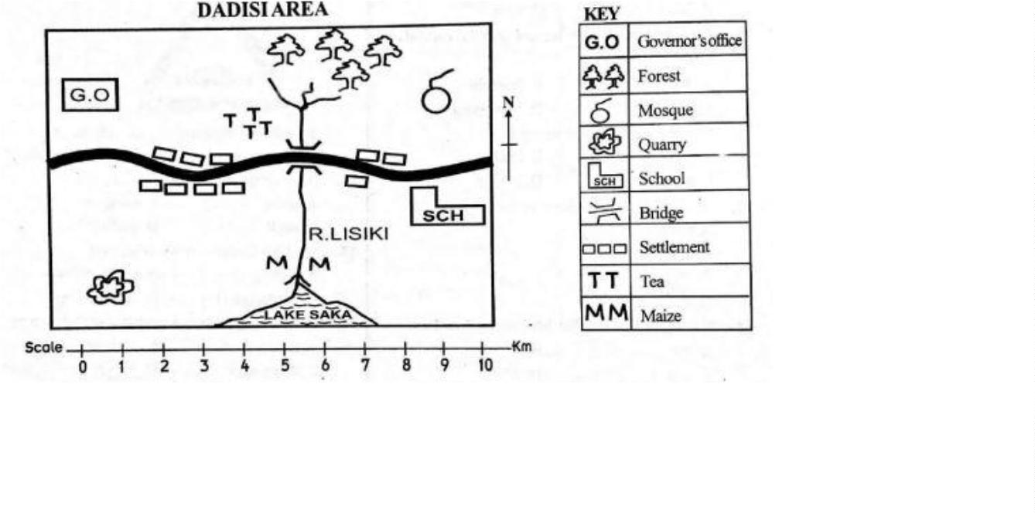
Study the map of Dasisi Area and answer questions 1–7

- Dasisi area is likely to be a
A. Ward B. County C. Location D. Sub-location
- What is the direction of the mosque from the Governor’s office?
A. North B. South C. West D. East
- River Lisiki flows from the:
A. Forest B. Lake C. Quarry D. Bridge
- The people of Dasisi are likely to be:
A. Christians B. Pagans C. Muslims D. Hindus
- The area receiving high rainfall is mainly around the:
A. Forest B. Lake C. School D. Bridge
- The forest in the area gives us:
A. Beef B. Timber C. Wool D. Mutton
- A food crop grown in Dasisi area is:
A. Tea B. Beans C. Coffee D. Maize
- The best soil for building modern houses is:
A. Sand B. Clay C. Loam D. Alluvial
- Which colour in the National flag represents plants?
A. White B. Black C. Green D. Red
- Members of the County Assembly represent an area called:
A. Constituency B. Ward C. Parliament D. Location
- Small rivers that join a big river are called:
A. Delta B. Streams C. Mouth D. Tributaries
- The fastest means of communication reaching many people is the:
A. Radio B. Television C. Mobile phone D. Facebook
- The sun sets in the:
A. North B. South C. West D. East
- Which of the following is Kenya’s capital city?
A. Eldoret B. Nairobi C. Kisumu D. Mombasa
- We cross a big river using a:
A. Matatu B. Ladder C. Fish D. Bridge
- The head of a county is the:
A. Governor B. President C. Chief D. Senator
- Kenya is divided into how many counties?
A. 57 B. 27 C. 47 D. 37
- People’s way of life is called:
A. Routine B. Motto C. Family D. Culture
- Carrying goods from place to place is called:
A. Communication B. Transport C. Weather D. Settlement
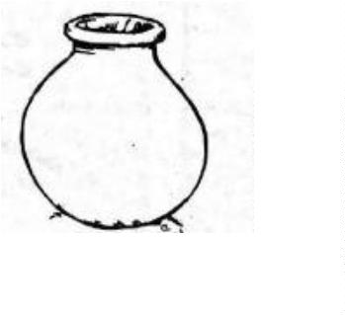
- The diagram shown below is a:

A. Pot B. Cooker C. Fridge D. Tablet
- Flat areas are called:
A. Grassland B. Plains C. Valleys D. Plateau
- Which one is NOT an element of weather?
A. Sunshine B. Wind C. Water D. Temperature
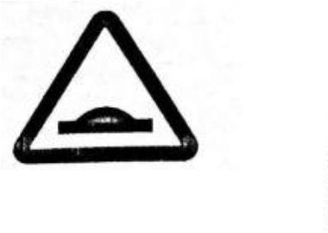
- The road sign shown means:

A. Children crossing B. No entry C. Slippery road D. Bump ahead
- Beef cattle are kept for:
A. Meat B. Milk C. Pork D. Mutton
- On 12th December we celebrate:
A. Labour Day B. Jamhuri Day C. Madaraka Day D. Heroes Day
- People who treat animals are called:
A. Surgeon B. Optician C. Veterinary D. Nurse
- The one who is NOT a member of a nuclear family is:
A. Sister B. Father C. Mother D. Uncle
- Which one is NOT a man-made feature?
A. Mountain B. Bridge C. Road D. Dam
- The best soil for growing crops is:
A. Clay B. Loam C. Silt D. Sand
- The Kenyan flag has how many colours?
A. Six B. Three C. Five D. Four
- Who was the first president of Kenya?
A. Jomo Kenyatta B. Uhuru Kenyatta C. Daniel Moi D. Mwai Kibaki
- Money paid as bride price is called:
A. Fees B. Fine C. Dowry D. Tax
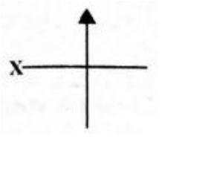
- The direction marked X is:

A. North B. South C. West D. East
- Kenya is headed by the:
A. Prime Cabinet Secretary B. President C. Speaker D. County Representative
- Which is the smallest county in Kenya?
A. Mombasa B. Marsabit C. Kakamega D. Wajir
- The sun sets in the:
A. West B. North C. South D. East
- During the hot season people wear ______ clothes.
A. Heavy B. White C. Red D. Light
- A raised flat land is called a:
A. Hill B. Plateau C. Ridge D. Mountain
- Which one is NOT a physical feature?
A. Roads B. Lakes C. Hills D. Valleys
- Natural things found on land are called:
A. Physical Features B. Forest C. Buildings D. Plants
- Which group consists only of counties?
A. Machakos, Kiambu, Nairobi
B. Ruiru, Juja, Kericho
C. Githurai, Uasin Gishu, Baringo
D. Kikuyu, Murang’a, Kiambaa
- A number of people living in an area is called:
A. Pollution B. Popularity C. Population D. Poultry
- Places with fertile soil are ______ populated.
A. Densely B. Sparsely C. Scarce D. Linear
- Which one is NOT an economic activity?
A. Fishing B. Going to school C. Tourism D. Farming
- A farmer is likely to ______ during the rainy season.
A. Weed B. Plant crops C. Water plants D. Harvest crops
- ______ is a way of life of people.
A. Future B. Culture C. Hope D. Dependence
- Which one is NOT part of traditional culture?
A. Dressing B. Houses
C. Food D. Vehicles
- The fastest means of transport is by:
A. Road B. Water C. Railway D. Air
- The national flag has how many colours?
A. 3 B. 2 C. 4 D. 5
- Who is the current president of Kenya?
A. William Ruto B. Kalonzo Musyoka
C. Musalia Mudavadi D. Rigathi Gachagua

©2026
All rights reserved
©COMPETENCE KENYA EXAMINATION AND ASSESSMENT BOARD
This is the last printed page

ANSWERS
- B
- D
- A
- C
- A
- B
- D
- C
- C
- B
- D
- C
- C
- B
- D
- A
- C
- D
- B
- A
- B
- C
- D
- A
- D
- C
- D
- A
- B
- D
- A
- C
- C
- B
- A
- A
- D
- B
- A
- A
- A
- C
- A
- B
- B
- B
- D
- D
- D
- A

