
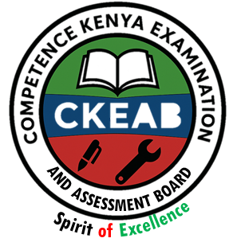

COMPETENCY-BASED EDUCATION (CBE)

SCHOOL-BASED ASSESSMENT CKEAB 002

GRADE 4 – MIDTERM ASSESSMENT (TERM 1, 2026)
Learner’s Name: ___________________________School Name: ______________________________
Assessment Number: ___________________________ Date: _______________________________

SCIENCE AND TECHNOLOGY ACTIVITIES ASSESSMENT
SCORE GRID: FOR FACILITATORS USE
Q. No.  SCIENCE AND TECHNOLOGY ACTIVITIES ASSESSMENT | 1 | 2 | 3 | 4 | 5 | 6 | 7 | 8 | 9 | 10 | 11 | 12 | 13 | 14 | 15 | 16 | 17 | 18 | 19 | 20 | 21 | 22 | 23 | 24 | 25 | 26 | 27 | 28 | 29 | 30 | TOTAL
Score per Qn | 1 | 1 | 1 | 1 | 1 | 1 | 1 | 1 | 1 | 1 | 1 | 1 | 1 | 1 | 1 | 1 | 1 | 1 | 1 | 1 | 1 | 1 | 1 | 1 | 1 | 1 | 1 | 1 | 1 | 1 | 30
Learner Score
Performance Level
Answer all the questions

Which one of the following is not a characteristic of all plants? All plants—
A. grow B. die C. reproduce D. walk
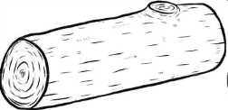
- Which one of the following is a non-living thing?
A.
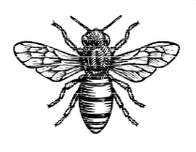

B.
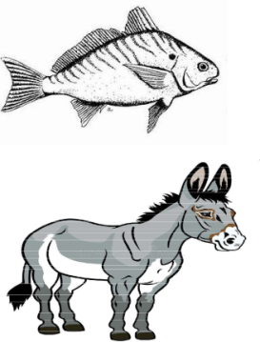
C.

D.
- Which among the following types of teeth is used for cutting and biting?
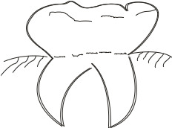
A.

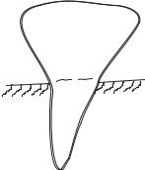
B.

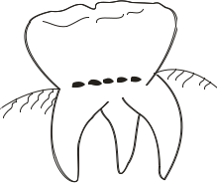
C.

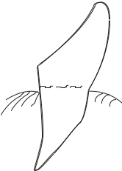
D.

Animals with a backbone are called
A. mammals B. invertebrates
C. vertebrates D. living things

Which of the following animals should not be in this group?
A. Elephant B. Antelope
C. Crocodile D. Wasp

Most digested food in the human body is absorbed in the—
A. mouth B. stomach
C. small intestine D. large intestine

The following are unfavourable weather conditions except
A. heavy rainfall B. dark night
C. extreme heat D. drought

Which one of the following is not a solid?
A. Stone B. Water C. Wood D. Metal

Which of the following activities cannot contaminate water?
A. Cooking
B. Urinating in water
C. Washing clothes in water
D. Bathing in water sources

The following materials can be used to filter dirty water except
A. a piece of cloth
B. a piece of paper
C. improvised water filter
D. sieve

The following are digital devices used when observing states of matter. Which one is not?
A. Laptop
B. Smartphone
C. Tablet
D. Notebook

The following are symptoms of an unhealthy digestive system. Which one is not?
A. Cough
B. Diarrhoea
C. Constipation
D. Stomachache

A goat and a bean plant are examples of:
A. living things
B. non-living things
C. vertebrates
D. invertebrates

When going to study plants in the environment, you need the following items except
A. digital device
B. dustbin
C. notebook
D. dust coat

Kim has reared the following animals on his farm. Which one cannot be reared at home?
A. Dog B. Goat C. Camel D. Hyena

Grade Four learners discussed characteristics of living things. Which one of the following is NOT a characteristic of living things?
A. They feed B. They grow
C. They lay eggs D. They die

Which one of the following is a non-living thing?
A. Soil B. Fish C. Cow D. Cactus plant

Things that have life are called
A. Plants
B. Animals
C. Living things
D. Non-living things

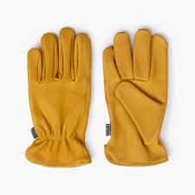
The protective clothing shown below is called:

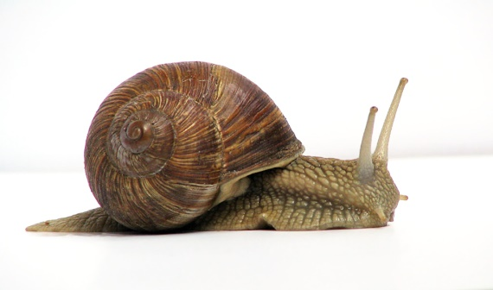
A. Gloves B. Gumboots
C. Goggles D. Overcoats

The animal shown below moves by

A. Crawling B. Galloping
C. Gliding D. Slithering

Which one of the following is NOT a reason why animals move?
A. To search for food B. To look for mates
C. To escape predators D. To escape old age

When a plant increases in size (height, length, and width), we say it has
A. Moved B. Grown
C. Reproduced D. Removed waste

Use the digestive system diagram to answer Questions 23–25
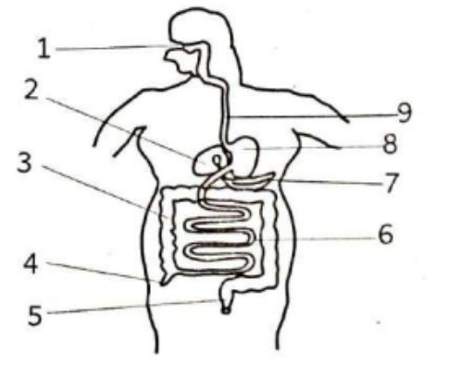

The part labelled 3 is the
A. Large intestine B. Small intestine
C. Pancreas D. Rectum

Digestion of food starts in the part labeled
A. 8 B. 6 C. 1 D. 9

Undigested food is temporarily stored in the part labelled
A. 8 B. 5 C. 3 D. 6

An adult human being has _________ teeth.
A. 4 B. 20 C. 32 D. 28

Which one of the following foods is harmful to our teeth?
A. Sweets B. Apple
C. Carrots D. Sugarcane

The following are invertebrates EXCEPT
A. Butterfly
B. Crab
C. Tilapia
D. Locust

When animals give birth to young ones, they
A. Reproduce
B. Grow
C. Feed
D. Respond to changes

A doctor who treats teeth is called a
A. Nurse
B. Optician
C. Dentist
D. Physician

©2026
All rights reserved
©COMPETENCE KENYA EXAMINATION AND ASSESSMENT BOARD
This is the last printed page

ANSWERS
- D
- A
- B
- C
- D
- C
- B
- B
- A
- B
- D
- A
- A
- B
- D
- C
- A
- C
- A
- C
- D
- B
- A
- C
- B
- C
- A
- C
- A
- C

