


COMPETENCY-BASED EDUCATION (CBE)

SCHOOL-BASED ASSESSMENT CKEAB 002

GRADE 4 – MIDTERM ASSESSMENT (TERM 1, 2026)
Learner’s Name: ___________________________School Name: ______________________________
Assessment Number: ___________________________ Date: _______________________________

MATHEMATICS ACTIVITIES ASSESSMENT
SCORE GRID: FOR FACILITATORS USE
Q. No. | 1 | 2 | 3 | 4 | 5 | 6 | 7 | 8 | 9 | 10 | 11 | 12 | 13 | 14 | 15 | 16 | 17 | 18 | 19 | 20 | 21 | 22 | 23 | 24 | 25 | 26 | 27 | 28 | 29 | 30 | TOTAL
Score per Qn  MATHEMATICS ACTIVITY ASSESSMENT | 1 | 1 | 1 | 1 | 1 | 1 | 1 | 1 | 1 | 1 | 1 | 1 | 1 | 1 | 1 | 1 | 1 | 1 | 1 | 1 | 1 | 1 | 1 | 1 | 1 | 1 | 1 | 1 | 1 | 1 | 30
Learner Score
Performance Level

- During the year, one thousand, eight hundred and four books were checked out of the school library.
A. 184 B. 1084 C. 1804 D. 1840
- Talent Primary School has 183 school days each year. Round off to the nearest ten.
A. 180 B. 190 C. 200 D. 210
- Kayla must read an 80-page book in 10 days. How many pages per day?
A. 8 B. 9 C. 70 D. 800
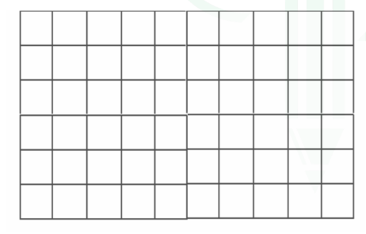
- Lisa covered the top of a box with square stickers. What is the area?

A. 32 B. 36 C. 60 D. 80
- The Nation newspaper has 8062 readers.
A. Eight hundred and sixty two
B. Eight thousand and sixty two
C. Eighty thousand and sixty two
D. Eight thousand six hundred two
- Which number multiplied by any odd number always gives an even number?
A. 1 B. 5 C. 6 D. 9
- There are 8 tables in Christy's coffee shop. Each table has 6 chairs around it. How many chairs are around the eight tables?
A. 42 B. 48 C. 54 D. 56
- Anna wants to check if she correctly solved the number sentence below. 32+8=4 Which number sentence could Anna use to see if her answer is correct?

A. 4 × 8 B. 8 − 4
C. 4 × 32 D. 32 × 8
- Matthew played his favourite video game and earned a score of 47675. The highest score he has ever earned for this video game is 57675. What is the difference between the highest score and the score he earned?
A. 1000 B. 5000 C. 10000 D. 50000
- Jayden wrote the number sentence below.

107 < _____

Which number can Jayden write on the line to make the number sentence correct?

A. 101 B. 106 C. 107 D. 109
- Miss Spence puts two packets of sugar in her cup of coffee. Which unit of measure is best for measuring how much each packet of sugar weighs?

A. Gram B. Kilogram C. Litres D. Mililitres
- Martha went to her grandmother's house. She arrived at 2: 30 p.m and left at 6:00 p.m. For how long was Martha at her grandmother's house?

A. 3hours B. 3hours 30minutes

C. 4hours D. 4hours 30 minutes
- Brittany opens a 20 grams can of chocolate sauce. She pours 3 grams of the sauce on each of 6 bowls of ice cream. How many grams of chocolate sauce are left in the can?

A. 1 B. 2 C. 3 D. 6
- Frank can do 3 times as many pull- ups as James. James can do 2 fewer pull-ups than Stephanie. Stephanie can do 12 pull-ups. How many pull- ups can Frank do?

A. 30 B. 34 C. 36 D. 38
- Allan painted a certain table as shown below. What Fraction is shaded?.
A. ½ B. ⅔ C. ¼ D. ⅓
- A clothing store has 274 customers in one day. What is 274 rounded off to the nearest ten?

A. 200 B. 270 C. 280 D. 300
- Mrs. Clark has a total of 42 bananas. There are 6 bananas in each bunch. Which step can be used to find how many bunches of bananas Mrs. Clark has?

A. Add 6 and 42 B. Divide 42 by 6

C. Multiply 42 by 6 D. Subtract 6 from 42
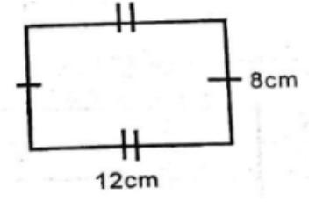
- Find the perimeter of the diagram below.

A. 40cm² B. 120cm² C. 40cm D. 96cm²
- Which one of the following numbers has the greatest value?

A. 9009 B. 9090 C. 9099 D. 9000
- Mr. Patel moved his chair to the other side of his living room. What measure could most likely be the mass of his chair?

A. 5 litres B. 5 grams

C. 5 kilograms D. 5 kilometres
- The first explorers to reach the South returned to their base camp after travelling 1860 miles. What is the number of miles written in words?
A. Eighteen thousand and sixty
B. Eighteen thousand and six hundred
C. One thousand eight hundred and six
D. One thousand eight hundred and sixty
- The distance from Gayle's house to three cities is as shown in the table below.
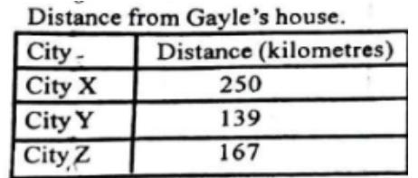

Which list shows the distances in order from the least to the greatest?
A. 250km, 139km, 167km
B. 167km, 139km, 250km
C. 139km, 250km, 167km
D. 139km, 167km, 250km
- Onyango has 5 hens. How many legs does all the hens have?
A. 5 B. 10 C. 2 D. 15

- Which is the distance round the figure below?
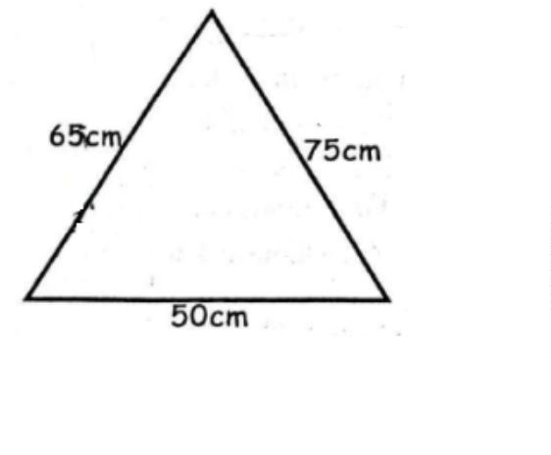

A. 190cm B. 140cm C. 160cm D. 180cm
- Maina bought 56 kg of maize, Nanok bought 75 kg of maize. How many kilograms of maize did Maina and Nanok buy altogether?
A. 121 B. 141 C. 131 D. 111
- What value is the same as 2 hundreds
A. 2 ones
B. 20 ones
C. 20 tens
D. 200 tens
- Which unit of measure is best for measuring the amount of water in a large fish tank?
A. Litre
B. Meter
C. Millilitre
D. Kilogram
- What is fourteen multiplied by 9?
A. 256
B. 126
C. 23
D. 96
- Wafula has 39 cows, 48 goats and 130 chickens. How many animals does he have in his farm altogether?
A. 217
B. 178
C. 169
D. 87

- A leap year has its first two months with __________ days
A. 61
B. 60
C. 59
D. 62

©2026
All rights reserved
©COMPETENCE KENYA EXAMINATION AND ASSESSMENT BOARD
This is the last printed page

ANSWERS
- C
- A
- A
- C
- B
- C
- B
- A
- C
- D
- A
- B
- B
- A
- D
- B
- B
- C
- C
- C
- D
- D
- B
- A
- C
- C
- A
- B
- A
- B

