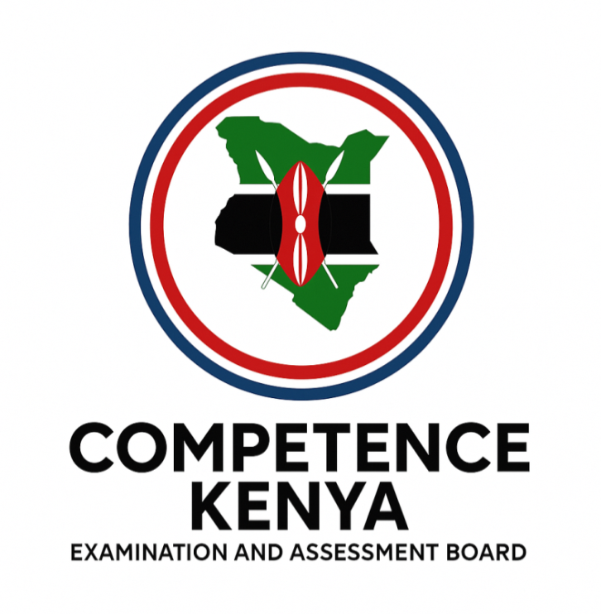
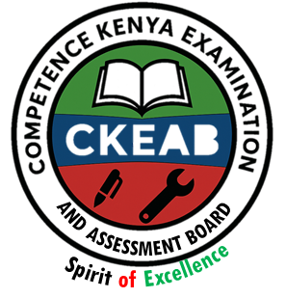
SECTION A

GRAMMAR

COMPETENCY-BASED EDUCATION (CBE)

SCHOOL-BASED ASSESSMENT CKEAB 002

GRADE 4 – MIDTERM ASSESSMENT (TERM 1, 2026)
Learner’s Name: ___________________________School Name: ______________________________
Assessment Number: ___________________________ Date: _______________________________

ENGLISH ACTIVITIES ASSESSMENT
SCORE GRID: FOR FACILITATORS USE

ENGLISH ACTIVITY ASSESSMENT
Q. No. | 1 | 2 | 3 | 4 | 5 | 6 | 7 | 8 | 9 | 10 | 11 | 12 | 13 | 14 | 15 | 16 | 17 | 18 | 19 | 20 | 21 | 22 | 23 | 24 | 25 | 26 | 27 | 28 | 29 | 30 | TOTAL
Score per Qn | 1 | 1 | 1 | 1 | 1 | 1 | 1 | 1 | 1 | 1 | 1 | 1 | 1 | 1 | 1 | 1 | 1 | 1 | 1 | 1 | 1 | 1 | 1 | 1 | 1 | 1 | 1 | 1 | 1 | 1 | 30
Learner Score
Performance Level
Q. No. | SECTION A | SECTION B | SECTION C | TOTAL
Score | 30 | 20 | 50 | 100
Learner Score
Performance
Read the dialogue below then answer Questions 1–5.
Betty: Excuse me, Brian.
Brian: Yes, Betty. How may I help you?
Betty: Do you know how a computer is used?
Brian: Yes, I do. I used one yesterday.
Betty: Oh! What did you use it for?
Brian: I used it to send an email to my brother who lives in Nairobi.
Betty: What is an email?
Brian: An email is a message sent from one computer to another through the internet.

- Betty says “excuse me”, this shows that she is?
A. Hardworking B. Polite C. Patient D. Kind
- What are the two friends talking about?
A. The day’s homework B. How to use internet
C. How to use a computer D. How to send an SMS
- Where does Brian’s brother live?
A. Nairobi B. Kisumu C. Nakuru D. Eldoret
- A message sent from one computer to another is called?
A. Internet B. WhatsApp C. Address D. An email
- The following are digital devices except?
A. Computer B. Television
C. Tablets D. Storybooks

Read the passage below then answer Questions 6–10.
Just the other day, television was the only thing that children watched. With advanced technology, parents must watch closely what the young ones are doing for leisure. A lot can be done on the internet. At the beginning, there were many cyber cafes where people went to surf. Today, cyber cafes are very few as you can do anything online from anywhere. All you need is data bundles or Wi-Fi, a smart phone, a computer or a laptop. After logging in you can download WhatsApp, Twitter and Facebook then chat with family and friends. The good thing with the internet is that you can video call people and see them.

- Cyber cafes are few because—
A. People do not surf
B. You can do anything online from anywhere
C. Children only watch television
D. Technology has not advanced
- The following are needed to go online except—
A. Data bundles B. A smart phone
C. A laptop D. A radio
- What is the good thing with the internet?
A. You can chat with people
B. You can surf
C. You can video call people
D. You can use it anywhere
- According to the passage, after logging in you can download all the following except—
A. TikTok B. WhatsApp C. Twitter D. Facebook
- Who should watch closely what the young ones do for leisure?
A. Friends
B. Relatives
C. Teachers
D. Parents

Read the passage below then answer Questions 11–15.
Slowly by slowly, people are learning more about HIV and AIDS. The knowledge on prevention is shared everywhere, including schools, homes, churches, mosques and market places. Long ago, people were scared to talk openly about the disease. Today, the information is clearly passed to children and adults. If you see your friends sharing cutting objects, politely tell them to stop. HIV and AIDS can be easily spread through sharing such objects. Many schools have weekly lessons teaching pupils how to protect themselves. At hospitals, people are tested and taught how to stay healthy.

- What should you do if you see friends sharing cutting objects?
A. Shout at them B. Politely tell them to stop
C. Ignore them D. Report them
- Where are people tested and taught how to stay healthy?
A. In schools B. At market places
C. Churches D. At hospitals
- Information about HIV and AIDS is clearly passed to—
A. Boys and girls B. Men and women
C. Children and adults D. Teachers and pupils
- Knowledge on prevention is shared in all the following places except—
A. Bus stations B. Schools C. Homes D. Churches
- The best title for the passage is—
A. Sharing cutting objects B. Prevention
C. HIV and AIDS D. Protecting the sick

Choose the best alternative to fill the blanks for questions 16-20.
Having clean water and 16 in a clean environment is still a challenge. Many people across the country 17 suffered due 18 the drought caused by human activities. In rural areas, people walk long distances in search 19 water. The water they get is usually dirty and 20 for use.
- A. leaving B. living C. leaving D. live
- A. has B. had C. have D. are
- .A. to B. from C. at D. on
- .A. from B. off C. out D. of
- .A. clean B. unsafe C. safe D. good

For questions 21 and 22 choose the adjective.
- He has a new car.
A. has B. he C. new D. car
- The food was delicious.
A. delicious B. food C. was D. the

For question 23–25 choose the correct article.
- Moses eats __________ apple every day.
A. the B. a C. an D. some
- __________ sun sets in the west.
A. An B. A C. None D. The
- We have been waiting for ___ hour.
A. a B. an C. the D. two

Choose the plural form of the irregular noun for question 26 and 27.
- During the party, three goose were slaughtered.
A. Gooses
B. Geeses
C. Goose
D. Geese
- The man owns four cows and three ox.
A. oxen
B. oxes
C. ox
D. oxis

Choose the best alternative to answer question 28 to 30
- We have learnt ___ rules on good manners.
A. alot
B. a lot of
C. little
D. much
- This book belongs to Peter. It is ___.
A. hers
B. him
C. his
D. he
- This school belongs to them. It is ___.
A. theirs
B. there
C. them
D. they

©2026
All rights reserved
©COMPETENCE KENYA EXAMINATION AND ASSESSMENT BOARD
This is the last printed page

SECTION B: (20 marks)

COMPOSITION ASSESSMENT
Write an interesting composition about:
MY FAMILY
____________________________________________________________________________________________________________________________________________________________________________________________________________________________________________________________________________________________________________________________________________________________________________________________________________________________________________________________________________________________________________________________________________________________________________________________________________________________________________________________________________________________________________________________________________________________________________________________________________________________________________________________________________________________________________________________________________________________________________________________________________________________________________________________________________________________________________________________________________________________________________________________________________________________________________________________________________________________________________________________________________________________________________________________________________________________________________________________________________________________________________________________________________________________________________________________________________________________________________________________________________________________________________________________________________________________________________________________________________________________________________________________________________________________________________________________________________________________________________________________________________________________________________________________________________________________________________________________________________________________________________________________________

SECTION C:

READING ASSESSMENT

THEME: “MY SCHOOL”

Listening & Speaking Oral Questions( 20 marks)
The teacher will ask you the following questions. Answer them orally
- What is the name of your school? (Learner responds)
- Who is your class teacher? (Learner responds)
- Mention one thing you like doing in school. (Learner responds)
- How do you keep your classroom clean? (Learner responds)
- Name two rules you follow in school. (Learner responds)
- What do you do when you arrive at school in the morning? (Learner responds)
- How do you keep yourself safe while playing at school? (Learner responds)
- Mention one game you enjoy playing at school. (Learner responds)
- Why do we respect teachers? (Learner responds)
- Tell us one way you help other learners at school. (Learner responds)

2) READING PASSAGE (30 marks)
Read the following passage
THE SCHOOL FARM
Our school has a small farm behind the classrooms. Learners visit the farm every Friday. We grow vegetables such as sukuma wiki, carrots, and onions. Each class takes care of its own garden.
Last Friday, Grade 4 learners watered the plants and removed weeds. Mr. Otieno, the Agriculture teacher, taught them how to use water carefully so that none is wasted. The vegetables from the school farm are used in the school kitchen. Learners enjoy eating the fresh food because it is healthy.

©2026
All rights reserved
©COMPETENCE KENYA EXAMINATION AND ASSESSMENT BOARD
This is the last printed page
ANSWERS
- B
- C
- A
- D
- D
- B
- D
- C
- A
- D
- B
- D
- C
- A
- C
- B
- C
- A
- D
- B
- C
- A
- C
- D
- B
- D
- A
- B
- C
- A
Bottom of Form

