


COMPETENCY-BASED EDUCATION (CBE)

SCHOOL-BASED ASSESSMENT CKEAB 002

GRADE 4 – MIDTERM ASSESSMENT (TERM 1, 2026)
Learner’s Name: ___________________________School Name: ______________________________
Assessment Number: ___________________________ Date: _______________________________

CREATIVE ARTS ACTIVITIES ASSESSMENT
SCORE GRID: FOR FACILITATORS USE
Question Number  CREATIVE ARTS ACTIVITY ASSESSMENT | 1 | 2 |  | 3 | 4 |  | 5 | 6 | 7 |  | 8 | 9 |  | 10 |  | 11 |  | 12 |  | 13 |  | 14 |  | 15 |  | 16 |  | 17 |  | 18 |  | 19 |  | 20 |  | 21 |  | 22 |  | 23 |  | 24 |  | 25
Score per Question | 1 | 1 |  | 1 | 1 |  | 1 | 1 | 1 |  | 1 | 1 |  | 1 |  | 1 |  | 1 |  | 1 |  | 1 |  | 1 |  | 1 |  | 1 |  | 1 |  | 1 |  | 1 |  | 1 |  | 1 |  | 1 |  | 1 |  | 1
Learner Score
Question Number | 26 |  | 27 |  |  | 28 |  | 29 |  | 30 |  |  | 31 |  | 32 |  | 33 |  | 34 |  | 35 |  | 36 |  | 37 |  | 38 |  | 39 |  | 40 |  | 41 |  | 42 |  | 43 |  | 44 |  | 45 |  | 46 |  | 47 |  | 48 | 49 | 50
Score per Question | 1 |  | 1 |  |  | 1 |  | 1 |  | 1 |  |  | 1 |  | 1 |  | 1 |  | 1 |  | 1 |  | 1 |  | 1 |  | 1 |  | 1 |  | 1 |  | 1 |  | 1 |  | 1 |  | 1 |  | 1 |  | 1 |  | 1 |  | 1 | 1 | 1
Learner Score

ANSWER ALL QUESTIONS

- Making a 3D piece of art using wood is called:
A. Drawing B. Painting
C. Carving D. Pottery
- Gradation in art refers to:
A. Change of tone from light to black
B. Change of colour from white to black
C. Change of tone from top to bottom
D. Change of colour from red to orange
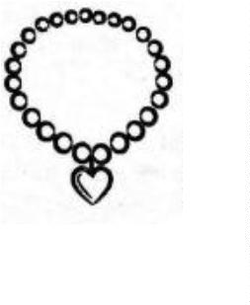
- The musical instrument shown below is worn around the:

A. Elbow B. Wrist C. Ankle D. Neck
- In the Kenya National Anthem, the line “Justice be our shield and defender...” is found in:
A. First stanza B. Second stanza
C. Third stanza D. Fourth stanza
- Singing a piece of music softly or loudly is referred to as:
A. Tempo B. Pitch
C. Harmony D. Dynamics
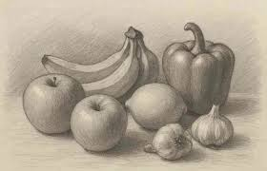
- The following picture has been drawn from observation.

What is its name?
A. Collage B. Still life drawing
C. Montage D. Imaginative drawing
- Grade 4 learners named “respect and equality for all players” in a game as:
A. Fair play B. Expert play
C. Rough play D. Foul play
- Which item is not needed to improvise a ball using local materials?
A. Old mattress B. Waste papers
C. Pieces of clay D. Sisal threads
- Describe the face drawn below:

A. Sad
B. Worried
C. Scared
D. Happy
- The sharp tool in crayon etching is used for:
A. Painting
B. Scratching
C. Sticking
D. Smothering
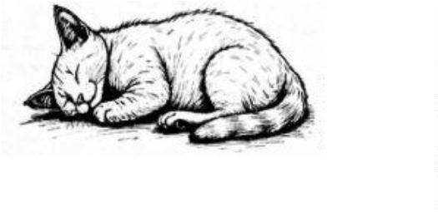
- Which material has not been used to create the animal form below?

A. Brush B. Pencil C. Chalk D. Paper
- Using different colours on a surface to create images or pictures is called:
A. Carving
B. Drawing
C. Modelling
D. Painting
- The four basic voices in a choir do not include:
A. Pitch
B. Tenor
C. Alto
D. Bass
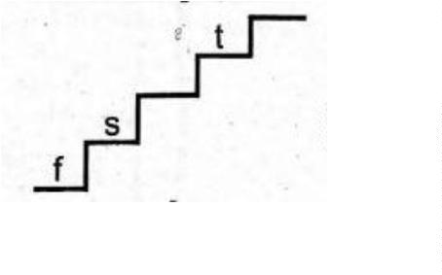
- Identify the missing solfa note:

A. m
B. d
C. l
D. r
- Which pass in volleyball is shown below?
A. Underarm pass
B. Head pass
C. Overhead pass
D. Over arm
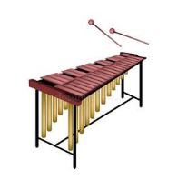
- The musical instrument shown below is played by:

A. Plucking
B. Strumming
C. Blowing
D. Hitting
- Adding black colour to any colour makes it:
A. Darker
B. Shinier
C. Duller
D. Lighter
- In a game, players from the opposing team are referred to as:
A. Friends
B. Opponents
C. Companions
D. Colleagues
- Which of the following is not rounders equipment?
A. Net B. Posts C. Ball D. Bat
- Mixing yellow and blue in equal measures produces:
A. Red B. Violet C. Orange D. Green
- Which game allows the use of hands only occasionally?
A. Volleyball B. Football
C. Handball D. Basketball
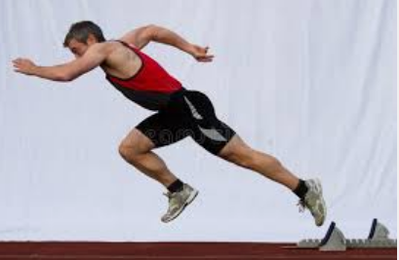
- Identify the stage in an elongated start race shown below:

A. Finishing B. Flight C. Take off D. Landing
- Singing the National Anthem encourages all the following except:
A. Love B. Unity C. Hatred D. Peace
- Children are soothed to sleep by singing:
A. Lullaby songs
B. Patriotic songs
C. Sacred songs
D. Popular songs
- Which item is not made using clay?
A. Bowl B. Vases C. Pot D. Wallet
- How should we sing the National Anthem?
A. Standing at attention
B. Dancing a little
C. Walking slowly
D. Moving sideways
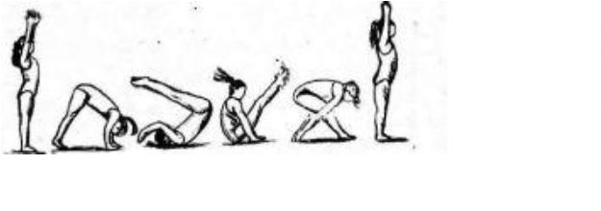
- Identify the gymnastic skill shown below:

A. Handstand B. Crab walk
C. V-balance D. Forward roll
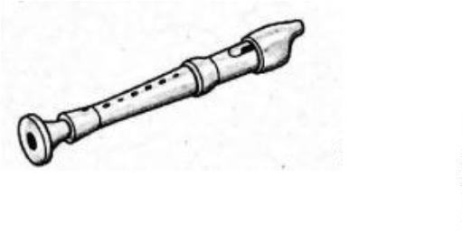
- What should not be done to the musical instrument shown below?

A. Playing using fingers
B. Should be turned regularly
C. Should be shared
D. Cleaning after use
- An example of a melodic percussion instrument is:
A. Drum B. Marimba
C. Shakers D. Kayamba
- A music performance of three people singing different voices is called:
A. Trio B. Choir C. Duet D. Solo
- Why is the drum warmed in the sun or near fire?
A. To clean it B. To play it
C. To tune it D. To store it
- Which skill is not used in netball?
A. Kicking B. Passing
C. Shooting D. Catching
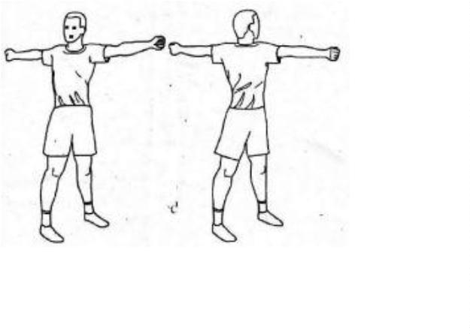
- Identify the warm-up activity shown below:

A. Headstand B. Arm rotations
C. Forward roll D. Backward roll
- The game of rounders uses all the following skills except:
A. Bowling B. Catching
C. Trapping D. Throwing
- Weaving and twining are skills used in:
A. Carving B. Pottery
C. Painting D. Basketry
- Which item is the odd one out?
A. Belt B. Plate
C. Pair of shoes D. Handbag
- Why is kneading important when preparing clay?
A. To eliminate air bubbles
B. To make the clay soft
C. To make the clay sticky
D. To make the clay clean
- What is the French rhythm name of the following notes?
A. taa B. ta-te
C. tafa-tefe D. taa-aa
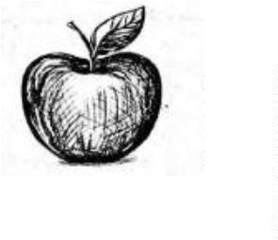
- Which technique was used to draw the object shown below?

A. Smudge B. Cross etching
C. Stippling D. Cross hatching
- Who controls a match in progress?
A. Referee B. Manager
C. Captain D. Coach
- Which colour is not secondary?
A. Green B. Orange C. Purple D. Red
- The following medals are awarded in athletics. Which one is not?
A. Gold
B. Aluminium
C. Silver
D. Bronze
- How many players are in a volleyball team?
A. Five B. Eleven
C. Seven D. Six
- The Kenyan flag has all the following colours except:
A. Yellow B. White
C. Green D. Black
- Working together as teammates to succeed is called:
A. Cooperation B. Hardwork
C. Teamwork D. Discipline
- Which of the following field events is not a jump?
A. Long jump B. Javelin
C. Triple jump D. High jump
- Kenyan folk songs are usually led by:
A. Drummers B. Singers
C. Dancers D. Soloists
- The parts of a descant recorder include all the following except:
A. Tuning peg B. Headjoint
C. Finger holes D. Middle joint
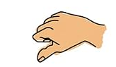
- Identify the Kodaly hand sign shown below:

A. r B. f C. m D. t
- Before diving into a swimming pool, it is advisable to check the:
A. Length
B. Width
C. Depth
D. Colour

©2026
All rights reserved
©COMPETENCE KENYA EXAMINATION AND ASSESSMENT BOARD
This is the last printed page

ANSWERS
- C
- C
- D
- A
- A
- B
- A
- C
- D
- A
- A
- D
- A
- C
- C
- A
- D
- B
- A
- B
- B
- A
- C
- A
- D
- A
- D
- B
- D
- A
- C
- A
- B
- C
- D
- B
- A
- D
- D
- A
- B
- B
- C
- A
- C
- B
- D
- A
- B
- C

