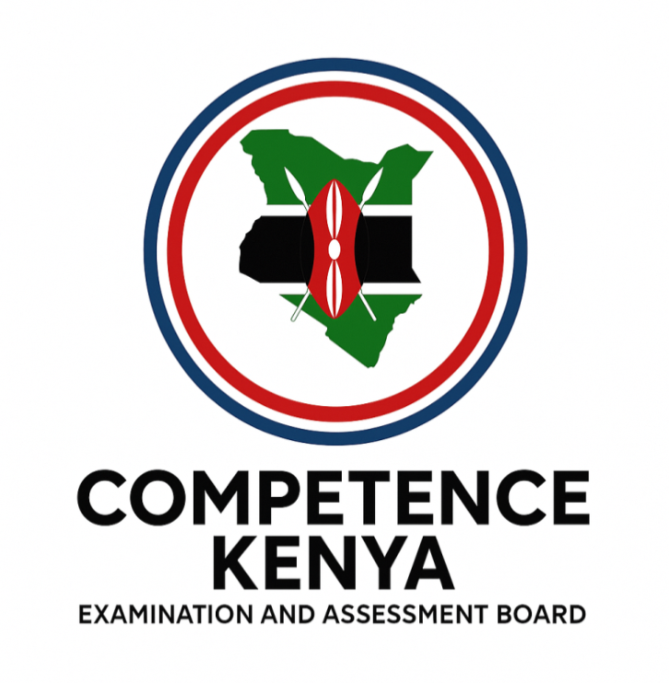
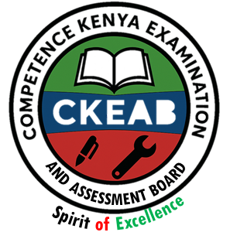

COMPETENCY-BASED EDUCATION (CBE)

SCHOOL-BASED ASSESSMENT CKEAB 002

CRE ACTIVITY ASSESSMENT

GRADE 4 – MIDTERM ASSESSMENT (TERM 1, 2026)
Learner’s Name: ___________________________School Name: ______________________________
Assessment Number: ___________________________ Date: _______________________________

CRE ACTIVITIES ASSESSMENT
SCORE GRID: FOR FACILITATORS USE
Question Number | 1 | 2 |  | 3 | 4 |  | 5 | 6 | 7 |  | 8 | 9 |  | 10 |  | 11 |  | 12 |  | 13 |  | 14 |  | 15 |  | 16 |  | 17 |  | 18 |  | 19 |  | 20 |  | 21 |  | 22 |  | 23 |  | 24 |  | 25
Score per Question | 1 | 1 |  | 1 | 1 |  | 1 | 1 | 1 |  | 1 | 1 |  | 1 |  | 1 |  | 1 |  | 1 |  | 1 |  | 1 |  | 1 |  | 1 |  | 1 |  | 1 |  | 1 |  | 1 |  | 1 |  | 1 |  | 1 |  | 1
Learner Score
Question Number | 26 |  | 27 |  |  | 28 |  | 29 |  | 30 |  |  | 31 |  | 32 |  | 33 |  | 34 |  | 35 |  | 36 |  | 37 |  | 38 |  | 39 |  | 40 |  | 41 |  | 42 |  | 43 |  | 44 |  | 45 |  | 46 |  | 47 |  | 48 | 49 | 50
Score per Question | 1 |  | 1 |  |  | 1 |  | 1 |  | 1 |  |  | 1 |  | 1 |  | 1 |  | 1 |  | 1 |  | 1 |  | 1 |  | 1 |  | 1 |  | 1 |  | 1 |  | 1 |  | 1 |  | 1 |  | 1 |  | 1 |  | 1 |  | 1 | 1 | 1
Learner Score

ANSWER ALL QUESTIONS

- God created the world in how many days?
A. 5 B. 6 C. 7 D. 4
- The first man created by God was:
A. Moses B. Adam C. David D. Jacob
- Eve was created from Adam’s:
A. Ear B. Rib C. Leg D. Hand
- The day of rest is called:
A. Passover B. Sabbath C. Easter D. Pentecost
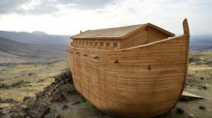
- Noah built the:

A. Temple B. Ark C. Tower D. Tent
- Abraham’s son was:
A. Solomon B. Saul C. Isaac D. Amos
- Who was thrown into a lions’ den?
A. Daniel B. Joseph C. Adam D. Job
- The mother of Jesus was:
A. Ruth B. Sarah C. Mary D. Esther
- Jesus was born in:
A. Nazareth B. Bethlehem
C. Jericho D. Egypt
- Jesus performed His first miracle at:
A. Capernaum B. Cana
C. Jerusalem D. Galilee
- Jesus used parables to:
A. Confuse people B. Teach people
C. Punish people D. Test people
- The good Samaritan helped a man who was:
A. Sleeping B. Injured
C. Swimming D. Running
- The story of the lost sheep teaches about:
A. Love B. Hate
C. Revenge D. Pride
- The fruits of the Holy Spirit include:
A. Anger B. Love C. Hatred D. Laziness
- The Bible is divided into ______ parts.
A. 3 B. 4 C. 2 D. 1
- Moses received the Ten Commandments at:
A. Mt. Zion B. Mt. Sinai
C. Mt. Kenya D. Mt. Carmel
- The greatest commandment teaches us to love:
A. Animals B. Money C. God D. Clothes
- Which book is found in the New Testament?
A. Genesis B. Exodus C. Matthew D. Psalms
- Prayer helps Christians to:
A. Sleep B. Grow spiritually
C. Fight D. Hate others
- The main Christian day of worship is:
A. Friday B. Saturday C. Sunday D. Monday
- Which disciple betrayed Jesus?
A. Peter B. John C. Judas D. Andrew
- Who denied Jesus three times?
A. Mark B. Peter C. Matthew D. James
- The Holy Spirit came during:
A. Easter B. Pentecost
C. Christmas D. Good Friday
- Fasting means:
A. Eating slowly B. Not eating for a time
C. Cooking fast D. Eating a lot
- Christians show kindness by:
A. Fighting B. Sharing C. Shouting D. Crying
- The smallest book in the Bible is:
A. Jude B. Obadiah C. Esther D. Jonah
- A place of worship is the:
A. Church B. Garage C. Hospital D. Stadium
- God’s promise to Noah was shown using:
A. Fire B. Rainbow C. Cloud D. Wind
- The Bible teaches us to obey:
A. Teachers B. Parents C. Police D. Friends
- An angel is a:
A. Messenger of God B. Messenger of kings
C. Farmer D. Doctor
- Jesus healed:
A. The blind B. Computers C. Tables D. Trees
- Christians forgive because:
A. Jesus forgives B. They fear people
C. They are forced D. It is easy
- A Christian home is one that:
A. Shares love B. Hates C. Fights D. Steals
- God is all-powerful, which means He is:
A. Omnipresent B. Omnipotent
C. Holy D. Rich
- We read the Bible to:
A. Pass exams B. Know God
C. Laugh D. Memorize words
- Jesus fed 5,000 people using:
A. Bread and fish B. Water
C. Fruit D. Milk
- A prayer said before eating is called:
A. Closing prayer B. Grace
C. Thanks D. Worship
- Jesus calmed the storm to show He has power over:
A. Plants B. Nature C. Buildings D. Clothes
- The Bible story that teaches obedience is about:
A. Jonah B. Zipporah C. Samson D. Herod
- Christians celebrate the birth of Jesus during:
A. Easter B. Christmas
C. Pentecost D. Passover
- A miracle is something:
A. Difficult B. Impossible by humans
C. Normal D. Dangerous
- Jesus taught the disciples through the:
A. Bible B. Parables C. Poems D. Songs
- The opposite of evil is:
A. Wicked B. Good C. Fear D. Anger
- Christians should pray:
A. Only on Sunday B. Daily
C. Once a month D. When happy
- God communicates to people through:
A. Phone B. Dreams C. TV D. Clouds
- Which prophet was swallowed by a fish?
A. Micah B. Jonah
C. Habakkuk D. Obadiah
- Christians celebrate the resurrection of Jesus during:
A. Easter B. Christmas
C. Jamhuri Day D. Mashujaa Day
- A good friend is:
A. Jealous B. Kind C. Proud D. Angry
- Christians help the needy by giving:
A. Food B. Noise C. Problems D. Anger
- The Bible teaches us to live in:
A. Conflict B. Peace C. Fighting D. Hatred

©2026
All rights reserved
©COMPETENCE KENYA EXAMINATION AND ASSESSMENT BOARD
This is the last printed page

ANSWER KEY
1B, 2B, 3B, 4B, 5B, 6C, 7A, 8C, 9B, 10B,
11B, 12B, 13A, 14B, 15C, 16B, 17C, 18C, 19B, 20C,
21C, 22B, 23B, 24B, 25B, 26B, 27A, 28B, 29B, 30A,
31A, 32A, 33A, 34B, 35B, 36A, 37B, 38B, 39A, 40B,
41B, 42B, 43B, 44B, 45B, 46B, 47A, 48B, 49A, 50B.

