
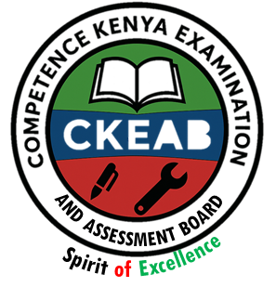

COMPETENCY-BASED EDUCATION (CBE)

SCHOOL-BASED ASSESSMENT CKEAB 002

GRADE 4 – MIDTERM ASSESSMENT (TERM 1, 2026)
Learner’s Name: ___________________________School Name: ______________________________
Assessment Number: ___________________________ Date: _______________________________

AGRICULTURE AND NUTRITION ACTIVITIES ASSESSMENT
SCORE GRID: FOR FACILITATORS USE

AGRICULTURE AND NUTRITION ACTIVITIES ASSESSMENT
Q. No. | 1 | 2 | 3 | 4 | 5 | 6 | 7 | 8 | 9 | 10 | 11 | 12 | 13 | 14 | 15 | 16 | 17 | 18 | 19 | 20 | 21 | 22 | 23 | 24 | 25 | 26 | 27 | 28 | 29 | 30 | TOTAL
Score per Qn | 1 | 1 | 1 | 1 | 1 | 1 | 1 | 1 | 1 | 1 | 1 | 1 | 1 | 1 | 1 | 1 | 1 | 1 | 1 | 1 | 1 | 1 | 1 | 1 | 1 | 1 | 1 | 1 | 1 | 1 | 30
Learner Score
Performance Level

ANSWER ALL QUESTIONS

1. Grade Four pupils wanted to make compost manure. Which one of the following materials did they not require?
A. Small stones B. Animal droppings
C. Dry grass D. Maize stalks
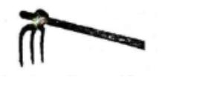
2.The diagram below shows a farm tool.

The tool is used for—
A. transporting seedlings B. levelling the seedbed
C. spraying crops D. digging hard soils
3.Which of the following is a characteristic of loamy soil?
A. Has the best drainage B. Is good for growing crops
C. Has the highest capillarity D. Is sticky when wet
4.Which one of the following practices is not carried out on a nursery bed?
A. Weeding B. Watering
C. Pruning D. Shading
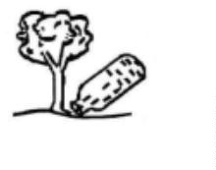
5.The method of irrigation shown is—

A. bottle irrigation B. drip irrigation
C. sprinkler irrigation D. overhead irrigation
6.Which one of the following farm animals is not correctly matched with its product?
A. Cow – milk B. Hen – eggs
C. Goat – mutton D. Sheep – pork
7.Which waste rots easily and mixes with soil?
A. Non-biodegradable waste B. Biodegradable waste
C. Metal D. Plastics
8.The use of scarecrows on a farm is—
A. To scare away birds and small animals
B. To make boundaries
C. To entertain visitors
D. To make farms look beautiful
9.Which practice helps conserve soil moisture?
A. Irrigation B. Weeding
C. Mulching D. Pruning
10.The following are digital devices used to collect information on animals except—
A. smartphones B. tablets C. laptops D. textbooks
11.Protection of resources by using them wisely and not wasting them is—
A. Precipitation B. Sedimentation
C. Water treatment D. Conservation
12.The removal of unwanted plants on a farm is called—
A. weeding B. spraying C. watering D. thinning
13.The following are small animals that destroy crops except—
A. cats B. mice C. birds D. squirrels
14.Which one of the following is not a use of water on the farm?
A. Watering animals B. Manufacturing pesticides
C. Washing farm tools D. Irrigation
15.Which crop cannot be grown in a kitchen garden?
A. Spinach B. Mango C. Kales D. Cabbage
16.________ helps to scare away birds in the shamba.
A. Scarecrow B. Other animals
C. Children D. Watchman
17.Tomatoes, kales and onions are—
A. cropping B. fruits C. vegetables D. sugarcane
18.Soil that contains very large particles is—
A. clay soil B. sandy soil
C. loam soil D. organic matter
19.Which one of the following is not a domestic animal?
A. Dog B. Cow C. Hare D. Goat
20.The following are materials used for compost manure preparation except—
A. Green leaves B. Fertilizer
C. Cattle dung D. Dry maize stalk
21.Which statement is not true about exercise?
A. It improves body posture
B. It makes bones and muscles stronger
C. Exercising makes us weak
D. It makes us positive and happy
22.Which of the following is not a material used to make shoes?
A. Rubber B. Canvas C. Wood D. Plastic
23.Which fuel used at home mostly pollutes the environment?
A. Gas B. Electricity
C. Solar D. Charcoal
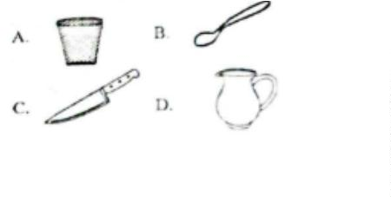
24.Which kitchen utensil is fragile?

25.The following are cleaning items used at home except—
A. Dustpan B. Mop C. Spade D. Brush
26.The main reason for repairing clothes is to—
A. prevent further damage
B. shorten their usefulness
C. avoid buying new clothes
D. make them clean
27. Bread, honey and rice belong to the food group called—
A. vitamins B. proteins
C. fruits and vegetables D. carbohydrates
28. How many times should we brush our teeth?
A. Once every day B. At least twice every day
C. Once every month D. Once every week
29. Which one of the following is not a communicable disease?
A. Cold B. Cancer C. Flu D. Chickenpox
30.A healthy lifestyle is—
A. exercising to the point of exhaustion
B. eating a balanced diet and exercising regularly
C. eating anything you like + exercising 3 times a week
D. working daily and drinking alcohol

©2026
All rights reserved
©COMPETENCE KENYA EXAMINATION AND ASSESSMENT BOARD
This is the last printed page

ANSWER KEY
- A
- D
- B
- C
- B
- D
- B
- A
- C
- D
- D
- A
- A
- B
- B
- A
- C
- B
- C
- B
- C
- C
- D
- D
- C
- A
- D
- B
- B
- B
Bottom of Form

