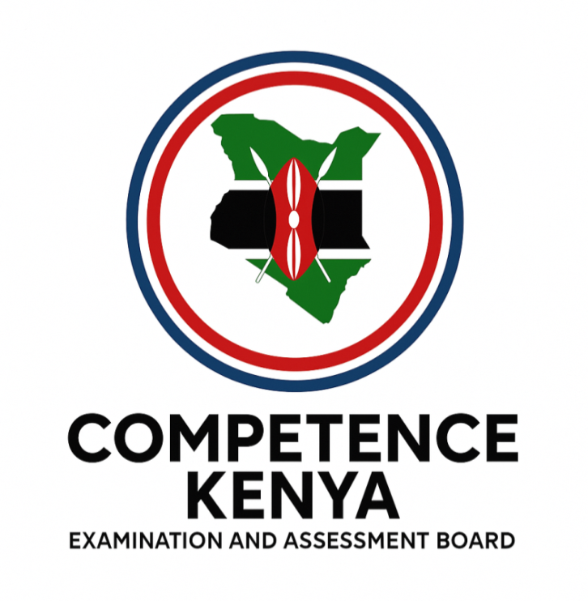
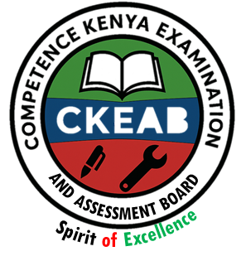

COMPETENCY-BASED EDUCATION (CBE)

SCHOOL-BASED ASSESSMENT

GRADE 3 – MIDTERM ASSESSMENT (TERM 1, 2026)
Learner’s Name: ___________________________School Name: ______________________________
Assessment Number: ___________________________ Date: _______________________________

READING ACTIVITIES ASSESSMENT
SCORE GRID: FOR FACILITATORS USE
Question Number | 1 | 2 | 3 | TOTAL
Score per Question | 10 | 15 | 25 | 50
Learner Score
Performance Level

Answer all the following questions
1. Read the words
1. cleaning
2. able
3. cheer
4. market
5. county
6. floor
7. edge
8. bridge
9. ugly
10. teacher
2. Read the sentences
1. The chief lives near the school.
2. I saw somebody washing clothes
3. They have many toys.

3. Read the passage
Passage 1
In a village near a river, there lived animals who were good friends. One day, the animals heard there would
be games down the river.

Passage 2
My name is Mary. I am six years old. I am in grade one. My school is called Faith Academy. In our school we have many desks. My classroom is big and nice. My teacher is called Madam Jane. She likes drawing pictures on the walls of our classroom. She teaches us English Activity too. In our classroom there is a blackboard. I go to school by bus. My friend is called Tina. We like our school.

©2026
All rights reserved
©COMPETENCE KENYA EXAMINATION AND ASSESSMENT BOARD
This is the last printed page

