
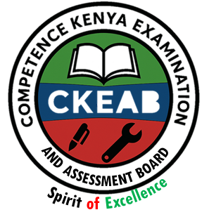

COMPETENCY-BASED EDUCATION (CBE)

SCHOOL-BASED ASSESSMENT CKEAB 002

GRADE 3 – MIDTERM ASSESSMENT (TERM 1, 2026)
Learner’s Name: ___________________________School Name: ______________________________
Assessment Number: ___________________________ Date: _______________________________

MATHEMATICS ACTIVITIES ASSESSMENT
SCORE GRID: FOR FACILITATORS USE
Question Number | 1 | 2 | 3 | 4 | 5 | 6 | 7 | 8 | 9 | 10 | 11 | 12 | 13 | 14 | 15 | 16 | 17 | 18 | 19 | TOTAL
Score per Question | 3 | 2 | 2 | 3 | 2 | 3 | 3 | 4 | 2 | 4 | 4 | 2 | 2 | 2 | 2 | 2 | 2 | 2 | 4 | 50
Learner Score
Performance Level

Answer all the following questions

A teacher recorded Mid-term Mathematics marks for five learners as follows:
Angela – 75%

Tom – 90%

Sandia – 84%

Nancy – 80%,

Tiffany – 70%
Arrange the marks from the highest to the lowest.

How many five-shillings coins make twenty shillings?
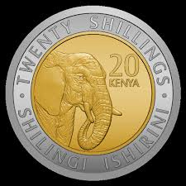
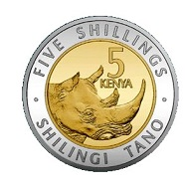

Write the number represented on the abacus below.

H T O

Mary received 70 books from a donor. She shared 20 books with her sister and 15 books with her brother.
How many books did she remain with?

Kevin bought 25 eggs. On his way back, 10 eggs broke.
How many eggs did he take home?

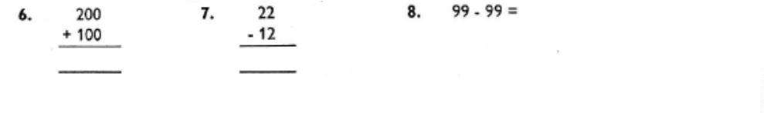
6. Work out the following:
a ) b) c)

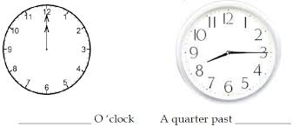
On the clock face below, show 3 o’clock.

b)

8. Write the missing numbers in the pattern
- 100, 90, 80, 70, 60, 50, ___________, ___________

- 25, 30, 35, 40, 45, _____________, _______________

9. Complete the following
- 109 = ___ hundreds ___ tens ___ ones

- 81 = ___ hundreds ___ tens ___ ones

- ___ = 6 hundreds 9 tens 3 ones

10. Colour to represent the following fraction
³/₈
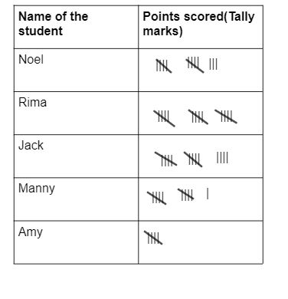
11. Learners drew sticks as shown below.
Count and write the number.

12. A teacher displayed shapes.
Name the shape in the third position

____________________________________________________.

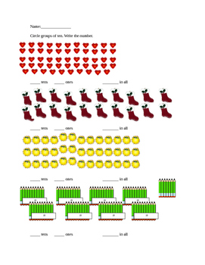
13. A learner drew many objects.
Circle the group with many objects

A B

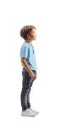
14. George stood at point 3 and moved four steps forward.
Which point did he stop at?

1 2 3 4 5 6 7 8 9 10 11 12

15. A farmer had 608 goats. He bought 48 more.
How many goats does he have altogether?

16. We are ______ learners in Grade 3.

17. The containers below have water.
Circle the one that holds more water.
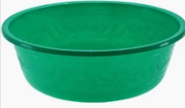
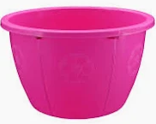

G H

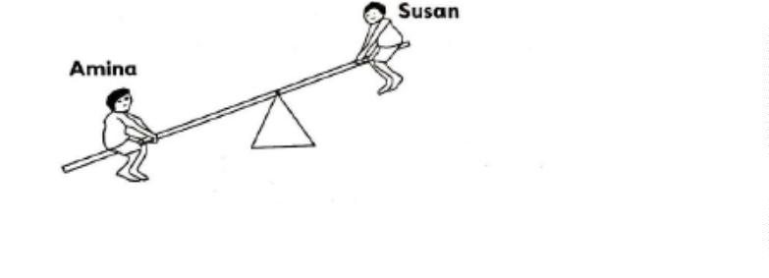
18. Amina and Susan were playing on the seesaw.

Amina is ______ than Susan. (lighter / heavier)

19. Circle the shape that is shaded half.
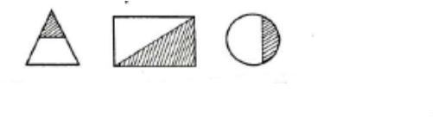
©2026
All rights reserved
©COMPETENCE KENYA EXAMINATION AND ASSESSMENT BOARD
This is the last printed page

