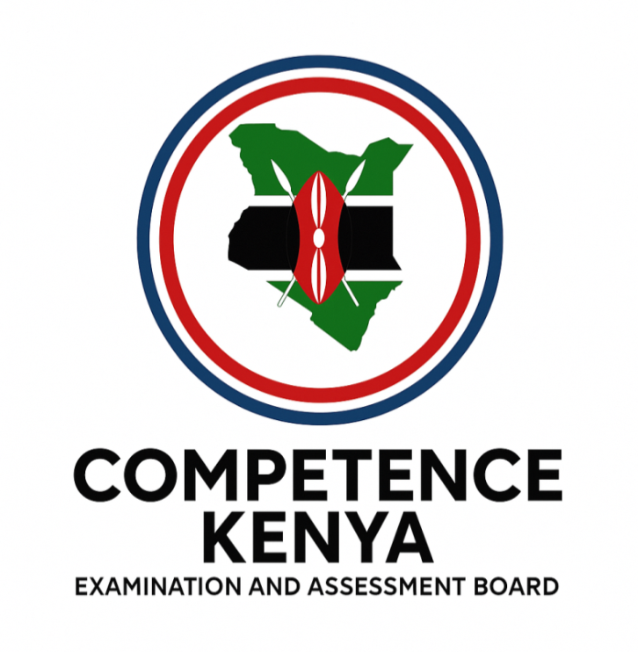
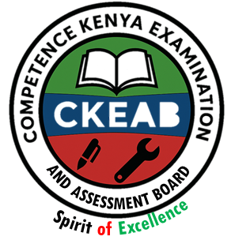

COMPETENCY-BASED EDUCATION (CBE)

SCHOOL-BASED ASSESSMENT CKEAB 002

GRADE 3 – MIDTERM ASSESSMENT (TERM 1, 2026)
Learner’s Name: ___________________________School Name: ______________________________
Assessment Number: ___________________________ Date: _______________________________

IRE ACTIVITIES ASSESSMENT
TOTAL MARKS: 50
SCORE GRID: FOR FACILITATORS USE

IRE ACTIVITY ASSESSMENT
Q. No. | 1 | 2 |  | 3 | 4 |  | 5 | 6 | 7 |  | 8 | 9 | 10 | TOTAL
Score | 3 | 1 |  | 1 | 1 |  | 1 | 1 | 1 |  | 1 | 4 | 9 | 50
Learner Score
Performance
Q. No. | 11 |  | 12 |  |  | 13 |  | 14 |  | 15 |  | 16 | 17 | 18 | 19 | 20 |  | 21 | TOTAL
Score | 1 |  | 2 |  |  | 1 |  | 2 |  | 1 |  | 2 | 1 | 2 | 1 | 2 |  | 1 | 16
Learner Score
Performance
Answer all questions in the spaces provided
- Name three Daughters of Prophet Muhammad (SAW) (3 marks)

- _____________________________________________________________.
- _____________________________________________________________.
- _____________________________________________________________.
- The angel of death is _______________________________________________________.(1 mark)
- Sunnah after Fardh is called _________________________________________________.(1 mark)
- Surah teaching freedom of worship? __________________________________________.(1 mark)
- There are _____________ pillars of Iman. (1 mark)
- Shahada is also known as ___________________________________________________.(1 mark)
- There are _______________________Total rakaat in a day: (1 mark)
- Swalatul Jumu’ah has ____________ rakaat (1 mark)
- First four months: (4 marks)
  - _____________________________________________________________.
  - _____________________________________________________________.
  - _____________________________________________________________.
  - _____________________________________________________________.
- Draw a Muslim prayer mat and colour. (9 marks)

11. Name the Holy Book Muslims use.
a) __________________________________ (1 mark)

12. Name two Pillars of Islam. (2 marks)
a) ______________________________
b) ______________________________

13. Identify the place of worship shown.
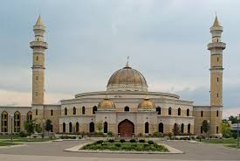
a) __________________________________ (1 mark)

14. Write two ways of showing respect to parents. (2 marks)
a) ___________________________________________________________________.
b) ___________________________________________________________________.

15. Who is the last Prophet in Islam?
a) __________________________________ (1 mark)

16. State two things Muslims do during Ramadhan. (2 marks)
a) _________________________________________________________________.
b) _________________________________________________________________.

17. What do Muslims say when they start something?
a) __________________________________ (1 mark)

18. State two qualities of a good Muslim. (2 marks)
a) ______________________________
b) ______________________________
19. Look at the picture.

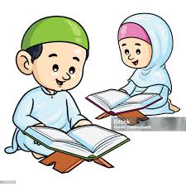

What are the children doing?
a) __________________________________ (1 mark)

20. Mention two Islamic prayers (Swalah). (2 marks)
a) __________________________________________________________________________________________.
b) __________________________________________________________________________________________.
21. Why should Muslims keep the environment clean?
a) __________________________________ (1 mark)

22. Name one celebration in Islam.
a) __________________________________ (1 mark)
©2026
All rights reserved
©COMPETENCE KENYA EXAMINATION AND ASSESSMENT BOARD
This is the last printed page

