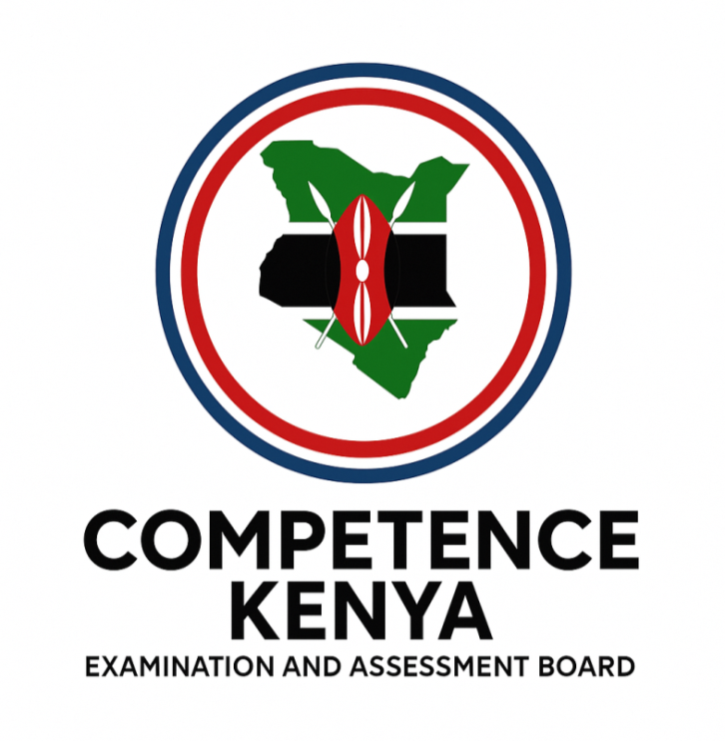
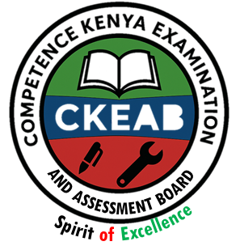

COMPETENCY-BASED EDUCATION (CBE)

SCHOOL-BASED ASSESSMENT CKEAB 002

GRADE 3 – MIDTERM ASSESSMENT (TERM 1, 2026)
Learner’s Name: ___________________________School Name: ______________________________
Assessment Number: ___________________________ Date: _______________________________

ENVIRONMENTAL ACTIVITIES ASSESSMENT
TOTAL MARKS: 50
SCORE GRID: FOR FACILITATORS USE
Q. No.  MATHEMATICS ACTIVITY ASSESSMENT | 1 | 2 | 3 | 4 | 5 | 6 | 7 | 8 | 9 | TOTAL
Score | 8 | 4 | 5 | 8 | 3 | 6 | 7 | 3 | 6 | 50
Learner Score
Performance
- 8 marks
- _____________________ can cause fire (sun, gas)
- A leaking gas causes _________________ (shock, explosion)
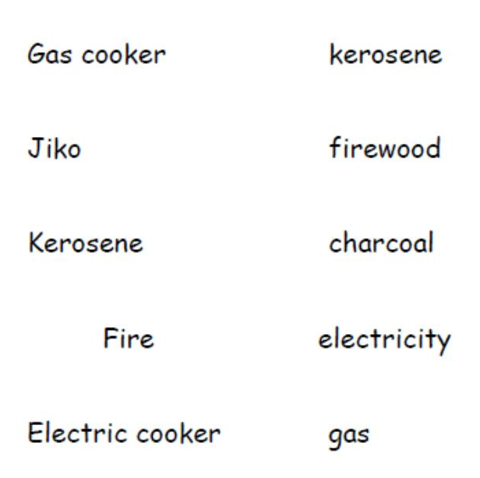
- A _______________________ gives us security (cat, dog)
- Match the following cooking equipment to the energy used

- 4 marks
- The process of making water safe is called ____________ (filtering, decantation)
- To kill germs we should __________________ water (boil, play, mix).
- You should wash your _____________before and after eating (hands, face, feet).
- Filtering water removes _________________ (dirt, germs).
- 5 marks
- The plants that we do not eat are called __________________ (non edible, edible)
- Name the following parts of a plant
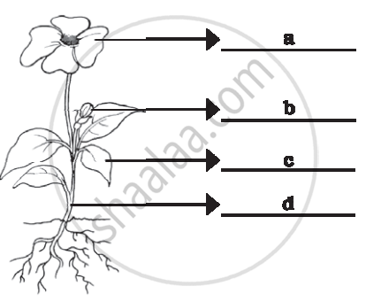
- 8 marks
- Soil that is rough and loose is called ________________ (coarse soil, fine soil)
- A long period without rain causes ____________ (drought, floods)
- ___________________ soil has big particles (sand, loam).
- The weather that interferes with our lives is called ____________ conditions (unfavorable, favorable).
- Group the following plants
Sodom apple sisal kale grass
Group | Non edible | Edible | Poisonous | Thorny
Plant

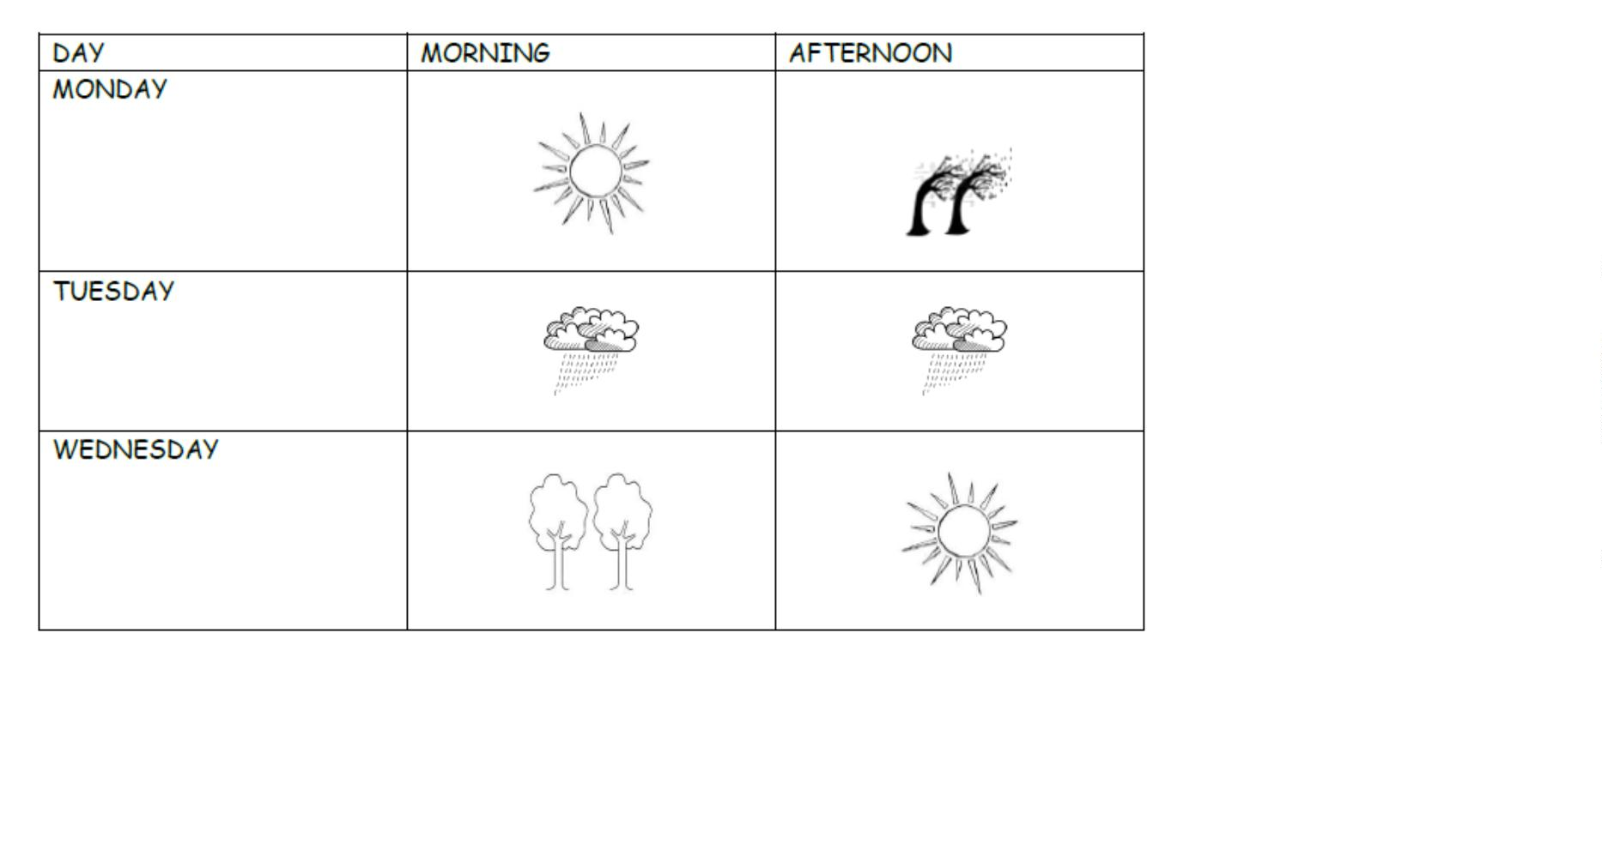
- Use the chart below to answer the questions that follow. 3 marks

- Which day did people carry umbrellas? _____________________________________.
- Which day was sunny in the morning? _____________________________________.
- The above table is called a ____________________ (weather chart, weather table).
- 6 marks
- The things we do to keep our bodies healthy are called _____________ (healthy habits, good manners)
- Dirty clothes can make us smell ___________ (bad, good).
- Drinking dirty water can make us _________________ (sick, healthy).
- Sitting in the wrong posture can make our backs feel _____________ (pain, good).
- Taking enough rest is ________________ (good, bad)
- Mosquitoes spread _______________ (malaria, typhoid)
- 7 marks
- Always stay in a _____________ classroom. (clean, dirty, wet)
- Dirty classrooms attract __________ (bees, flies, butterfly)
- We learn ______________ in a clean classroom (well, badly)
- We put collected rubbish in the ________________ (dustbin, desk)
- We use a ________________ to wipe desks (cloth, mop)
- After the floor dries, we _____________ the desks (arrange, leave)
- We empty the dustbin into a __________________ (rubbish pit, toilet)

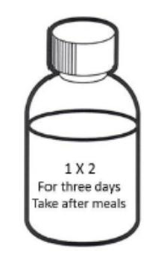
- 3 marks

- How many times a day should medicine be taken? _____________________________________.
- For how many days? _____________________________________.
- Before or after eating? _____________________________________.
- 6 marks
- Dirty feet will keep __________________ (jiggers, ticks, lice)
- Hygiene is the rule of ____________ (cleanliness, first aid, walking)
- We wear _____________ clothes when it is sunny (light, heavy)
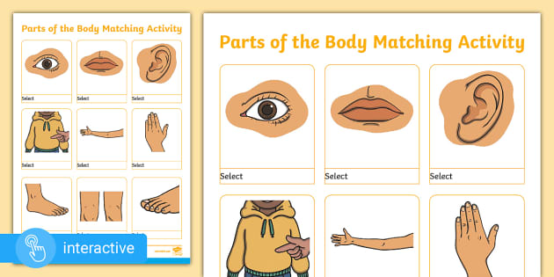
- Name the parts:

_____________________. __________________. __________________.

©2026
All rights reserved
©COMPETENCE KENYA EXAMINATION AND ASSESSMENT BOARD
This is the last printed page

