
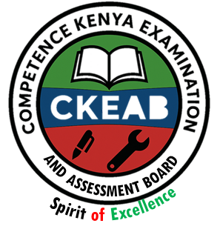

COMPETENCY-BASED EDUCATION (CBE)

SCHOOL-BASED ASSESSMENT CKEAB 002

GRADE 3 – MIDTERM ASSESSMENT (TERM 1, 2026)
Learner’s Name: ___________________________School Name: ______________________________
Assessment Number: ___________________________ Date: _______________________________

ENGLISH ACTIVITIES ASSESSMENT
SCORE GRID: FOR FACILITATORS USE

ENGLISH ACTIVITY ASSESSMENT
Q. No. | TASK 1 | TASK 2 | TASK 3 | TASK 4 | TASK 5 | TASK 6 | TOTAL
Score per Question | 5 | 5 | 10 | 25 | 5 | 10 | 60
Learner Score
Performance Level

TASK 1: LISTENING AND SPEAKING (5 Marks)

TASK 1 (5 marks)
- The teacher greets the learner. The learner responds.
The teacher says:
“I am Teacher ______. Tell me about the task of cleaning your classroom.
You have been asked to clean your Grade 3 classroom.”

a) What materials will you need for cleaning? (2 marks)
(Learner responds)

b) Where will you take the rubbish after cleaning? (2 marks)
(Learner responds)

c) Give one reason why we should clean our class. (1 mark)
(Learner responds)

TASK 2(5 marks)
- The teacher reads the passage aloud:
Today, visitors came to our school. They were new. We didn't know them. The teacher welcomed them. They
were happy They came to our classroom. They talked to us. We listened. They read a book. It was fun. We
asked questions. They answered. We learned new things. Then, they left. We said goodbye. It was a good
day After the visitors left, we talked about what we learned. We felt happy to meet someone new. We hope
they will come back again.
Learners answer the following questions in English:
- Who came to the school?
(Learner responds)
- How did the learners feel about the visitors?
(Learner responds)
- Where did the visitors talk to the learners?
(Learner responds)
- Who asked questions?
(Learner responds)
- How did the learners feel after the visitors left?
(Learner responds)
TASK 3 (10 marks)
- Learner reads aloud:
At our school, we have a special day called Sports Day It's a day when we play lots of games and have fun
together. Sports Day is super exciting! On Sports Day, we wear our sports clothes and gather in the big field.
There are colourful flags and balloons all around.

TASK 4: GRAMMAR (25 marks)

Fill in the missing sounds (3 marks)
- t __ __ cher
- b __ ttle
- bl __ ckboard


Write the action shown in each picture (4 marks)
- The man is __________________ (walking / talking / digging)


- These learners are _________________ in school. (singing / playing / walking)

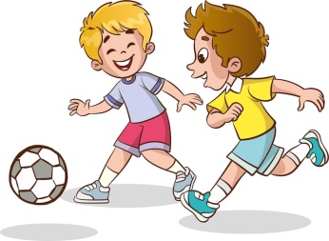
- They are ___________________ football. (watching / planning / playing)



- The boy is __________________. (reading / running / sweeping)

Make sentences using the words (3 marks)
- boy: __________________.
- cow: __________________.
- book: __________________.

Write the plural form (5 marks)
- Man: __________________.
- Calf: __________________.
- Child: __________________.
- Glass: __________________.
- Boy: __________________.

Write the past tense (5 marks)
- Come: __________________.
- Walk: __________________.
- Go: __________________.
- Sleep: __________________.
- Close: __________________.

TASK 5: COMPREHENSION (5 marks)
- Read the passage about visiting the park and answer:
Today, we went to the park. It was sunny outside. We saw trees, flowers, and birds. We played on swings and slides. We ran on the grass. We ate snacks and drank juice. We had fun with our friends. After playing for a while, we decided to have a picnic. We spread out a big mat on the grass and sat down to eat. Some of us had sandwiches, some had fruits, and others had cookies. We shared our snacks and laughed together.
After eating, we explored more of the park. We walked along the trails, looking at the flowers and listening to the birds chirping. Some of us even spotted a squirrel hopping from one side to the other! When it was time to go home, we felt happy and tired. It was a wonderful day at the park with our friends.
- Where did the children go? _______________________________________________________________.
- What was the weather like? ______________________________________________________________.
- What did the children see? _______________________________________________________________.
- What activities did they do? ______________________________________________________________.
- How did they feel? _____________________________________________________________________.

6. TASK 6: WRITING (10 marks)
Write five complete sentences about:

MY PET
____________________________________________________________________________________.
____________________________________________________________________________________.
____________________________________________________________________________________.
____________________________________________________________________________________.
____________________________________________________________________________________.

©2026
All rights reserved
©COMPETENCE KENYA EXAMINATION AND ASSESSMENT BOARD
This is the last printed page

