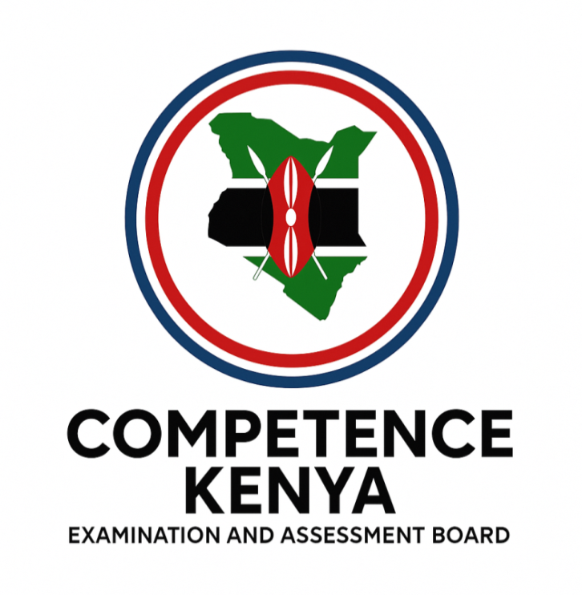
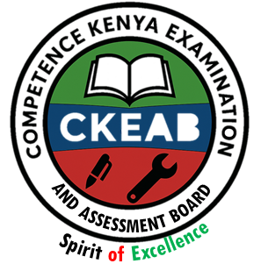

COMPETENCY-BASED EDUCATION (CBE)

SCHOOL-BASED ASSESSMENT CKEAB 002

GRADE 3 – MIDTERM ASSESSMENT (TERM 1, 2026)
Learner’s Name: ___________________________School Name: ______________________________
Assessment Number: ___________________________ Date: _______________________________

CREATIVE ARTS ACTIVITIES ASSESSMENT
TOTAL MARKS: 50
SCORE GRID: FOR FACILITATORS USE
Q. No. | 1 | 2 | 3 | 4  CREATIVE ARTS ACTIVITY ASSESSMENT | 5 | 6 | 7 | 8 | 9 | 10 | 11 | 12 | 13 | 14 | 15 | 16 | 17 | 18 | 19 | TOTAL
Score | 8 | 4 | 5 | 8 | 3 | 6 | 7 | 3 | 6 | 1 | 2 | 2 | 1 | 1 | 3 | 3 | 2 | 1 | 10 | 50
Learner Score
Performance

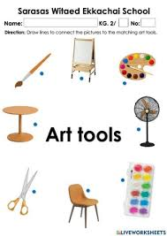
ANSWER ALL QUESTIONS

1. Look at the picture and name the art tool. (4 marks)

_________________. ____________________.

____________________. ____________________.

2. Draw THREE primary colours. (3 marks)

Name them: (3 marks)
a) ____________ b) ____________ c) ____________

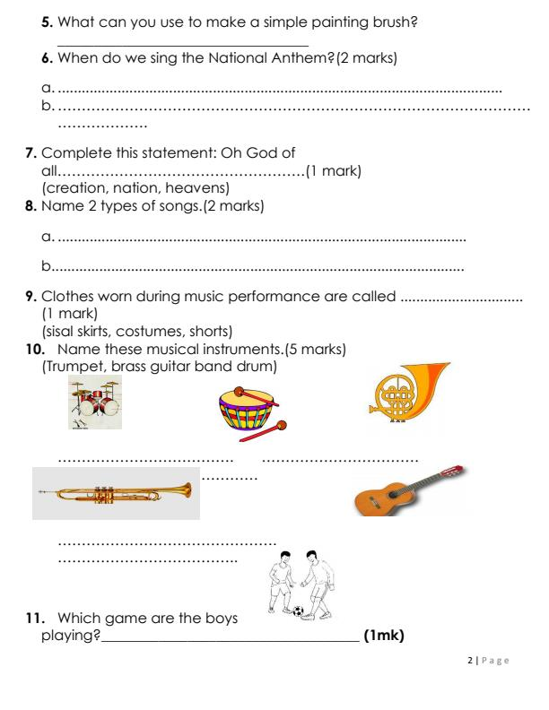
3. Sarah plays the instrument shown below

a) Identify the musical instrument shown.
__________________________________ (1 mark)
b) The instrument is played by? (1 mark)
_______________________________________________________________.

4. State two uses of songs in school. (2 marks)
a) _______________________________
b) _______________________________

5. Mention two traditional Kenyan dances. (2 marks)
a) _______________________________
b) _______________________________

6. Observe the picture.

What game are the children playing? ( 1 mark)
________________________________________________________
7. State two safety rules when playing on the field. (2 marks)
a) _________________________________
b) _________________________________

8. What are the steps of washing hands? Write any two. (2 marks)
a) __________________________________
b) __________________________________

9. Name two materials used in making a collage. (2 marks)
a) _________________________________
b) _________________________________

10. Look at the picture.

What type of line is this?
_________________________________ (1 mark)

11. Name two wind instruments. (2 marks)
a) _________________________________
b) _________________________________

12. Why do we warm up before exercises? Give one reason. (2 marks)
_____________________________________________________________________________________________

13. Mwangi ate a watermelon

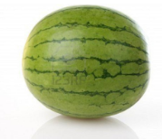
The watermelon is in which shape?____________________________ (Oval, circular, rectangular) (1 mark)
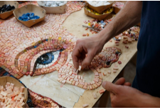
- Grade 3 learners made the following art work

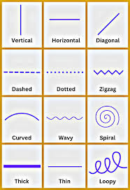
Which technique did they use? ____________________ (mosaic, painting) (1 mark)
- Write the names of the following lines: (3 marks)

_________________. _________________. _________________.
- (3 marks)
- Which music instrument is played by plucking? ___________________(guitar, violin, flute)
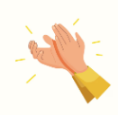
- Importance of singing games? _______________________________________________________________
- The diagram shows rhythm formation.

Which type? ________________________________________ (clapping, snapping)
- (2 marks)
- Pot making uses which method? ___________________________ (coiling, weaving, smoking)
- A basket is made by which technique? _________________________(weaving, seaming)
- Which game is played in the pool? (1 mark)

________________________________________________-

(swimming, football, handball)

- Draw and colour a lion. (10 marks)

©2026
All rights reserved
©COMPETENCE KENYA EXAMINATION AND ASSESSMENT BOARD
This is the last printed page

