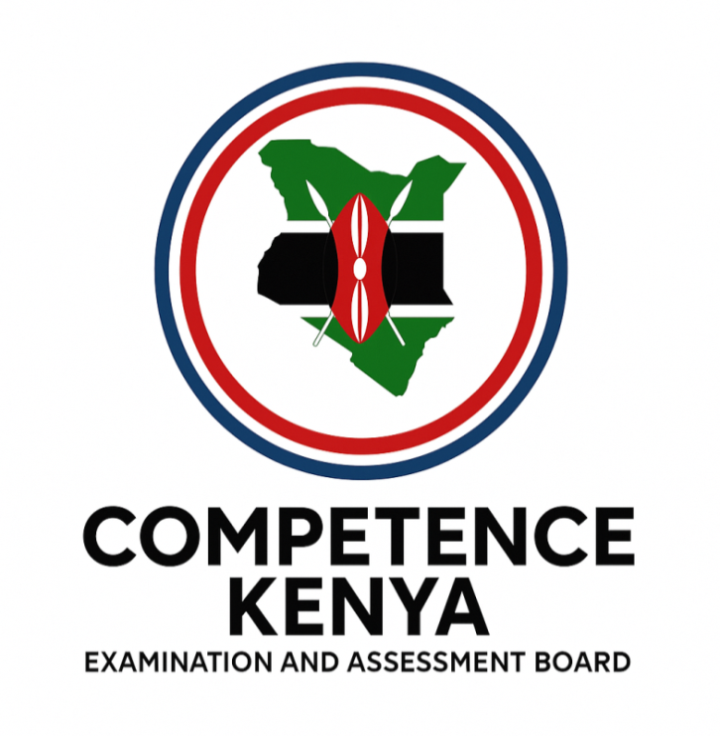
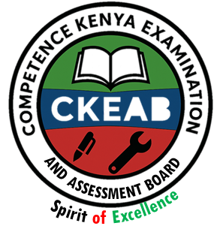

COMPETENCY-BASED EDUCATION (CBE)

SCHOOL-BASED ASSESSMENT CKEAB 002

CRE ACTIVITY ASSESSMENT

GRADE 3 – MIDTERM ASSESSMENT (TERM 1, 2026)
Learner’s Name: ___________________________School Name: ______________________________
Assessment Number: ___________________________ Date: _______________________________

CRE ACTIVITIES ASSESSMENT
TOTAL MARKS: 20
SCORE GRID: FOR FACILITATORS USE
Q. No. | 1 | 2 | 3 | 4 | 5 | 6 | 7 | 8 | 9 | 10 | 11 | 12 | 13 | 14 | 15 | 16 | TOTAL
Score | 1 | 2 | 1 | 2 | 1 | 2 | 1 | 2 | 1 | 2 | 2 | 1 | 3 | 3 | 3 | 3 | 30
Learner Score
Level

ANSWER ALL QUESTIONS

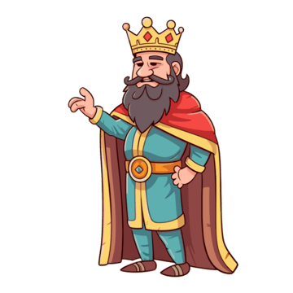
1. Identify the picture. Who is this?

a) __________________________________ (1 mark)

2. State two ways we show love to others. (2 marks)
a) ________________________________________________________________________________________.
b) ________________________________________________________________________________________.

3. Name the Holy Book used by Christians.
a) __________________________________ (1 mark)

4. Write two things God created. (2 marks)
a) ______________________________.
b) ______________________________.
5. What did Jesus teach about prayer?
a) __________________________________ (1 mark)

6. Give two examples of miracles done by Jesus. (2 marks)
a) ______________________________
b) ______________________________
7. Look at the picture.



What are the children doing? (1 mark)
_________________________________________.
8. List two ways Christians help the needy. (2 marks)
a) ______________________________
b) ______________________________
9. Who was the mother of Jesus?
__________________________________ (1 mark)

10. Why should we obey our parents? Give two reasons. (2 marks)
a) ______________________________
b) ______________________________

11. Name two Christian places of worship. (2 marks)
a) ______________________________
b) ______________________________

12. What is the importance of the Ten Commandments?
a) __________________________________ (1 mark)

13. Bible Events. (3 marks)
- What guided the Wise Men? __________________________________
- Who was swallowed by a fish?________________________________
- Moses saw a burning _________________________

14. Christian Values (3 marks)
- Which should leaders avoid? _____________________________________.
- Virtue from Peter walking on water? ________________________________________.
- A way of thanking God?____________________________________________.

15. Bible Stories (3 marks)
- Where was the beaten man going? ______________________________
- Who had faith in God? ____________________________________
- Who died for lying to God?________________________________

16. Family (3 marks)
- Name three members of the nuclear family.
- ______________________________________________.
- ______________________________________________.
- ______________________________________________.

©2026
All rights reserved
©COMPETENCE KENYA EXAMINATION AND ASSESSMENT BOARD
This is the last printed page

