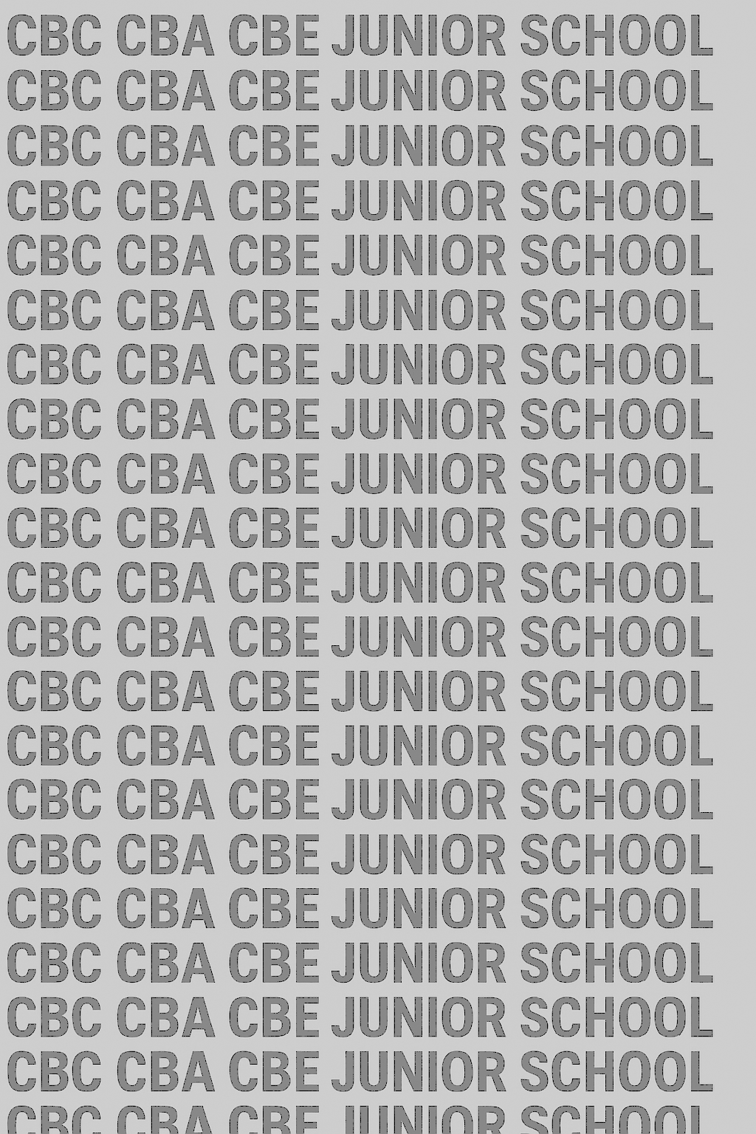
KENYA JUNIOR SCHOOL EDUCATION ASSESSMENT
GRADE 7 MIDTERM TERM 1 FEBRUARY 2026
COMPETENCE ASSESSMENT EXAMINATION CODE OO2

LEARNER’S DETAILS
Name: _______________________________________________________________________________________.
School: ______________________________________________________________________________________.
Assessment Number: ________________________________. Date: __________________________________.

School Code: _______________________________. Signature: ________________________________.

INSTRUCTIONS TO LEARNERS
- Answer all questions in this paper.
- Section A has 20 multiple-choice questions (20 marks).
- Section B has 30 structured questions (80 marks).
- Show all your working clearly in the spaces provided.
- Do not use calculators unless instructed.
- Manage your time well.
- The total marks for this paper are 100.
-Mathematics- -002- -Paper Code 903-

Section A – Multiple Choice Questions (20 Marks)
Question Number | 1 | 2 | 3 | 4 | 5 | 6 | 7 | 8 | 9 | 10 | 11 | 12 | 13 | 14 | 15 | 16 | 17 | 18 | 19 |   20
Maximum Score | 1 | 1 | 1 | 1 | 1 | 1 | 1 | 1 | 1 | 1 | 1 | 1 | 1 | 1 | 1 | 1 | 1 | 1 | 1 | 1
Learner’s Score

Section B – Structured Questions (80 Marks)
Question Number | 1 | 2 | 3 | 4 | 5 | 6 | 7 | 8 | 9 | 10 | 11 | 12 | 13 | 14 | 15 | 16 | 17 | 18 | 19 | 20 | 21 | 22 | 23
Maximum Score | 2 | 2 | 2 | 2 | 2 | 2 | 2 | 2 | 2 | 2 | 2 | 2 | 2 | 2 | 2 | 2 | 2 | 2 | 2 | 2 | 2 | 2 | 2
Learner’s Score

Performance Levels Grid
Level | Level | % Range | Points | Learner’s score | Remarks
Exceeding (EE) | EE1 | 90–100% | 8 |  | Exceptional mastery; exceeds expectations
 | EE2 | 75–89% | 7 |  | Very strong performance
Meeting (ME) | ME1 | 58–74% | 6 |  | Solid understanding
 | ME2 | 41–57% | 5 |  | Partial achievement
Approaching (AE) | AE1 | 31–40% | 4 |  | Limited achievement
 | AE2 | 21–30% | 3 |  | Very limited
Below (BE) | BE1 | 11–20% | 2 |  | Poor performance
 | BE2 | 1–10% | 1 |  | Extremely weak

SECTION A (20 Marks)
Answer all the questions. Each question carries 1 mark.
- Write 325,406,712 in words.
A. Three hundred twenty-five million, four hundred six thousand, seven hundred twelve
B. Thirty-two million, five hundred forty-six thousand, seven hundred twelve
C. Three hundred twenty-five thousand, four hundred six million, seven hundred twelve
D. Three hundred twenty-five million, forty-six thousand, seven hundred twelve

- The total value of digit 9 in 859,234,715 is:
A. 9 B. 900 C. 90,000,000 D. 900,000
- A number is divisible by 9 and 15. What is the least possible number greater than 200 that satisfies this condition?
A. 210
B. 225
C. 240
D. 270
- The Highest Common Factor (HCF) of two numbers is 18, and their Lowest Common Multiple (LCM) is 540. If one number is 90, what is the other number?
A. 108
B. 120
C. 162
D. 270
- A farmer used $\frac{2}{5}$ ​ of his land for maize, $¼​$ for beans, and the rest for vegetables. If he has 60 hectares of land, how many hectares are under vegetables?
A. 15
B. 18
C. 20
D. 25
- The value of $\frac{0.48×0.25}{0.06}$ ​ is:
A. 2.0
B. 2.4
C. 3.0
D. 4.0

WORKING SPACE

- Which of the following is true?
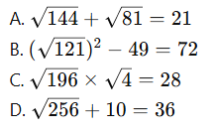
- Round off 456,782,913 to the nearest hundred million.
A. 400,000,000 B. 450,000,000 C. 500,000,000 D. 460,000,000
- Which of the following is NOT a natural number?
A. 0 B. 1 C. 2 D. 3
- Which of the following numbers is odd?
A. 246 B. 321 C. 640 D. 128
- Which number is a prime number?
A. 51 B. 29 C. 49 D. 77
- Which of the following is a multiple of 6?
A. 45 B. 78 C. 97 D. 125
- Which number is divisible by 11?
A. 253 B. 319 C. 462 D. 735
- Express 48 as a product of prime factors.
A. 2 × 24 B. 2 × 2 × 2 × 2 × 3 C. 4 × 12 D. 48 × 1
- The GCD of 24 and 36 is:
A. 6 B. 8 C. 12 D. 18
- Which number comes next in the sequence: 2, 4, 8, 16, …
A. 18 B. 20 C. 24 D. 32
- Arrange in decreasing order: 485,219; 582,149; 814,259; 148,295.
A. 814,259; 582,149; 485,219; 148,295
B. 148,295; 485,219; 582,149; 814,259
C. 582,149; 814,259; 485,219; 148,295
D. 485,219; 582,149; 814,259; 148,295

WORKING SPACE

- The number 2,135 is divisible by:
A. 5 only B. 2 and 5 C. 5 and 7 D. 2, 3 and 5
- The difference between the greatest 8-digit number and the smallest 7-digit number is:
A. 89,999,999 B. 9,000,000 C. 90,000,000 D. 99,999,999
- If a = 36 and b = 18, find (a ÷ b) × 6.
A. 6 B. 12 C. 18 D. 36

WORKING SPACE

SECTION B (80 Marks)
Answer all questions. Each question carries 2 marks.
- Write in figures:
(a) Seven hundred and forty-five million, two hundred and three thousand, six hundred and nine.

(b) Eighty-nine million, four thousand and seventy point three two one.

- Write in words:
(a) 50,807,631.4

(b) 300,000,009

- Find the total value of:
(a) 8 in 9275342.18

(b) 4 in 24081.5963

- Round off:
(a) 489,736,214 to the nearest hundred million

(b) 72,361,983 to the nearest tenth of thousandths

- Write the next three numbers in the sequence:
(a) 2, 6, 18, 54, …

(b) 105, 95, 85, …

- Arrange in increasing order:
308,419,621; 381,429,216; 138,241,962; 813,249,126

- Test for divisibility:
(a) 3456 by 2

(b) 936 by 11

- Express the following numbers as a product of prime factors:
(a) 84

(b) 315
- A school bought 432 books. They want to distribute them equally among 18 classes. How many books will each class get?

- A farmer harvested 2,568 mangoes. He packed them in crates of 24 each. How many crates did he need?

- A learner read 7,320 words in 6 minutes. How many words did she read per minute?

- Jane bought 3 pens at Ksh 45 each and 4 books at Ksh 120 each. How much did she spend?

- A lorry carried 7,800 kg of maize. If each sack weighs 60 kg, how many sacks were carried?

- Find the difference between the greatest 9-digit number and the smallest 8-digit number.

- A trader bought 15 cartons of juice. Each carton had 24 bottles. If he sold each bottle at Ksh 50, how much money did he get?

- Add:
($\frac{1}{2}$ of 10 (3,249,517 + 4,813,725-12,547) + 5,029,408)×0.1

- Arrange the following fractions in ascending order:
$$\frac{2}{3},\frac{5}{6},\frac{3}{4},\frac{7}{12}$$

- A class of 45 learners shared 180 mangoes equally. How many mangoes did each pupil get?

- A school has 360 pupils who are to be grouped for games.
- List all the prime factors of 360.

- Find the greatest number of pupils per group if each group must have an equal number of boys and girls.

- If the school has 12 footballs and 18 volleyballs, use HCF to determine the maximum number of groups that can be formed so that each group gets an equal number of footballs and volleyballs.

- The traffic lights at three different road junctions change after 40 seconds, 60 seconds, and 90 seconds respectively.
(a) Find the least common multiple (LCM) of the three times.

(b) After how many minutes will the three lights change together again?

(c) If each cycle uses 500 watts of electricity, calculate the energy consumed by all three lights until they next change together.

- A rectangular field has an area of 5,184 m².
(a) If the field is square in shape, find the length of each side.

(b) Find the perimeter of the field.

(c) If fencing costs Ksh 320 per metre, calculate the total fencing cost.

- A farmer divides his land among three sons in the ratio $\frac{2}{5}:\frac{3}{10}:\frac{1}{2}$
(a) Find the fraction of land each son gets.

(b) If the total land is 24 hectares, how many hectares does each son get?

(c) The eldest son sells $\frac{2}{3}$ of his share. How many hectares remain?

- A shopkeeper recorded the following sales in one week:
Monday – Ksh 12,350.75
Tuesday – Ksh 15,280.50
Wednesday – Ksh 14,999.95
Thursday – Ksh 11,840.25
Friday – Ksh 16,205.80
(a) Find the total sales for the week.

(b) Find the difference in the highest and the lowest sales.

(c) Round off the total sales to the nearest hundred and nearest thousand.
©2026
All rights reserved
©COMPETENCE KENYA EXAMINATION AND ASSESSMENT BOARD
This is the last printed page

