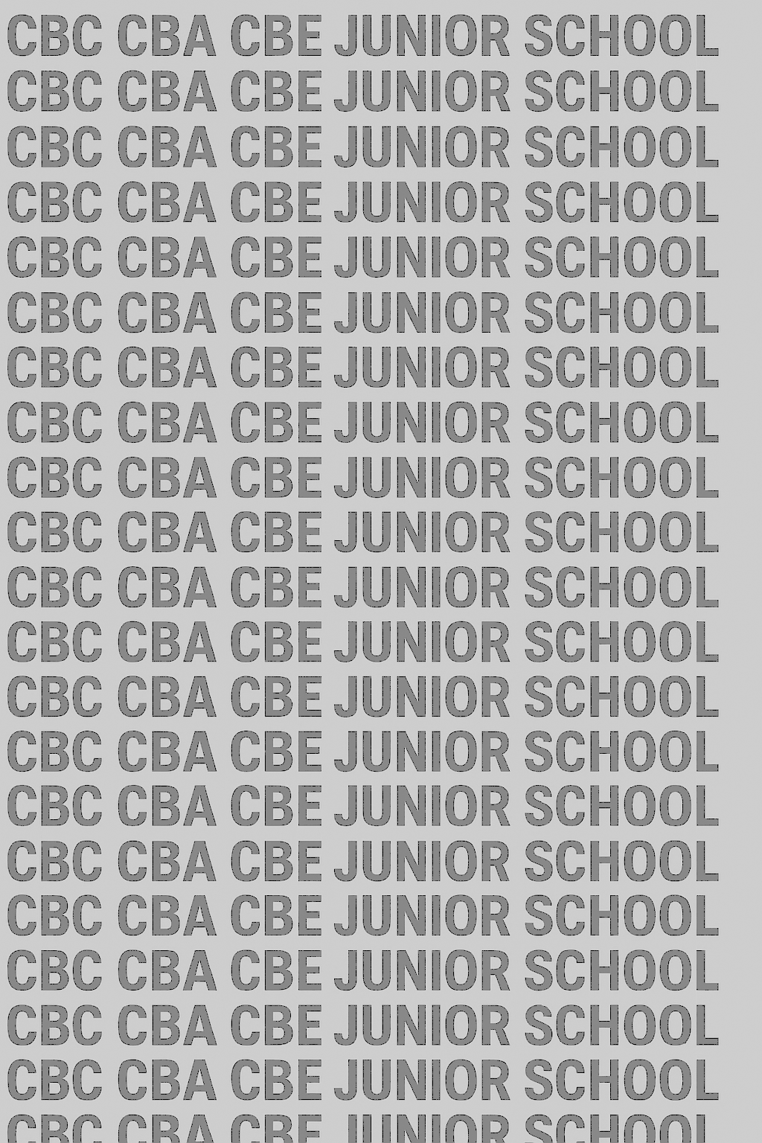

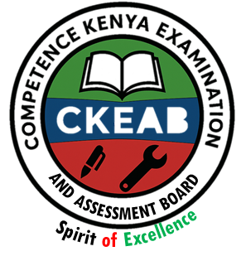
KENYA JUNIOR SCHOOL EDUCATION ASSESSMENT


GRADE 7 TERM 1 FEBRUARY 2026

ISLAMIC RELIGIOUS EDUCATION
CKEAB 002

Time - 1 hour 45 minutes

LEARNER’S DETAILS

Name: ________________________________________________. School: _____________________________________
Assessment Number: _____________________________. Date: ______________________________.
School Code: ____________________________. Signature: ____________________________.
INSTRUCTIONS TO LEARNERS
- Write your name and assessment number in the spaces provided.
- Write the name and code of your school in the spaces provided.
- Write the date of the assessment and sign in the spaces provided.
- This question paper consists of two sections: A and B.
- Answer ALL questions in this paper.
- Write ALL the answers in the spaces provided in this question paper.
- Do NOT remove any page from this question paper.
- Answer the questions in English.
For official use only
SECTION A: MULTIPLE CHOICE QUESTIONS (20 Marks)
-IRE- -FORMATIVE ASSESSMENT- -002- - Paper Code 908-
Question No. | 1 | 2 | 3 | 4 | 5 | 6 | 7 | 8 | 9 | 10 | 11 | 12 | 13 | 14 | 15 | 16 | 17 | 18 | 19 | 20 | TOTAL
Max Score | 1 | 1 | 1 | 1 | 1 | 1 | 1 | 1 | 1 | 1 | 1 | 1 | 1 | 1 | 1 | 1 | 1 | 1 | 1 | 1 | 20
Candidate’s Score
SECTION B: STRUCTURED QUESTIONS (60 Marks)
Task | Qn Nos. | Max Marks | Candidate's Score  GRAND TOTAL
SECTION A | 20 | 20
SECTION B | 10 | 80
TOTAL | 50 | 100
This paper consists of 8 printed pages. Candidates should check the question paper to ascertain that all the pages are printed as indicated and that no questions are missing. This paper has 16 printed pages. Please check out to ensure all pages are printed
Turn over

SECTION A: (20 MARKS)
Answer all questions by choosing the correct answer

  - Amina always checks her behaviour using teachings from the Qur’an and Hadith. This shows that she is using Islam as a source of…
A. wealth
B. morality
C. entertainment
D. fashion
  - During a class debate, learners discussed why Muslims must behave uprightly. Which statement BEST explains the purpose of morality in Islam?
A. To make Muslims famous
B. To promote uprightness in society
C. To please other human beings
D. To make Muslims win competitions
  - Jamal returns money he found on the playground. Which Islamic value has he demonstrated?
A. Laziness
B. Truthfulness
C. Anger
D. Pride
  - Fatuma forgave her classmate who broke her ruler. According to Islamic teaching, forgiveness helps to…
A. break friendships
B. bring harmony in society
C. create hatred
D. discourage kindness
  - Ali started abusing drugs after joining a bad peer group. What is one effect of drug abuse?
A. Improved performance
B. Good reputation
C. Poor health
D. Better character
  - Which reason BEST explains why Islam prohibits drug abuse?
A. Drugs are too expensive
B. Drugs destroy one’s character
C. Drugs are difficult to find
D. Drugs make life boring
  - The prayer performed when entering the mosque is…
A. Tahajud
B. Dhuha
C. Tahiyatul Masjid
D. Janaza
  - The prayer for the deceased is known as…
A. Swalatul Musafir
B. Swalatul Janaza
C. Swalatul Khusuf
D. Swalatul Dhuha
  - Zakatul Fitr is paid…
A. daily
B. before Eid-ul-Fitr
C. during Hajj
D. in the month of Muharram
  - Which of the following is exempted from Zakat?
A. Business goods
B. Jewellery
C. Food for family use
D. Livestock
  - The first revelation came to Prophet Muhammad (S.A.W.) in…
A. Madina
B. Cave Hira
C. Jerusalem
D. Mount Uhud
  - The Qur’an was revealed in portions because…
A. it had too many pages
B. Arabs loved poetry
C. it was easy for implementation
D. the Prophet (S.A.W.) requested it
  - Surah Ad-Dhuha teaches Muslims to…
A. be proud
B. ignore the needy
C. appreciate Allah’s blessings
D. worship idols
  - One lesson from Surah Al-Balad is the importance of…
A. leading an easy life
B. avoiding difficult tasks
C. striving in good deeds
D. insulting parents
  - Visiting graves to seek help from the dead is an example of…
A. Tawheed B. Shirk C. Zakat D. Saum
  - The belief in One God is known as…
A. Shirk B. Tawheed
C. Sunnah D. Saum
  - The Hadith “actions are judged by intentions’’ teaches Muslims to…
A. judge others
B. seek fame
C. have sincere intentions
D. hide their actions
  - According to the Hadith on friendship, a good friend is compared to…
A. a gardener
B. a musk seller
C. a fisherman
D. a tailor
  - Saum that is compulsory on every healthy adult Muslim is called…
A. Qadha B. Kafara C. Fardh D. Nadhir
  - Which of the following is a benefit of observing Saum?
A. Becoming lazy
B. Achieving taqwa
C. Getting rich
D. Avoiding prayers

SECTION B: (80 MARKS)
Answer all questions.
21. During a school assembly, the guidance counselor teaches students about sources of morality in Islam.
a) Identify three sources of morality in Islam. (3 marks)
i.______________________________________________________________________________________________. ii._____________________________________________________________________________________________. iii._____________________________________________________________________________________________. b) Explain how morality promotes uprightness in society using a real-life example. (3 marks)
________________________________________________________________________________________________________________________________________________________________________________________________________________________________________________________________________________________________c) Describe two Islamic values you practise at home. (4 marks)
i.______________________________________________________________________________________________. ii._____________________________________________________________________________________________.
22. Hawa lied to her teacher but later felt guilty and decided to apologise.
a) Explain two Islamic teachings on truthfulness. (4 marks)
i.______________________________________________________________________________________________. ii._____________________________________________________________________________________________.
b) Give two reasons why forgiveness is important in daily life. (4 marks)
i.______________________________________________________________________________________________. ii._____________________________________________________________________________________________.
c) State one reward of practising truthfulness. (2 marks)
________________________________________________________________________________________________________________________________________________________________________________________________
23. Omar has started abusing drugs after joining a group of older boys in his estate. His parents are worried.
a) Describe two effects of drug abuse on a learner. (4 marks)
i.______________________________________________________________________________________________. ii._____________________________________________________________________________________________. b) Explain the Islamic reason for prohibiting drugs. (3 marks)
i.______________________________________________________________________________________________. ii._____________________________________________________________________________________________.
iii.____________________________________________________________________________________________
c) Suggest three remedies that can help Omar overcome drug abuse. (3 marks)
i.______________________________________________________________________________________________. ii._____________________________________________________________________________________________.
iii.______________________________________________________________________________________________.
24. Your school Islamic Club is learning about prayers.
a) Describe how Tahajud and Tahiyatul Masjid are performed. (4 marks)
________________________________________________________________________________________________________________________________________________________________________________________________________________________________________________________________________________________________________________________________________________________________________________________________
b) Explain the importance of performing Swalatul Janaza. (3 marks)
i.______________________________________________________________________________________________. ii._____________________________________________________________________________________________. iii.______________________________________________________________________________________________.
c) Identify three occasions when special prayers (Kusuf/Khusuf/Musafir) are performed. (3 marks)
i.______________________________________________________________________________________________. ii._____________________________________________________________________________________________. iii.______________________________________________________________________________________________.
25. During Ramadan, your community conducts a lesson on Zakat.
a) Describe Zakatul Maal and Zakatul Fitr. (4 marks)
________________________________________________________________________________________________________________________________________________________________________________________________________________________________________________________________________________________________________________________________________________________________________________________________b) Identify three items exempted from Zakat. (3 marks)
i.______________________________________________________________________________________________. ii._____________________________________________________________________________________________. iii.______________________________________________________________________________________________. c) Explain the importance of Zakat to the needy in the society. (3 marks)
i.______________________________________________________________________________________________. ii._____________________________________________________________________________________________. iii.______________________________________________________________________________________________.
26. Your class is studying the revelation of the Qur’an.
a) Explain the rationale for the revelation of the Qur’an. (3 marks)
i.______________________________________________________________________________________________. ii._____________________________________________________________________________________________. iii.______________________________________________________________________________________________. b) Describe two stages of revelation of the Qur’an. (4 marks)
i.______________________________________________________________________________________________. ii._____________________________________________________________________________________________. c) Explain one importance of the first revelation at Cave Hira. (3 marks)
i.______________________________________________________________________________________________. ii._____________________________________________________________________________________________. iii.______________________________________________________________________________________________.
27. Read Surah Ad-Dhuha and Surah Al-Balad and answer:
a) Explain the meaning of each surah in your own words. (4 marks)
________________________________________________________________________________________________________________________________________________________________________________________________________________________________________________________________________________________________________________________________________________________________________________________________
b) State two lessons from Surah Ad-Dhuha. (2 marks)
i.______________________________________________________________________________________________. ii._____________________________________________________________________________________________. c) State two lessons from Surah Al-Balad. (2 marks)
i.______________________________________________________________________________________________. ii._____________________________________________________________________________________________. d) Give two ways you can apply these lessons in your life. (2 marks)
i.______________________________________________________________________________________________. ii._____________________________________________________________________________________________.
28. Your teacher explains that shirk destroys a Muslim’s Iman.
a) Describe two types of shirk. (4 marks)
i.______________________________________________________________________________________________. ii._____________________________________________________________________________________________. b) Give two ways shirk is manifested today. (2 marks)
i.______________________________________________________________________________________________. ii._____________________________________________________________________________________________.
c) Explain two effects of shirk on a Muslim. (4 marks)
i.______________________________________________________________________________________________. ii._____________________________________________________________________________________________.
29. Study the Hadith on intention and the Hadith on good friends.
a) State two lessons from the Hadith on intention. (2 marks)
i.______________________________________________________________________________________________. ii._____________________________________________________________________________________________.
b) State two lessons from the Hadith on choice of friends. (2 marks)
i.______________________________________________________________________________________________. ii._____________________________________________________________________________________________. c) Explain how these two Hadith guide a Muslim’s behaviour. (3 marks)
i.______________________________________________________________________________________________. ii._____________________________________________________________________________________________. iii.______________________________________________________________________________________________. d) Describe one way you can practise each Hadith in your daily life. (3 marks)
________________________________________________________________________________________________________________________________________________________________________________________________
30. Your school imam teaches about Tawheed and Saum.
a) Explain the significance of Tawheed for a Muslim. (3 marks)
i.______________________________________________________________________________________________. ii._____________________________________________________________________________________________. iii.______________________________________________________________________________________________.
b) State two ways of showing belief in Tawheed. (2 marks)
i.______________________________________________________________________________________________. ii._____________________________________________________________________________________________. c) Describe any two types of Saum. (3 marks)
i.______________________________________________________________________________________________. ii._____________________________________________________________________________________________.
©2026
All rights reserved
©COMPETENCE KENYA EXAMINATION AND ASSESSMENT BOARD
This is the last printed page

