GRADE 7 MARKING SCHEME.
CREATIVE ARTS AND SPORTS SECTION A: (40 MARKS)
No. | Answer | Explanation / Guide
1 | B | Both Creative Arts and Sports require practice, skill development and execution.
2 | C | Both storytelling and choreography revolve around a theme.
3 | B | Colour and tone are elements of Visual Arts.
4 | C | Dribbling while running shows coordination of eyes, hands, and feet.
5 | B | Attire refers to clothing worn by performers or athletes.
6 | C | Value refers to lightness or darkness of a colour.
7 | A | Balance gives a sense of stability in artwork.
8 | A | Rhythm is created by repeating elements to guide the eye.
9 | B | Adding white creates a tint.
10 | B | Texture refers to how a surface feels or appears to feel.
11 | C | Setting is the time and place of a story.
12 | B | Conflict is the struggle between opposing forces.
13 | C | Theme is the main message or lesson.
14 | A | Exposition introduces characters and setting.
15 | B | The antagonist opposes the hero.
16 | D | A semibreve has 4 beats in 4/4 time.
17 | B | “Taa-aa” represents a minim.
18 | D | A minim rest hangs from the fourth line.
19 | B | Two quavers equal one crotchet.
20 | B | Top number shows beats per bar.
21 | A | C Major has no sharps or flats.
22 | B | A good melody is singable with clear shape.
23 | A | Second line on treble clef is note E.
24 | B | C to D is a Major 2nd.
25 | A | Ledger lines extend the staff.
26 | B | Straight, dry wood is safest and best for carving.
27 | B | Correct javelin phases follow that sequence.
28 | C | Cross over transfers power from legs to arm.
29 | C | Always carve away from the body.
30 | B | A valid throw lands tip-first in the sector.
31 | B | Lark’s Head Knot attaches strings to a frame.
32 | B | Jump shot is released at highest jump point.
33 | B | Low dribble protects the ball.
34 | B | Flick pass uses wrist action.
35 | A | Handball allows 3 steps without dribbling.
36 | B | Push-ups build muscular strength.
37 | A | “Tafa-te” = four semiquavers.
38 | A | Movement guides the viewer’s eye.
39 | B | This integrates Visual Arts and Music.
40 | C | A rest symbol indicates silence.

SECTION B: STRUCTURED QUESTIONS (60 MARKS)
Award marks for ANY correct, relevant answers.

41. MUSIC COMPOSITION AND RHYTHM

(a) Factors to consider
- Tempo of the march
- Mood of the performance
- Beat consistency
- Skill level of performers
- Occasion or purpose

(b) French Rhythm Names
French Name | Note symbol | Note Name (English)
Taa-aa | 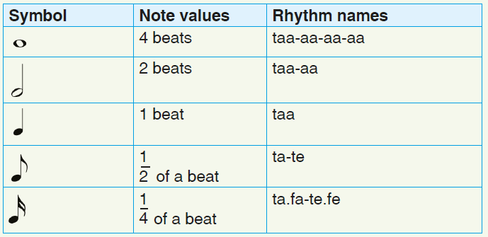 | Minim
Taa |  | Crotchet
Ta-te |  | Two Quavers
Taa-aa-aa-aa |  | Semibreve

(c) Acceptable rhythmic patterns

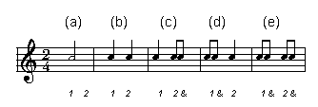
- Any correct 2-bar rhythm in 2/4
- Combination of crotchets, minims, quavers, rests
- Beats must total 2 per bar

42. VISUAL ARTS & STORYTELLING

(a) Story elements
- Character: Person in the story
- Setting: Time and place
- Plot: Sequence of events
- Theme: Main message or lesson

(b) Four elements of art (any four):

Line

Shape

Colour

Texture

Form

Space

Value (tone/light and dark)

(c) shading using cross hatching technique to show tone/value

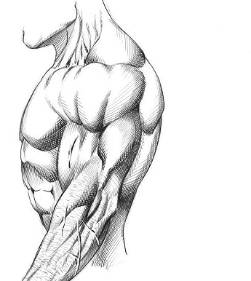

43. ATHLETICS – JAVELIN

(a) Qualities of wood
- Straight
- Dry
- Smooth
- Strong
- Lightweight

(b) Description
- Approach run: Athlete runs steadily holding javelin
- Release: Javelin thrown forcefully at correct angle

(c) Diagram
- Accept labelled drawing showing:
  - Grip
  - Shaft
  - Tip/Point

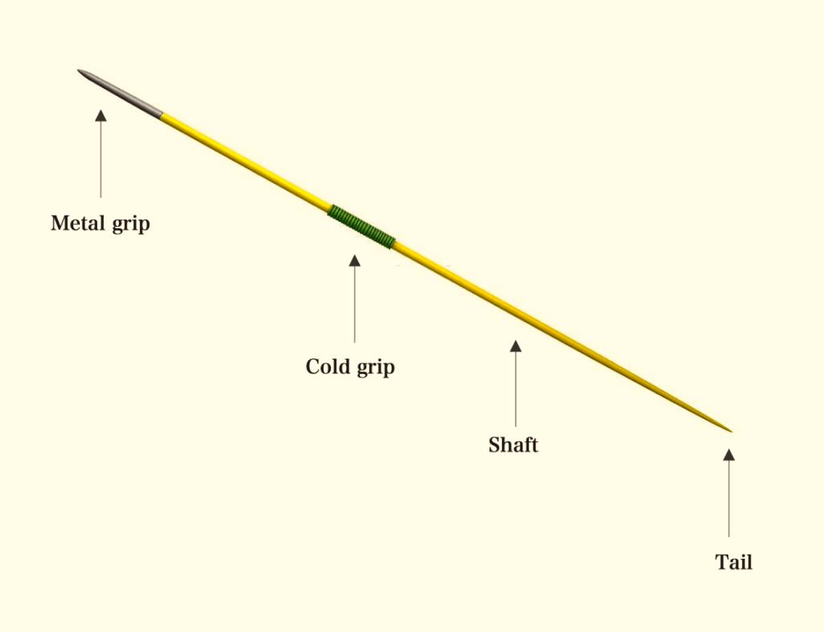

44. HANDBALL AND CRAFTS

(a) Lark’s Head Knot steps
- Fold rope in half
- Pass loop over frame
- Pull ends through loop
- Tighten firmly

(b) Jump shot use
- When defender is close
- To score over opponents
- When space is limited

(c) Dribbling
Dribble | Height | Use
Low | Below waist | Protect ball
High | Waist to chest | Fast movement

(d) Safety rule
- Do not pull rope suddenly
- Keep safe distance
- Use blunt tools

45. MELODY

(a) Treble clef
- Accept correct clef symbol
- Middle C on ledger line
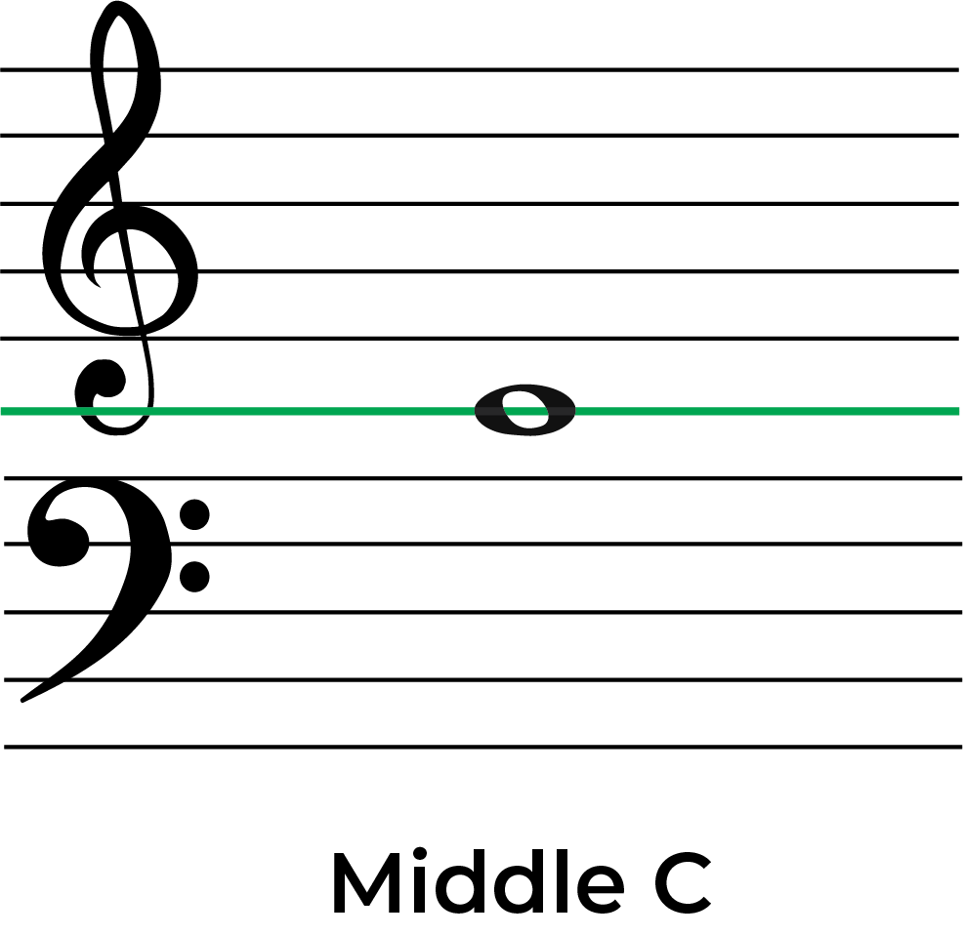

(b) Qualities of good melody
- Singable
- Repetitive patterns
- Balanced rhythm
- Clear contour

(c) Repetition in design
- Repeating shapes
- Repeating colours
- Repeating lines
- Repeating patterns

(d) C Major scale
C, D, E, F, G, A, B, C

46. PHYSICAL FITNESS & INTEGRATION

(a) Coordination
- Ability to use body parts together smoothly

(b) Exercises
- Strength: Push-ups, squats
- Coordination: Skipping rope, dribbling

(c) Music in exercise
- Keeps rhythm
- Motivates learners
- Improves timing
- Makes exercise enjoyable

(d) Relationship chart
- Audience: Both are performed before spectators

