
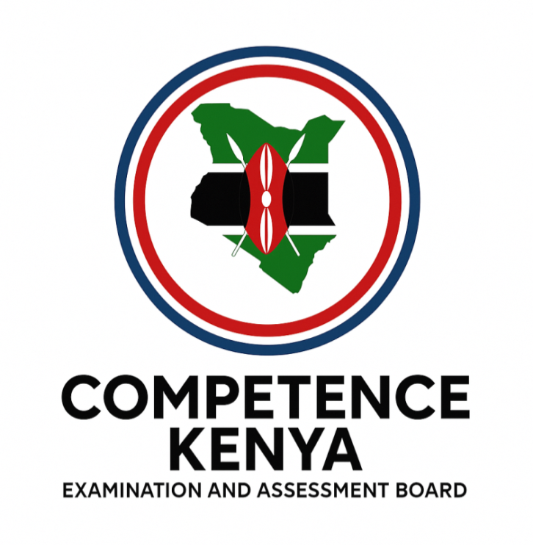
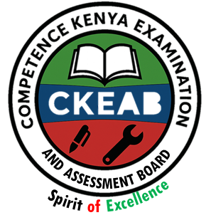
KENYA JUNIOR SCHOOL EDUCATION ASSESSMENT

GRADE 7 TERM 1 FEBRUARY 2026

CHRISTIAN RELIGIOUS EDUCATION
CKEAB 002

Time - 1 hour 45 minutes

LEARNER’S DETAILS
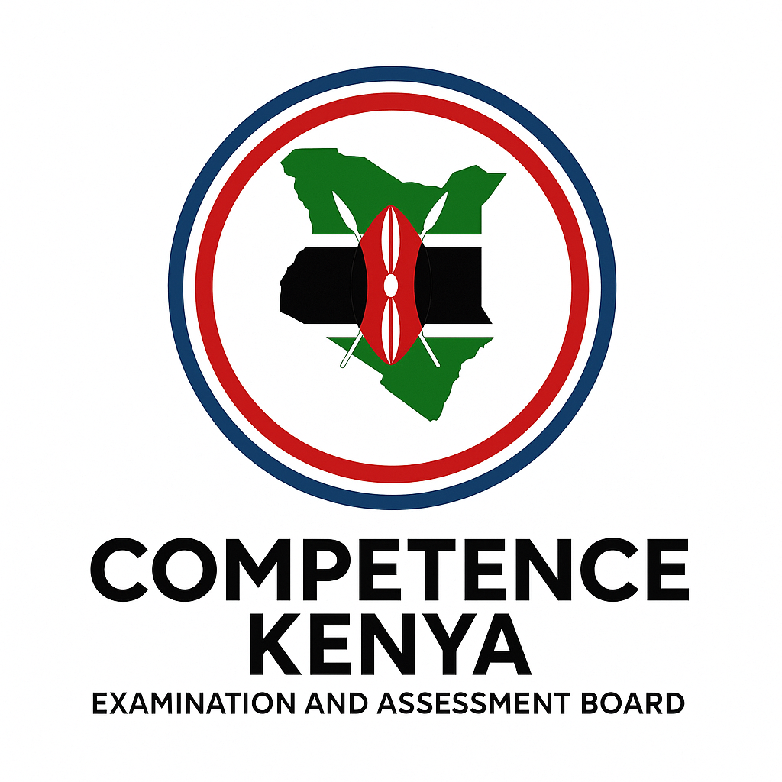
Name: ________________________________________________. School: _____________________________________
Assessment Number: _____________________________. Date: ______________________________.
School Code: ____________________________. Signature: ____________________________.
INSTRUCTIONS TO LEARNERS
- Write your name and assessment number in the spaces provided.
- Write the name and code of your school in the spaces provided.
- Write the date of the assessment and sign in the spaces provided.
- This question paper consists of two sections: A and B.
- Answer ALL questions in this paper.
- Write ALL the answers in the spaces provided in this question paper.
- Do NOT remove any page from this question paper.
- Answer the questions in English.
For official use only
SECTION A: MULTIPLE CHOICE QUESTIONS (20 Marks)
-CRE- -FORMATIVE ASSESSMENT- -002- - Paper Code 908-
Question No. | 1 | 2 | 3 | 4 | 5 | 6 | 7 | 8 | 9 | 10 | 11 | 12 | 13 | 14 | 15 | 16 | 17 | 18 | 19 | 20 | TOTAL
Max Score | 1 | 1 | 1 | 1 | 1 | 1 | 1 | 1 | 1 | 1 | 1 | 1 | 1 | 1 | 1 | 1 | 1 | 1 | 1 | 1 | 20
Candidate’s Score
SECTION B: STRUCTURED QUESTIONS (60 Marks)
Task | Qn Nos. | Max Marks | Candidate's Score  GRAND TOTAL
SECTION A | 20 | 20
SECTION B | 10 | 80
TOTAL | 50 | 100
This paper consists of 6 printed pages. Candidates should check the question paper to ascertain that all the pages are printed as indicated and that no questions are missing.
Turn over

SECTION A: (20 MARKS)
Answer all questions by choosing the correct answer

- During a lesson, the teacher asked learners why they study CRE. Mercy said it helps her to make good decisions in life. This shows that studying CRE:
A. Helps learners pass exams only.
B. Helps learners to grow spiritually and morally.
C. Is meant only for Christians.
D. Helps people get jobs in church.
- After learning about creation, pupils discussed what they had learned. From this, we know that the first account of creation teaches that God:
A. Created human beings first.
B. Created all things through His word.
C. Needed help to create.
D. Rested on the sixth day.
- According to the second account of creation, God formed man from:
A. Dust of the ground and breathed life into him.
B. Clay and water.
C. Air and fire.
D. Sand and wind.
- When comparing the two creation stories, one difference is that:
A. The first account shows order, while the second is more detailed about man.
B. The second account was written before the first.
C. The first account talks only about animals.
D. Both accounts talk only about Adam.
- From the two creation stories, Christians learn that God is:
A. Angry and cruel. B. Loving and powerful.
C. Fearful and weak. D. A man with limits.
- During a tree-planting day at school, learners discussed stewardship. The word stewardship means:
A. Being a boss over creation.
B. Taking care of God’s creation responsibly.
C. Using all resources for personal gain.
D. Owning everything on earth.
- When God created Adam and Eve, He told them to take care of the garden. This shows that human beings were given:
A. Power to destroy creation.
B. Responsibilities over creation.
C. Permission to rule others.
D. Control over the sun and moon.
- A group of pupils started cleaning the school compound and planting trees. This act shows:
A. Misuse of resources.
B. Stewardship and care for creation.
C. Disobedience to God.
D. Wasting time.

- Some people throw waste into rivers and cut trees carelessly. This is an example of:
A. Using resources wisely.
B. Misusing God’s creation.
C. Obeying the creation story.
D. Conserving the environment.
- During a discussion on conservation, Brian said that we should recycle and reuse items. His answer shows that he understands:
A. The importance of the Bible.
B. Ways of conserving the environment.
C. The story of Adam and Eve.
D. The difference between the testaments.
- In a church, people read the Bible before and after preaching. This shows that one function of the Bible is to:
A. Tell jokes.
B. Guide Christians in worship.
C. Teach about animals.
D. Provide entertainment.
- A Christian reads the Bible daily for encouragement. This shows that the Bible is:
A. A book for decoration.
B. Important for spiritual growth.
C. A source of punishment.
D. Meant only for teachers.
- The Bible has two main parts. They are:
A. Old and New Testaments.
B. Genesis and Revelation.
C. Law and Prophets.
D. Psalms and Proverbs.
- The book of Exodus is found in the:
A. New Testament.
B. Old Testament.
C. Psalms.
D. Gospel books.
- The book of Luke is found in the:
A. Law books. B. Old Testament.
C. New Testament. D. Wisdom books.
- While reading the Bible, learners came across stories about creation and prophets. These are found in the:
A. Old Testament.
B. New Testament.
C. Psalms only.
D. Epistles.
- Paul wrote letters to early Christians. These letters are found in which part of the Bible?
A. Prophetic books.
B. Epistles of the New Testament.
C. The Pentateuch.
D. Historical books.
- The school environment club was formed to promote cleanliness and planting trees. This activity helps in:
A. Conservation of the environment.
B. Destroying forests.
C. Wasting resources.
D. Showing power over nature.
- A good steward is one who:
A. Misuses God’s resources.
B. Cares for others and manages resources well.
C. Ignores the needs of the community.
D. Wastes food and water.
- During a discussion on creation, a pupil said, “God rested on the seventh day.” This teaches that Christians should:
A. Rest and worship God on the Sabbath.
B. Work every day without rest.
C. Never take time off.
D. Avoid worshiping.

SECTION B: (80 MARKS)
Answer all questions in the spaces provided.
- Importance of Studying CRE (6 marks)
a) State two reasons why Christians study CRE. (2 marks)

- __________________________________________________________________________________________.
- __________________________________________________________________________________________.
b) Explain two ways CRE helps learners in their daily life. (2 marks)
- __________________________________________________________________________________________.
- __________________________________________________________________________________________.
c) Give two ways CRE promotes peace in society. (2 marks)
- __________________________________________________________________________________________.
- __________________________________________________________________________________________.
- a) Describe what God created on the first and second days according to the first account. (2 marks)

- __________________________________________________________________________________________.
- __________________________________________________________________________________________.
b) Explain two differences between the first and second accounts of creation. (4 marks)

First account of creation | Second account of creation
c) State two similarities between the two accounts of creation. (2 marks)
- __________________________________________________________________________________________.
- __________________________________________________________________________________________.
d) Give two lessons Christians learn from the creation stories. (2 marks)

- __________________________________________________________________________________________.
- __________________________________________________________________________________________.

- a) Mention three attributes of God shown in the creation stories. (3 marks)
- __________________________________________________________________________________________.
- __________________________________________________________________________________________.
- __________________________________________________________________________________________.
b) Explain how one of these attributes is shown in the creation story. (3 marks)
- __________________________________________________________________________________________.
- __________________________________________________________________________________________.
- __________________________________________________________________________________________.
- a) Define the term stewardship. (2 marks)
_________________________________________________________________________________________
________________________________________________________________________________________

b) Give four ways human beings show stewardship over creation. (4 marks)
- __________________________________________________________________________________________.
- __________________________________________________________________________________________.
- __________________________________________________________________________________________.
- __________________________________________________________________________________________.
c) State two reasons why God gave man power over creation. (2 marks)
- __________________________________________________________________________________________.
- __________________________________________________________________________________________.
d) Give two examples of poor stewardship in society today. (2 marks)
- __________________________________________________________________________________________.
- __________________________________________________________________________________________.
- a) State two responsibilities that God gave man over creation. (2 marks)

- __________________________________________________________________________________________.
- __________________________________________________________________________________________.
b) Explain two ways learners can perform these responsibilities today. (2 marks)

- __________________________________________________________________________________________.
- __________________________________________________________________________________________.
- a) Give four ways Christians can take care of God’s creation. (4 marks)

- __________________________________________________________________________________________.
- __________________________________________________________________________________________.
- __________________________________________________________________________________________.
- __________________________________________________________________________________________.
b) State two reasons why we should care for creation. (2 marks)
- __________________________________________________________________________________________.
- __________________________________________________________________________________________.
c) Mention two results of failing to care for God’s creation. (2 marks)

- __________________________________________________________________________________________.
- __________________________________________________________________________________________.
- a) Who is a good steward? (2 marks)

____________________________________________________________________________________________________________________________________________________________________________________
b) State three characteristics of a good steward. (3 marks)
- __________________________________________________________________________________________.
- __________________________________________________________________________________________.
- __________________________________________________________________________________________.
c) Explain three reasons why Christians should be good stewards. (3 marks)

- __________________________________________________________________________________________.
- __________________________________________________________________________________________.
- __________________________________________________________________________________________.
- a) Give two ways in which human beings use natural resources correctly. (2 marks)

- __________________________________________________________________________________________.
- __________________________________________________________________________________________.

b) Mention three ways in which human beings misuse God’s creation. (3 marks)
- __________________________________________________________________________________________.
- __________________________________________________________________________________________.
- __________________________________________________________________________________________.
c) Explain two effects of misusing resources. (2 marks)

- __________________________________________________________________________________________.
- __________________________________________________________________________________________.
d) Suggest three ways of promoting proper use of resources. (3 marks)

- __________________________________________________________________________________________.
- __________________________________________________________________________________________.
- __________________________________________________________________________________________.

- a) Explain two reasons why it is important to conserve the environment. (2 marks)

- __________________________________________________________________________________________.
- __________________________________________________________________________________________.
b) Give four ways Christians can conserve the environment. (4 marks)

- __________________________________________________________________________________________.
- __________________________________________________________________________________________.
- __________________________________________________________________________________________.
- __________________________________________________________________________________________.
c) State two dangers of environmental destruction. (2 marks)

- __________________________________________________________________________________________.
- __________________________________________________________________________________________.
- a) State two functions of the Bible. (2 marks)

- __________________________________________________________________________________________.
- __________________________________________________________________________________________.
b) Give two reasons why the Bible is important to Christians. (2 marks)
- __________________________________________________________________________________________.
- __________________________________________________________________________________________.
c) Mention the two main divisions of the Bible. (2 marks)
- __________________________________________________________________________________________.
- __________________________________________________________________________________________.
d) Classify the following books into the correct testament by applying a tick () (4 marks)
BOOK | Old Testament | New Testament
i. Genesis:
ii. Luke
iii. Psalms
iv. Romans

©2026
All rights reserved
©COMPETENCE KENYA EXAMINATION AND ASSESSMENT BOARD
This is the last printed page

MARKING SCHEME

SECTION A: MULTIPLE CHOICE ANSWERS (20 MARKS)
No. | Answer | Explanation / Guide
1 | B | CRE helps learners grow spiritually and morally and make right decisions.
2 | B | The first creation account shows God created everything through His word.
3 | A | God formed man from dust and breathed life into him (Genesis 2).
4 | A | The first account is orderly; the second focuses on details about man.
5 | B | God is loving (creates good things) and powerful (creates everything).
6 | B | Stewardship means caring for God’s creation responsibly.
7 | B | Human beings were given responsibility over creation.
8 | B | Cleaning and planting trees show stewardship and care.
9 | B | Careless cutting trees and polluting rivers misuse God’s creation.
10 | B | Recycling and reusing are ways of conserving the environment.
11 | B | The Bible guides Christians in worship and faith.
12 | B | Daily Bible reading promotes spiritual growth.
13 | A | The Bible is divided into Old and New Testaments.
14 | B | Exodus is a book in the Old Testament.
15 | C | Luke is one of the Gospels in the New Testament.
16 | A | Creation and prophets are found in the Old Testament.
17 | B | Paul’s letters are Epistles in the New Testament.
18 | A | Cleaning and tree planting help conserve the environment.
19 | B | A good steward manages resources well and cares for others.
20 | A | God resting teaches Christians to rest and worship.

SECTION B: STRUCTURED QUESTIONS (80 MARKS)
Award marks for ANY correct points. Learners may give different correct answers.

21. Importance of Studying CRE

(a) Reasons Christians study CRE
- To know God better
- To understand Christian teachings
- To strengthen faith
- To learn moral values

(b) Ways CRE helps learners in daily life
- Helps make good decisions
- Teaches good behaviour
- Promotes honesty and respect
- Guides problem-solving

(c) Ways CRE promotes peace
- Teaches love and forgiveness
- Encourages unity
- Promotes respect for others
- Discourages violence

22. Creation Accounts

(a) What God created
- Day 1: Light, separation of light and darkness
- Day 2: Sky/heavens, separation of waters

(b) Differences between the two accounts
- First account is orderly; second focuses on man
- First shows creation by word; second shows forming
- First mentions seven days; second does not
- Second gives details of Adam and Eve

(c) Similarities
- God is the creator
- Creation was good
- Human beings are special

(d) Lessons Christians learn
- God is powerful
- God is orderly
- Humans should obey God
- Humans should care for creation

23. Attributes of God

(a) Attributes shown
- Powerful
- Loving
- Caring
- Creative
- Wise

(b) How attributes are shown
- God created everything
- God provided a good environment
- God gave life to human beings

24. Stewardship

(a) Definition
- Caring for God’s creation responsibly
- Managing resources entrusted by God

(b) Ways humans show stewardship
- Planting trees
- Cleaning the environment
- Conserving water
- Protecting animals

(c) Reasons God gave man power
- To care for creation
- To manage resources wisely

(d) Poor stewardship examples
- Cutting trees carelessly
- Polluting rivers
- Wasting food
- Burning plastics

25. Responsibilities Over Creation

(a) Responsibilities
- Taking care of the environment
- Protecting plants and animals

(b) How learners perform them
- Participating in clean-ups
- Planting trees
- Avoiding littering

26. Caring for God’s Creation

(a) Ways Christians care
- Recycling
- Tree planting
- Proper waste disposal
- Saving water

(b) Reasons to care
- Creation belongs to God
- To ensure future generations benefit

(c) Results of failing to care
- Environmental destruction
- Shortage of resources
- Diseases

27. Good Steward

(a) Who is a good steward
- A person who manages God’s resources responsibly

(b) Characteristics
- Responsible
- Caring
- Honest
- Obedient

(c) Reasons Christians should be good stewards
- God commands it
- To please God
- To protect creation

28. Use of Natural Resources

(a) Correct use
- Recycling
- Conserving water
- Tree planting

(b) Misuse
- Deforestation
- Pollution
- Overgrazing

(c) Effects of misuse
- Soil erosion
- Climate change
- Resource depletion

(d) Promoting proper use
- Environmental education
- Laws and rules
- Community clean-ups

29. Environmental Conservation

(a) Importance
- Protects life
- Prevents disasters
- Preserves resources

(b) Ways Christians conserve
- Planting trees
- Recycling
- Avoiding pollution
- Cleaning surroundings

(c) Dangers of destruction
- Floods
- Drought
- Loss of biodiversity

30. The Bible

(a) Functions
- Guides Christians
- Teaches God’s word

(b) Importance
- Strengthens faith
- Gives moral guidance

(c) Main divisions
- Old Testament
- New Testament

(d) Classification
Book | Old Testament | New Testament
Genesis | ✓
Luke |  | ✓
Psalms | ✓
Romans |  | ✓

NOTE:
Allow any other correct answer that a learner might give.

