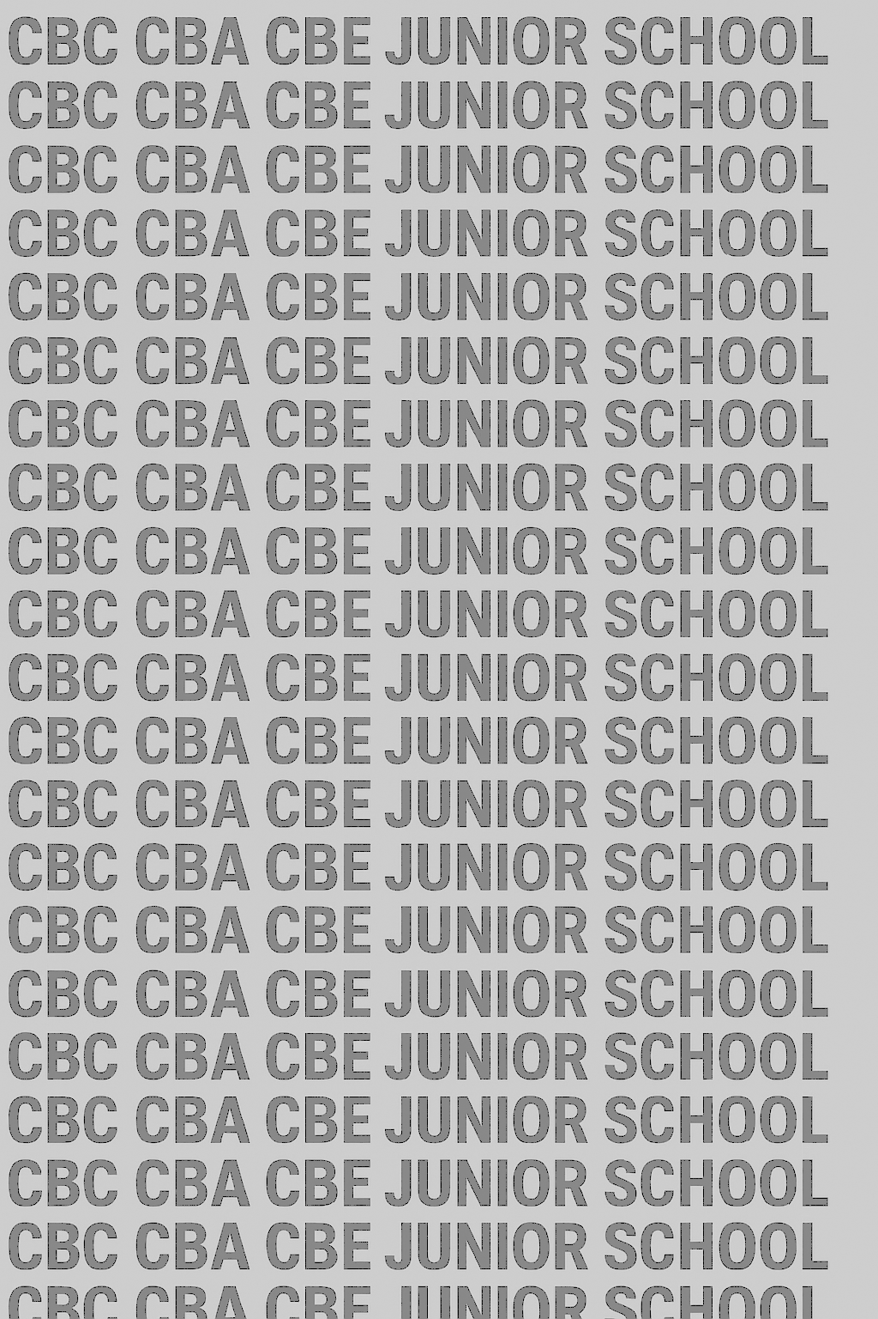
KENYA JUNIOR SCHOOL EDUCATION ASSESSMENT
GRADE 9 TERM 1 JANUARY 2026
CREATIVE ARTS AND SPORTS CKEAB 001

LEARNER’S DETAILS
Name: _______________________________________________________________________________________.
School: ______________________________________________________________________________________.
Assessment Number: ________________________________. Date: __________________________________.
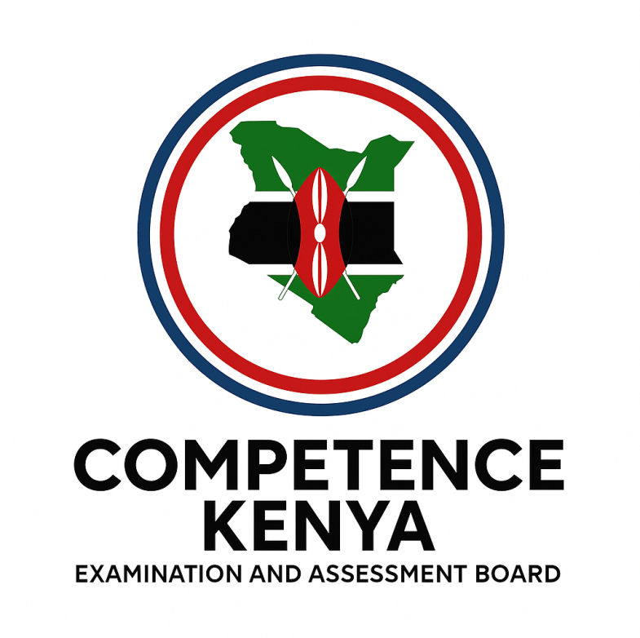
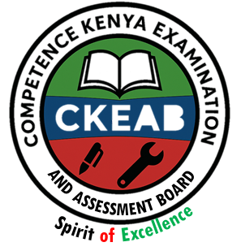
School Code: _______________________________. Signature: ________________________________.

INSTRUCTIONS TO LEARNERS
- Write your Name and Assessment Number in the spaces provided.
- Write the Name and Code of your School in the spaces provided.
- Sign and write the date of the assessment in the spaces provided above.
- This question paper consists of two sections: A and B.
- Section A contains multiple-choice questions numbered 1 to 40.
- Section B contains structured questions numbered 41 to 45.
- Answer all questions in Section A on the separate answer sheet provided.
- Answer all questions in Section B in the spaces provided in this question paper.
- Do NOT remove any page from this question paper.
- Answer all questions in English.
- This paper contains 8 printed pages. Ensure all pages are present.

SECTION A: MULTIPLE CHOICE QUESTIONS (40 Marks)
Question Number | 1 | 2 |  | 3 | 4 |  | 5 | 6 | 7 |  | 8 | 9 | 10 | 11 | 12 | 13 | 14 | 15 | 16 | 17 | 18 | 19 | 20 | 21 | 22
Maximum Score | 1 | 1 |  | 1 | 1 |  | 1 | 1 | 1 |  | 1 | 1 | 1 | 1 | 1 | 1 | 1 | 1 | 1 | 1 | 1 | 1 | 1 | 1 | 1
Candidate’s Score |  | -CREATIVE ARTS AND SPORTS- -001- - Paper Code 911-
Question Number | 23 |  | 24 |  |  | 25 |  | 26 |  | 27 |  | 28 | 29 | 30 | 31 | 32 | 33 | 34 | 35 | 36 | 37 | 38 | 39 | 40 | TT
Maximum Score | 1 |  | 1 |  |  | 1 |  | 1 |  | 1 |  | 1 | 1 | 1 | 1 | 1 | 1 | 1 | 1 | 1 | 1 | 30 | 1 | 1 | 40
Candidate’s Score

SECTION B: STRUCTURED QUESTIONS. (50 Marks)
Section | Questions | Maximum Score | Candidate’s Score | Performance Scale
Section A | 1–40 | 40
Section B | 41–63 | 50
GRAND TOTAL |  | 90

This paper consists of 8 printed pages.

Candidates should check the question paper to ensure that all pages are printed as indicated and no questions are missing.

TURN OVER

SECTION A: (40 MARKS)
Answer all the questions. Choose the correct answer for each.

PART I: PERFORMING ARTS
- Which of the following is not a role of performing arts in society?
A. Entertain B. Educate
C. Bring people together D. Gossip
- What is a dance?
A. Movement of the body in a rhythmic way
B. Beat of a song
C. Written work
D. Collection of sounds
- ___ is a combination of sound, silence, and emphasis.
A. Melody B. Rhythm C. Harmony D. Tone
- Performing Arts involves performance and presentation to an audience. Which is not used in performing?
A. Body movement B. Facial expression
C. Voice expression D. Shouting loudly
- Which of the following notes is correctly matched with its rest?
  - Semibreve -
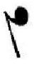

  - Minim -
  - Crotchet -
  - Quaver -
- Name the keys marked
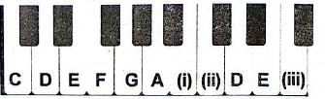
(i), (ii), and (iii) respectively.
A. GAC B. BCF C. DAB D. EGD
- What is the value of this dotted note?
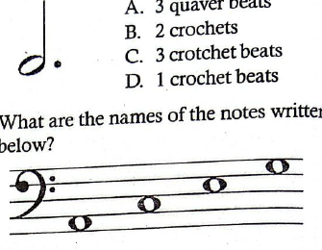

A. 3 quaver beats B. 2 crochets
C. 3 crotchet beats D. 1 crotchet beat
- What are the names of the notes written below?
A. GDFA B. ACEG C. GBDF D. FACE
- Which one is a career in Performing Arts?
A. Architect B. Athlete
C. Coach D. Playwright
- ___ time in music means:
A. 4 quaver beats per bar
B. 4 crotchet beats per bar
C. 4 minim beats per bar
D. 4 beats per bar
- Which is not an element of a play?
A. Theme B. Character
C. Costume D. Language
- In the grand staff, the F-clef and G-clef are joined by a note in the middle. What is it called?
A. Ledger line B. Middle C
C. Bar D. Tie
- Symbols used to increase or decrease a note by a semitone are called:
A. Accidentals B. Notation
C. Tie D. Bar

PART II: SPORTS
- Four learners performed races as shown below:
Learner | Distance
Abdi | 400 m
Amos | 800 m
Amani | 200 m
Ann | 100 m
Who among the four learners performed a middle-distance race?
A. Ann B. Amani C. Amos D. Abdi
- The following are steps followed during a Javelin throwing activity:
(i) Throwing
(ii) Aiming
(iii) Standing position
(iv) Following through
Which is the correct order of performing the activity?
A. (ii), (iii), (iv), (i)
B. (iii), (ii), (i), (iv)
C. (ii), (iv), (i), (iii)
D. (iii), (i), (ii), (iv)
- The main reason why learners engage in sports activities is to:
A. Develop teamwork through group activities
B. Learn rules of various games
C. Maintain a healthy life through physical fitness
D. Promote body growth and development
- In a game of football, players shoot when they:
A. Are under pressure to score from the defenders
B. Are under pressure to score from their teammates
C. Have the ball and are near the goal
D. Have the ball and an opportunity to score
- When practising the skill of passing the ball in Handball, the captain asked the team to:
(i) Stand with feet shoulder-width apart
(ii) Hold the ball with both hands and spread the fingers
(iii) Bring the ball to the side near the hip and bend the elbows
(iv) Swing arms backwards and then forward, then pass the ball
The type of pass performed by the team is:
A. Flick pass
B. Front pass
C. Jump pass
D. Side pass
- During a lesson, learners watched a video clip showing a 1500 meters race. They observed that the race is a:
A. Relay race where teams of four athletes run equal distance
B. Long-distance race where athletes run 25 laps on a field
C. Middle-distance race where athletes run for 3.75 laps on a field
D. Short-distance race where athletes run on a straight section of the field
- Volleying is one of the basic skills used in volleyball. The following are steps followed when performing a volley:
i. Stand with feet shoulder-width apart
ii. Position the hands
iii. Follow through
iv. Transfer bodyweight
v. Contact the ball
Which of the following is the correct order of steps?
A. (i), (ii), (iii), (iv), (v)
B. (i), (ii), (v), (iv), (iii)
C. (v), (iv), (iii), (ii), (i)
D. (iv), (ii), (i), (v), (iii)
- A Grade 9 teacher advised learners to practice the skill of triple jump. Which of the following shows the correct arrangement of the steps?
A. Approach, flight, take-off, landing
B. Approach, take-off, flight, landing
C. Approach, landing, flight, take-off
D. Approach, flight, landing, take-off
- A Grade 9 sports teacher introduced the skill of kicking in rugby. Learners demonstrated as follows:
i. Juma – Place kick
ii. Zubeida – Punt kick
iii. Amani – Drop kick
iv. Zawadi – Grubber kick
Which learner demonstrated the kick performed by releasing the ball and kicking it before it touches the ground?
A. Juma
B. Zawadi
C. Zubeida
D. Amani
- During interschool basketball competitions, Kiptanui was declared best player. The teammates hugged him and sang songs in celebration. The teammates showed:
A. Love
B. Honesty
C. Integrity
D. Responsibility
- Grade 8 learners were asked to discuss fair play in sports. Which could they have discussed?
A. Competition and responsibility
B. Tolerance and respect
C. Respect and contest
D. Competition and tolerance
- During a sports lesson, learners explained reasons for not using drugs to improve performance. Which is the BEST reason?
A. Drug gives advantage to the performer
B. Drug use leads to wastage of money
C. Drug use leads to lateness in school
D. Drug use leads to poor academic performance
- Learners in Jimbo School were asked to identify careers in sports. Which of the following is not related to sports?
A. Sports coach B. Fitness trainer
C. Performance analyst D. Playwright
PART III: VISUAL ARTS
27. Which of the following careers is not in visual arts?
A. Teacher B. Sculptor C. Illustrator D. Coach
28. A learner made an artwork by cutting and pasting images. What type of artwork is this?
A. Painting B. Mosaic C. Collage D. Montage
29. Who is an art curator?
A. Person in charge of an art exhibition
B. Person who makes the artwork
C. Artist
D. Person who buys artworks
30. Colours that are opposite each other on the colour wheel are called:
A. Tertiary colours B. Analogous colours
C. Primary colours D. Complementary colours
31. A method of creating rapid still images to give an illusion of movement is called:
A. Flip book B. Animation
C. Frame D. Speed
32. What is the name of the pattern below?
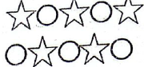
A. Pattern B. Repeat pattern
C. Alternate repeat pattern D. Motif
33. Which of the following shows cool colours?
A. Red, orange B. Blue, white
C. Black, yellow D. Purple, red
34. Which of the following is not a principle of art?
A. Proportion B. Dominance C. Texture D. Balance
35. Which is not a position for taking photographs?
A. Bird’s eye view B. Normal view
C. Front view D. Worm’s eye view
36. What is a logo design?
A. Symbol to showcase products
B. Symbol to identify an individual
C. For buying products
D. For display purposes
37. In clay modeling, which technique is the odd one out?
A. Coil B. Coil and stitch
C. Slab D. Pinch
38. What is drawing in visual arts?
A. Colouring of artworks
B. Making marks on a surface using dry media
C. Applying paint on paper
D. Creating artworks
39. Kigol Casa School was making a javelin from wood. Which methods were used to decorate it?
A. Cutting and pasting
B. Incising/Polishing
C. Carving
D. Modelling
40. Who is a sculptor?
A. Makes sculptures
B. Makes pots
C. Carves wood
D. Paints

SECTION B (50 MARKS)
Answer all questions in the spaces provided
41. Define the following terms as used in Creative Arts and Sports: (6 marks)
(a) Sports:
_______________________________________________________________________________________________
(b) Creative Arts:
_______________________________________________________________________________________________
(c) Music:
________________________________________________________________________________________________

42. Creative Arts and Sports play an important role in society. Explain four economic roles of Creative Arts and Sports in Kenya: (4 marks)
(i) _________________________________________________________________________________
(ii) _________________________________________________________________________________
(iii) _________________________________________________________________________________
(iv) _________________________________________________________________________________
43. Grade 9 learners at Testimony Comprehensive School were asked to list occasions during which folk songs were performed in traditional African society. List four likely occasions: (4 marks)
(i) _________________________________________________________________________________
(ii) _________________________________________________________________________________
(iii) _________________________________________________________________________________
(iv) _________________________________________________________________________________
44. State two differences between Visual Arts and Performing Arts: (4 marks)
Visual Arts | Performing Arts
45. On the staff below, write the corresponding note using semibreves: (4 marks)
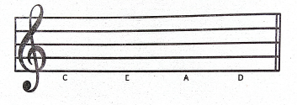
46. Mr. Juhudi, a Creative Arts and Sports teacher, invited a resource person to tell a story to Grade 9 learners. While narrating, the resource person sang a song. State three roles of the song in the story: (3 marks)
(i) _________________________________________________________________________________
(ii) _________________________________________________________________________________
(iii) _________________________________________________________________________________
47. State three ways the resource person could involve learners in the storytelling: (3 marks)
(i) _________________________________________________________________________________
(ii) _________________________________________________________________________________
(iii) _________________________________________________________________________________
48. Use the picture below to answer this question:
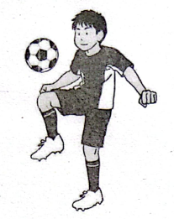
Which name is given to the ball control skill the player is using? (1 mark)
_______________________________________________________
49. When does a football player use the ball control skill displayed above? (1 mark)
_____________________________________________________________________________
50. Mention two importance of music in society: (2 marks)
________________________________________________________________________________________________________________________________________________________________________________________________
51. Costumes are very important in folk dance performance. Identify three roles of costumes: (3 marks)
(i) _________________________________________________________________________________
(ii) _________________________________________________________________________________
(iii) _________________________________________________________________________________
52. State four occasions during which folk songs were performed in traditional African society: (4 marks)
(i) _________________________________________________________________________________
(ii) _________________________________________________________________________________
(iii) _________________________________________________________________________________
(iv) __________________________________________________________________________________
53. After completing an artwork, it is necessary to display it. Outline three reasons for displaying an artwork: (3 marks)
(i) _________________________________________________________________________________
(ii) _________________________________________________________________________________
(iii) _________________________________________________________________________________
54. Explain the meaning of the following elements of a play: (4 marks)
(a) Theme: ________________________________________________________________________________________________________________________________________________________________________________________________
(b) Character: ________________________________________________________________________________________________________________________________________________________________________________________________
55. List four career opportunities in Creative Arts and Sports: (4 marks)
(i) _________________________________________________________________________________
(ii) _________________________________________________________________________________
(iii) _________________________________________________________________________________
(iv) _________________________________________________________________________________
16. The Kenya National Anthem is an example of which type of song? (1 mark)
_________________________________________________________

©2026
All rights reserved
©COMPETENCE KENYA EXAMINATION AND ASSESSMENT BOARD
THIS IS THE LAST PRINTED PAGE

