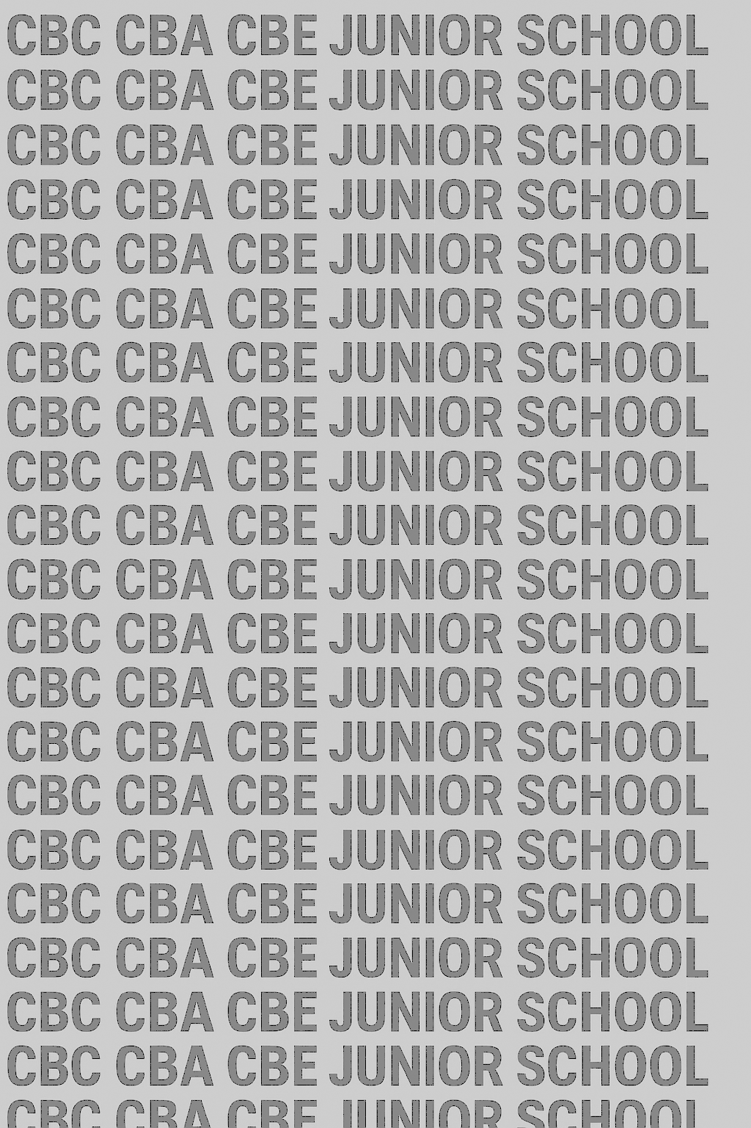
KENYA JUNIOR SCHOOL EDUCATION ASSESSMENT
GRADE 8 TERM 1 JANUARY 2026
INTEGRATED SCIENCE CKEAB 001

LEARNER’S DETAILS
Name: _______________________________________________________________________________________.
School: ______________________________________________________________________________________.
Assessment Number: ________________________________. Date: __________________________________.
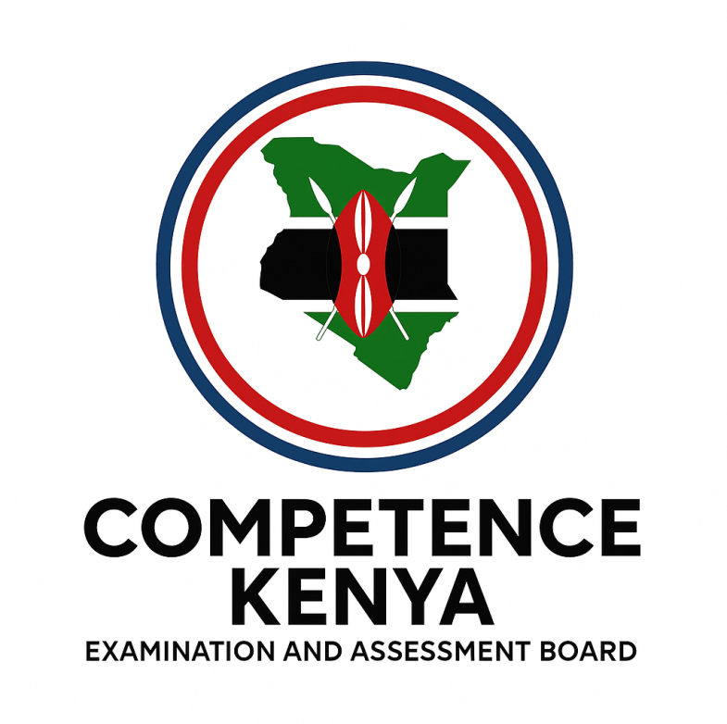
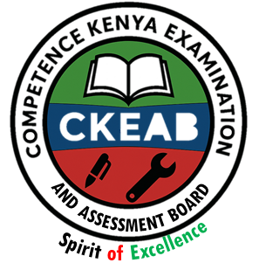
School Code: _______________________________. Signature: ________________________________.

INSTRUCTIONS TO LEARNERS
- Write your Name and Assessment Number in the spaces provided above.
- Write the Name and Code of your school in the spaces provided above.
- Sign and write the date of the assessment in the spaces provided.
- This question paper consists of TWO sections: A and B.
  - Section A: Multiple Choice Questions 1–30
  - Section B: Short, structured questions 31–41
- Answer ALL questions in Section A on the separate ANSWER SHEET provided.
- Answer ALL questions in Section B in the spaces provided in this QUESTION PAPER.
- Do NOT remove any page from this question paper.
- Answer ALL the questions in English.
- .

SECTION A: MULTIPLE CHOICE QUESTIONS (30 Marks)
Question Number | 1 | 2 |  | 3 | 4 |  | 5 | 6 | 7 |  | 8 | 9 | 10 | 11 | 12 | 13 | 14 | 15
Maximum Score | 1 | 1 |  | 1 | 1 |  | 1 | 1 | 1 |  | 1 | 1 | 1 | 1 | 1 | 1 | 1 | 1
Candidate’s Score
Question Number | 16 |  | 17 |  |  | 18 |  | 19 |  | 20 |  | 21 | 22 | 23 | 24 | 25 | 26 | 27 | 28 | 29 | 30 | Total score
Maximum Score | 1 |  | 1 |  |  | 1 |  | 1 |  | 1 |  | 1 | 1 | 1 | 1 | 1 | 1 | 1 | 1 | 1 | 1 | 30
Candidate’s Score

SECTION B: STRUCTURED QUESTIONS. (50 Marks)
-Agriculture and Nutrition- -002- - Paper Code 906/1-
Qn No. | 31 | 32 | 33 |  | 34 | 35 | 36 | Total
Max Score | 5 | 8 | 6 |  | 6 | 10 | 15 | 50
Cand score
Section |  |  |  | Maximum Marks |  |  |  |  | Learner’s Score | Percentage (%)
A. Multiple Choice |  |  |  | 30
B. Structured Questions |  |  |  | 50
TOTAL |  |  |  | 80

This paper consists of 8 printed pages.

Candidates should check the question paper to ensure that all pages are printed as indicated and no questions are missing.

TURN OVER

SECTION A: MULTIPLE CHOICE QUESTIONS (30 MARKS)
Answer all the questions. Choose the correct answer for each.

1. Anita brought two magnets close as shown below.
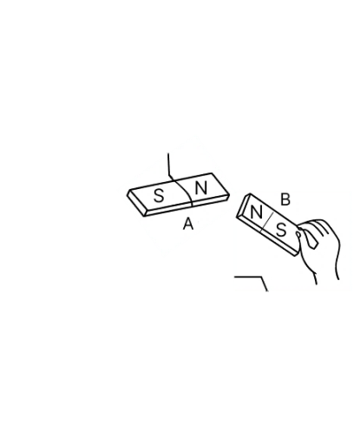
What happened?
A. They attracted B. They repelled
C. Nothing happened D. They lost magnetism
2. Which classification is correct?
 | Magnetic | Non-magnetic
A | Glass | Wood
B | Copper | Aluminium
C | Aluminium | Steel
D | Iron | Copper
3. A suspended magnet always aligns in a particular direction due to:
A. Pressure B. Earth’s magnetic field
C. Temperature D. Gravity
4. A push, pull, or lift is referred to as:
A. Pressure
B. Energy
C. Force
D. Work
5. Identify the diagram below:
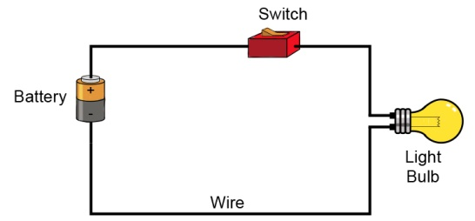
A. Simple solar panel
B. Simple power station
C. Simple electric circuit
D. Simple wire connection
6. Maimuna is a Grade 8 learner whose interest is in exploring the nature of matter, energy, space, time, and how they interact.
Which component of Science is Magdalene interested in?
A. Biology B. Chemistry
C. Physics D. Botany
7. As Grade 7 learners were being orientated in Science, they came across the symbol below on one of the containers.
What does the symbol represent?
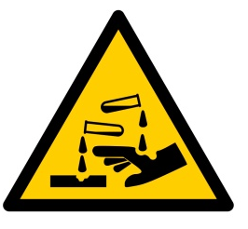
A. Toxic substances B. Radioactive materials
C. Corrosive substances D. Flammable substances
8. During a laboratory activity, a chemical accidentally splashed on Tom’s face, causing a burn.
What should be done first?
A. Apply pressure on the burn with a clean cloth
B. Rinse his face with cool running water for at least 10 minutes
C. Apply ointment to relieve pain
D. Give a painkiller
9. The following are safety precautions to observe in the laboratory except one. Which one?
A. Maintain safety while in the laboratory
B. Inhale all chemicals before use
C. Wear protective equipment
D. Clearly label and store chemicals properly
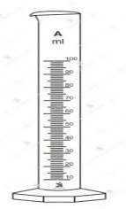
10. Identify the apparatus shown below.
A. Measuring cylinder
B. Thermometer
C. Beam balance
D. Pipette
11. Angela was explaining SI units to her sister. Which unit did she incorrectly match to its quantity?
A. Square metre – Area
B. Watt – Work
C. Ampere – Electric current
D. Kelvin – Temperature
12. Why should the emergency exit in a Science laboratory be clearly marked?
A. To allow visitors easy access
B. To decorate the laboratory
C. To provide a quick escape in case of emergency
D. It is mandatory to have a marked exit
13. Grade 8 learners were learning about evaporation and came across the term solvent. What does it mean?
A. A substance that dissolves another substance
B. A substance that dissolves in another substance
C. A mixture of two or more substances
D. A substance used to solve problems
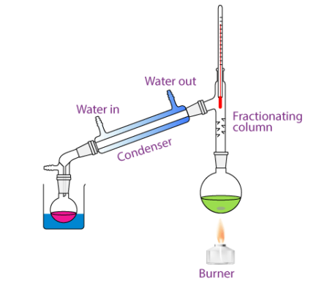
14. Grade 8 learners observed the diagram below while discussing methods of separating homogeneous mixtures.
X

Which method is shown?
A. Fractional distillation B. Crystallisation
C. Solvent extraction D. Simple distillation
15. In question 14, what is the name of the part labelled X?
A. Thermometer B. Condenser
C. Flask D. Clamp stand
16. Valentine and her classmates carried out the experiment to separate a mixture of sand and iodine solid as shown below.
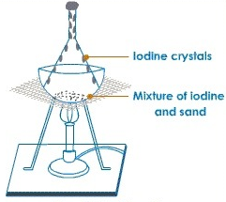
Which method of separation was it?
A. Sublimation B. Crystallisation
C. Distillation D. Chromatography
17. The most convenient separation method used by oil refining companies is:
A. Evaporation B. Sublimation
C. Simple distillation D. Fractional distillation
18. Which of the following is NOT a base?
A. Ammonia B. Calcium hydroxide
C. Sulphuric acid D. Sodium hydroxide
19. A substance has a pH between 0–6. It is most likely:
A. Neutral B. An acid
C. A base D. An alkaline solution
20. Graphine dipped blue litmus paper into a solution and it retained its colour. The solution is:
A. Basic B. Acidic C. Neutral D. Water
21. Which of the following is NOT a characteristic of matter?
A. Matter has mass
B. Matter occupies space
C. Matter is made of particles
D. Matter always exists as a solid
22. Which of the following is NOT a physical change in boys during adolescence?
A. Deepening of voice
B. Muscle development
C. Growth of facial, chest and pubic hair
D. Broadening of hips
23. In which part of the female reproductive system does fertilisation take place?
A. Uterus B. Oviduct C. Vagina D. Ovary
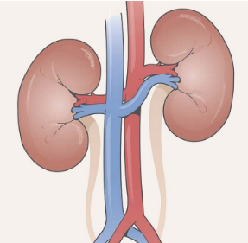
24. Identify the organ marked X shown below.
X

A. Lungs B. Heart C. Skin D. Kidney
25. Which of the following is an example of a temporary physical change?
A. Burning paper
B. Rusting of iron
C. Melting candle wax
D. Cooking an egg
26. Mary was diagnosed with a kidney disorder. Which of the following is NOT a possible cause?
A. High blood pressure
B. Urinary tract infections
C. High blood sugar
D. Regular exercise
27. Which source was wrongly classified?
Renewable | Non-renewable
Solar energy | Coal
Geothermal energy | Natural gas
Hydro-electric energy | Oil
Nuclear energy | Wind energy
A. Solar energy
B. Nuclear energy
C. Natural gas
D. Wind energy
28. Which of the following is NOT an electrical appliance?
A. Refrigerator
B. Solar panel
C. Microwave
D. Television
29. Which of the following diagrams represents an element?
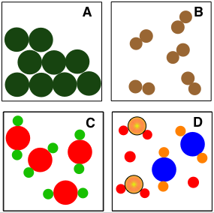
30. Which one of the following is a chemical symbol for iron?
A. K
B. Na
C. Fe
D. Cu

SECTION B: (40 Marks)
Answer all questions in the spaces provided
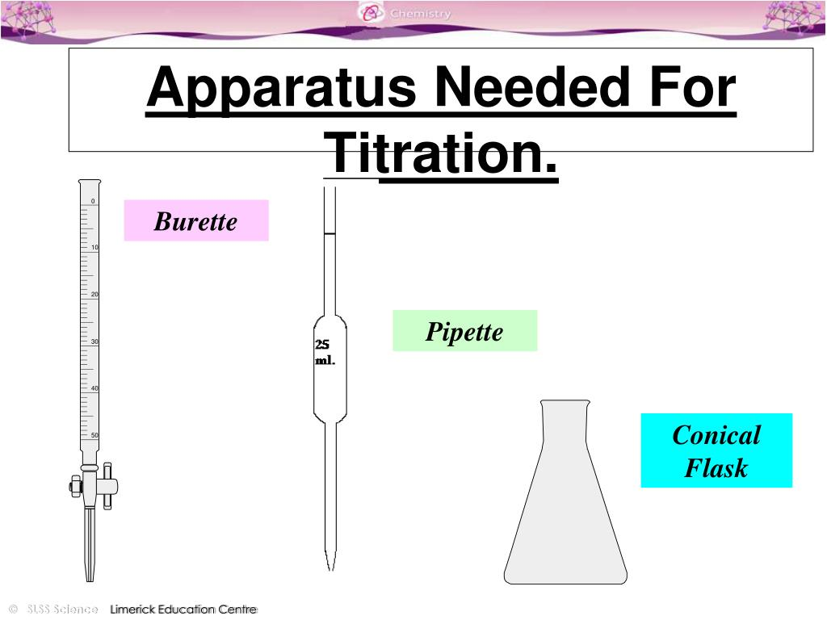
31. Identify the following laboratory apparatus. (3 marks)

A B C

A: _________________________________
B: _________________________________
C: _________________________________
32. Identify the SI Units for: (3 marks)
a) Time ___________________
b) Electric current ___________________
c) Amount of substance ___________________

33. Write the symbols in full. (3 marks)
a) Mg ____________________________________________
b) Cu ____________________________________________
c) Li ____________________________________________
34. State two preventive measures learners should take to avoid ingesting harmful substances in the laboratory. (3 marks)
a) _________________________________________________________________________________________
b) _________________________________________________________________________________________
35. The skin is an excretory organ. Name two waste products it removes. (2marks)
a) ________________________________________________
b) ________________________________________________
36. Calculate the density of a wooden block of mass 250grammes whose volume is 20cm³. (2 marks)

37. State the importance of the following in a simple electric circuit: (3 marks)
a) Battery ____________________________________________
b) Light bulb _________________________________________
c) Wires _____________________________________________
38. State two uses of magnets. (1 mark)
________________________________________________________________________________________________________________________________________________________________________________________________
39. Which is the best method to separate the following? (4 marks)
a) Crude oil into different fuels ___________________
b) Mixed inks ___________________
c) Oil from water ___________________
d) Sugar from water ___________________
40. Abigael is confused about acids and bases. State three physical differences. (3 marks)
 | Acids | Bases
i
ii
iii
41. Identify the labelled parts of the female reproductive system and state their functions. (8 marks)
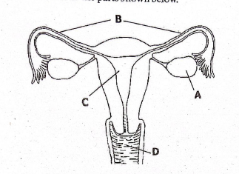
Part | Part name | Part function
A
B
C
D
42. (a) Label the parts of the Bunsen burner shown below. (3 marks)
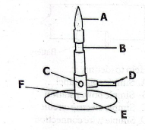
A: ___________________ B: ___________________ C: ___________________
(b) Identify the names of the parts of the microscope shown below. (3 marks)
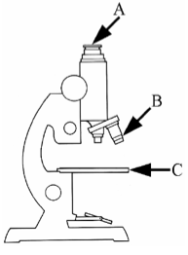
A: ___________________ B: ___________________ C: ___________________

©2026
All rights reserved
©COMPETENCE KENYA EXAMINATION AND ASSESSMENT BOARD
THIS IS THE LAST PRINTED PAGE

