KENYA JUNIOR SCHOOL EDUCATION ASSESSMENT

MARKING SCHEME
GRADE 8: CREATIVE ARTS AND SPORTS – TERM 1 – JANUARY 2026

SECTION A (40 MARKS)
Qn | Ans | Explanation
1 | C | The instrument shown is played by Blowing (descant).
2 | D | Humour is not an element of dance; the elements are space, time, energy.
3 | B | The theme is the message or lesson of a story.
4 | C | A straight horizontal line on the staff is a staff line.
5 | D | Audience is NOT an element of storytelling; it is a participant.
6 | C | A period of silence in music is called a rest.
7 | A | The hand signs match So, Re, Mi, Do, Mi, Do.
8 | D | Tertiary colours are also called intermediate colours.
9 | A | Hammer is not used in javelin carving; chisels and gouges are.
10 | B | A star is a geometric shape, not organic.
11 | D | Paper layout is NOT a principle of art.
12 | B | The character who opposes the main character is the antagonist.
13 | A | Isukuti is a traditional Kenyan celebratory dance.
14 | A | Tempo refers to speed of music.
15 | A | Warm-up activity: jogging.
16 | B | The symbol shown is the treble clef.
17 | C | Being talkative is NOT a requirement for storytelling.
18 | C | Qualities: easy to sing, easy to remember, starts on d/m/s.
19 | B | Plot refers to organization of events in a story.
20 | B | Raiders must chant "kabaddi" throughout the raid.
21 | B | Twisting is a non-locomotor movement.
22 | D | Picture shows a jump pass.
23 | C | Throwing style is NOT a factor when carving a javelin.
24 | B | Flight is the 3rd phase: approach → take-off → flight → landing.
25 | A | Pull-ups do NOT build coordination.
26 | B | A handball team has 7 players.
27 | A | The picture shows a chest trap.
28 | A | Part II is the Shaft.
29 | C | Using various materials in artwork = collage.
30 | A | Bending cannot be done on wood; incising, smoking, texturing can.
31 | C | High knees involve lifting knees high while running.
32 | C | Relay races require baton passing.
33 | C | A palette knife is used for painting and mixing.
34 | C | Yellow → yellow-green → green are analogous.
35 | B | Lightness/darkness of color is value.
36 | A | A burin is used for engraving.
37 | C | A poster should NOT have crowded text.
38 | B | Cardboard is best for mounting.
39 | C | Shaping clay on a turning wheel is throwing.
40 | C | Following lifeguard instructions is a key rule.

SECTION B

PART 1: SPORTS

41. Type of pass in basketball (1 mark)
Correct Answer: bounce pass

42. Definitions (4 marks)
Provide any well-explained version:

(a) Dribbling
- Continuous bouncing of the ball using one hand.
- Moving with the ball while tapping it continuously.
- Controlling the ball while moving by repeatedly pushing it to the ground.

(b) Coordination
- Ability to use body parts smoothly together.
- Harmonious working of muscles during movement.
- Ability to control different parts of the body at the same time.

(c) Flexibility
- Ability of muscles and joints to bend freely.
- Range of movement around a joint.
- How far a muscle can stretch without injury.

(d) Dodging
- Quick movement to avoid an opponent.
- Sudden change of direction to escape a tackle.
- Skill of sidestepping to create space.

43. Handball shot (1 mark)
Correct Answer: Jump shot

44. Importance of dribbling in handball (2 marks)
Any two:
- Helps advance the ball forward.
- Allows a player to avoid defenders.
- Helps maintain ball control.
- Creates space to pass or shoot.
- Helps in changing direction quickly.

45. Qualities of a good pass in handball (2 marks)
Any two:
- Accurate
- Timely
- Well-directed
- Firm but controllable
- Easy for teammate to receive
- Appropriately paced

46. Race finishing techniques (2 marks)
Any three:
- Chest tape finish
- Shoulder dip finish
- Lunge finish
- Leaning finish
- Torso extension

47. Command in elongated start (1 mark)
Correct Answer: “On your marks”
Others NOT acceptable.

48. Parts of the hockey stick (4 marks)
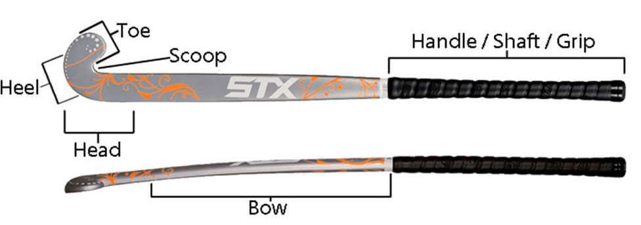
- E: Handle / grip
- F: Shaft
- G: heel/scoop
- H: Head/blade
- I: Toe

49. Component tested (1 mark)
Answer: Coordination
Other acceptable:
- Hand–eye coordination

50. Kabaddi terms (2 marks)

(a) Raider
- Player who enters opponents' side to tag players and return safely.
- Attacking player who chants "kabaddi" inside opposition court.

(b) Skills
- Abilities used to perform actions effectively.
- Techniques like kicking, tagging, dodging.
- Learnt movement patterns used in the game.

PART 2: VISUAL ARTS

51. Difference between analogous & complementary colours (2 marks)
Analogous:
- Colours next to each other on colour wheel.
- They blend smoothly (e.g., blue, blue-green, green).
Complementary:
- Colours opposite each other on colour wheel.
- They contrast strongly (e.g., red & green).

52. Stages of clay preparation (4 marks)
Any four:
- Wedging
- Kneading
- Sorting
- Sifting
- Moistening
- Mixing
- Pugging
- Removing air bubbles
- Storing and covering

53. Factors to consider when costing artwork (2 marks)
Any two:
- Cost of materials
- Time spent
- Artist’s skill level
- Size of artwork
- Complexity of design
- Market demand
- Production tools used

54. Factors influencing artwork purchase (2 marks)
Any two:
- Price
- Quality
- Aesthetic appeal
- Size
- Colours used
- Reputation of artist
- Purpose (gift, decoration)

55. Identify the pattern (1 mark)
- Repeated angular pattern

56. Career pathways in Arts (2 marks)
Any two with explanation:
- Graphic designer – creates digital visuals.
- Animator – makes moving images.
- Fashion designer – designs clothing.
- Painter – produces artworks.
- Sculptor – creates three-dimensional art.
- Art teacher – teaches creative arts.

57. Components of perspective in drawing (2 marks)
Any two:
- Horizon line
- Vanishing point(s)
- Converging lines
- Eye level
- Foreground, middle ground, background

PART 3: PERFORMING ARTS

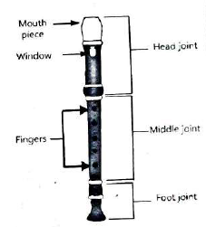
58. Draw and label a descant recorder (3 marks)

Teacher accepts any neat labelled drawing showing:
- Mouthpiece
- Window
- Body
- Finger holes
- Foot

59. Draw a bass clef (2 marks)
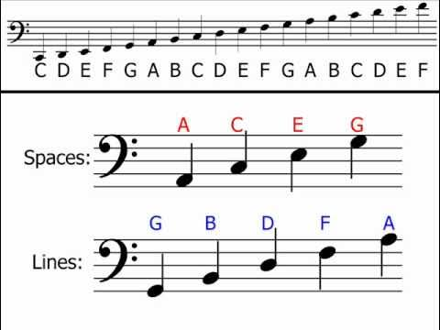
Correct shape with two dots around F line.

60. Definitions (2 marks)
Tied note:
- Two notes of same pitch connected to make one longer sound.
- Combines durations of notes.
Dotted note:
- A note with a dot adding half its value.
- Extends duration by 50%.

61. Aerophones in Kenya (2 marks)
Any two:
- Nzumari (Coastal)
- Adungu (Luo/Lugbara)
- Wandindi
- Flutes / Obokano variants
- Horn trumpet

62. Genres of performing arts disciplines (4 marks)
Discipline | ANY Two Genres
Film | Documentary, Action, Drama, Animation, Comedy, Thriller
Drama | Tragedy, Comedy, Farce, Melodrama, Opera
Music | Gospel, Traditional, Jazz, Hip-hop, Classical
Dance | Isukuti, Ballet, Salsa, Contemporary, Maasai adumu

63. Qualities of a good speaker (2 marks)
Any two:
- Clear voice
- Confidence
- Good posture
- Maintains eye contact
- Uses correct pace
- Uses gestures well

NOTE TO FACILITATORS (TEACHERS):
The marking scheme provided is not exhaustive. Facilitators are advised to use their professional judgment when awarding marks. Any correct, relevant, and scientifically or contextually acceptable answer that demonstrates understanding of the concepts should be credited. Where examples are required, learners may provide other valid examples apart from those listed in the scheme.

©2026
All rights reserved
©COMPETENCE KENYA EXAMINATION AND ASSESSMENT BOARD

