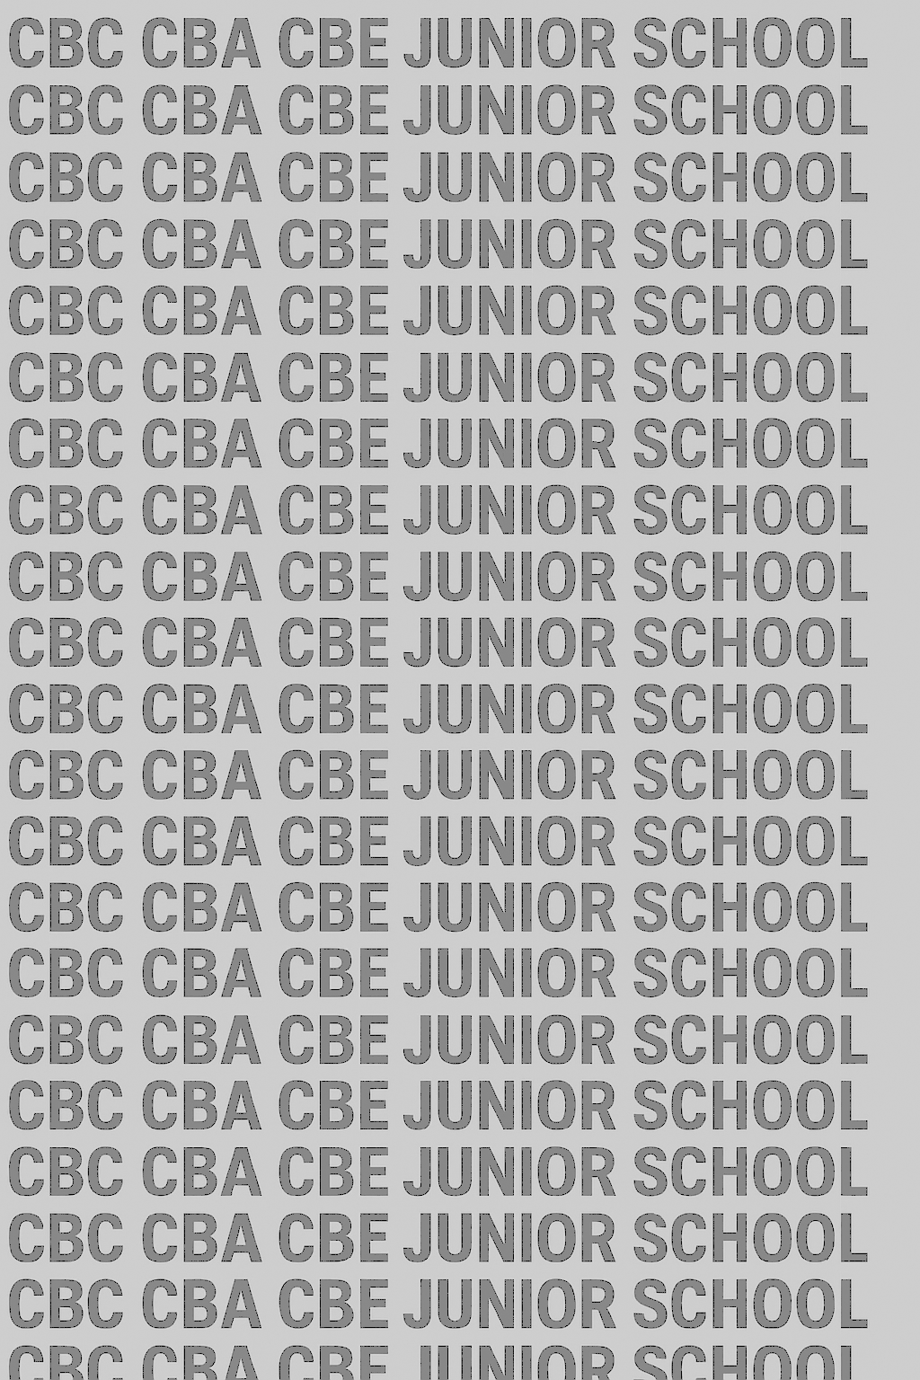
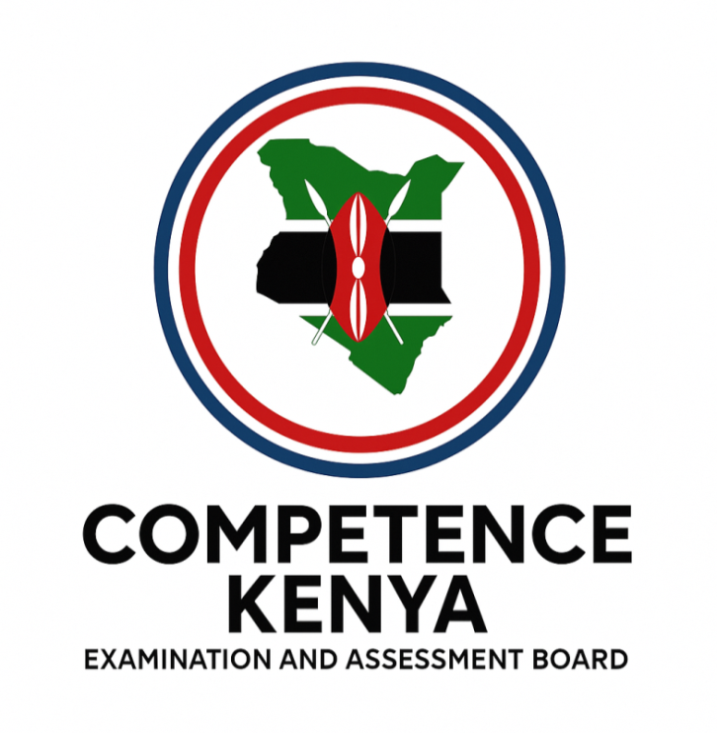
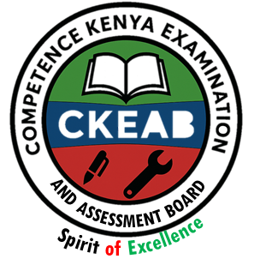
KENYA JUNIOR SCHOOL EDUCATION ASSESSMENT


GRADE 7 TERM 1 JANUARY 2026

ISLAMIC RELIGIOUS EDUCATION
CKEAB 001

Time - 1 hour 45 minutes

LEARNER’S DETAILS
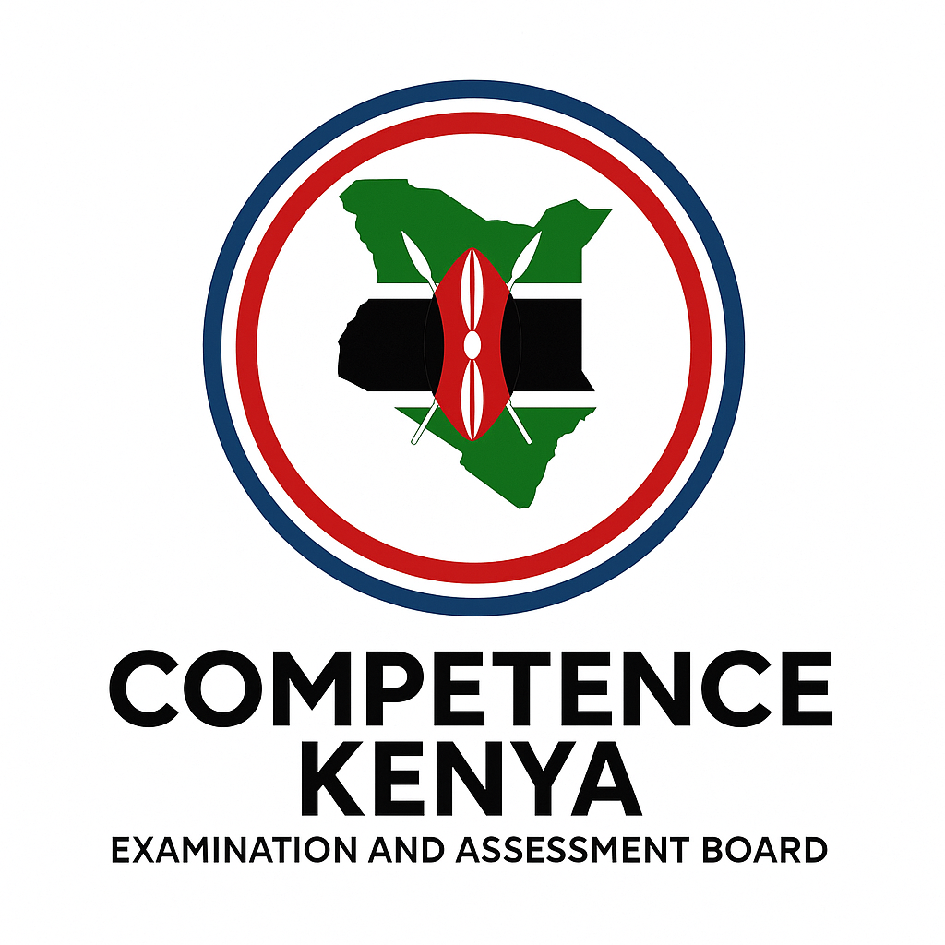
Name: ________________________________________________. School: _____________________________________
Assessment Number: _____________________________. Date: ______________________________.
School Code: ____________________________. Signature: ____________________________.
INSTRUCTIONS TO LEARNERS
- Write your name and assessment number in the spaces provided.
- Write the name and code of your school in the spaces provided.
- Write the date of the assessment and sign in the spaces provided.
- This question paper consists of two sections: A and B.
- Answer ALL questions in this paper.
- Write ALL the answers in the spaces provided in this question paper.
- Do NOT remove any page from this question paper.
- Answer the questions in English.
-CRE- -FORMATIVE ASSESSMENT- -001- - Paper Code 909-
For official use only
SECTION A: MULTIPLE CHOICE QUESTIONS (20 Marks)
Question No. | 1 | 2 | 3 | 4 | 5 | 6 | 7 | 8 | 9 | 10 | 11 | 12 | 13 | 14 | 15 | 16 | 17 | 18 | 19 | 20 | TOTAL
Max Score | 1 | 1 | 1 | 1 | 1 | 1 | 1 | 1 | 1 | 1 | 1 | 1 | 1 | 1 | 1 | 1 | 1 | 1 | 1 | 1 | 20
Candidate’s Score
SECTION B: STRUCTURED QUESTIONS (60 Marks)
Task | Qn Nos. | Max Marks | Candidate's Score  GRAND TOTAL
SECTION A | 20 | 20
SECTION B | 10 | 80
TOTAL | 50 | 100
This paper consists of 5printed pages. Candidates should check the question paper to ascertain that all the pages are printed as indicated and that no questions are missing. This paper has 16 printed pages. Please check out to ensure all pages are printed
Turn over


SECTION A: (20 MARKS)
Answer all questions by choosing the correct answer

1. During a school assembly, the IRE teacher reminded learners that Allah revealed the Qur’an to guide people on how to live. This shows that the main rationale for the revelation of the Qur’an is to
A. entertain people B. guide mankind
C. teach Arabic poetry D. describe history only
2. Jamilah was stressed about a problem and decided to read the Qur’an for comfort. This shows that the Qur’an was revealed as
A. a history book B. a book of fun
C. a mercy to mankind D. a scientific text
3. When Angel Jibril first appeared to Prophet Muhammad (PBUH) in Cave Hira, he commanded him to
A. write a letter B. migrate to Madinah
C. read D. fight the Quraysh
4. The first revelation taught Muslims the importance of
A. travelling B. seeking knowledge
C. becoming wealthy D. eating healthy foods
5. The Qur’an was revealed in portions to make it
A. difficult to understand B. easy to implement
C. confusing for believers D. only for the Arabs
6. Fatma reads the Qur’an every morning before school. This best shows the Qur’an as
A. a book for old people B. a book of divine guidance
C. a book of stories only D. a book for scholars only
7. A Muslim who follows the teachings of the Qur’an in daily life will
A. drift further from Allah B. earn rewards from Allah
C. cause conflicts D. worship idols
8. Surah Ad-Dhuha reminds Muslims that Allah
A. abandons the needy
B. never abandons His servants
C. punishes without reason
D. dislikes orphans
9. The lesson from Surah Ad-Dhuha about helping orphans teaches Muslims to be
A. proud B. selfish
C. caring D. rude
10. Surah Al-Balad teaches that life is
A. easy and simple
B. full of enjoyment only
C. a struggle (hardship) and a test
D. only about wealth
11. The act of freeing a slave, as mentioned in Surah Al-Balad, teaches Muslims to
A. oppress the weak B. support the oppressed
C. ignore injustice D. take advantage of others
12. The Qur’an encourages Muslims to follow the
A. bad path B. easy wrong path
C. difficult right path D. path of laziness
13. If a Muslim gives food to a poor neighbour, he follows the teaching of
A. Surah Al-Fil B. Surah Al-Balad
C. Surah Al-Ikhlas D. Surah Al-Qari’ah
14. When reciting Surah Ad-Dhuha, a Muslim learns to always
A. boast about wealth
B. remember Allah’s past favours
C. complain about problems
D. ignore people in need
15. The Qur’an can guide Muslims on how to
A. steal from others B. speak politely
C. insult the elderly D. cheat in exams
16. Learning the meaning of the Qur’an is important because it
A. helps in singing
B. helps in applying its teachings
C. replaces the need to pray
D. stops one from reading Arabic
17. The story of the first revelation encourages Muslims to
A. avoid learning
B. seek knowledge
C. refuse reading
D. fear education
18. A Muslim who memorizes and follows Surah Ad-Dhuha gains
A. worldly power
B. spiritual nourishment
C. fame in society
D. wealth
19. Surah Al-Balad teaches Muslims to help people facing
A. blessings
B. hardships
C. celebrations
D. holidays
20. The Qur’an remains relevant today because it
A. changes every year
B. guides all aspects of life
C. belongs only to scholars
D. is a book for the past only

SECTION B: (80 MARKS)
Answer all questions.
21. A Grade 7 Muslim Club planned a discussion on why Allah revealed the Qur’an.
a) Explain three reasons why the Qur’an was revealed as a guide for mankind. (6 marks)
- __________________________________________________________________________________________
- __________________________________________________________________________________________
- __________________________________________________________________________________________
b) Describe two ways the revelation of the Qur’an shows Allah’s mercy to humankind. (4 marks)
- __________________________________________________________________________________________
- __________________________________________________________________________________________
c) Give two ways the revelation of the Qur’an benefits Muslims today. (2 marks)
- __________________________________________________________________________________________
- __________________________________________________________________________________________
22. During a class trip to Mount Longonot, the teacher narrated the event of the first revelation at Cave Hira.
a) Describe the incident of the first revelation. (6 marks)
- __________________________________________________________________________________________
- __________________________________________________________________________________________
- __________________________________________________________________________________________
- __________________________________________________________________________________________
b) Explain two lessons Muslims learn from the first revelation about the importance of seeking knowledge. (4 marks)
- __________________________________________________________________________________________
- __________________________________________________________________________________________
c) Give two reasons why Angel Jibril asked Prophet Muhammad (PBUH) to “Read!” (2 marks)
- __________________________________________________________________________________________
- __________________________________________________________________________________________
23. Your IRE teacher explained that the Qur’an was revealed gradually over 23 years.
a) Give three reasons why the Qur’an was revealed in portions. (6 marks)
- __________________________________________________________________________________________
- __________________________________________________________________________________________
- __________________________________________________________________________________________
b) State two benefits of gradual revelation to early Muslims. (4 marks)
- __________________________________________________________________________________________
- __________________________________________________________________________________________
24. a) Explain three ways the Qur’an guides a Muslim in day-to-day life. (6 marks)
- __________________________________________________________________________________________
- __________________________________________________________________________________________
- __________________________________________________________________________________________
b) Describe two ways a learner can show respect for the Qur’an. (4 marks)
- __________________________________________________________________________________________
- __________________________________________________________________________________________
c) Give two ways one can earn rewards by practicing Qur’anic teachings. (2 marks)
- __________________________________________________________________________________________
- __________________________________________________________________________________________
25. A group of learners memorised Surah Ad-Dhuha and wanted to apply its lessons in school.
a) State the meaning of Surah Ad-Dhuha (Q.93:1–11) in your own words. (6 marks)
- __________________________________________________________________________________________
- __________________________________________________________________________________________
b) Explain four lessons from the surah that Muslims can apply in daily life. (8 marks)
- __________________________________________________________________________________________
- __________________________________________________________________________________________
- __________________________________________________________________________________________
- __________________________________________________________________________________________
26. At a community meeting, the Imam spoke about helping the needy using lessons from Surah Al-Balad (Q.90:1–20).
a) Summarize the meaning of Surah Al-Balad. (6 marks)
- __________________________________________________________________________________________
- __________________________________________________________________________________________
- __________________________________________________________________________________________
b) Explain four teachings from the surah related to hardships and good deeds. (8 marks)
- __________________________________________________________________________________________
- __________________________________________________________________________________________
- __________________________________________________________________________________________
- __________________________________________________________________________________________
c) Describe three ways a Grade 7 learner can apply the teachings of Surah Al-Balad in daily life. (6 marks)
- __________________________________________________________________________________________
- __________________________________________________________________________________________
- __________________________________________________________________________________________

©2026
All rights reserved
©COMPETENCE KENYA EXAMINATION AND ASSESSMENT BOARD
This is the last printed page

