Name: …………………………………………................. Adm. No: ..….....……Class…………
232/3 Index No................................................
PHYSICS
PAPER 3 Candidate’s sign. ...........................
(PRACTICAL)
JULY 2025 Date: .............................
TIME: 2½ HOURS.

MOKASA II EXAMINATION
INSTRUCTIONS TO CANDIDATES:
- Write your; NAME, ADM. NO and CLASS in the spaces provided above.
- Sign and write the date of examination in the spaces provided above.
- Answer all the questions in the spaces provided in the question paper.
- You are supposed to spend the first 15 minutes of the 2 ½ hours allowed for this paper reading through the whole paper carefully before commencing your work
- Marks are awarded for a clear record of the observation actually made, their suitability, accuracy and the use made of them.
- Candidates are advised to record their observations as soon as they are made.
Mi Girls, Kabarak, Sacho

- Non programmable Silent Electronic calculators and mathematical tables may be used.
- Candidates should answer the questions in English.

FOR EXAMINER’S USE ONLY.
Question 1 | b | c | e | f | g (i) | g (ii)
Maximum Score | 1 | 6 | 5 | 3 | 3 | 2 | Total
Candidate’s Score

Question 2 | iii | iv | v | vi | a | b
Maximum Score | 2 | 1 | 1 | 7 | 1 | 5 |  | Total
Candidate’s Score
GRAND TOTAL
This paper consists of 9 printed pages;
Candidates are advised to check the question paper to ascertain that all the pages are printed and that no page is missing.

QUESTION ONE
You are provided with the following apparatus;
- A Stirrer
- Stand , a boss and a clamp
- A thermometer
- An Ammeter
- A voltmeter
- A beaker (250 ml)
- A source of boiling water
- Two dry cells in a cell holder
- A switch
- Seven connecting wires
- A component labeled X
Proceed as follows
- Set up the circuit as shown in the figure 1 below
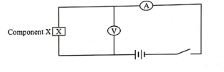
Figure 1
- Close the switch; read and record the current I through the component X and the potential difference V across it.
I .................................................... (1 mark)
V .................................................. (1 mark)
Open the switch.
- Determine the resistance R of component X, at room temperature; given that
(1 mark)
R = V
I

............................................................................................................................................................................................................................................................................................................................................................................................................................Set up the apparatus as shown in the figure 2 below and pour hot water into the beaker so that the component X and the thermometer bulb are fully immersed.
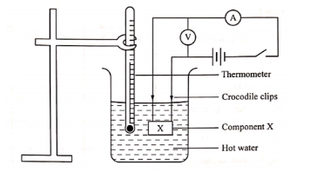
Figure 2
- Stir the water from time to time, when the temperature falls to 75ºc. Switch on the circuit, read and record the current I and the potential difference V in table 1. Then open the switch.
- Repeat part (c); as the temperature falls to the other values shown in table 1 and complete the table 1 below.
Table 1 (7 marks)
Temperature  of hot water (ºc) | 75 | 70 | 65 | 60 | 55 | 50
Temperature in Kelvin (K)
Current I (A)
Voltage (V) |  |  |  |  |  | Table 1
Resistance R = V ( Ω )
I
- On the axis provided, plot a graph of Resistance R ( Ω ) against T (K) (5 marks)

- From your graph; determine the following values of R; for the given temperatures

(i) R₁; when T₁ = 323K

R1 = ................................................................... (1 mark)

(ii) R₂; when T₂ = 343K

R2 = ................................................................... (1 mark)
(iii) Hence find the value of β given that$β=\frac{\ln\left(\frac{R1}{R2}\right)}{\begin{aligned}\left(\frac{1}{T1}-\frac{1}{T2}\right) \\ \end{aligned}}$ (2 marks)
................................................................................................................................................................................................................................................................................................................................................................................................................................................................................................................................................................................................................................................
- What conclusion can we draw from the graph above. (1 mark)
....................................................................................................................................................................................................................................................................................................................................................................................................................................................................................

QUESTION TWO
Part One 2(a);
You are provided with the following apparatus:
- A Complete Stand
- A stop watch
- A meter rule
- A spiral spring
- One 50 g mass
- Two 100 g masses
- Two pieces of wood/ Tying string
Proceed as follows
- Hang the spring vertically by clamping one end as shown in figure 3below using the two pieces of wood
Tying String
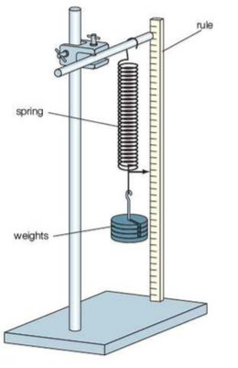
Figure 3
Length L of spring

- Measure the length of the un-loaded spring, L_{o}

L_{o}= _ _ _ _ _ _ _ _ _ _ _ cm (1 mark)

- Hang 100g mass and measure the length of the loaded spring, L
L=_ _ _ _ _ _ _ _ _ _ _ _cm (1 mark)

- Extension e = _ _ _ _ _ _ cm (1 mark)

- Determine the spring constant K of the spring

K=_ _ _ _ _ _ _ _ _ _ _ (1 mark)
- Displace the 100g mass by a small vertical displacement and release so that it makes vertical oscillations. Record the time for 20 oscillations and record in the table below
(5 marks)
Mass m (g) | 100 | 150 | 200
Mass, m(Kg)
Time for 20 oscillations(s)
Periodic time, t(s)
T²(s²)

(f)Repeat (e)above with the other masses in the table. Complete the table
(g) Determine the average value of T² (1 mark)
........................................................................................................................................................................................................................................................................................................................ ............................................................................................................................................................
g = 4π² x 0.150 . T²
- Hence determine the value of g, given that; (1 mark)
............................................................................................................................................................................................................................................................................................................

Part Two (2b)
By focusing a distant object e.g. a window as shown in the figure below; move the screen to and fro until a sharp image is formed on the screen.
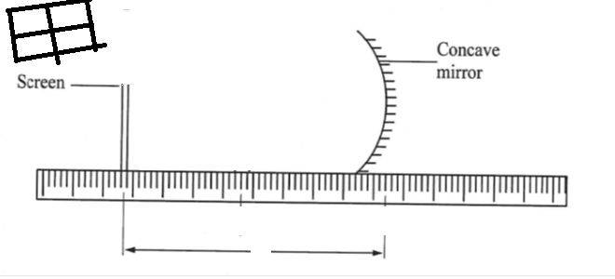
Ll
Window
Measure the distance l between the mirror and the screen
- l = .......................................................................................................... (1 mark)
Light the candle and place it in between the mirror and screen as shown in the diagram below.
Set the distance u = 25cm and adjust the position of the screen until a sharp image of the candle flame is obtained
- Read and record the distance v between the screen and the mirror.

v = ........................................................... (1 mark)

- Determine the magnification m of the mirror given that $m=\left(\frac{v}{u}\right)$ (1 mark)
........................................................................................................................................................................................................................................................................................................................ .........................................................................................................................................................
- Calculate the value of f₁ given that; (1 mark)

Repeat the above part for u =35cm

Read and record the value of v1 = .......................................................................................... (1 mark)

- Determine the magnification m₁ of the mirror (1 mark)
..................................................................................................................................................................................................................................................................................................................................................................................................................................................................
- Hence find the value of f₂ (1 mark)
..................................................................................................................................................................................................................................................................................................................................................................................................................................................................
- Determine the average value of f (1 mark)
..................................................................................................................................................................................................................................................................................................................................................................................................................................................................
This is the last printed page

