NAME____________________________INDEX NUMBER_________ CLASS___ADM________

232/2 PHYSICS CANDIDATE’S SIGNATURE___________
PAPER 2 DATE________________________________
TIME: 2HOURS

MOKASA 2 JOINT EXAMINATIONS
Kenya Certificate of Secondary Education (KCSE)
INSTRUCTIONSTO CANDIDATES
- write your Name, index Number Class and admission number in the spaces provided above.
- Sign and write the date of examination in the spaces provided above.
- This paper consists of two sections A and B.
- Answer all the questions in section A and B in the spaces provided.
- All working must be clearly shown
- Mathematical tables and Silent non programmable electronic calculators may be used
- This paper consists of 13 printed pages
- Candidate should check the question paper to ascertain that all the pages are printed as indicated and that no questions are missing
- Candidate should answer the questions in English.
For examiners Use
SECTION | Questions | Maximum score | Candidate’s score
A | 1-9 | 25
B | 10 | 10
B | 11 | 7
B | 12 | 12
B | 13 | 9
B | 14 | 5
B | 15 | 12
 |  | 80
Section A (25 marks) answer all the questions in the spaces provided
- State one importance of atomic physics in the manufacturing industry. (1 mark)
...............................................................................................................................………………… …………………………………..................................................................................................…
2. The figure below shows steps involved in charging two conductors simultaneously.

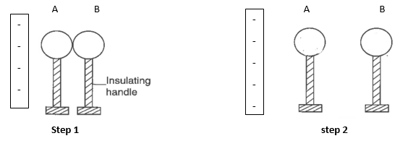

- Give the name of the method. (1 mark)
.............................................................................................................................……………… ..................................................................................................…………………………………
- Sketch a diagram to show the final step of the illustration. Include the charge distribution on the spheres in the diagram you have sketched. (2 marks)
- (a) State one property which differentiates electromagnetic waves from each other. (1mark)
..........................................................................................................................................……… …….......................................................................................................................……………..
(b) Give one way of detecting infrared waves. (1 mark)
.................................................................................................................................................… …..............………………………………………………………………………………………
- State reason for topping up a lead-acid accumulator with distilled water. (1mark)
………………………………………………………………………………………………………………… …………………………………………………………………………………………………………………
(b) state the reason why the current produced by a simple cell falls rapidly when the cell is being used. (1mark)
…………………………………………………………………………………………………… …………………………………………………………………………………………………… …………………………………………………………………………………………………….

- The figure below shows an object placed in front of a pinhole camera. Using rays; show how the image is formed on the screen. (2marks)
Object
Pinhole
Screen

X Y

State what would happen to the image if the screen is moved from point X to point Y. (1mark)
….…………………………………………………………………………………………………

- In the set-up, the suspended meter rule is in equilibrium balanced by the magnet and the weight shown. The iron core is fixed to the bench.
K

Soft Iron core

S

N

Suspender

Weight W

Meter rule

- State and explain the effect on the weight W when the switch K is closed. (2 marks)
….………………………………………………………………………………………………… …………………………………………………………………………………………………… …………………………………………………………………………………………………… .
- What would be the effect of greatly reducing the number of turns/windings of the soft iron; on weight W. (1 mark)

- A concave mirror of focal length 10cm forms a virtual image 6 cm high and 30cm from the mirror. Locate the image by actual scale drawing. (3 marks)
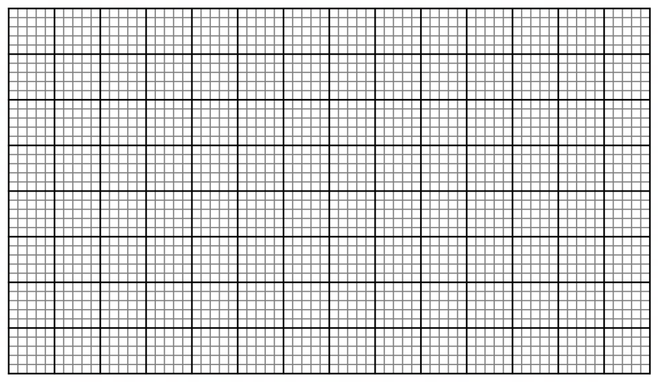
Using your graph determine the magnification. (2 marks)
......................................................................................................................................................… ............................................................................................................................…………………
- In a siren, sound is produced when a jet of air is directed perpendicularly to the ring of holes on a rotating wheel. Explain the effect on the pitch of sound produced when the speed of rotations of the wheel is increased. (2marks)
…………………………………………………………………………………………………… …………………………………………………………………………………………………… …………………………………………………………………………………………………… …………………………………………………………………………………………………… …………………………………………………………………………………………………… ……………………………………………………………………………………………………

- In an x-ray tube it is observed that the intensity of X-rays increases when the potential difference across the filament is increased. Explain the observation. (3marks)
………………………………………………………………………………………………………………… ………………………………………………………………………………………………………………… ………………………………………………………………………………………………………………… ………………………………………………………………………………………………………………… ………………………………………………………………………………………………………………… ………………………………………………………………………………………………………………… …….…………………………………………………………………………………………………………..

Section B (55 marks) Answer all the questions in the spaces provided
- (a) The figure below shows a passively charged gold leaf electroscope. Use it to answer the questions that follow.
Q
Gold leaf
P
Metal case
+
+

+
+
+
+
+
+
+
+
+
+
+
Brass cap

(i) Explain why the part labelled P is made of an insulator. (1 Mark)
……………………………………………………………………………………………………………………………………………………………………………………………………………………………………………………………………………………………………………………………………...
(ii) State why the brass cap is made circular. (1 Mark)
…………………………………………………………………………………………………………………………………………………………………………………………………………………………
(b) The figure below shows a capacitor C being charged.

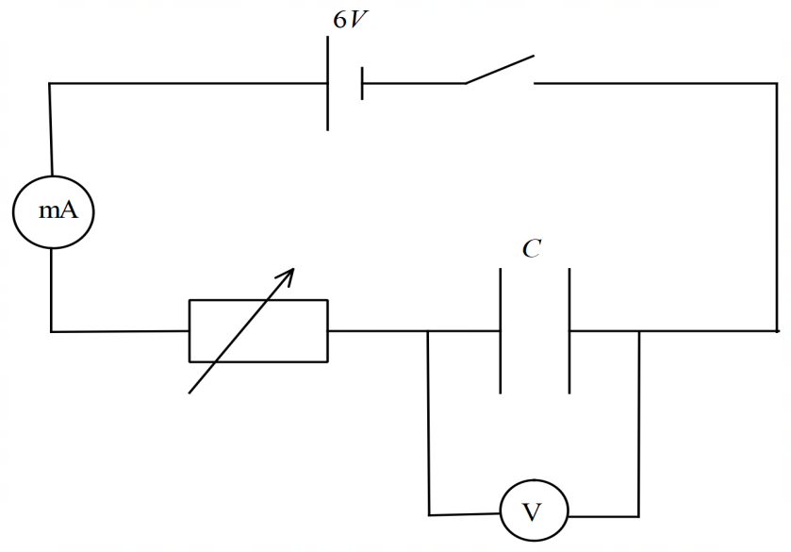

i) State and explain what would be observed on the milliammeter when the switch is closed. (2 Marks)
……………………………………………………………………………………………………………………………………………………………………………………………………………………………………………………………………………………………………………………………………………………………………………………………………………………………………………………

ii) On the axis provided below, sketch the graph of voltage against time after the capacitor is fully charged and the switch is opened. (1 Mark)

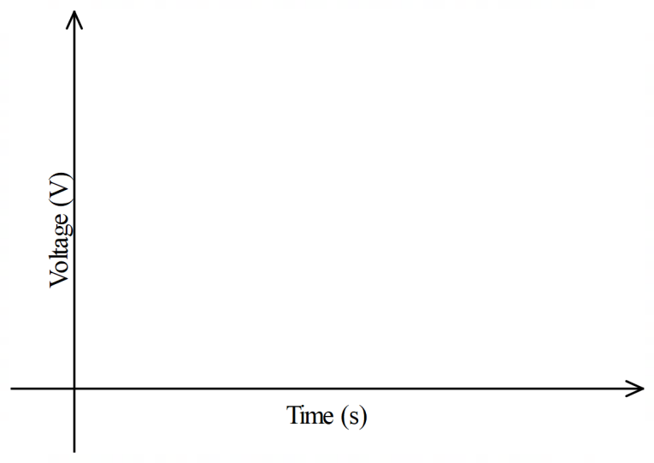
(c) The figure below shows a resistor network in series – parallel arrangement. Use the information provided in the diagram to answer the questions that follow.
3 Ω

R₁

6 Ω

4 Ω

6 V

R₂

R₃

Determine:
(i) The total resistance of the circuit. (2 Marks)
……………………………………………………………………………………………………………………………………………………………………………………………………………………………………………………………………………………………………………………………………………………………………………………………………………………………………………………
(ii) The total current of the circuit. (1 Mark)
………………………………………………………………………………………………………………………………………………………………………………………………………………………
(iii) The voltage drop across resistor R₁. (2 Marks)
……………………………………………………………………………………………………………………………………………………………………………………………………………………………………………………………………………………………………………………………………..
11. (a) Jayden constructed a step-up transformer which operated from a 240V a.c supply to give an output of 8V for ringing a door bell. The primary coil had 3000 turns and current of 2.4A flows through the bell. If the transformer is 100% efficient find.
- Number of turns in the secondary coil. (2 marks)
.....................................................................................................................................................................................................................................................................................................................................................................................................................................………………………………………………….
- Current in the primary coil of the transformer. (2marks).
................................................................................................................................................................................................................................................................................………………………………………(b) The turns of the transformer coil above are wound on an iron core made of sheets (Laminated core) of iron instead of a solid core. Explain. (2marks)
.................................................................................................................................................................................................................................................................................................................................................................................................................................…………………………………………………….
c) Find the cost of running five 60W bulbs and four 100W bulbs for 8 hours if electrical energy costs sh. 5 per unit. (3marks)
........................................................................................................................................................................................................................................................................................................................................................................................................................................................................................................................................................……………………………………………………………………………………
12. (a) Explain why radio waves signals are easier to receive than T.V waves signal in a place surrounded by hills. (2marks)
……………………………………………………………………………………………………………………………………………………………………………………………………………………………………………………………………………………………………………………………………………………………………………..
(b) Draw on the diagrams to illustrate what happens when a plane-waves are incident on a slit.
(i) When the width of the slit is large than the wavelength of the waves. (2marks)

(ii) when the width of the slit is smaller compared with the wavelength of the waves. (2marks)

(c) the figure below shows the set up used to demonstrate interference of sound. And observer moves along XY.
Audio frequency Generator
S₂
S₁
Y
X
O
C
8.4 m
3.4 m
A

- State and explain the observation made. (2 marks)
………………………………………………………………………………………………………………………………………………………………………………………………………………………………………………………………………………………………………………………………………

- What will the student hear if he /she walks along the line OC. (1mark)
…………………………………………………………………………………………………………………………………………………………………………………………………………………………………………………
(d) Determine the frequency of the signal generator from the set up above given that A is the second constructive interference after the central order and the speed of sound is 320 m/s. (3marks)
….………………………………………………………………………………………………………………………………………………………………………………………………………………………

- The figure below shows a wave profile moving at a velocity of 150 m/s.
Displacement (m)
6

111
101
9
81
71
6
51
41
3
2
1
0
Time (ms)
-6

Determine
The frequency of the wave. (2marks)
….………………………………………………………………………………………………………………………………………………………………………………………………………………………
The wavelength of the wave. (2marks)
….………………………………………………………………………………………………………………………………………………………………………………………………………………………
(c) State two factors which determine the speed of electrons emitted by a metal surface. (2 marks)
…………………………………………………………………………………………………………………………………………………………………………………………………………………………………………………………………………………………………………………………………………………………………………………………………………………………………………………..

(d) Fig. below shows a negatively charged electroscope with a clean zinc plate placed on the cap. Ultraviolet light is shone on the zinc plate.

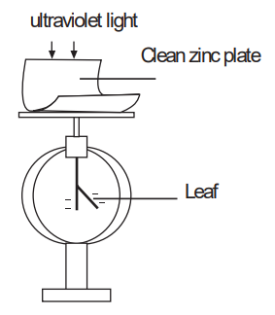

(i) Explain what happens to the leaf of the electroscope when ultraviolet light is shone on it. (2marks)
……………………………………………………………………………………………………………………………………………………………………………………………………………………………………………………………………………………………………………………………………………………………………………………………………………………………………………………
(ii) What would happen if ultraviolet light is replaced with infra-red radiation? (1mark)
…………………………………………………………………………………………………………………………………………………………………………………………………………………………
14. (a)State one condition for total internal reflection to occur (1 mark)
…………………………………………………………………………………………………………………………………………………………………………………………………………………………

(b) The figure below shows two rays A and B entering a semi-circular glass block which has critical angle of 42⁰. The rays are incident at an air glass boundary at point O
Air
O
45⁰
Glass
30⁰
A

B

Complete the path of the two rays from point O. Label A¹ and B¹ respectively on the corresponding rays. (2 marks)
(c) An object is placed 15cm from a diverging lens and the image is formed 6cm from the lens. What is the focal length of the lens? (2 marks)
….……………………………………………………………………………………………………………………………………………………………………………………………………………………………………………………………………………………………………………………………………………………………………………………………………………………………………………………………………………………………………………………………………………………………………………………………………………………………………………………………………………
15. (a) Fig below shows an expansion cloud chamber.
Radioactive source

Alcohol Vapour
Piston
Glass

(i) What is the purpose of the vapour? (1mark)
….………………………………………………………………………………………………… ……………………………………………………………………………………………………
(ii) Explain how the radiations emitted by the radioactive source in the chamber are detected. (3marks)
….………………………………………………………………………………………………… …………………………………………………………………………………………………… …………………………………………………………………………………………………… ……………………………………………………………………………………………………
(iii) Identify with reason the type of emission that formed the tracks below. (2marks)

….……………………………………………………………………………………………………………………………………………………………………………………………………………………………………………………………………………………………………………………………………..

(b) The graph below shows radioactive decay of a radioactive substance.
Time (years)
O
300
250
200
100
50
150
400
350
60
50
40
30
20
10
Remaining amount (grams)

Use the graph to determine the: -
- The half – life of the substance. (1 mark)

….………………………………………………………………………………………………………………………………………………………………………………………………………………………

- The mass remaining after 48 years. (1 mark)

….……………………………………………………………………………………………………………………………………………………………………………………………………………………………………………………………………………………………………………………………………

(d) Figure below shows a bridge rectifier

C
R

Describe how full-wave rectification is achieved. (3 marks)
.……………………………………………………………………………………………………… ……………………………………………………………………………………………………… ……………………………………………………………………………………………………… ……………………………………………………………………………………………………… ……………………………………………………………………………………………………… ………………………………………………………………………………………………………
A capacitor has been connected across the resistors as shown. State the function of the capacitor. (1 mark)
.…………………………………………………………………………………………………………………………………………………………………………………………………………………………….……………………………………………………………………………………………

This is the last page

