NAME:……………………………..........…………...……...........… Class …………ADM NO......................

232/1; PHYSICS Candidate’s Signature:………………
PAPER 1
JULY 2025 Date……………………………….
TIME: $2$ HRS

MOKASA 2 JOINT EXAMINATION
Kenya Certificate of Secondary Education (K.C.S.E.)

INSTRUCTIONS TO CANDIDATES
- Write your name and index number in the spaces provided.
- Mathematical tables and non-programmable calculators may be used.
- Attempt all the questions in the spaces provided.
- ALL working MUST be clearly shown.

For Examiners Use
SECTION | QUESTIONS | MAXIMUM SCORE | CANDIDATE’S SCORE
A | 1 – 8 | 25
B | 9 | 10
B | 10 | 08
B | 11 | 09
B | 12 | 07
B | 13 | 11
B | 14 | 10
 | TOTAL | 80

This paper consists of 11 printed pages. Candidates should check to ascertain that all pages are printed as indicated and that no questions are missing.

SECTION A ( 25 MARKS)
- A cube of length 2.08 cm has a mass of 0.02 kg. Determine its density. (2marks)
.........................................................................................................................................................................................................................................................................................................................................................................................................................................................................................................................................
- The graph below shows the volume against temperature of water between 0⁰C and 10⁰C
Volume(cm³)
Temperature (⁰C)
0
4
10

State two disadvantages of the behavior of water represented by the graph. (2marks)
..........................................................................................................................................................................................................................................................................................................................................................................................................................................................................................................................................................
- A drop of olive oil of volume 5 x 10⁻⁴ cm³ spreads out on a clean water surface to a form a thin film of area 7.5 x 10⁻¹ m². Find the thickness of the film. (3marks)
..........................................................................................................................................................................................................................................................................................................................................................................................................................................................................................................................................
- The figure below shows a Bunsen burner.
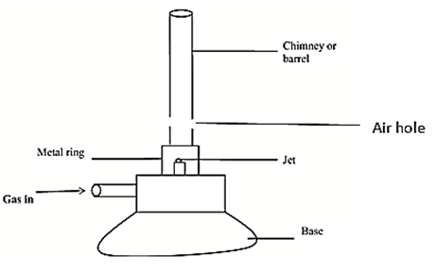
Explain how air is drawn into the Burner when the gas tap is opened. (3marks)
............................................................................................................................................................................................................................................................................................................................................................................................................................................................................................................................................................
- a)The diagram shown in the figure below shows a system in equilibrium with the rule horizontal.
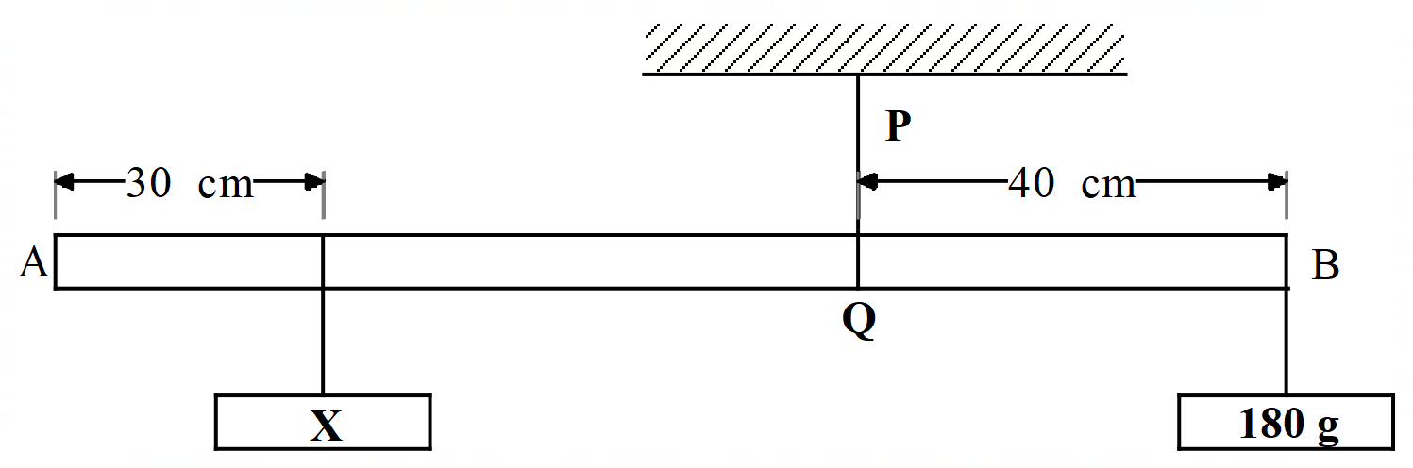
AB is a uniform rule of length 1.0m and weight 1.8N. Find the weight of the block X. (3marks)
..........................................................................................................................................................................................................................................................................................................................................................................................................................................................................................................................................
b) Explain one way a person walking up a flight of stairs increases stability. (2marks)
............................................................................................................................................................................................................................................................................................................................................................
- (a) Explain how some small insects are able to walk on water. (1marks)
.......................................................................................................................................................................................................................................................................................................................................................................
(b) The figure below shows two tubes of different sizes dipped in a beaker containing mercury.
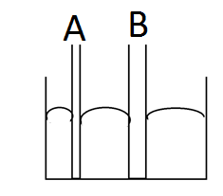
(i) Indicate on each tube the level of mercury (1mark)
(ii) Explain your answer in (i) above (1marks)
........................................................................................................................................................................................................................................................................................................................................................................
c)Explain why metals are good conductors of heat. (2marks)
...........................................................................................................................................................................................................................................................................................................................................................................................................................................................................................................................................................
- The figure below shows two identical beakers H and K full of water at 90ºC. Two similar cold wet clothes are wrapped, one around the top of H and the other around the bottom of K.
Cold Wet cloth

Cold Wet cloth
Water
K
H

State with a reason, the beaker in which the water cools faster (2 marks)
...........................................................................................................................................................................................................................................................................................................................................................................................................................................................................................................................................................
- The figure shows an inverted test tube which floats in water enclosed in a plastic bottle.
Trapped air
Trapped water
Plastic bottle
AIR

The sides of the plastic bottle are squeezed. State and explain what would be observed. (3 Marks)
....................................................................................................................................................................................................................................................................................................................................................................... ....................................................................................................................................................................................
SECTION B (55 MARKS)
- (a) State the law of floatation. (1mark)
...........................................................................................................................................................................................................................................................................................................................................................
- A hydrometer of mass 12.8 g is immersed in liquid of density 800 kg/m³. The hydrometer floats on the liquid. Determine the volume of liquid displaced. (2marks)
........................................................................................................................................................................................................................................................................................................................................................................................................................................................................................................................
- A body of mass 2.0 kg is suspended from a spring balance calibrate in newtons. It reads 17.0N when the body is completely submerged in water. Given the intensity of the earth’s gravitational field is 10N/kg, find:
- the upthrust of the water on the body. (2marks)
.......................................................................................................................................................................................................................................................................................................................................................................................................................................................................................................................
- the mass of the water displaced by the body. (1mark)
........................................................................................................................................................................
- the volume of water displaced given the density of water is 1000kg/m³. (2marked)
................................................................................................................................................................................................................................................................................................................................................
- the density of the material the body is made of. (2marks)
...............................................................................................................................................................................................................................................................................................................................................

- The figure below shows a hydraulic press system using a lever of negligible mass on the side of a small piston pivoted at point P. A force of 100N is applied at R.
P
100 cm
50 cm
Liquid
Piston B Area = 360cm²
A Bale
100 N
Piston A Area = 30cm²
R

Determine;
(i) The effort exerted at the smaller piston A. (2 marks) ...........................................................................................................................................................................................................................................................................................................................................................................................................................................................................................................................................................
(ii) The V.R of the lift (2 marks) ............................................................................................................................................................................................................................................................................................................................................................................................................................................................................................................................................................
(iii) The M.A of the system (2 marks) .........................................................................................................................................................................................................................................................................................................................................................................................................................................................................................................................................................
(iii) The efficiency of the system (2 marks) ..........................................................................................................................................................................................................................................................................................................................................................................................................................................................................................................................................................

- a) The diagrams below show mercury tubes with trapped air in vertical and horizontal positions.

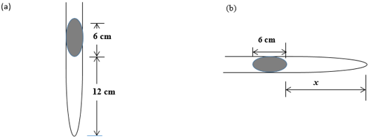
i)Determine the length of the air column x in diagram (b) given atmospheric pressure is 75cm Hg. (3 mark)
..........................................................................................................................................................................................................................................................................................................................................................................................................................................................................................................................................................

ii)Give reason for the differences in the two air columns (a) and (b). (1 mark)
...............................................................................................................................................................................
b)The diagram below shows a set up that a student used to investigate the pressure law 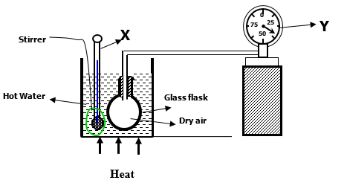
(i) State the law which is being investigated (1 Marks)
........................................................................................................................................................................................................................................................................................................................................................................
(ii) Describe how you would verify the law investigated above (3 Marks)
...............................................................................................................................................................................................................................................................................................................................................................................................................................................................................................................................................................................................................................................................................................................................................
State one assumption made while performing the above investigation. (1 Mark) ....................................................................................................................................................................................

- (a) State Newton’s second law of motion. (1mark)
............................................................................................................................................................................................................................................................................................................................................................
(b) a block of mass 2 kg is pushed along a table with a constant velocity by a force of 5 N.
i. Determine the frictional force between the block and the table. (1 mark)
....................................................................................................................................................................................
ii. The force is then increased to 9.0 N. Find the acceleration of the block (2mark)
...........................................................................................................................................................................................................................................................................................................................................................................................................................................................................................................................................................
- The graph below represents stretching force against total length of the spring. 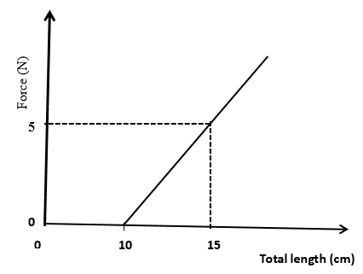
Form the graph determine
- the original length of the spring used. (1mark)
....................................................................................................................................................................................
- the spring constant. (2marks)
...........................................................................................................................................................................................................................................................................................................................................................................................................................................................................................................................................................
- (a)i State one factor which affects heating by an electric current. (1 mark)
....................................................................................................................................................................................
ii)State the property of a fuse wire that makes it suitable for controlling excessive current. (1mark)
...................................................................................................................................................................................
b). i. Define the term heat capacity. (1 mark)
........................................................................................................................................................................................................................................................................................................................................................................c)In an experiment to determine the specific heat capacity of aluminiunm, the set up below was used. 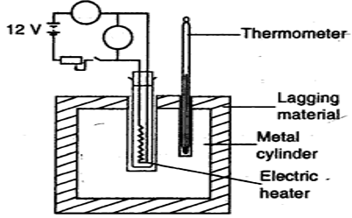

i) Complete the diagram by inserting labels of relevant devices used in the experiment. (1mark)
.................................................................................................................................................................................
ii) State the measurements to be taken in the experiment. (2 marks)
............................................................................................................................................................................................................................................................................................................................................................................................................................................................................................................................................................
iii) Explain how the measurements above are used to determine the specific latent heat of fusion for the material the block is made of. ( 2 marks)
........................................................................................................................................................................................................................................................................................................................................................................
ii) State one precaution taken in the above experiment. (1 mark)
...................................................................................................................................................................................

- A helicopter moving at 20m/s drops a parcel from a height of 100m above a flat ground. Determine:
- The time it takes for the parcel to hit the ground. (2 marks)
………………………………………………………………………………………………………

- The horizontal distance the parcel was dropped from in order to land on the desired target. ( 2 marks)
....................................................................................................................................................................................................................................................................................................................................

- The figure below shows a graph of velocity against time for a moving body.
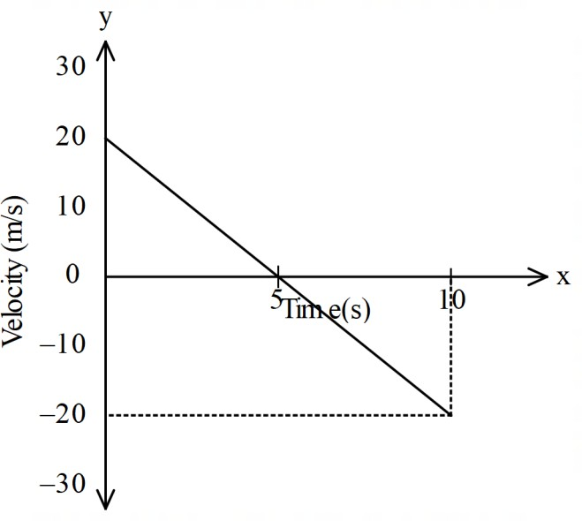
    - Describe the motion of the body during the 10 seconds. (2 marks)
............................................................................................................................................................................................................................................................................................................................................................................................................................................................................................................................................
    - Determine the displacement of the body for the entire motion. (2 marks)
............................................................................................................................................................................................................................................................................................................................................................................................................................................................................................................................................................ c) A body of mass 5.0 kg is attached to the end of a string of length 50 cm and whirled in a horizontal circle. If the tension of the string is 81 N, determine the velocity of the body. (3 marks)
………………………………………………………………………………………………………………………………………………………………………………………………………………………………………………………………………………………………………………………………………………......................................

END OF PAPER

