NAME…………………………………………….………..ADM NO………….….....................………
SCHOOL……………………………..................CLASS......................... SIGN…………....................….
232/1
PHYSICS
PAPER 1
TIME: 2 hours
JULY 2025

NYAGA SECONDARY SCHOOL
MOCK EXAMINATION 2025
Kenya Certificate of Secondary Education (K.C.S.E)
FORM FOUR
232/1
PHYSICS
PAPER 1
TIME: 2 Hours

INSTRUCTIONS TO CANDIDATE
- This paper consists of two Sections A and B.
- Answer all the questions in the spaces provided.
- All working must be clearly shown.

For Examiners Use Only
Section | Question | Total Score | Candidates Score
SECTION 1 | 1-12 | 25
SECTION 2 | 13 | 10
SECTION 2 | 14 | 12
SECTION 2 | 15 | 11
SECTION 2 | 16 | 12
SECTION 2 | 17 | 10
Total |  | 80

SECTION 1: 25 MARKS
1. The figure below shows part of the scale of a vernier calliper whose are completely closed. State the zero error. (2marks)
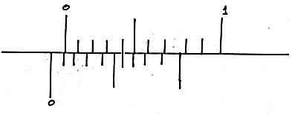
2. Explain why a body going round a circular track at constant speed is said to be accelerating. (1mark)
………………………………………………………………………………………………………………………………………………………………………………………………………………………………
3. The figure below shows a glass capillary tube dipped in a liquid at room temperature.
a) Indicate on the diagram the level of the liquid in the capillary tube when the liquid is heated slightly. (1mark)
b) Explain your answer in part “a” above. (1mark)
………………………………………………………………………………………………………………………………………………………………………………………………………………………………
4. A balloon is filled with a helium which is lighter than air. It is observed to rise in air up to a height of 40m. State the reason why the balloon stops rising. (1mark)
………………………………………………………………………………………………………………………………………………………………………………………………………………………………
5. The figure below shows the temperature changes against quantity of heat supplied to one kilogram each of liquids A and B.
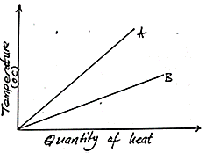
Which of the two liquids has a higher specific heat capacity? Give reason. (2marks)
………………………………………………………………………………………………………………………………………………………………………………………………………………………………………………………………………………………………………………………………………………………………………………………………………………………………………………………………
6. A box on an inclined plane is under two forces as shown.
The toy moves upwards with a constant velocity. State the value of F₁ and give a reason for your answer. (2marks)
………………………………………………………………………………………………………………………………………………………………………………………………………………………………………………………………………………………………………………………………………………………………………………………………………………………………………………………………
7. A water tank with height 3.6m is full of water. A thin metal plate rests flat at the bottom of the tank. If the plate has an area of 2cm². Determine the force exerted on the thin metal plate if the density of water is 1000kg/m³ and the atmospheric pressure is 104,000Pa. (3marks)

8. The figure below shows a uniform ruler balanced at the centre due to action of some forces as shown below. A is a magnet of weight 30N and B is a permanent magnet fixed onto the bench.
Determine the force between A and B. (3marks)

9. The figure below shows two identical flasks A and B filled with water. Show the level of water one minute after the bulb placed in between the flasks is switched on. Explain your observation. (2marks)
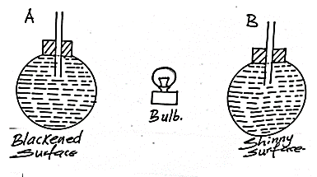
………………………………………………………………………………………………………………………………………………………………………………………………………………………………………………………………………………………………………………………………………………………………………………………………………………………………………………………………
10. The figure below shows an unloaded spring when supporting a load of 300g and a wooden block.
Calculate the mass of the wooden block. (4marks)

11. The figure below shows an incompressible fluid flowing through a pipe, A₁ and A₂ are the cross-sectional areas of the pipes in the larger section and smaller section of the pipe respectively, while V₁ and V₂ are speeds of the fluid at the two sections of the pipe.
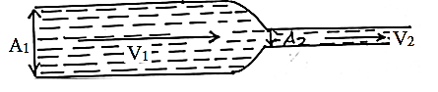
Derive an expression for the ratio of the speeds in terms of A₁ and A₂. (2marks)

12. Apart from the base area, state any other factor that affects stability. (1mark)
………………………………………………………………………………………………………………………………………………………………………………………………………………………………
SECTION B: 55 MARKS
13. Figure below shows a set up in an experiment to determine specific heat capacity of water.
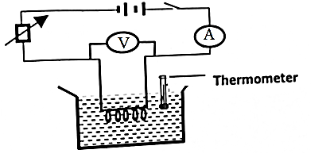
The data below was obtained from the experiment.
- Voltage V across the heater = 12V
- Current 1 in the circuit = 1.4A
- Time t heating = 600s
- Mass m of water = 0.4kg
- Change in temperature = 6⁰C
i) Define specific heat capacity. (1mark)
………………………………………………………………………………………………………………………………………………………………………………………………………………………………

ii) State two improvements that would be made in the set up to obtain accurate results. (2marks)
………………………………………………………………………………………………………………………………………………………………………………………………………………………………………………………………………………………………………………………………………………………………………………………………………………………………………………………………
iii) Use the above results to determine he specific heat capacity of water. (3marks)

b) Explain why the cooling unit (freezer) inside a refrigerator is placed near the top but an elastic immersion heater in water tank should be near the bottom. (2marks)
………………………………………………………………………………………………………………………………………………………………………………………………………………………………………………………………………………………………………………………………………………………………………………………………………………………………………………………………
c) State two factors that will lead to increase in the rate of evaporation of a liquid. (2marks)
………………………………………………………………………………………………………………………………………………………………………………………………………………………………
14.(a) A bullet of mass 24g travelling in a horizontal path with a velocity of 450m/s strikes a wooden block of mass 976g resting on a rough horizontal surface. After impact, the bullet and the block move together for a distance of 9m before coming rest.
i) Name the type of collision which takes place above. (1mark)
………………………………………………………………………………………………………………………………………………………………………………………………………………………………
ii) Determine the velocity of the two bodies when they start sliding. (2marks)

iii) Determine the force which brings the two bodies to rest. (3marks)

b) A missile is fired horizontally from the top of a cliff 320m high to a target 56m away. If the missile hits the target, determine the horizontal velocity of the missile. (3marks)

c) The graph below shows how the velocity varies with time for a body thrown vertically upwards.
Determine the total distance moved by the body. (3marks)

15(a) Define the term efficiency as used in machine (1mark)
………………………………………………………………………………………………………………………………………………………………………………………………………………………………
b) A hydraulic lift is used to raise a load of 100kg through a height of 20m. The radius of the effort piston is 1.6cm while the load piston has a radius of 8.0cm. if the machine is 75% efficient, calculate;
i) Its velocity ratio. (2marks)

ii) Its mechanical advantage. (2marks)

iii) Effort required. (2marks)

iv) Energy wasted in using the machine. (2marks)

c) A block and tackle pulley system is used to lift a mass of 200kg. If the machine has a velocity ratio of 5, and efficiency of 80%.
Sketch in the space provided below the possible arrangement of the system, if provided with two block and tackle pulleys each with two pulleys. (2marks)

16(a) The diagram in figure below shows an experiment to investigate the relationship between volume and temperature of a fixed mass of gas at constant pressure.
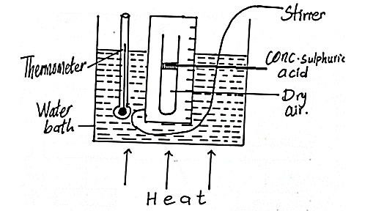

i) Which measurement are taken in the above experiment. (2marks)

ii) State the law being investigated in the above experiment. (1mark)
………………………………………………………………………………………………………………………………………………………………………………………………………………………………
iii) Describe how the experiment above is used to verify the law. (4marks)

iv) State one assumption made in this experiment. (1mark)
………………………………………………………………………………………………………………………………………………………………………………………………………………………………
b(i) State the condition necessary for a body to float. (1mark)
………………………………………………………………………………………………………………………………………………………………………………………………………………………………
ii) A certain solid of volume 50cm³ displaces 10cm³ of kerosene (density 800kgh/m³) when floating. Determine the density of the solid. (3marks)

17(a) The graph below was obtained when an experiment to investigate the variation of the centripetal force, F with the radius, r of the circle on which a body rotates was performed.
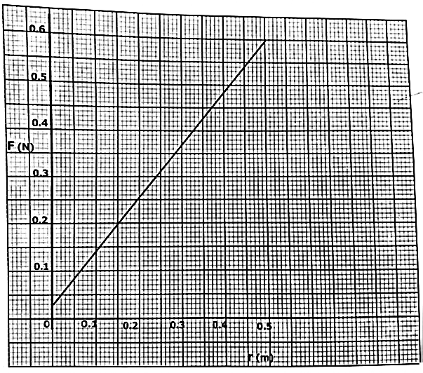
From the graph, determine the angular velocity, w of the body given that m = 100g and F = mw²r + c where c is constant. (4marks)

b) A stone of mass 0.2kg tied to a string is whirled in a horizontal circle of radius 1.0m at a constant speed of 3.0m/s.
Determine;
i) The angular velocity of the stone. (2marks)

ii) The tension in the string. (2marks)

iii) The number of revolutions the stone makes in one minute. (2marks)

THIS IS THE LAST PRINTED PAGE!

