Name …………………………………………........... Index/Adm No……………………………….
Candidate’s Signature……………………………… Date……………………………………………

511/3
MUSIC
Paper 3
July 2025

MOKASA 2 2025
Kenya Certificate of Secondary Education
MUSIC
Paper 3
2 ½ Hours
Instructions to candidates
- Write your name and index number in the spaces provided.
- Sign and write the examination date in the spaces provided.
- Answer all the questions in this paper except in question 4 where you will choose any two of the questions numbered (a)(b)(c) and (d).
- All answers must be written in the spaces provided.
- This paper consists of 12 printed pages. Ensure that all pages are printed and no questions are missing
For Examiner’s Use Only
Section | Question | Maximum Score | Candidate’s Score
A | 1a | 9
A | 1b | 6
A | 2 | 15
B | 3 | 14
B | 4 | 14
B | 5 | 10
B | 6 | 10
B | 7 | 06
C | 8 | 16
Total Score |  | 100

SECTION A: BASIC SKILLS (30 Marks)

- (a) Continue the following opening to make a melody of sixteen bars for voice. Modulate the melody to the dominant, introducing a duplet and dynamic variation. (9marks)

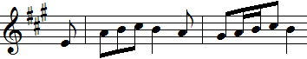

- 16 Bars 1 mark
- Phrasing 1 mark
- Lyricism 2 marks
- Modulation 2 marks
- Dynamic variation 1 mark
- V.R 1 mark
- Duplet 1 mark

b) Using Staff Notation, compose a melody and set it to the lyrics below. Add phrase marks. (6 marks)
Taifa tulijenge, taifa letu Kenya
Sisi wazalendo, tulijenge Kenya.
- Syllabic Division 1 mark
- Lyricism 2 marks
- Phrasing 1 mark
- V.R 1 mark
- Cadences 1 mark

- Harmonize the following melody for Soprano, Alto, Tenor, and Bass (SATB). Choose appropriate chords from: I, ii, IV, V, and vi. Use a passing tone in bar 3 and a cadential six-four. (15marks)
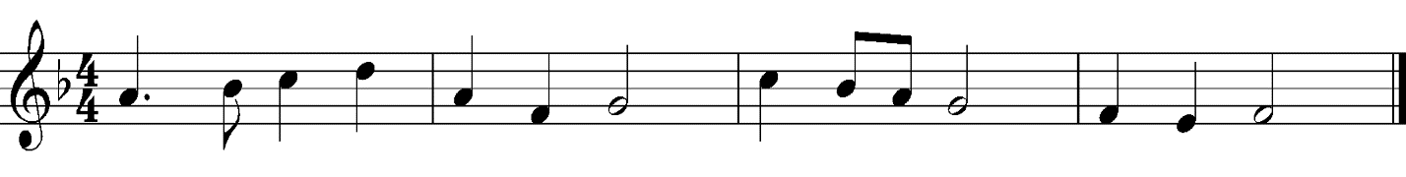
- Correct chords 7 marks
- Passing tone 1 ½ marks
- Cadential six-four 1 ½ marks
- V.R 1 mark
- V.L 1 mark
- C.P 2 marks
- Cadences 1 mark
SECTION B: HISTORY OF MUSIC (48 MARKS)

3. AFRICAN MUSIC

- Identify the following aerophones in terms of community of origin and categories they belong to
(5 marks)
    - Aluti- Iteso Horn
    - Bung’o- double-reed from the Mijikenda
    - Ekerongwe- Kuria flute
    - Muturiru- Agikuyu flute
    - Aryembut – Sabaot horn

- Mwomboko is a dance from a community in Kenya. Identify the following: (3 marks)

- Community of origin ( ½ )- Agikuyu
- Performers ( ½ )- Old men and women
- occasion of performance ( ½ )- Entertainment
- Accompanying instruments used (1 ½)- Accordion and Karing’aring’a

- Outline three ways in which formal education has affected traditional African music. (3 marks)
- Music is taught as a subject thus the wide spread knowledge of African music
- More time spent in school means there is no time to pass down African music within the community
- More emphasis is placed on western music, thus a decline in the learning of African music
- African music can be notated due to learning of western style of notation learnt in school
- Any other correct answers

- Why is the call and response style common in traditional African performances? (3 marks)
- It allows for spontaneity
- It makes it easier for people to learn the songs
- Gives direction to the response on what to do next
- Any other correct answer

- WESTERN MUSIC.
Answer any two of the following questions (a), (b), (c) and (d)

- Giovanni da Palestrina
    - a) What led to Palestrina’s appointment as the Maestro di Cappella at the Julian Chapel? (1 mark)
- because of the favourable impression of his first compositions, the three masses dedicated to the pope
b) Outline two key roles he played during his appointment at Julian Chapel. (2 marks)
- training young choristers
- preparing the choir for masses
- Composing music for the chapel

    - List four types of vocal works Palestrina composed during his career. (2 marks)
- Masses
- Motets
- Hymns
- Lamentations, psalms, Litanies, Antiphons, Magnificats,
- Madrigals (spiritual and Secular)
- Cantoines (sacrae and profanae)
    - Outline any two influences on Palestrina’s musical career. (2 marks)
- Northern European polyphonic style
- His appointments in church
- The counter-reformation
- The Roman musical scene
- His contemporaries

- Henry Purcell
    - State any two appointments that influenced parcel’s music (2 marks)
- Chorister at the Chapel Royal
- Assistant to the keeper of the Royal instruments
- Composer for the King’s violins
- Organist at Westminster Abbey
- Organist at Chapel Royal
- Keeper of the King’s Instruments

    - Apart from Dido and Aeneas, which other work is Henry famously known for? (1 mark)
- King Arthur semi-opera
- The Fairy Queen semi-opera
- Remember not, lord our offences- Anthem
- My Heart is Inditing Anthem
- I was glad anthem
- Funral March for Queen Mary canzona
- Any other correct answers
    - Outline any two charactersitics of Henry purcells music (2 marks)
- Masterful harmony and counterpoint
- Versatility and dramatic expressiveness
- Word painting
- French and Italian style influence
- Any other correct answer

    - What type of work is “My Heart is Inditing” and when was it performed. (2 marks)
- Verse Anthem
- Written for the coronation of King James II, performed at Westminster Abbey April 23rd 1685

- Pyotr Ilyich Tchaikovsky
    - Identify tchaikovsky’s nationality. (1 mark)
- Russian

    - Identify the period that he lived. (1 mark)
- Romantic Period
    - What do you understand by ‘The Five’? Name any two members. (2 marks)
- A group of five outstanding musicians from Russia
- Balakirev, Mussorgsky, Rimsky-Korsakov, Barodin, Cesar Cui

    - Give an example of the following works by Tchaikowsky (3 marks)
Overture – Romeo and Juilet, The Storm
Symphony – Winter Daydreams in G minor, Little Russian, Pathetique in B minor
Concertos – Piano Concerto No.1 in Bb minor, Violin Concerto in D Major

- Igor Stravinsky
    - Outline any two features that characterized Stravinsky’s Ballets. (2 marks)
- Innovative orchestration
- Compelling Narratives
- Engaging Choreography

    - Name the three prominent periods in which Stravinsky’s compositional style output is divided into. (3 marks)
- Russian period (1909-1920)
- Neo-classical Period (1920-1951)
- Serial Period (1954-1968)

    - Identify the following works by Stravinsky: (2 marks)
The Nightingale Opera
Apollo Ballet
Scherzo Fantastique Orchestral
Babel Canatata
- PRESCRIBED TRADITIONAL AFRICAN MUSIC (10 MARKS)

Rendile Folk Song (PPMC)
      - Identify two roles of Vocal Embelishments in the recording. (2 marks)
- Contribute to the Harmonic Effect in the performance
- Enrich texture
- Indicate climax
- Create variation in the performance

      - Identify two styles of performance used in the recording (2 marks)
- Call-response
- Chanting
- Unison singing
- Overlapping
      - Describe the performance in terms of tempo (1 mark)
- Relatively fast and lively with a steady tempo throughout the performance

      - State two ways in which harmony has been achieved in the recording. (2 marks)
- Overlapping
- Singing a fifth apart
- Singing an Octave apart
- Use of vocal ornaments above the melodies

      - Describe the last section of the performance. (2 marks)
- Both males and females are prominent in this section
- There is a male soloist leading the section with all performers responding
- Heaving is heard in the background
- Ululations are performed
- Shouts are heard
- The performance fades to the end

- PRESCRIBED WESTERN MUSIC
EineKleineNachtmusik (K 525)- ‘Allegro’- W.A.Mozart
    - Outline three characteristics of the Classical period evident in the composition. (3 marks)
- Use of the Sonata form
- The presence of the string orchestra
- Homorphonic texture
- Balanced phrasing
- Gradual dynamics

    - Using bar numbers, discuss the key changes between Bars 76-137 (3 marks)
- 76-124 G Major
- 126 E Major
- 127-137 G Major
iii. Identify any two articulation marks used in the piece citing where they are used. (2 marks)
- Staccato, Slurs, Ties,
iv. With the help of Bar numbers, identify sections where the following have been used; (2 marks)
Monophonic texture Bars 1-4, 56-59, 70-73, 76-79, 128
Homophonic texture Bars 5-55, 60-69, 74-75, 80-127, 129-137
7. Unprepared Analysis
Study the music excerpt and answer the questions that follow.
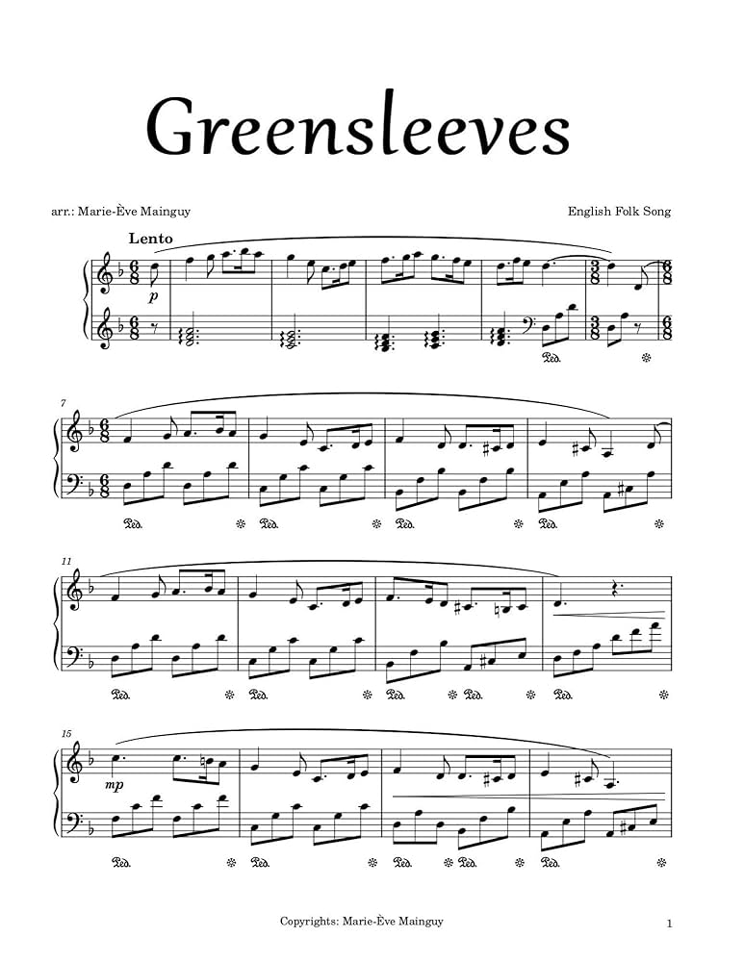
- Name the key of the music. D minor (1 mark)

- For what medium is this music scored for. Give a reason. ( 2 marks)

- Piano
- Presence of a pedal sign, use of Albertti Bass, the treble and bass clefs braced together

- Name the technique employed in the music on the bass staff from bar 7. (1 mark)
- Albertti Bass

- To which key does the music modulate to at bars 16-17? (1 mark)
- C Major

- Citing bar numbers identify any two-bar exact repetition. ( 1 mark)
- Bars 7-8 and 12-13

8. SECTION C: GENERAL MUSIC KNOWLEDGE (16 MARKS)

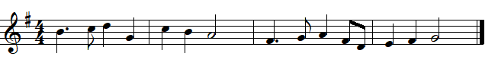
    - Transpose the following melody a perfect 5th down into the alto clef. (4 marks)

ANSWER:
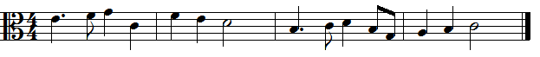

    - Define the following terms (5 marks)
- Tutti- All performers play or sing together

- Da capo- Go back to the beginning

- Coda- the concluding section of the sonata form

- Sarabande- A dance in triple meter (from Spain)

- Baton – A stick used by a conductor to direct a performance especially orchestral

    - a. What is the origin of the Kenya national anthem (1 mark)
- A pokomo Lullaby
  - Name two composers that arranged the Kenyan national anthem. (1 mark)
- George Washington Omondi
- G. W. Senoga-Zake
- Thomas Kalume
- Graham Hyslop
- Peter Kibukosia
iv. Outline any three factors that affect the distribution of African instruments. (3 marks)
- Availability of skilled people to make them
- Availability of materials
- Socio-economic activities of the community
- Availability of skilled players
- Cultural beliefs and restrictions

- Name any two double reed instruments found in the orchestra. (2 marks)
- Oboe
- Bassoon

