JULY MOCK EXAM 2025
MUSIC PAPER 1
511/1 (15 Minutes per candidate)
Voice
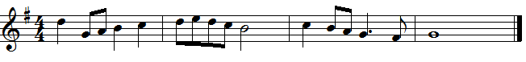
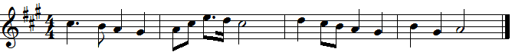
Flute
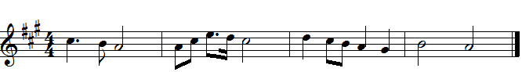

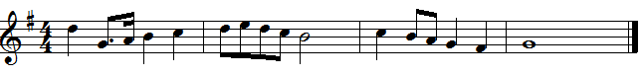
Alto saxophone
1.
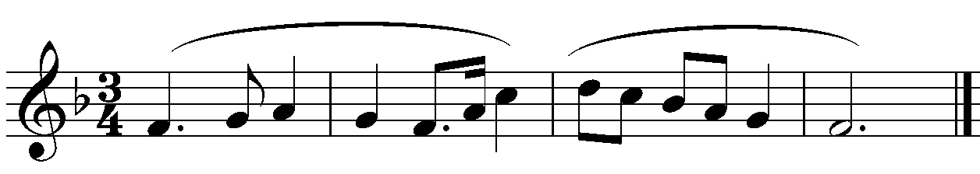

2.
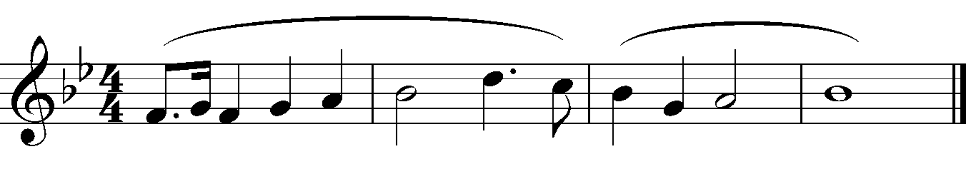
Guitar
1.
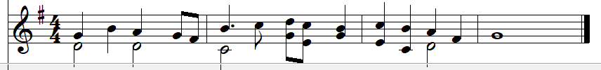
2.
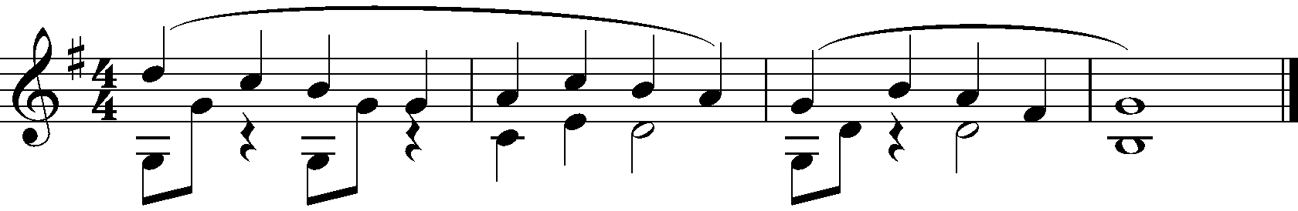
Violin

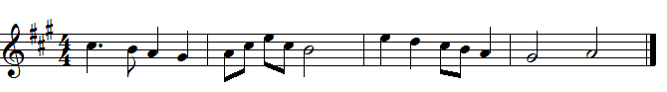

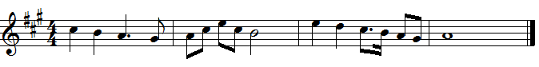

Clarinet/Alto Saxophone/Trumpet

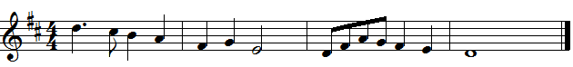

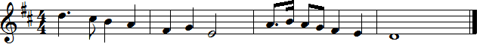

Trombone/Tuba

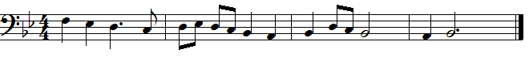
Viola
1.
2.
Piano
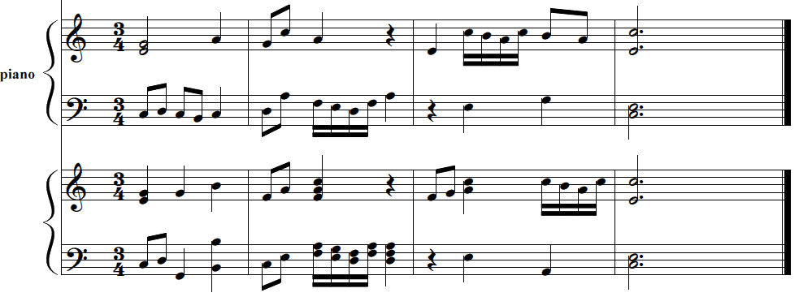
Descant Recorder
1.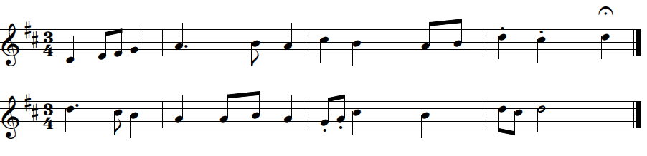
Cello/Bass
1.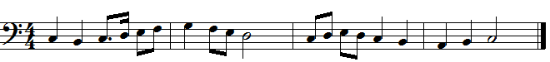
2.

