NAME……………………………………….CLASS……… ADM……….
MOKASA II JOINT EXAMINATIONS.
$121/2$ MATHEMATICS $Paper 2$

ALT A
FORM FOUR
MOCK
July. 2025$-2\frac{1}{2} hours$

Instructions to candidates
- Write your name and admission number in the spaces provided above.
- Sign and write the date of examination in the spaces provided.
- This paper consists of two sections: Section I and Section II.
- Answer all questions in section I and only five questions from section II.

- Show all the steps in your calculations, giving the answers at each stage in the spaces provided below each question.
- Marks may be given for correct working even if the answer is wrong.
- Non-programmable silent electronic calculators and KNEC mathematical tables may be used, except where stated otherwise.
- This paper consists of 14 printed pages.
- Candidates should check the question paper to ascertain that all the pages are printed as indicated and that no questions are missing.
- Candidates should answer the questions in English.

For Examiner’s Use Only
Section I
$$1$$ | $$2$$ | $$3$$ | $$4$$ | $$5$$ | $$6$$ | $$7$$ | $$8$$ | $$9$$ | $$10$$ | $$11$$ | $$12$$ | $$13$$ | $$14$$ | $$15$$ | $$16$$ | $$Total$$

Section II
$$17$$ | $$18$$ | $$19$$ | $$20$$ | $$21$$ | $$22$$ | $$23$$ | $$24$$ | $Total$  Grand Total
SECTION I (50 marks)

Answer all questions in this section
- The dimensions of a rectangle are 40 cm and 45 cm. If there is an error of 5% in the measurement of it’s dimensions, find the percentage error in calculation of it’s the area of the rectangle. (3 Marks)

- Solve the following pairs of simultaneous equations. (4 marks)

- Without using a calculator or mathematical tables, evaluate leaving your answer in the form a$\sqrt{b}+c$ where a, b and c are integers. (3 Marks)
$$\frac{tan {60}^{0}}{1-\cos{{30}^{0}}}$$

- A quantity $y$ varies partly as $x$ and partly as the square of x. When $x=$ 20, $y=$ 45 and when $x=$ 24, $y=$ 60. Find $y$when $x=$ 4. (3 Marks)

- Solve for X in log ₂ X + 3 = log ₂ X ⁴ . (3 Marks)

- Make x the subject of the formula in: (3 Marks)
y + x² = (x + t) (x + y)

- The position vectors of points P and Q are 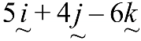 and 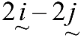respectively. A point X divides PQ in the ratio 5:-3, find the coordinates of X, hence magnitude of OX. (3 Marks)

- A jewelry room is guarded by three policemen X, Y and Z. The probability of a thief being caught by X is$\frac{1}{3}$, Y is $\frac{1}{5}$ and Z is $\frac{1}{4}$. Find the probability that the thief is caught by policeman Z. (3 Marks)

- Solve the equation $\cos^{2}$x – 2sin x = 2 for the range 0⁰ ≤ x ≤360⁰. (3 Marks)

- In the figure below, O is the centre of the circle and A if joined to B, passes through the centre of the circle O.

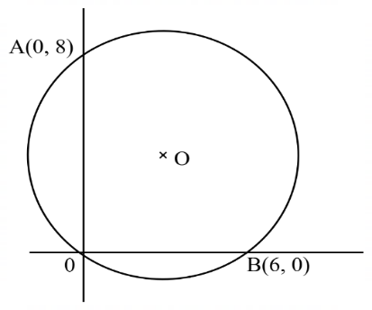
- Determine the centre and radius of the circle. (2 marks)

- Express the equation of the circle in the form x² + y² + ax + by = 0 where $a and b$are constants. (2 marks)

- The table below shows the monthly income tax rates for the year $2024$
$$Monthly taxable income$$ | $$Tax rates (percentages)$$
$$1-9,880$$ | $$10\%$$
$$9,881-19,480$$ | $$15\%$$
$$19,481-29,080$$ | $$20\%$$
$$29,081-38,680$$ | $$25\%$$
Mr. Michael’s monthly earning comprises of a basic salary of $ksh.X$ and allowances amounting to sh.5,200. When Mr. Michael claims a monthly tax relief of $ksh.1, 056$, his employer deducts from his earnings a tax of $ksh.1,282$. Calculate the value of $X$. (3 marks)

- A matrix M$\left(\begin{matrix}2 & 1 \\ 2 & 2\end{matrix}\right)$ maps an object point A(x,y) to A’(x₁,y₁). A matrix T $\left(\begin{matrix}1 & 2 \\ 3 & 1\end{matrix}\right)$ maps A’ to A’’(X₂,Y₂). Find the matrix which maps A’’ to A. (3 Marks)

- Three grades of coffee A, B and C were mixed in the ratio 1:2:3. The cost per kg of each of the grades A, B and C were sh 700, sh 490 and sh 630 respectively. Calculate the selling price per kg if a profit of 20% is to be realized. (3 Marks)

- The gradient function of a curve is given by 4x³ + 2x - 1. If the curve passes through a point (-2,1), find the equation of the curve. (3 Marks)

- Complete the table below for curve y = x² – 2x, draw the graph. Using the graph, find the gradient when x=2. (3 Marks)
X | 1 | 2 | 3 | 4
Y

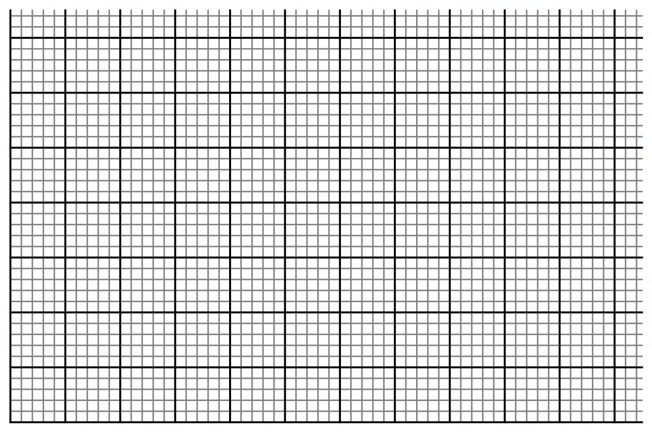

- The difference between the fourth and the seventh terms of an increasing arithmetic progression is 12. Calculate the sum of the first fifteen terms of the progression if the first term is 9. (3 Marks)

SECTION II (50 MARKS)
Answer any five questions from this section
- The table below shows the heights (in metres) of seedlings in Mr. Wanjala’s seedbed
- Use the information above to complete the table below. (3 Marks)
$$Height \left(m\right)$$ | $$F$$ | $$mid-point(x)$$ | $$t=\left(\frac{1000x-105}{40}\right)$$ | $ft$ | $$t^{2}$$ | $$ft^{2}$$
$$0.01-0.04$$ | $$12$$ |  |  | $$-24$$ |  | $$48$$
$$0.05-0.08$$ | $$17$$ |  | $$-1$$ |  | $$1$$
$$0.09-0.12$$ | $$31$$ |  | $$0$$ | $$0$$ | $$0$$ | $$0$$
$$0.13-0.16$$ | 28 |  | $$1$$
$$0.17-0.20$$ | $$23$$ |  | $$2$$ | $$46$$ | $$4$$
$$0.21-0.24$$ | $$9$$
- Using the completed table above, determine;
- The mean height of the seedlings. (2 Marks)

- The standard deviation of height of the seedlings. (3 Marks)

- Determine the probability of the number of seedlings whose height exceeds $0.142 m$. (2 Marks)

- Taking the radius of the earth, R = 6370km and π = ²²/₇.
- Calculate the shortest distance in km between the two cities, P(60ºN, 80ºW) and Q (60ºN, 10ºE). (2 Marks)

- An airplane flew from P at 1200hrs local time to Q along the parallel of latitude at a speed of 1001km/h. What was the local time at Q when it arrived? (4 Marks)

- The airplane then flew due south from point Q(60ºN, 10ºE) to point B at speed of 194.4 knots. The distance covered by the airplane was 3888nm. Find the position of B and the local time it arrived at B if it rested for 30mins at Q in twelve hour system. (4 Marks)

- (a) Complete the table below correct to 2 decimal places. (2 Marks)
 | 0 | 15 | 30 | 45 | 60 | 75 | 90 | 105 | 120 | 135 | 150 | 165 | 180
 |  | -1.7 | -1.00 |  |  |  | 2.0 |  | 1.0 |  | -1.0 | -1.7 | -2.0
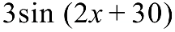 | 1.5 |  |  |  |  | 0.0 |  |  |  | -2.6 | -1.5
(b) Using a scale of 1 cm for $15°$ on the $x$-axis and 2 cm for 1 unit on the $y$-axis, and on the same Axes draw the graphs of 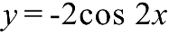 and 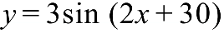 for 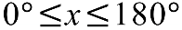. (5 Marks)

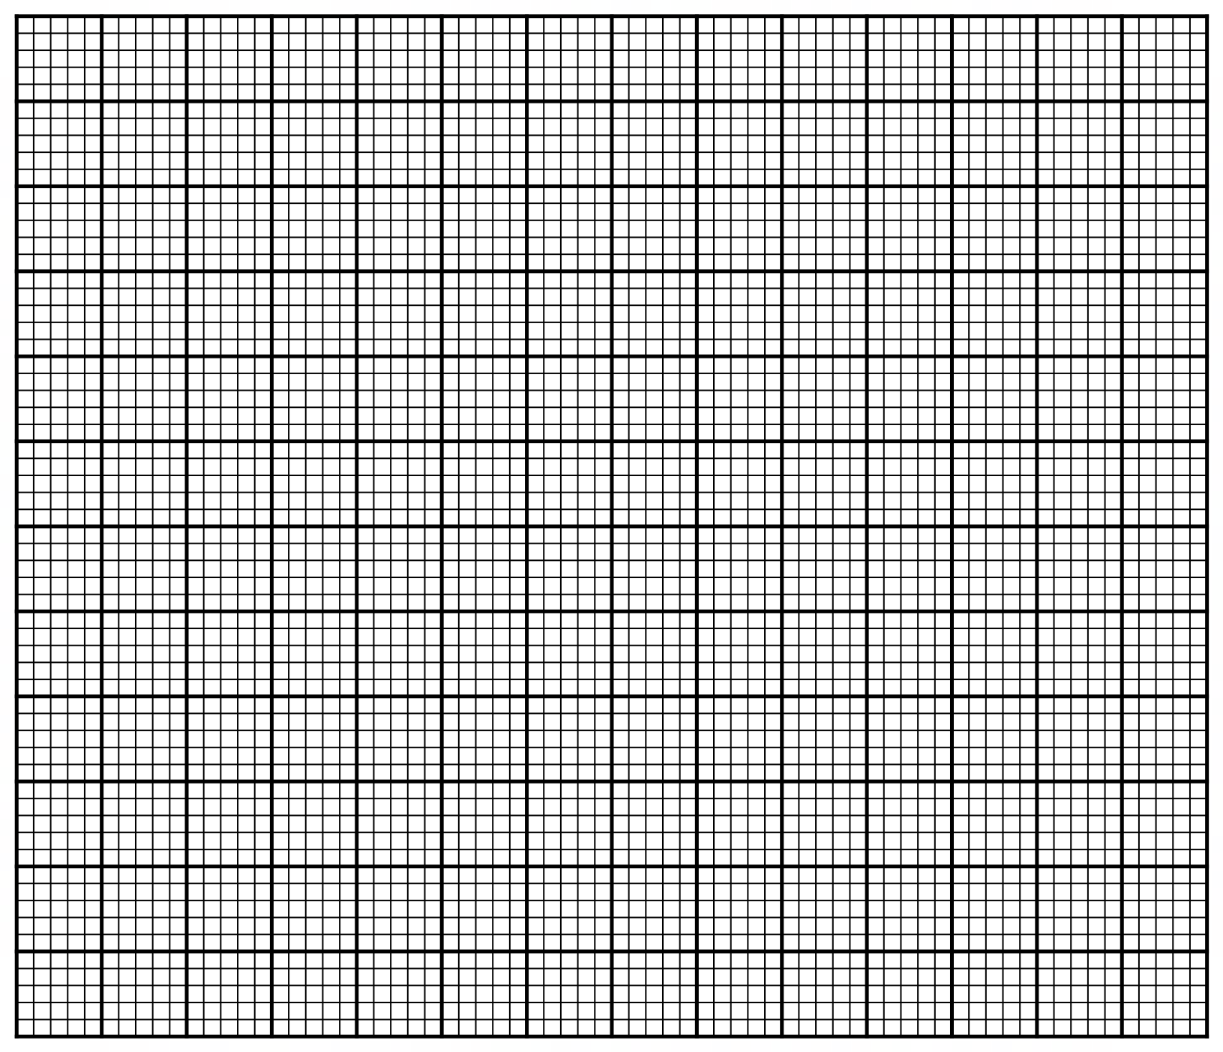

c) Using the graph in (b) above, solve the equation (2 Marks)

d) Find the range of values of $x$ for which 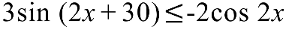 (1 Mark)

- In the figure below a triangular prism is placed on top of a cuboid. Point K and J lie vertically above line AD and BC respectively. $AB=KJ=18 m$, $BC=12 m$ and $CH=10 m$. . N is the mid-point of BC.
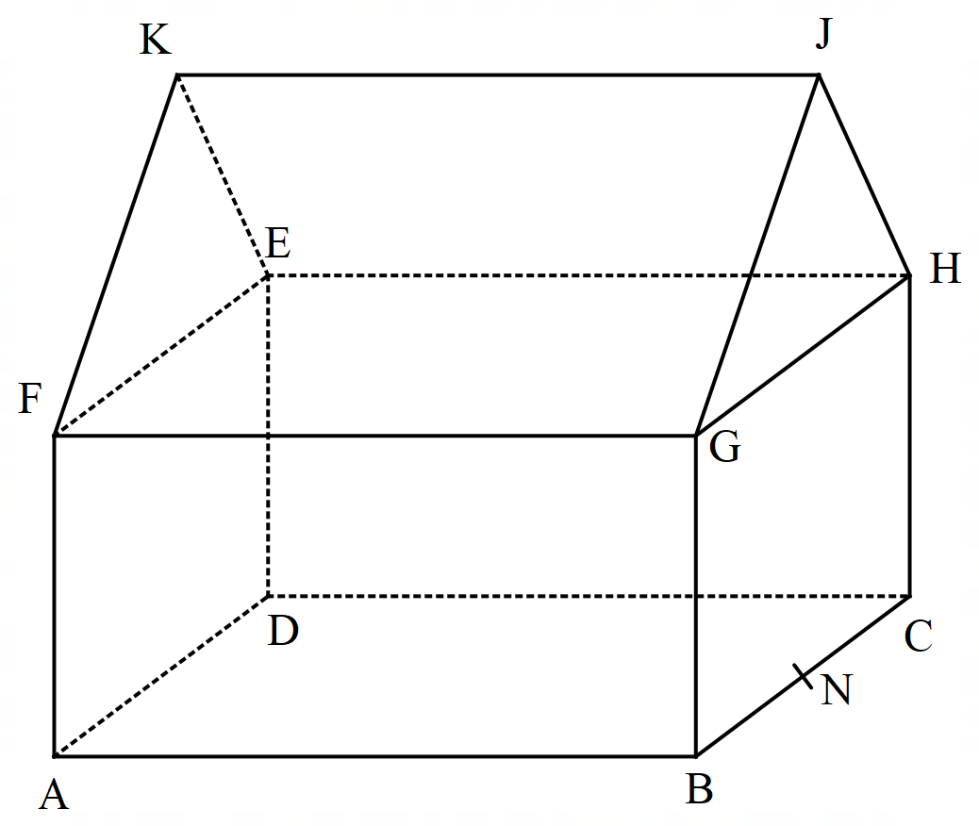
Calculate,
- The height of ridge $KJ$ above the base $ABCD$. (2 Marks)

- The angle between line $FJ$ and plane $EFGH$. (2 Marks)

- The angle between plane $FEJ$ and plane $ABCD$. (2 Marks)

- The angle between plane$FEN$and plane $ABCD$. (2 Marks)

- The angle between GC and AD. (2 Marks)
- A piece of land can be bought on cash at ksh.1,000,000 or on hire purchase terms, by making a down payment of ksh. 200,000 and a 24 monthly installment of sh.100,000 each.
- Calculate the carrying charge (2 Marks)

- Calculate the rate of interest charged per month on hire purchase terms. (2 Marks)

- If the piece of land appreciated at a rate of 5% p.a for the first two years compounded annually, in the next 3 years it appreciated at a rate of 12% p.a compounded quarterly. Calculate the value of the land after 5 years. (4 Marks)

- After five years, due to the environmental degradation the value of the land depreciated at a rate of 6% p.a. How long will it take for the value to depreciate to 1,153,625. (2 Marks)

- In the figure below O is the centre of the circle. A, B, C and D are points on the circumference of the circle. A, O, X, C and E are points on a straight line. DE is a tangent to the circle at D. Angle BOC$=48°$ and angle CAD$=36°$.
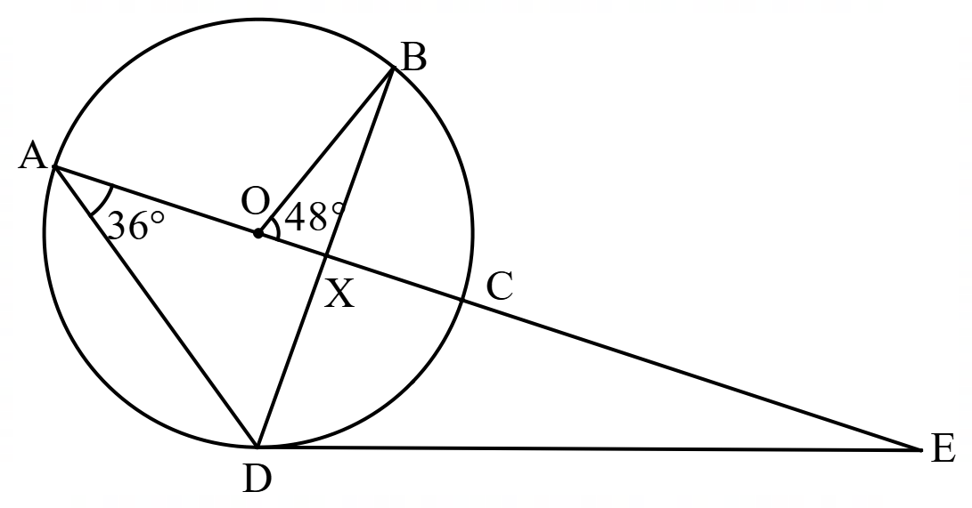
- Giving reasons in each case, find the value of each of the following angles:
- DBC (2 Marks)

- DEC (2 Marks)

- BCD (2 Marks)

- Given that AD = 15 cm, CE = 12cm. Calculate correct to 2 decimal places the:
- radius of the circle. (2 Marks)

- length DE (2 Marks)

- Using a ruler and a pair of compasses only for all constructions in this question;
- Construct triangle ABC in which$AB = 6cm$, $BC= 7cm$and $∠ABC = 75°$. (3 Marks)

- Find locus x such that $AX = 3 cm$. (1 Mark)

- On the same side of BC as A, construct the locus of P such that $∠BPC = 120°$. (3 Marks)

- Show by the shading, the locus of Q inside triangle ABC such that BPC ≤ 120⁰ and $AQ≥3 cm$. (1 Mark)
- On the opposite of C, construct the locus of T such that the area of triangle (2 Marks)
- A farmer has 50 hectares of land in which he plants potatoes and carrots. Each hectare of potatoes require 6 men while carrots require 2 men. The farmer has 240 men available. He must plant at least 10 hectares of potatoes. The profit on potatoes is sh.1,000 per hectare and carrots is sh.1,200 per hectare. If he plants x hectares of potatoes and y hectares of carrots.
- Write down four inequalities to represent the given information. (4 Marks)

- On the grid provided draw the inequalities. (3 Marks)

- Using your graph determine the number of hectares for each vegetable which will give maximum profit. (3 Marks)

