NAME …………………… …………………………………ADM NO ………………………….…….
SCHOOL.……………………………………………………CANDIDATE’S SIGN……...……………
CLASS............................................ DATE……………………………………..
121/2
MATHEMATICS ALT. A
Paper 2
JULY 2025
Time: 2 ½ Hours

NYAGA SECONDARY SCHOOL
MOCK EXAMINATION 2025
FORM FOUR EXAMS
Kenya Certificate of Secondary Education. (K.C.S.E)
MATHEMATICS ALT. A
Paper 2
INSTRUCTION TO CANDIDATES
a) Write your name and Admission number in the spaces provided above.
b) Sign and write the date of examination in the spaces provided above.
c) The paper consists of two sections. Section I and Section II.
d) Answer ALL the questions in Section I and any FIVE questions in Section II.
e) Show all the steps in your calculations, giving your answer at each stage in the spaces provided
below each question.
f) Marks may be given for correct working even if the answer is wrong.
g) Non-programmable silent electronic calculators and KNEC Mathematical tables may be used
except where stated otherwise.
h) Candidates should answer the questions in English.
i) This paper consists of 15 printed pages.
j) Candidates must check the question paper to ascertain that all pages are printed as indicated
and that no question(s) is/are missing
FOR EXAMINER’S USE
SECTION I
1 | 2 | 3 | 4 | 5 | 6 | 7 | 8 | 9 | 10 | 11 | 12 | 13 | 14 | 15 | 16 | Total

SECTION II

17 | 18 | 19 | 20 | 21 | 22 | 23 | 24 | Total

SECTION I (50MARKS)
Answer all questions in this section.
1. The third term of a geometrical progression is 2 and the fifth term is 18. Find the possible values of the common ratio and the second term in each case. (4marks)

2. A plot of land was valued at sh. 1.5 million at the start of 2008. The plot appreciated by 18% during 2008. If in every year after 2008 it appreciated by 12% of its previous year’s value. Find
a) The plot’s value at the start of 2009. (1mark)

b) The plot’s value at the end of 2012. (2marks)

3. A bag contains 3 yellow, 4 black and 5 green beads. Two beads are drawn at random from the bag, one after the other without replacement. Find the probability that at least one is yellow.
(2marks)

4. The tangent to the circle x² + y² – 2x - 6y + 5 = 0 at the point (3,4) meet the x-axis at p. Find the coordinate of P. (3marks)

5. In a school trip there were x buses and y luxury vans. Each bus was hired at Ksh. 1000 and could carry 60students. Each van was hired at Ksh. 2000 and could carry 30 students. Express the following statements as inequalities in x and y.
i) There must be vans.
ii) There should be at least 3 buses.
iii) The school should not spend more than Ksh. 18,000 on the trip.
iv) Not more than 420 students are to go on the trip. (4marks)

6. The position of an airport P and Q are (60⁰N 45⁰W) and Q (60⁰N K⁰E). It takes a plane 5 hours to travel due east from P to Q at an average speed of 600 knots. Calculate the value of K. (3marks)

7. Without using tables or a calculator, evaluate leaving your answer in the form where a,b and c are constants. (3marks)

8. T in a transformation A represented by the matrix under T, a square of area 10cm² is mapped onto a square of area 110cm². Find the value of x. (3marks)

9.a) Draw a line MN = 7cm and show the locus of a point P which is such that MPN = 90⁰. (2marks)

b) On the locus of P in the diagram in (a) above, locate the locus of T which is such that it is equidistant from M and N. (1mark)

10. Point T divides the line MN externally in the ratio 5:2 taking the position vectors of M and N to be M= and N = respectively. Find the coordinates of T. (2marks)

11.a) Expand (3 + x)⁷ in ascending power of x up to the term in X⁴. (1mark)

b) Use the expansion above (a) to find the value of (2.97)⁷ correct to 3 d.p. (2marks)

12. Two taps A and B, when opened at the same time can fill a tank in 3 hours and 36minutes. Tap A, working alone takes 3 hours longer than B to fill the tank. How many hours does it take tap A to fill the tank. (3marks)

13.a) ABC is a triangle in which BC = 17cm, CA = 9cm, AB = 10cm. Without using tables or calculators, calculate as fraction in simplest form Cos A. (2marks)

b) Calculate also without using tables or calculators, the area of triangle BC. (2marks)

14. If x is angle in the first quadrant such that 18 cos² x + 27 sin x = 25. Find tan x without using tables or calculators. (3marks)

15. In the figure ABC is a tangent to circle BDEF at B. BC = 17cm, DC = 10cm and BG = 15cm. Chord FD intersect chord BE at G and FG: GD = 1:5.
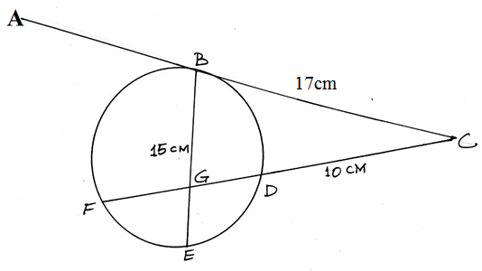
Find the length of
a) FD (1mark)

b) GE (2marks)

16. The following table has some values of x and y for the function y = x³ + 3 for the interval
x | -3 | -2.5 | -2 | -1.5 | -1 | -0.5 | 0 | 0.5 | 1 | 1.5 | 2
y | 12 | 9.25 | 7 | 5.25 | 4 | 3.25 | 3 | 3.25 | 4 | 5.25 | 7
a) Use the values to draw the graph of the function y = x³ + 3 on a grid. (2marks)
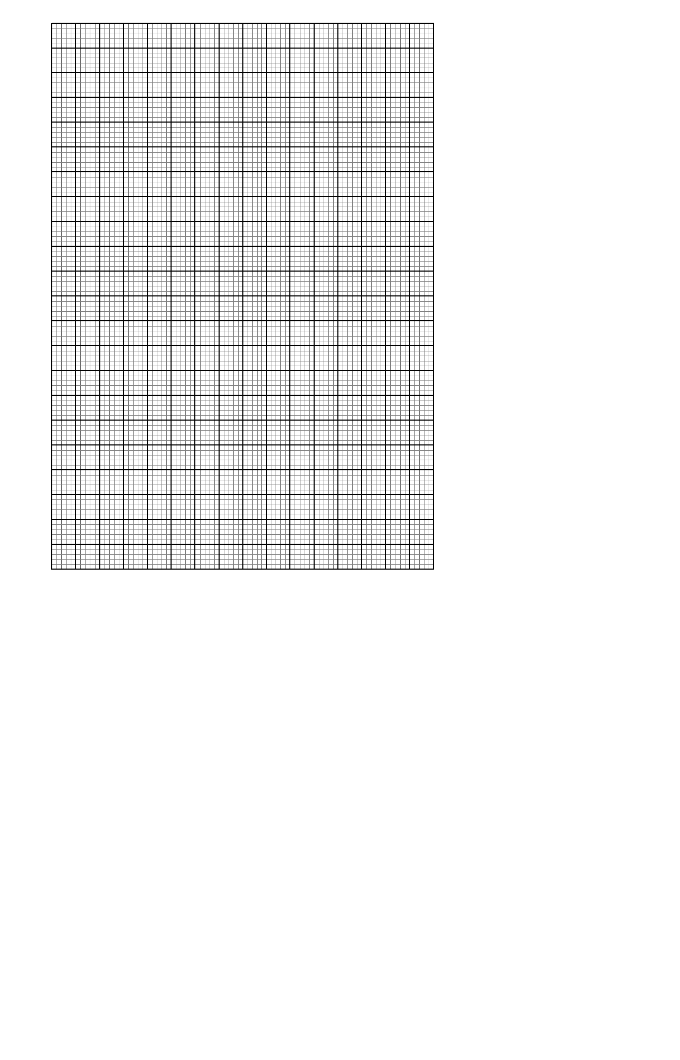
b) Use the mid- ordinate rule to estimate the area bounded by the curve, the x-axis and the lines x = -3 and x = 2. (2marks)

SECTION II (50MARKS)
Answer ANY FIVE questions only.
17.a) The mass of a cylinder of a given material varies jointly as the square of the radius and as the height. If the radius is increased by 20% and height by 10%. What is the percentage increase in mass? (3marks)

b) Several companies were invited to an inspirational talk by a popular businessman. The charge m, in shillings per person for attending the talk is partly fixed and partly inversely proportional to the total number of people p, in a company that will attend the talk.
i) Express m in terms of p. (1mark)

ii) 60 people from company A attended the talk and their total charge was sh. 30,000. 80 people from company B attended the talk and their total charge was sh. 36,000. What was the charge per person for company C if 75 people from the company attended the talk? (4marks)

iii) When a person that had already paid the full amount decided not to attend and requested for a refund, he/she was only to be refunded the fixed charge. 25% of some people from company D requested for a refund after they decided not to attend the talk. The talk organizers refunded them and were left with 22,800. Determine the number of people from the company D that had initially paid the attendance. (2marks)

18.a) Solve for A in (2marks)

b) Complete the table below and use it to answer the questions below. (2marks)
x | -180 | -150 | -120 | -90 | -60 | -30 | 0 | 30 | 60 | 90 | 120 | 150 | 180
2cosx |  |  |  |  |  | 1.73 |  |  |  | 0
Sin2x |  |  |  |  |  | -0.87 |  |  |  | 0
i) Draw the graph of y = sin 2x and y = cos x on the same set of axes using a scale of 1cm for 30⁰ on x-axis and 2cm for 1unit on y-axes. (4marks)
ii) Estimate the values of x for which
a) 2 cos x – sin 2x = 0 (1mark)

b) 2 cos x = - 0.6 (1mark)

19.a) The figure below is a circle centre O and radius 6cm. if the area of the sector OPQ = 4п cm². Calculate the size of angle PRQ. (2marks)

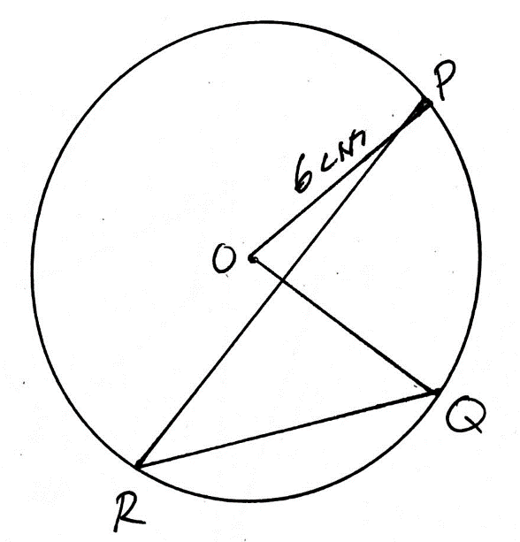

b) In the figure below ABCDE is a pentagon inscribed in a circle centre B. CB is parallel to DAF and AB = CD = DE. Angle BAD = 72⁰ and BFA = 38⁰. Giving reasons in each case, determine the following angles.

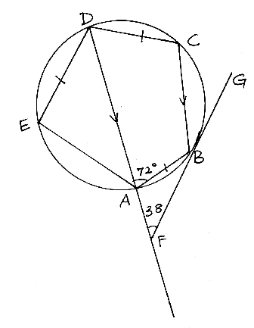

i) ABF (2marks)

ii) BDA (2marks)

iii) BCD (2marks)

iv) DAE (2marks)

20.a) A particle starting from rest at a point O moves in a straight line such that its velocity V m/s after t, seconds is given by V = 6t – 2t². Calculate the distance travelled by the particle between t = 2 and t = 5. (3marks)

b) The acceleration of a particle a m/s² of an object that starts moving from rest at time t seconds is given by a = 2t – 6. If the initial velocity is 15m/s.
i) Give an expression for the objects velocity. (2marks)

ii) Find the velocity at t = 3sec. (1mark)

iii) Give an expression in terms of t for the object’s displacement. (1mark)

iv) Determine its total displacement in 2nd and 3rd seconds. (2marks)

c) Find the minimum velocity that the object attained. (1mark)

21. The following table shows the ages in a years of 70 people that attended a conference.
Age in years | 30-34 | 35-39 | 40-44 | 45-49 | 50-54 | 5-59 | 60-64 | 65-70
Frequency | 3 | 5 | 7 | 9 | 11 | 15 | 14 | 6
a) Calculate
i) Mean (2marks)

ii) Standard deviation (2marks)

b) On the grid provided, draw an ogive for the data. (3marks)
c) Use your graph to find
i) Median (1mark)

ii) The inter quartile range. (1mark)

iii) The 35th percentile (1mark)

22. A tetrahedron has equilateral triangular base ABC of side 10cm. The vertex V is such that VA= VB = VC= 8cm. Calculate
a) The height of the pyramid. (2marks)

b) The angle between the planes ABC and BCV. (2marks)

c) The angle between AV and the base ABC. (2marks)

d) The angle between planes ACV and BCV. (3marks)

e) The volume of the pyramid. (1mark)

23. The table below shows income tax rules that were used in 2023.
Income (sh per month) | Rate %
1 - 10164 | 10
10165 – 19740 | 15
19741 – 29316 | 20
29317 – 38892 | 25
Over 38,892 | 30

From January to June that year Janet’s monthly taxable earnings amounted to sh. 32,500.
a) Find the gross tax on her monthly earnings. (3marks)

b) Janet was entitled to the following tax reliefs.
Monthly personal relief of sh. 1,162
Monthly insurance relief at the rate of 15% of the premium paid subject to a maximum relief amount of sh. 5,000 per month.
How much tax did she pay in a month if she paid a monthly premium of sh. 2,900 towards her life insurance policy? (2marks)

c) In June 2023, she received additional earnings that were taxed at 25% in each shilling. If she paid 31.55% more tax that month. Find the percentage increase in her earnings. (5marks)

24. The coordinates of the vertices of a rhombus ABCD are A(3,4), B(5,1), C(3,-2), D(1,1).
a.(i) Find the co-ordinates of vertices of its image A¹B¹C¹D¹ under the transformation defined by the matrix (2marks)

ii) Draw the object and its image on a grid. (2marks)

iii) On the same grid draw the image A^{II}B^{II}C^{II}D^{II} of A^{I}B^{I}C^{I}D^{I} under the transformation given by (2marks)
b(i) Describe the transformation that map A^{II}B^{II}C^{II}D^{II} back onto A^{I}B^{I}C^{I}D^{I}. (1mark)

ii) Find the matrix of transformation that map A^{II}B^{II}C^{II}D^{II} onto A^{I}B^{I}C^{I}D^{I} (1mark)

iii) Find a single matrix which will map ABCD onto A^{II}B^{II}C^{II}D^{II}. (2marks)

