Name……………………………………………….Adm No………..Class……
Index No……………………….. Signature…………………………

121/1
Mathematics Paper 1
Time: 2 ½ Hours
Term 2, 2025

NYAGA SECONDARY SCHOOL
MOCK EXAMINATION 2025

Kenya Certificate of Secondary Education (K.C.S.E)
INSTRUCTIONS TO CANDIDATES
- Write your name and Admission number in the spaces provided at the top of this page.
  - This paper consists of two sections: Section I and Section II.
  - Answer ALL questions from section I and ANY FIVE from section II
  - All answers and workings must be written on the question paper in the spaces provided
below each question.
  - Show all the steps in your calculation, giving your answer at each stage in the spaces
below each question.
  - Non – Programmable silent electronic calculators and KNEC mathematical tables may be
used, except where stated otherwise.

FOR EXAMINERS USE ONLY

SECTION I
1 | 2 | 3 | 4 | 5 | 6 | 7 | 8 | 9 | 10 | 11 | 12 | 13 | 14 | 15 | 16 | TOTAL

SECTION II
17 | 18 | 19 | 20 | 21 | 22 | 23 | 24 | TOTAL

GRAND TOTAL

SECTION I (50 MARKS)

1.Without using Logarithm tables or calculators, evaluate, 64 ^{½} x 27000^{2/3}
2⁴ x 3⁰x 5²
(3mks)

2. Simplify the expression $\frac{{3a}^{2}+4ab+b^{2}}{{4a}^{2}+3ab-b^{2}}$ (3mks)

3.The external length, width and height of an open rectangular container are 41 cm, 21 cm and 15.5cm respectively. The thickness of the material making the container is 5 mm. If the container has 8 litres of water, calculate the internal height above the water level. (3marks)

4. Translation T is represented by the column vector $\left(\begin{matrix}5 \\ 4\end{matrix}\right)$ and another translation U by column vector$\left(\begin{matrix}-3 \\ 2\end{matrix}\right)$. A point P is mapped to a point Q by T and then Q is mapped to a point R by U. If R has coordinates $\left(7,-4\right)$ determine the coordinates of P. (3 marks)

5. A line L₁ whose equation is $5x-3y-15=0$ passes through the points A and B. Point A is on the x-axis while point B is equidistant from x and y-axes and lies in the fourth quadrant of a Cartesian plane. Calculate the exact coordinates of points A and B. (3 marks)

6. Two trains T₁ and T₂ travelling in same direction, on parallel tracks, are just12m apart. Train T₁ is 72m long and travelling at 108km/h. T₂ is x m long and travelling at 72km/h. Find the length of T₂ in metres if they pass each other completely after 16.2s. (3 mks)

7. The actual area of an estate is 3510 hectares. The estate is represented by a rectangle measuring 2.6cm by 1.5cm on the map whose scale is l: n. Find the value of n. (give your answer in standard form) (3 marks)

8. The angles of elevation from two points A and B to the top of a storey building are 48⁰ and 57⁰ respectively. If AB = 50m and the point A and B are opposite each other; Calculate;
a) The distance of point A to the building (3 mks)

b) The height of the building (1 mks)

9. The mean of five numbers is 20. The mean of the first three numbers is 16. The fifth number is greater than the fourth by 8. Find the fifth number. (3mks)

10. A Kenyan bank buys and sells foreign currencies as shown below
Buying Selling
(In Kenya shillings) In Kenya Shillings
1 Hong Kong dollar 9.74 9.77
1 South African rand 12.03 12.11
A tourists arrived in Kenya with 105 000 Hong Kong dollars and changed the whole amount to Kenyan shillings. While in Kenya, she pent Kshs 403 897 and changed the balance to South African rand before leaving for South Africa. Calculate the amount, in South African rand that she received. (3mks)

11.In the figure below, ABCD is a cyclic quadrilateral. Point 0 is the centre of the circle. Angle ABO = 30° and angle ADO = 40°.
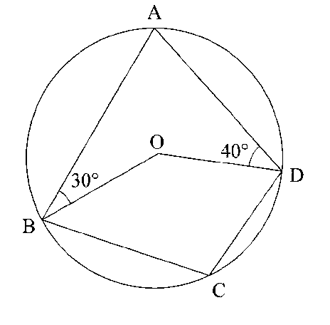

Calculate the size of angle BCD. (3 marks)

12.Find the inequalities that define the region R shown in the figure below. (3 marks) 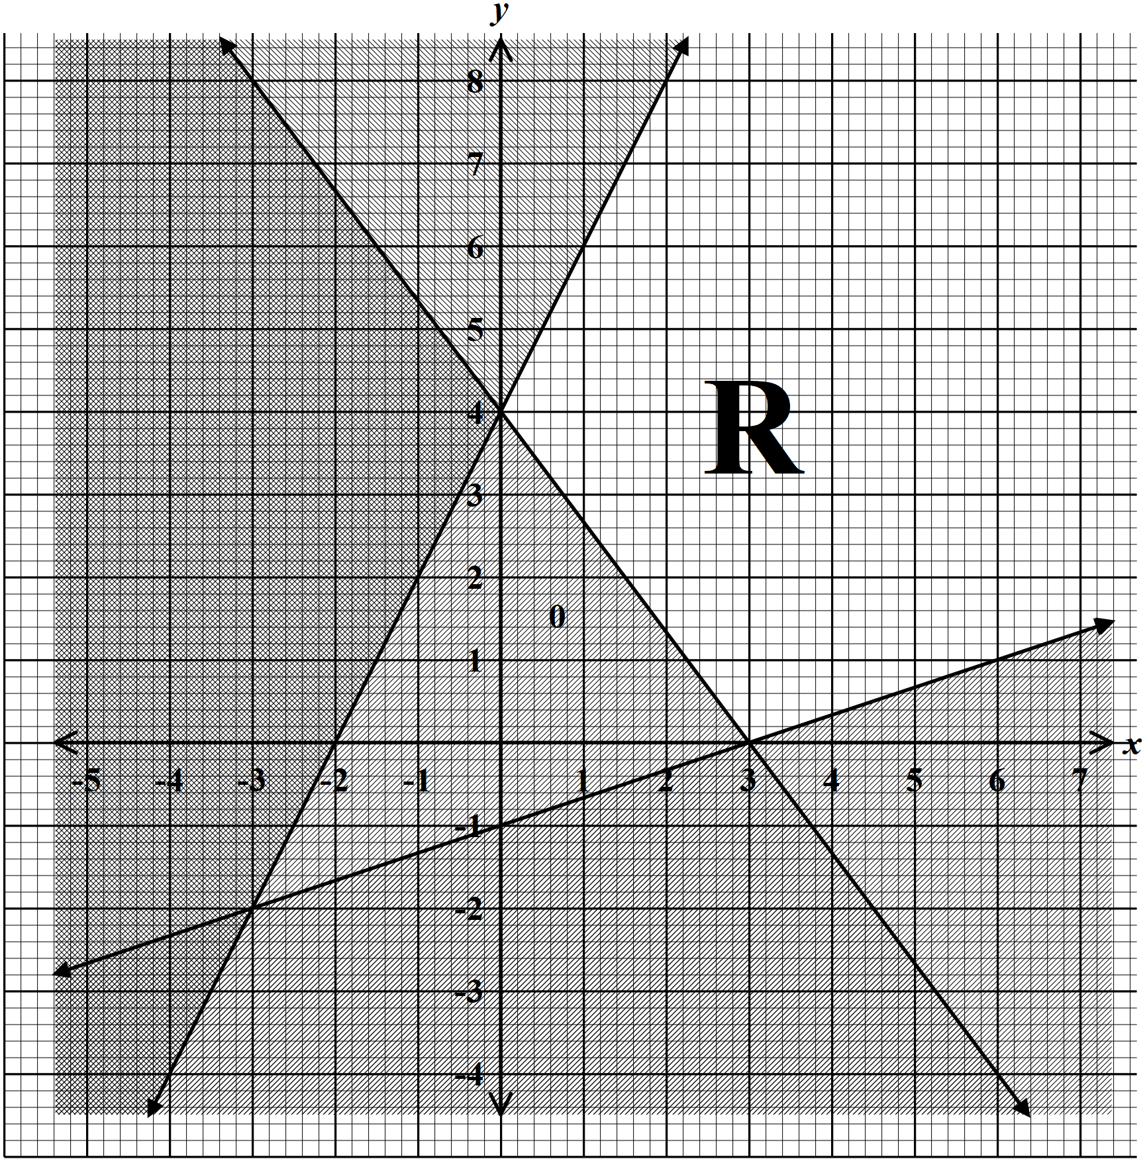

13.The length of a rectangle is increased by 20$\%$ while the width is decreased by 10$\%$ . Find the percentage change in area. (3marks)

14.Using the grid provided below, solve the simultaneous equation ( 4marks)
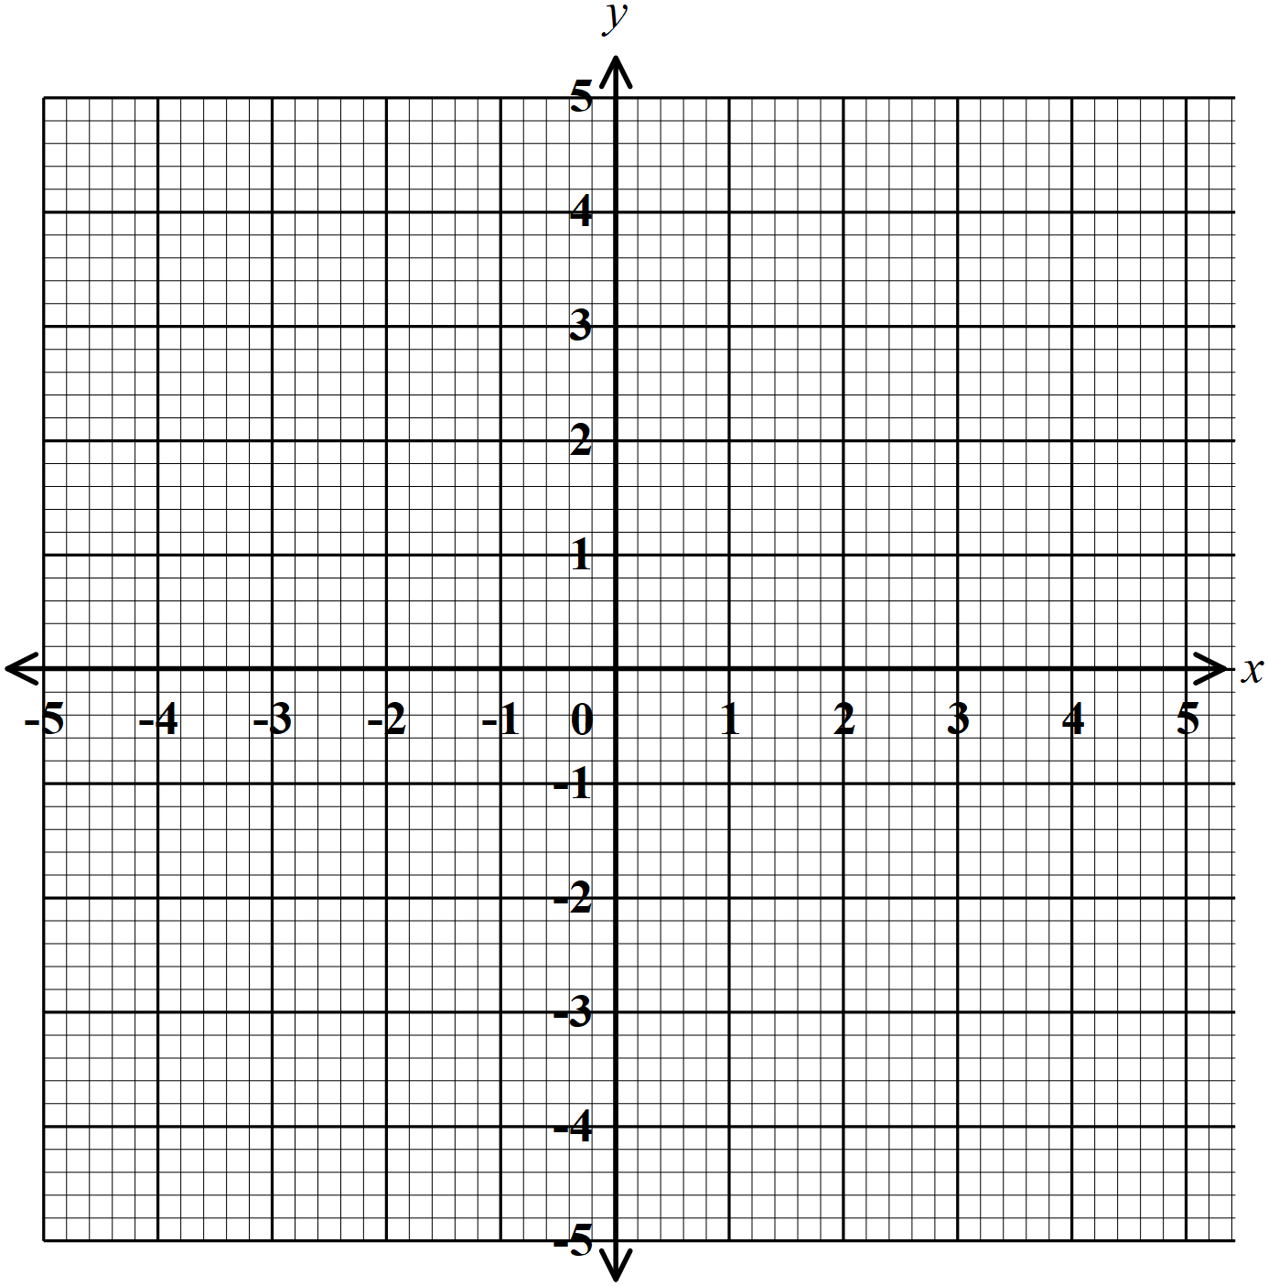

15. Using a ruler and a pair of compasses only, construct a rhombus PQRS such that PQ = 6 cm and angle PQR = 135⁰ hence measure the shortest diagonal. (3mks)

16.A transformation whose matrix is given by $\left(\begin{matrix}2x-1 & -3 \\ 2 & x\end{matrix}\right)$ maps a triangle with area 8 cm² onto another triangle with area 72 cm², calculate the value of $x$ (3 marks )

SECTION II (50 MARKS)
17(a) Find the equation of a straight line which is perpendicular to 3y – 5x = 5 and passes through the point of intersection of the lines 2x + y = 5 and x – 2y = 0 (5 marks)

(b) A straight line y = $2/3x- \frac{2}{3}$ meets the x axis at point T.
(i) Determine the coordinates of T (2 marks)

(ii) Determine the acute angle between the line y = $\frac{2}{3}x- 2/3$ and x – axis (2 mks)

(iii)Find the y –intercept of line y = $2/3x- 2/3$ (1mks)

18. While designing the water circulation system, planners of an estate used assumption that each housing unit in the estate will require at least 0.32m³ of water per day. To satisfy this need, they are to use a water pipe of radius 8cm to distribute the water. The water will be flowing in the pipe for only 14 hours a day at the rate of 24cm/s.
a.Determine the amount of water to the nearest litres, supplied in one hour. (3marks)

b. What is the maximum number of housing units that can be supported by the water circulation system? (Assume that a housing unit requires at most 0.32m³ of water per day). (2marks)

c. Each housing unit will pay a flat rate of sh. 280 per month for the supply of water. If the number of housing units in the estate is to be maximum and all end up being occupied, calculate the amount of money that will be collected in a month. (2 marks)

d. The maximum number of housing units were constructed and all got occupied. The estate ended up using on average 0.35m³ of water per housing unit per day. How much longer was the water pumped per day to satisfy the estate’s water demand? (3marks)

19. The equation of the curve is
(a) Determine
(i) The stationary points (4marks)

(ii) The nature of the stationary points in (a) (i) above (2 marks)

(b) Determine
(i) The equation of the tangent to the curve at (2marks)

(ii) The equation of the normal to the curve at (2marks)

20.The table below shows values of x and some values of y for the curve y = x³ + 2x²- 3x – 4
For -3 ≤ x ≤ 2
X | -3 | -2.5 | -2 | -1.5 | -1 | -0.5 | 0 | 0.5 | 1 | 1.5 | 2
y | -4.0 | -0.4 |  | 1.6 | 0 |  | -4.0 | -4.9 |  |  | 6
Complete the table by filling in the missing values of y, correct to 1 decimal place. (2 marks)
(b) On the grid provided, draw the graph of y = x³ + 2x² - 3x - 4. (3 marks)
Use the scale: 1 cm represents 0.5 units on x axis and 1 cm represents 1 unit on y axis.
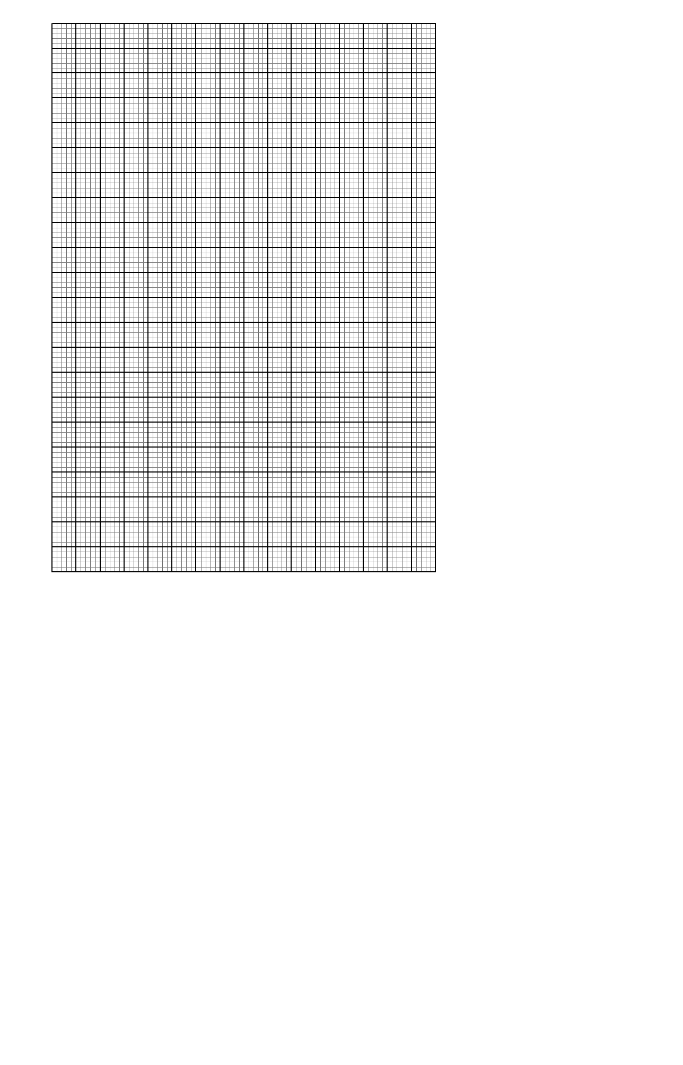

(c) Use the graph to:(i) Solve the equation x³ + 2x² - 3x - 4 = 0; (3 marks)

(ii) Estimate the coordinates of the turning points of the curve. (2 marks)

21.Three variables p, q and r are such that p varies directly as q and inversely as the square of r.
(a) When p=9, q=12 and r = 2.
Find p when q= 15 and r =5 (4mks)

(b)Express q in terms of p and r. (1mks)

(c)If p is increased by 10% and r is decreased by 10%, find;
(i)A simplified expression for the change in q in terms of p and r
(3mks)

(ii)The percentage change in q. (2mks)

22. A point A is (-1, 8) and B is (8, 2).
a. Find $\vec{AB}$. (2mks)

b. Find $\left|\vec{AB}\right|$ (2mks)

c. Given that a point P divides $\vec{AB}$ in the ratio 1:2, find the position vector of point P.(2mks)

d. Another point R has co-ordinates (11, 0) Show that points A, B and R are collinear(4mks)

23.The diagram below shows the speed-time graph for a train traveling between two stations. The train starts from rest and accelerates uniformly for 150 seconds. It then travels at a constant speed for 300 seconds and finally decelerates uniformly for 200 seconds.

Speed (m/s)

Time in seconds

Given that the distance between the two stations is 10 450 m, calculate the:
a) Maximum speed, in Km/h, the train attained; (3 mks)

b) Acceleration, (2 mks)

c) Distance the train traveled during the last 100 seconds; (2 mks)

d) Time the train takes to travel the first half of the journey. (3mks)

24. The coordinates of a triangle ABC are A(1, 1) B(3, 1) and C (1, 3).
(a)Plot the triangle ABC. (1mark)
(b)Triangle ABC undergoes a translation vector$\left(\begin{matrix}2 \\ 2\end{matrix} \right)$. Obtain the image of A' B' C ' under the transformation, write the coordinates of A' B' C'. (2 marks)
(c)A' B' C' undergoes a reflection along the line X = 0, obtain the coordinates and plot on the graph points A" B" C", under the transformation (2 marks)
(d)The triangle A" B" C" , undergoes an enlargement scale factor -1, centre origin. Obtain the coordinates of the image A'" B"' C"'. (2 marks)
(e)The triangle A"' B"' C"' undergoes a rotation centre (1, -2) angle 120⁰. Obtain the coordinates of the image A^{iv} B^{iv} C^{iv}. (2 marks)
(f) Which triangles are directly congruent. (1 mark)

