Name: ……………………………………..…..… ADM. No: ………………… Class: …………………………..Signature: ………………………………….

312/2
GEOGRAPHY
Paper 2
MOKASA II
JULY/AUGUST 2025
Time: 2³/₄ Hours.

MOKASA II JOINT EXAMINATION.
Kenya Certificate of Secondary Education
Geography
Paper 2
MOKASA II
Time: 2³/₄ Hours.

Instructions to candidates
- This paper consist of sections A and B.
- Answer ALL questions in section A, question 6 and any other two questions in section B.
- All answers to be written on the answer booklet provided.
- Candidates should check the question papers to ascertain that all the pages are printed as indicated and that no questions are missing.
FOR EXAMINERS USE ONLY:
SECTION | QUESTION | CANDIDATE SCORE
A | 1-5
B | 6
B | 7
B | 8
B | 9
B | 10
TOTAL SCORE
SECTION A
Answer All Questions In This Section.
1. (a) What is human geography? (2 marks)
(b) Give three benefits of studying human geography. (3 marks)
2. (a) Give two example of highland forests in Kenya. (2 marks)
(b) State three characteristic of coniferous forests. (3 marks)
3. (a) Apart from tsetse fly control, give two other methods of land reclamation. (2 marks)
(b) Give three methods of controlling tsetse flies. (3 marks)
4. (a) Study the map of a major fishing ground provided and use it to answer the questions that follow.
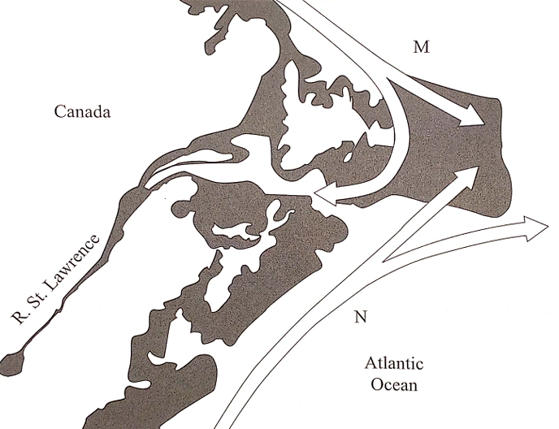

- Identify the fishing ground. (1 marks)
- Identify the ocean currents marked M and N. (2 marks)
(b) Name two fish species found in this fishing ground. (2 marks)
5. (a) Define regional trade. (2 marks)
(b) State three benefits Kenya has enjoyed by being a member of East African Community (E.A.C) trading bloc. (3 marks)

SECTION B.
Answer Question 6 and Any Other Two Questions in This Section.
6. Study the photograph below and use it to answer the questions below.
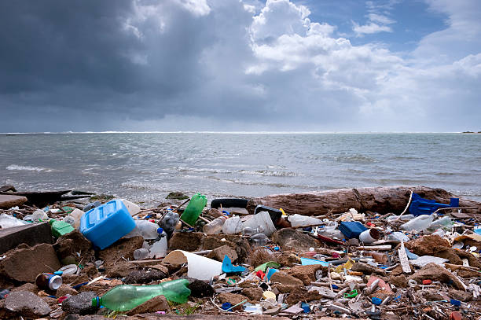
- (i). Identify the type of the photograph. (1 Mark)
(ii). Give reasons for your answer in (i) above. (2 Marks)
(iii). Draw a rectangle measuring 12cm by 10cm. On it, sketch and label features shown on the photograph. (4 Marks)
(b). (i) A part from land and water pollution name two other types of pollution. (2 Marks)
(ii).Identify three ways through which water is polluted. (3 Marks)
(iii) Explain three measures to curb water pollution along the shores of Lake Victoria. (6 Marks)
c.) State four reasons why land pollution is common in urban centers. (4 Marks)
- State three reasons for the need to conserve and manage the environment. (3 Marks)
7. (a) (i) What is a mineral ore? (2 marks)
(ii) Identify two examples of fossil fuels. (2 marks)
(iii) State three ways in which minerals occur in the crust. (3 marks)
- (i) Describe how diamond is processed in South Africa. (5 marks)
(ii) Give two uses of diamond. (2 marks)
(iii) State four problems facing diamond mining in South Africa. (4 marks)
(c) Form four students of Sakamo High School went for a field work in mining field around their school.
(i) How did they record their data? (3 marks)
(ii) Give four problems that they might have encountered during the field. (4 marks)
8. (a) (i) Name three large scale wheat growing counties in Kenya. (3 marks)
(ii) State five physical conditions that favor wheat growing. (5 marks)
(b) Compare wheat growing in Kenya and Canada under the following sub-headings:
- Mechanization. (2 marks)
- Government policy. (2 marks)
- Marketing. (2 marks)
(c) (i) What is market gardening? (2 marks)
(ii) State four characteristic of horticulture farming in Kenya. (4 marks)
(iii) State five challenges facing horticulture farming in Kenya. (5 marks)
9. (a) (i) State three reasons why some industries are located near water sources (3 Marks)
(b) (i) State four ways in through which the government of Kenya is helping to develop the Jua Kali industries (4 Marks)
(ii) Explain three problems of industrialization in Kenya (6 Marks)
(c) The map below shows the Ruhr industrial region of Germany.
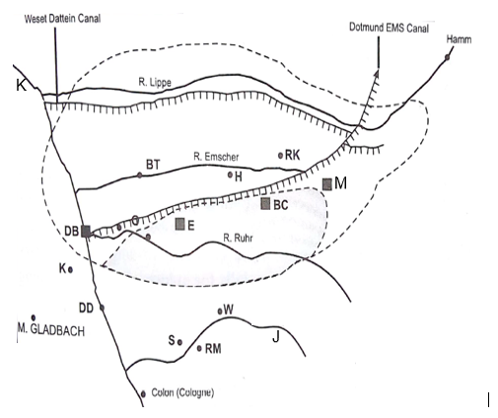
- Identify the town marked M (1 Marks)
(ii) Name the rivers marked J and K (2 Marks)
(iii) State the problems that face the Ruhr industrial region (3 Marks)
(d) Explain three factors that led to the development of car and electronics industry in Japan (6 Marks)

10. (a) (i) Differentiate between population and demography. (2 marks)
(ii) Explain how the following factors influence population distribution in Kenya.
  - Drainage (4 marks)
  - Vegetation (2 marks)
(b) (i) State four importance of population census. (4 marks)
(ii) Explain three measures that the governments of Kenya has taken to reduce infant mortality. (6 marks)
(c) (i) Give three causes of high dependency ratio in kenya. (3 marks)
(ii) Explain two ways in which population of Kenya differ from that of Sweden. (4 marks)

