MOKASA II JOINT EXAMINATION
Kenya Certificate of Secondary Education
312/2
Paper 2, 2025
GEOGRAPHY
M A R K I N G S C H E M E

SECTION A: 25 MARKS
Answer All Questions In This Section.
1. (a) What is human geography? (2 marks)
- It is a branch of geography that studies human activities carried out on the earth surface.
(b) Give three benefits of studying human geography. (3 marks)
- It prepares one for career opportunities.
- It creates international awareness which promotes international understanding and cooperation.
- It creates awareness on social values which create national unity in our country.
- It promotes development of valuable skills such as observation and critical thinking.
- It equips learners with environmental knowledge which help them to conserve the environment.
- It equips learners with practical skills such as observation, critical thinking, data analysis and map reading which help them to appreciate manual work.
2. (a) Give two example of highland forests in Kenya. (2 marks)

- Aberdare Forest
- Mt. Kenya Forest
- Cherangani Forest
- Kaptagat Forest
- Londiani Forest
- Marmanet Forest
- Mt Elgon
- Kakamega
- Nandi
- Molo
- Burnt Forest
- Turbo
- Tinderet
- Karura
- Ngong Hills
- Nyambene Hills

(b) State three characteristic of coniferous forests. (3 marks)

- Most trees are conical in shape.
- Most trees are light in weight
- The forest occur in pure stands.
- Most trees are soft woods
- Most trees bear cones.
- Most trees are ever green.
- Most trees have thick barks.
- Most trees have needle-like leaves
- Most trees have shallow root system that spread widely.
- Trees have a slow growth rate.
- Most trees have slender straight trunks with flexible branches.

3. (a) Apart from tsetse fly control, give three other methods of land reclamation. (2 marks)
- Irrigation for semi-arid areas.
- Drainage of swamps by cutting drainage channels.
- Planting trees/ afforestation.
- Constructing dykes and dams to control floods.
(b) Give three methods of controlling tsetse flies. (3 marks)
- Selective bush clearing.
- Spraying with insecticides.
- Sterilizing the male flies.
- Catching flies with nets.
- Creating buffer zone
4. (a) Study the map of a major fishing ground provided and use it to answer the questions that follow.
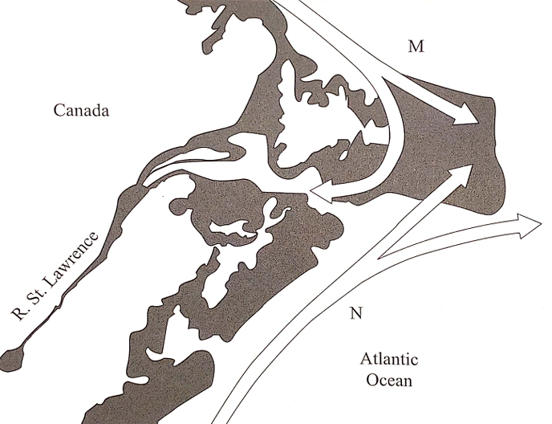
- Identify the fishing ground. (2 marks)
  - North West Atlantic fishing ground.
- Identify the ocean currents marked M and N. (2 marks)
M- Cold Labrador current.
N- Warm Gulf Stream.
(b) Name two fish species found in this fishing ground. (2 marks)

- Mackerel
- Sardines
- Flounder
- Haddock
- Tuna
- Herring
- Halibut
- Pilchard
- Lobsters
- Whiting
- Shellfish
- Hake
- Menhaden

5. (a) Define regional trade. (2 marks)
- It is the buying and selling of goods and services between countries that are found within the same geographical region. Eg. COMESA, ECOWAS, EAC, SADC and EU.
(b) State three benefits Kenya has enjoyed by being a member of East African Community (E.A.C) trading bloc. (3 marks)
- There is improved access to raw material which has promoted development of industries.
- It has offered a larger market for good produced in Kenya which has booted growth of industries hence more earnings.
- It has promoted exchange of research findings and training which help in economic development.
- It has led to improved transport links between the member countries which ensures faster movement of goods and people.
- It has increased employment opportunities because of free movement of people within the region.
- It has promoted mutual understanding between Kenya and its neighbors thus creating a viable environment for trade.
- It has increased the number of tourists visiting Kenya as a result of opening border points which is a source of revenue.

SECTION B.
Answer Question 6 and Any Other Two Questions in This Section.
6. Study the photograph below and use it to answer the questions below.
- (i). Identify the type of the photograph. (1 Mark)
- Ground general view
(ii). Give reasons for your answer in (i) above. (2 Marks)
- The objects reduce in size from the foreground towards the background
- The photograph focusses on many different features
- The camera was held horizontally to the ground.

(iii). Draw a rectangle measuring 12cm by 10cm. on it sketch and label features shown on the photograph. (4 Marks)
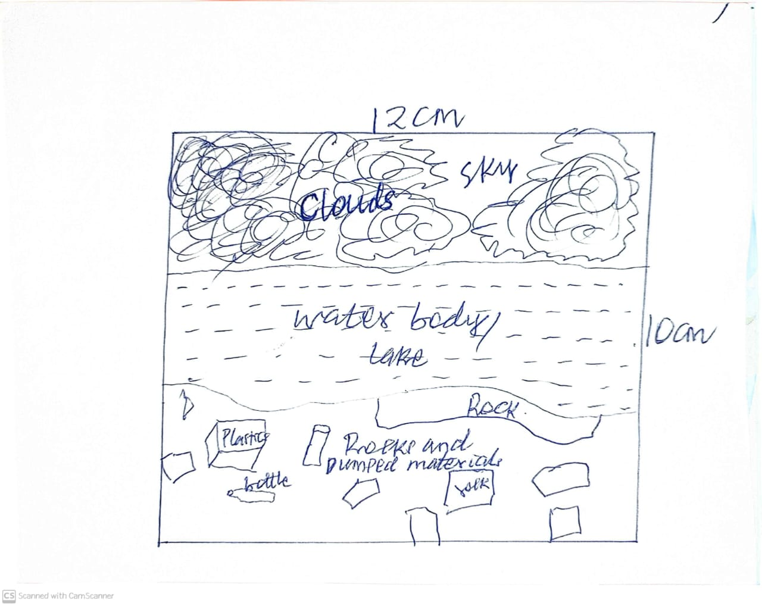
(i). A part from land and water pollution name two other types of pollution. (2 Marks)
- Air pollution.
- Noise / sound pollution

(ii).Identify three ways through which water is polluted. (3 Marks)

- Discharge of agricultural chemicals into rivers/lakes by rain water.
- Discharge of raw sewage into water bodies
- Directing effluents from industries and factories to water bodies.
- Oil spills from tankers and burst oil pipes.
- Testing of nuclear weapons under the sea.
- Bathing and washing clothes in the lakes and rivers.

(iii) Explain three measures to curb water pollution along the shores of Lake Victoria (6 Marks)
- Treating industrial waste before being discharged into water bodies.
- Recycle industrial waste in order to reduce industrial waste turn over.
- Farmers to be advised to use more of organic manure to reduce use of agro-chemicals fertilizers.
- Clean up campaigns to be done/ clean beaches and dumps along river valleys and lakes.
- Educating people on the appropriate ways of waste disposal/ effects of water pollution.
- Planting trees along river banks to control soil erosion.

(c). State four reasons why land pollution is common in urban centers. (4 Marks)

- High turnover of garbage by the high urban population and industries.
- Laxity in collection of wastes / garbage.
- Poorly enforced by-laws concerning dumping.
- Shortage or scarcity of garbage bins.
- Ignorance on the part of the residents.

(d) State three reasons for the need to conserve and manage the environment. (3 Marks)

- To sustain human life
- To protect endangered species of plants and animals
- The natural resources in the environment are of economic value
- Plants and animals are of aesthetic value
- For posterity
- To curb global warming

7. (a) (i) What is a mineral ore? (2 marks)
- A rock bearing a valuable mineral within the rocks of crust.
(ii) Identify two examples of fossil fuels. (2 marks)
  - Petroleum/crude oil
  - Natural gas
  - Coal
(iii) State three ways in which minerals occur in the crust. (3 marks)
  - Some occur in veins and loads.
  - Some occur in seams and beds.
  - Some occur as alluvial deposits.
  - Some occur as weathered rock products.
(b) (i) Describe how diamond is processed in South Africa. (5 marks)
- The rock ore is crashed into small pieces.
- The particles are washed with water to remove dirt.
- Diamonds and rock particles are passed over a rotating table covered with grease.
- Diamonds stick on the grease while the wet rock particles have slide over.
- The rotating table is stopped and diamonds recovered.
- The diamonds are then sorted out and taken to the factory.
(ii) Give two uses of diamond. (2 marks)
- Used for making instruments for cutting hard rocks and metals
- Used as a polishing equipment.
- Used for jewelry
(iii) State four problems facing diamond mining in South Africa. (4 marks)
- Fluctuations of world prices lead to low profits.
- Low mineral content in the Ore.
- High cost of mining the deep mines.
- Depleting diamond reserves.
- Competition of skilled labor with other sectors of economy.
- Striking workers slows production.
- Collapse of underground mines.
- Dusty conditions in the mines due to blasting.
(c) Form four students of Sakamo High School went for a field work in mining field around their school.
(i) How did they record their data? (3 marks)
- Note taking
- Tallying
- Tabulating
- Photographing/filming/video recording.
(ii) Give four problems that they were likely to encounter on the field. (4 marks)
- Sudden illness.
- Dusty environment that can cause respiratory problems.
- Inaccessible areas due to hips of worthless earth.
- A lot of noise pollution.
8. (a) (i) Name three large scale wheat growing counties in Kenya. (3 marks)

  - Uasin-gishu
  - Nakuru
  - Narok
  - Nyandarua
  - Laikipia
- Meru
- Transnzoia
- Nyeri
- Transmara.
- Elgeyo/ keiyo
- Samburu.

(ii) State five physical conditions that favor wheat growing. (5 marks)
- Presence of cool to warm conditions up to maturity.
- Presence of a warm dry sunny period for ripening and harvesting of wheat.
- Presence of moderate to high rainfall per year.
- Presence of gently sloping landscape for ease of farm mechanization and drainage.
- Presence of high altitude which creates cool conditions.
- Presence of frost free conditions during the growing period.
- Presence of extensive land for large scale wheat farming.
- Deep well drained soils.

(b) Compare wheat growing in Kenya and Canada under the following sub-headings:
- Areas of cultivation. (2 marks)
- In Kenya wheat is cultivated in the high altitude regions with cool conditions as lowlands are too humid for wheat to thrive while in Canada wheat is grown in lowlands as the highlands are too cold for crops.
- Transportation. (2 marks)
  - In Kenya there is a poor network of roads and railways used to transport wheat while in Canada there is well developed network of roads, railways and water ways for transporting wheat.
- Marketing. (2 marks)
- In Canada wheat is for both local and export markets while in Kenya it is for local market only.
- Canada has a larger and reliable local market compared to Kenya.
(c) (i) What is market gardening? (2 marks)
  - It is the intensive cultivation of vegetables and fruits for sale in the nearest urban markets.
(ii) State four characteristic of horticulture farming in Kenya. (4 marks)
  - Farms are generally small in size.
  - There is intensive use of land for maximum produce.
  - It is mostly done under greenhouses especially for flowers.
  - It is carried out under irrigation.
  - It is labor intensive.
  - It is capital intensive.
  - It is export market oriented with little going to the local market.
  - Most horticultural farms are owned by the rich people or foreign companies.
  - Horticulture farmers are highly specialized for quality produce.
  - Modern farming methods are used for optimum production.
(iii) State five challenges facing horticulture farming in Kenya. (5 marks)
  - High freight charges by airlines which make products expensive to market hence less profits to the farmers.
  - Poor and impassable road network during the rainy season which make the delivery of products difficult hence loss to the farmers.
  - Inadequate refrigeration facilities lead to spoilage of their produce hence wastage and loss.
  - Poor marketing strategies leading to exploitation of farmers by the middle men which make farmers incur losses.
  - Presence of low quality produce which fetches low prices in the world market making farmers to incur losses.
  - Farmers face competition from the established and upcoming producers which limits the quantity sold to the world market.
  - Presence of stringent quality standards at the international markets increases the cost of production hence lowering the profit margin of farmers.
  - Fluctuation of world market prices leading to inconsistent profit margins which discourage farmers.
  - High cost of inputs leading to low and poor production as it is difficult to control pests and diseases like late bright, rust, purple bloth and nematodes.

9.(a) (i) State three reasons why some industries are located near water sources (3 Marks)

- Some industries need large amount of water for cleaning.
- Some industries use water for cooling machines.
- Some industries dispose off their waste materials through water.
- Water provides cheap means of transport.
- Water is a raw material in some of the industries.

(b) (i) State four ways in through which the government of Kenya is helping to develop the Jua Kali industries (4 Marks)

- The ministry of Trade and Industry has set up a department to promote this industry.
- Kenya Industrial estates provides loans to Jua Kali industry for the purchase of materials.
- Kenya industrial estates has put permanent structures/sheds where the artisans can operate at low costs.
- The local authorities have set aside land for use by Jua Kali artisans
- Jua Kali artisans have been encouraged to form cooperatives to assist in the marketing of their products.

(ii) Explain three problems of industrialization in Kenya (6 Marks)

- Some industries lead to displacement of people disrupting their economic /social life.
- Some industries emit gases that are toxic causing harm to human/animals.
- Industrialization leads to rural-urban migration increasing urban population hence shortage of houses /congestion /increase in crime rates.
- Uncontrolled disposal /dumping of industrial wastes leading to land degradation /pollution.
- Industrial wastes /effluents pollute water sources making it unfit for human /animal consumption.
- There is imbalance in economic development due to concentration of infrastructure /social services in the industrial centers.
- Industrialization may cause neglect of agriculture sector leading to shortage of food /importation of food.

(c) The map below shows the Ruhr industrial region of Germany.

(i) Identify the town marked M (1 Marks)
- Dortmund
(ii) Name the rivers marked J and K (2 Marks)
- J- River Wupper
- K- River Rhine
(iii) State the problems that face the Ruhr industrial region (3 marks)

- There is environmental pollution from smoke/fumes and solid wastes discharged into the rivers.
- There is congestion and overcrowding in housing and social amenities due to large influx of people.
- Depletion of coal mines due to coal being non-renewable.

(d.) Explain three factors that led to the development of car and electronics industry in Japan (6 marks)

- The country has adequate capital from rich families / companies to invest in the car manufacturing and Electronic industries.
- The advanced technology has increased efficiency leading to mass production of high quality products.
- Highly developed sources of energy such as HEP / nuclear power provide the power required in the industries.
- Large population with high purchasing power provides a large local market for cars and electronics.
- Japan has highly skilled and industrious work force which has promoted massive production of quality cars/ electronics.
- The efficient transport system which eases the transportation of raw materials for industries.
- The rise of Empire Meiji who promoted industrial development in Japan.
- The rugged terrain of Japan hinders agricultural development making industrialization as an alternative source of income.
- Strategic location of Japan in relation to other countries makes it accessible to leading sea routes.

10. (a) (i) Differential between population and demography. (2 marks)
- Population is the total number of people living in an area while demography is the study of human population
- Explain how the following factors influence population distribution in Kenya.
- Drainage (4 marks)
- Low lying areas that are prone to periodic flooding and water logging are sparsely populated because they are unsuitable for agriculture and other economic activities.
- Fresh water sources offers water for doestic use thus attracts may people in place.
- Flood free areas attract many people to settle there since it is safe.

- Vegetation (2 marks)
- Savannah lands harbor wild animals/disease carrying vectors that discourage human settlement and other economic activities leading to sparse population.
(b) (i) State four importance of population census. (4 marks)
- Useful for planning purposes e.g. education.
- To help in distribution of resources.
- To estimate population growth.
- To identify rates of birth and deaths.
- To help government make decision in creating new administrative boundaries.
(ii) Explain three measures that the governments of Kenya has taken to reduce infant mortality. (6 marks)
- There has been widespread immunization for children to control diseases.
- The government provides free medical services for children under 5 years.
- The government encourages provision of homes for orphans.
- There is a government policy granting longer maternity leaves for mothers.
- Research on infant related diseases has been stepped up.
- Improved education on nutrition and hygiene.
(c) (i) Give three courses of high dependency ratio. (3 marks)
- High level of unemployment.
- High birth rates.
- Slow economic growth.
- High fertility rate
- High mortality of the middle aged people.
(ii) Explain two ways in which population in Kenya differ from that of Sweden. (4 marks)
- Low life expectancy in Kenya while high life expectancy in Sweden.
- High birth rate in Kenya while low birth rate in Sweden.
- High death rate in Kenya while low death rate in Sweden.
- High dependency ratio in Kenya from children while Sweden has high dependency ratio from the aged.
- In Kenya, most people live in rural areas while on Sweden many people live in urban areas.

