KENYA JUNIOR SCHOOL EDUCATION ASSESSMENT (KJSEA)
GRADE 9: SOCIAL STUDIES
CODE: 011 YEAR: 2025 TIME: 1 Hour 40 Minutes
Candidate’s Name: ___________________________________. Assessment Number: _____________________.
School Name: ________________________________________. School Code: _______________________________.

Candidate’s Signature: ______________________________. Date: ________________________________________.
INSTRUCTIONS TO CANDIDATES
- Write the required details in the spaces provided above.
- This paper consists of two sections: A and B.
- Answer ALL questions in Section A and in Section B.
- All answers must be written in the spaces provided.
For official use only
SECTION A: MULTIPLE CHOICE QUESTIONS (20 Marks)
Question No. | 1 | 2 |  | 3 | 4 |  | 5 | 6 | 7 |  | 8 | 9 | 10
Max Score | 1 | 1 |  | 1 | 1 |  | 1 | 1 | 1 |  | 1 | 1 | 1
Candidate’s Score
Question No. | 11 |  | 12 |  |  | 13 |  | 14 |  | 15 |  | 16 | 17 | 18 | 19 | 20 | TOTAL
Max Score | 1 |  | 1 |  |  | 1 |  | 1 |  | 1 |  | 1 | 1 | 1 | 1 | 1 | 20
Candidate’s Score
SECTION B: STRUCTURED QUESTIONS (60 Marks)
Task | Qn Nos. | Max Marks | Candidate's Score
TASK 1: MAPWORK | Q1 a–c | 5
TASK 2: CITIZENSHIP | Q1 a–c | 5
TASK 3: HISTORY | Q1–12 | 30
TASK 4: GEOGRAPHY | Q1–8 | 30
TASK 5: LIFE SKILLS | Q1–3 | 10
TOTAL SCORE (Standardized to 60 Marks) | — | 60
2025 THE COMPETENCE KENYA ASSESSMENT COUNCIL. Turn over

SECTION A: MULTIPLE CHOICE QUESTIONS (20 Marks)
Answer ALL questions in this section.

- During a civic education lesson, a learner says that citizens should respect laws and pay taxes. Which component of citizenship is being emphasized?
A. Rights
B. Responsibilities
C. Freedoms
D. Privileges
- A cargo ship left Cape Town at 8:00 a.m. local time and sailed east across 30° of longitude. If each 15° changes time by one hour, what time was it when they arrived?
A. 10:00 a.m.
B. 6:00 a.m.
C. 2:00 p.m.
D. 12:00 noon
- A farmer wants to exchange maize for fish but finds it hard to find a fisher with the exact quantity he needs. Which limitation of barter trade does this illustrate?
A. Lack of durability of goods
B. Lack of double coincidence of wants
C. Difficulty in measuring value
D. Lack of standard currency
- Two feuding communities in Rift Valley agree to meet and discuss resource sharing peacefully. Which method of conflict resolution are they using?
A. Coercion
B. Negotiation
C. Arbitration
D. Litigation
- The ruins of Gedi on the Kenyan Coast are visited by students on a field trip. Which type of historical site is this?
A. Burial ground
B. Military fort
C. Ancient settlement
D. Industrial site
- The Kenyan government seeks views from citizens before passing a new law. Which constitutional process is being followed?
A. Judicial review
B. Public participation in legislation
C. Electoral process
D. Executive order

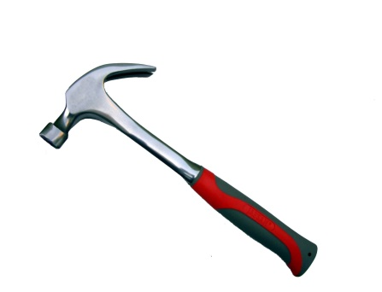
- Which one of the tool below is a stone age tool
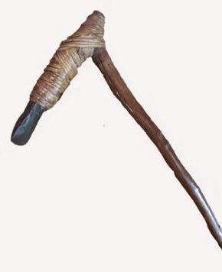

A B


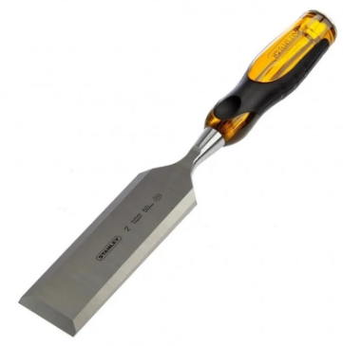

C D

- Sylvia saw a population pyramid with a very broad base, rapidly tapering towards the top,
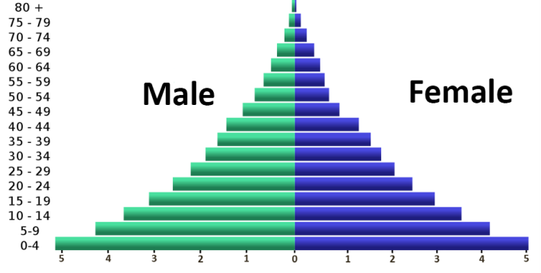
This is characteristic of a:
A) Developed country B) Developing country C) Stationary population D) Declining population
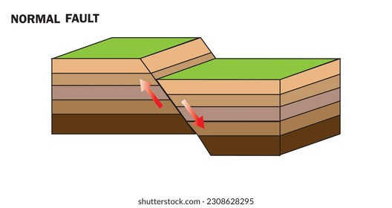
- Identify the type of fault shown below

    - Recumbent fault
    - Normal fault
    - Reverse fault
    - Asymmetrical fault
- The theory that suggests the Earth's outer rigid layer is broken into large pieces that move over the asthenosphere is known as:
A) Continental Drift theory
B) Plate Tectonics theory
C) Big Bang theory
D) Glacier theory
- A campaign promotes education for girls in rural areas, arguing it is a basic right. Which human right is being promoted?
A. Right to work B. Right to education
C. Right to property D. Right to vote
- A learner constantly compares herself to peers and feels inadequate. Her teacher advises her to focus on achievements. Which approach is this?
A. Isolation
B. Focusing on strengths
C. Seeking approval
D. Ignoring feelings
- An elder recounts stories of early pastoralist communities. Which method of historical information is being used?
A. Oral tradition
B. Written sources
C. Archaeological records
D. Photographs
- A geologist observes folding in rock layers. Which geological process is illustrated?
A. Faulting
B. Folding
C. Volcanism
D. Erosion
- Below are leaders in Kenya:
i. Jaramogi Oginga Odinga
ii. Wangari Maathai
iii. Daniel arap Moi
iv. Mwai Kibaki
Which leaders advocated for environmental conservation?
A. i and ii B. i and iii
C. ii and iii D. iii and iv
- Youths from rural Machakos move to Nairobi to work in factories. This migration is termed:
A. Rural to rural
B. Urban to urban
C. Rural to urban
D. Urban to rural





- Mwangangi was asked to identify the body that is in charge of General elections in Kenya. Which one is the one?

A B C D

- Kenya's Bill of Rights is found in which chapter of the Constitution of Kenya (2010)?
A) Chapter One B) Chapter Four
C) Chapter Ten D) Chapter Twelve
- For one to be elected at an MP in Kenya he or she must be above?
    - 18 years
    - 35 years
    - 21 years
    - 50 years

- Identify the following historical monument in Ethiopia

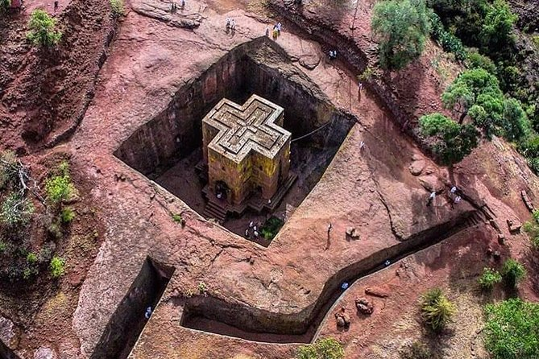

  - Pyramids of Giza
  - Fort Jesus
  - Great Zimbabwe Ruins
  - Rock-Hewn Churches of Lallibela

SECTION B: STRUCTURED QUESTIONS (80 Marks)

TASK 1: Map-work (5 Marks)
- tudy the map of Dobo area and use it to answer question 21
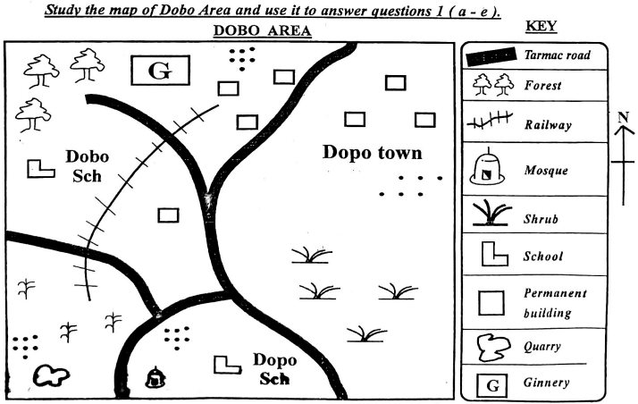
  - What is the type of climate in south eastern part of Dobo area?
___________________________________________________________________________________
  - The railway line in the map is likely to transport
____________________________________________________________________________________________
  - Which cash crop is grown in Dobo Area?.
______________________________________________________________________________________________
  - What is the direction of the ginnery from the quarry?
_____________________________________________________________________________________________
  - Describe the population settlement in Dobo Area.
___________________________________________________________________________________________

TASK 2: Citizenship (5 Marks)
- A learner helps a disabled neighbor cross the road and reads about street children in Nairobi.
a) Which principle of leadership did she demonstrate? (1mk)
____________________________________________________________________________________________________________
b) Identify two bodies concerned with human rights in Kenya. (2mks)
i. ____________________________________________________________________________________________________________
ii. ____________________________________________________________________________________________________________
c) Suggest two ways of acquiring citizenship in Kenya. (2mks)
i. ____________________________________________________________________________________________________________
ii. ____________________________________________________________________________________________________________

TASK 3: History (30 Marks)
- Study African history:
a) Describe two advancements of Middle Stone Age tools. (4mks)
i. ___________________________________________________________________________________________________________
ii. ___________________________________________________________________________________________________________
b) Highlight two achievements of the Swahili civilization. (2mks)
i. __________________________________________________________________________________________________________________
ii. __________________________________________________________________________________________________________________
c) Outline two factors leading to the Trans-Atlantic slave trade. (2mks)
i. __________________________________________________________________________________________________________________
ii. __________________________________________________________________________________________________________________
d) Mention the routes used in the Trans-Atlantic slave trade. (2mks)
i. ___________________________________________________________________________________________________________
ii. ___________________________________________________________________________________________________________
e) Explain two effects of the Trans-Atlantic slave trade on African societies. (4mks)
i. ___________________________________________________________________________________________________________
ii. ___________________________________________________________________________________________________________
f) (i)In which year was the current Constitution of Kenya promulgated? (1 mark)
_________________________________________________________________________________________________________________
(b) Who was the president at the time? (1 mark)
__________________________________________________________________________________________________________________
(c) Mention two major changes brought about by the 2010 Constitution. (2 marks)
i)________________________________________________________________________________________________________________
ii)_______________________________________________________________________________________________________________

g) Explain three challenges African countries faced after independence. (3mks)
i. ___________________________________________________________________________________________________________
ii. ___________________________________________________________________________________________________________
iii. ___________________________________________________________________________________________________________
h) Describe two contributions of the African diaspora. (2mks)
i. _____________________________________________________________________________________________________________
ii. ____________________________________________________________________________________________________________
i) State two ways agriculture changed early human societies. (2mks)
i. ________________________________________________________________________________________________________________
ii. ________________________________________________________________________________________________________________
i) Africa is home to a diverse array of UNESCO World Heritage Sites, each with unique significance.
a) Locate the following World Heritage Sites by naming the country in which each is found: (3 marks)
i) Rock-Hewn Churches of Lalibela ______________________________________________________________
ii) Vallée de Mai Nature Reserve __________________________________________________________________
ii) Victoria Falls ___________________________________________________________________________________
j) Name the European powers that colonised each of the following African countries:((4 marks)
  - Congo____________________________________________________
  - Mozambique____________________________________________________
  - Libya____________________________________________________
  - Namibia____________________________________________________

TASK 4: Geography (30 Marks)
- Study environmental and population issues in Africa:
a) State two causes of high population growth in Kenya. (2mks)
i. ________________________________________________________________________________________________________
ii. _______________________________________________________________________________________________________
b) Explain two impacts of rapid population growth on the environment. (2mks)
i. ______________________________________________________________________________________________________________
ii. _____________________________________________________________________________________________________________
c) State one difference between Kenya and Germany’s population structure. (1mk)
________________________________________________________________________________________________________________________________________________________________________________________________________________________________________
d) Identify two types of migration common in Africa besides rural-urban. (2mks)
i. __________________________________________________________________________________________________________________
ii. __________________________________________________________________________________________________________________
e) Describe two characteristics of mountain climate near Mt. Kenya. (2mks)
i. __________________________________________________________________________________________________________________
ii. __________________________________________________________________________________________________________________
f) Explain three reasons for establishing a multi-purpose dam along Tana River. (3mks)
i. __________________________________________________________________________________________________________________
ii. __________________________________________________________________________________________________________________
iii. _________________________________________________________________________________________________________________
g) Differentiate between weather and climate. (2mks)
___________________________________________________________________________________________________________________________________________________________________________________________________________________________________________________________________________________________________________________________________________________________
h) Identify two challenges in environmental conservation in Africa. (2mks)
i. __________________________________________________________________________________________________________________
ii. __________________________________________________________________________________________________________________
j) Name two non-renewable resources. (2mks)
i. __________________________________________________________________________________________________________________
ii. __________________________________________________________________________________________________________________
k) The diagram below shows a simple fold

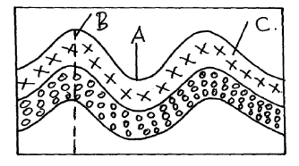

(i) Name the part marked A, B and C. ( 3 marks)
- __________________________________________________________________________
- __________________________________________________________________________
- __________________________________________________________________________

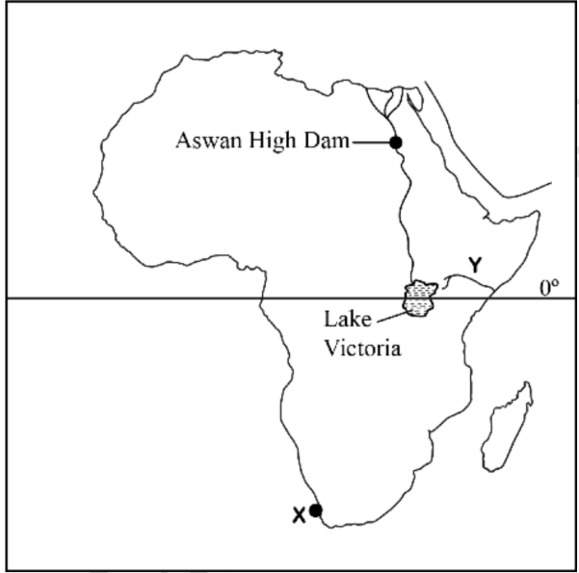
l)A Grade 9 teacher used a map shown to facilitate learning on a multipurpose river project in Africa. Use it to answer the following questions

Z

(i) Identify the river project marked Z (1 mark)

__________________________________________________________________________________________________

ii) Name the multipurpose river project formed along the river marked Y(1 mark)

__________________________________________________________________

b) Explain three economic benefits of multipurpose river projects. (3 marks)

i. __________________________________________________________________________________________________________________
ii. __________________________________________________________________________________________________________________
iii. _________________________________________________________________________________________________________________

m) During a field study on weather, learners recorded the following rainfall (in mm) and temperature (°C) for five days:
Day | Rainfall (mm) | Temperature (°C)
Monday | 10 | 22
Tuesday | 15 | 21
Wednesday | 0 | 26
Thursday | 5 | 24
Friday | 20 | 20

i) Using the data provided, draw a combined graph where:

Rainfall is represented using a simple bar graph.


Temperature is represented using a line graph on the same set of axes.
(3 marks)

ii) Which day recorded the highest rainfall? (1 mark)
____________________________________________________________________________________________________________________

TASK 5: Life Skills (10 Marks)
- Grade 9 learners face peer pressure and anger management issues.
a) Identify three strategies to manage peer pressure. (3mks)
i. ___________________________________________________________________________________________________________
ii. __________________________________________________________________________________________________________
iii. __________________________________________________________________________________________________________
b) Explain two positive impacts of managing anger effectively. (4mks)
i. ___________________________________________________________________________________________________________
ii. __________________________________________________________________________________________________________
c) Outline the first three stages in implementing a Community Service Learning Project. (3mks)
i. ___________________________________________________________________________________________________________
ii. __________________________________________________________________________________________________________
iii. __________________________________________________________________________________________________________

This is the last printed page.
KENYA JUNIOR SCHOOL EDUCATION ASSESSMENT (KJSEA) – MARKING SCHEME
GRADE 9: SOCIAL STUDIES
CODE: 011 YEAR: 2025
SECTION A: MULTIPLE CHOICE QUESTIONS (20 Marks)
Qn | Answer | Explanation
1 | B | Respecting laws and paying taxes are examples of citizens’ responsibilities.
2 | A | Each 15° longitude = 1 hour. 30° east → 2 hours ahead: 8:00 + 2 = 10:00 a.m.
3 | B | Lack of double coincidence of wants is a limitation of barter trade; it’s difficult to find someone with exactly what you need.
4 | B | Negotiation involves peaceful discussion to resolve conflicts.
5 | C | Gedi ruins are remains of an ancient settlement along the Kenyan coast.
6 | B | Seeking citizen views before lawmaking is public participation in legislation.
7 | A Age hand axe | Stone age tools include hand axes, scrapers, or choppers made of stone.
8 | B | Broad base, narrow top → high birth rate, developing country.
9 | B | The diagram represents a normal fault.
10 | B | Plate tectonics theory explains movement of Earth’s lithospheric plates.
11 | B | Promoting education for girls emphasizes the right to education.
12 | B | Focusing on strengths is a positive approach to improving self-esteem.
13 | A | Oral tradition is the recounting of historical events by elders.
14 | B | Folding in rock layers indicates tectonic folding processes.
15 | A | Jaramogi Oginga Odinga and Wangari Maathai advocated environmental conservation.
16 | C | Moving from rural Machakos to Nairobi is rural-to-urban migration.
17 | B | The body in charge of elections in Kenya is the Independent Electoral and Boundaries Commission (IEBC).
18 | B | Kenya’s Bill of Rights is in Chapter Four of the Constitution (2010).
19 | B | Minimum age to be elected as MP is 35 years.
20 | D | Rock-Hewn Churches of Lalibela are historical monuments in Ethiopia.
SECTION B: STRUCTURED QUESTIONS (80 Marks)
TASK 1: Map-work (5 Marks)
21. Map of Dobo area
a) Type of climate (SE part)
i. Semi-arid / arid / hot and dry
b) Railway likely transports
i. Cash crops/cotton/
c) Cash crop grown in Dobo area
i. cotton
d) Direction of ginnery from quarry
i. North-east
e) Population settlement
i. clustered
- Concentrated near schools/markets/Quarry/farms/Ginnery
TASK 2: Citizenship (5 Marks)
22. Learner helps a disabled neighbor
a) Principle of leadership demonstrated
i. Service / empathy / responsibility / civic leadership
b) Two bodies concerned with human rights in Kenya
i. Kenya National Human Rights Commission (KNHRC)
ii. Kenya National Commission on the Rights of Children (KNCRC)
Other possible answers:
iii. Independent Policing Oversight Authority (IPOA)
iv. Judiciary
v. Human Rights NGOs
c) Two ways of acquiring citizenship in Kenya
i. Birth / ius soli
ii. Registration / naturalization
Other possible answers:
iii. Descent from Kenyan parent
iv. Adoption by Kenyan parents
v. Marriage to a Kenyan citizen
TASK 3: History (30 Marks)
23a) Two advancements of Middle Stone Age tools
i. More refined flaking techniques
ii. Production of small blades and points
Other answers:
iii. Specialized hunting tools
iv. Bone and antler tools
v. Use of microliths
vi. Improved durability
vii. Standardized shapes
23b) Two achievements of the Swahili civilization
i. Development of trade networks
ii. Building stone towns and mosques
Other answers:
iii. Adoption of Islam
iv. Use of Swahili language
v. Maritime trade with Asia
vi. Urbanization and city-states
23c) Two factors leading to the Trans-Atlantic slave trade
i. European demand for labor in colonies
ii. African participation and internal wars
Other answers:
iii. Profit from cash crops
iv. Development of plantation economies
v. Coastal trading posts
vi. Lack of alternative labor sources
23d) Routes used in the Trans-Atlantic slave trade
i. West African coast to Americas (Middle Passage)
ii. European ports to Africa (Outward journey)
Other answers:
iii. Caribbean islands
iv. Brazil
v. North America
23e) Two effects of Trans-Atlantic slave trade on African societies
i. Depopulation of communities
ii. Social disruption and wars
Other answers:
iii. Loss of skilled labor
iv. Economic stagnation
v. Spread of firearms and conflicts
vi. Cultural disintegration
vii. Introduction of European influence
viii. Increased coastal trade
23f) Constitution of Kenya
i. Year promulgated: 2010
ii. President at the time: Mwai Kibaki
iii. Two major changes:
- Devolution / creation of county governments
- Bill of Rights / strengthened human rights
Other possible changes:
- Judiciary independence
- Referendum processes
- Separation of powers
- Gender equality clauses
23g) Three post-independence challenges in Africa
i. Political instability / coups
ii. Ethnic conflicts
iii. Economic underdevelopment
Other answers:
iv. Corruption
v. Lack of infrastructure
vi. Poor health systems
vii. High illiteracy rates
viii. Dependence on former colonial powers
23h) Contributions of African diaspora
i. Trade and economic linkages
ii. Spread of African culture abroad
Other answers:
iii. Investment in Africa
iv. Education and skill transfer
v. Advocacy for African rights
vi. Remittances to families
23i) Two ways agriculture changed early human societies
i. Settled communities
ii. Food surplus → population growth
Other answers:
iii. Specialization of labor
iv. Development of trade
v. Creation of social hierarchies
23j) World Heritage Sites and countries
i. Rock-Hewn Churches of Lalibela → Ethiopia
ii. Vallée de Mai Nature Reserve → Seychelles
iii. Victoria Falls → Zambia/Zimbabwe
23k) European colonizers
i. Congo → Belgium
ii. Mozambique → Portugal
iii. Libya → Italy
iv. Namibia → Germany
TASK 4: Geography (30 Marks)
24a) Two causes of high population growth in Kenya
i. High birth rate
ii. Early marriages / low contraceptive use
Other answers:
iii. Cultural preferences for large families
iv. Immigration
v. Declining mortality rates
24b) Impacts of rapid population growth
i. Environmental degradation
ii. Pressure on resources
Other answers:
iii. Deforestation
iv. Pollution
v. Soil erosion
vi. Water shortages
vii. Traffic congestion
viii. Poor sanitation
24c) Difference between Kenya and Germany population structure
i. Kenya → broad base (youthful); Germany → narrow base (aging)
24d) Two types of migration besides rural-urban
i. Urban to rural
ii. Rural to rural
Other answers:
iii. International / cross-border
iv. Urban to urban
v. Seasonal / temporary
24e) Characteristics of mountain climate near Mt. Kenya
i. Cool temperatures
ii. High rainfall
Other answers:
iii. Frost at high altitude
iv. Cloud cover
v. Windy conditions
24f) Three reasons for establishing multipurpose dam along Tana River
i. Hydro-power generation
ii. Irrigation
iii. Water supply
Other answers:
iv. Flood control
v. Fisheries development
vi. Tourism
24g) Weather vs Climate
i. Weather → short-term atmospheric conditions
ii. Climate → long-term average of weather patterns
24h) Two challenges in environmental conservation
i. Deforestation
ii. Poaching / wildlife loss
Other answers:
iii. Water pollution
iv. Soil degradation
v. Urbanization
vi. Mining impacts
24i) Two non-renewable resources
i. Coal
ii. Oil / petroleum
Other answers:
iii. Natural gas
iv. Minerals (iron, gold, uranium)
24j) Diagram of fold: Name A, B, C
i. A → Axial plane
ii. B → Anticline
iii. C → Syncline
24k) Multipurpose river project
i. River Z → Aswan
ii. River Y → The seven fork-scheme
24l) Three economic benefits of multipurpose river projects
i. Hydro-electric power generation
ii. Irrigation for agriculture
iii. Flood control
Other answers:
iv. Fisheries development
v. Water supply for domestic use
vi. Tourism opportunities
24m) Rainfall & Temperature Data Graph
i. Combined graph: Bar for rainfall, line for temperature
ii. Day with highest rainfall → Friday (20 mm)

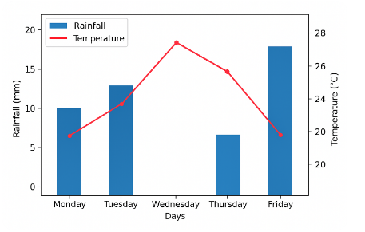

TASK 5: Life Skills (10 Marks)
25a) Three strategies to manage peer pressure
i. Refusal skills / saying no
ii. Surrounding oneself with positive friends
iii. Focusing on personal goals
Other answers:
iv. Avoid risky situations
v. Seeking advice from adults
vi. Self-awareness / reflection
vii. Joining clubs / support groups
25b) Two positive impacts of managing anger
i. Maintains healthy relationships
ii. Reduces conflict
Other answers:
iii. Improves mental health
iv. Enhances decision-making
v. Improves academic performance
vi. Promotes self-control
25c) First three stages in implementing Community Service Learning Project
i. Planning / identifying community needs
ii. Organizing resources and volunteers
iii. Implementation / execution of project activities
Other answers:
iv. Monitoring progress
v. Evaluation and reflection
vi. Reporting results

