KENYA JUNIOR SCHOOL EDUCATION ASSESSMENT (KJSEA)
GRADE 9: AGRICULTURE AND NUTRITION (THEORY)
CODE: 011 YEAR: 2025 TIME: 2 HOURS
Candidate’s Name: ___________________________________. Assessment Number: _____________________.
School Name: ________________________________________. School Code: _______________________________.
Candidate’s Signature: ______________________________. Date: ________________________________________.


INSTRUCTIONS TO CANDIDATES:
Instructions to Candidates:
AGRICULTURE AND NUTRITION

- Write your name and assessment number in the spaces provided.
- Answer ALL questions in Section A and Section B.
- All answers must be written in the spaces provided in this question booklet.
- This paper consists of 12 printed pages.
Candidates should check the question paper to ascertain that all pages are printed as
indicated and that no questions are missing.
- Candidates should answer the questions in English.

For Official Use Only

SECTION A: MULTIPLE CHOICE QUESTIONS (30 Marks)
Question Number | 1 | 2 |  | 3 | 4 |  | 5 | 6 | 7 |  | 8 | 9 | 10 | 11 | 12 | 13 | 14 | 15
Maximum Score | 1 | 1 |  | 1 | 1 |  | 1 | 1 | 1 |  | 1 | 1 | 1 | 1 | 1 | 1 | 1 | 1
Candidate’s Score
Question Number | 16 |  | 17 |  |  | 18 |  | 19 |  | 20 |  | 21 | 22 | 23 | 24 | 25 | 26 | 27 | 28 | 29 | 30 | Total score
Maximum Score | 1 |  | 1 |  |  | 1 |  | 1 |  | 1 |  | 1 | 1 | 1 | 1 | 1 | 1 | 1 | 1 | 1 | 1 | 30
Candidate’s Score

SECTION B: STRUCTURED QUESTIONS. (50 Marks)
Task | Task 1: Agriculture |  |  |  | Task 2: Nutrition
Question Number | 31 | 32 | 33 | 34 | 35 | 36 | 37 | 38
Maximum Score | 2 | 4 | 3 | 5 | 9 | 3 | 4 | 3
Candidate’s Score
Maximum task score | 23 |  |  |  | 27
Candidate’s task score
© 2025 COMPETENCE KENYA ASSESSMENT COUNCIL Turn over

SECTION A: MULTIPLE CHOICE QUESTIONS (30 Marks)
Answer all questions in this section.

- The practice of growing leguminous crops alongside cereals mainly helps in:
A) Conserving soil moisture
B) Fixing nitrogen in the soil
C) Improving taste of cereals
D) Preventing soil erosion
- Which of the following is a perennial crop?
A) Maize B) Beans
C) Coffee D) Cowpeas
- Which type of irrigation method is most water-efficient?
A) Overhead irrigation
B) Flood irrigation
C) Furrow irrigation
D) Drip irrigation
- The main advantage of zero grazing in dairy production is:
A) Cows are free to roam
B) Animals get maximum exercise
C) Easy disease and feed management
D) It requires less labour
- Which of the following is NOT a nutrient deficiency symptom in plants?
A) Yellowing of leaves
B) Wilting of plants due to drought
C) Stunted growth
D) Poor flowering
- Which food group provides the body with energy?
A) Proteins B) Vitamins
C) Carbohydrates D) Minerals
- The most suitable tool for light weeding in vegetable beds is:
A) Jembe
B) Rake
C) Hoe
D) Hand fork
- Pasteurization of milk is important because it:
A) Improves its taste
B) Prevents spoilage by killing harmful bacteria
C) Increases milk thickness
D) Makes milk change colour
- Which of the following is an artificial method of vegetative propagation?
A) Grafting
B) Suckers
C) Rhizomes
D) Bulbs
- Which of the following is the correct sequence of steps in hand washing clothes?
A) Drying → Soaking → Washing → Rinsing → Ironing
B) Soaking → Washing → Rinsing → Drying → Ironing
C) Washing → Soaking → Drying → Rinsing → Ironing
D) Soaking → Rinsing → Washing → Ironing → Drying
- Which of the following is a macronutrient needed by plants?
A) Zinc
B) Nitrogen
C) Copper
D) Boron
- A balanced diet is defined as:
A) A meal that is tasty
B) A meal eaten three times daily
C) A meal containing all food nutrients in correct proportions
D) A meal with more energy foods than others
- The main cause of iron deficiency anaemia in humans is:
A) Lack of proteins
B) Lack of Vitamin C
C) Lack of Vitamin A
D) Lack of iron
- In soil conservation, terraces are used mainly to:
A) Increase soil fertility
B) Reduce soil erosion
C) Improve crop rotation
D) Improve drainage
- Which of the following methods is suitable for preserving leafy vegetables for a long time?
A) Drying B) Salting
C) Freezing D) Smoking
- Identify the part marked x
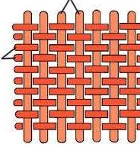
X

Y

  - Warp
  - Weft
  - Yarn
  - Horizontal
- The following picture shows value addition practice in crop production. Use it to answer questions below.
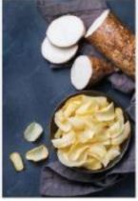
(i) Which of the following pairs of crops is more appropriate for the value addition practice shown?
A. Arrow roots and potatoes.
B. Sweet potatoes and groundnuts.
C. Groundnuts and pumpkin.
D. Pumpkin and sim-sim.
- Which of the following equipment is best for accurately measuring small amounts of liquid in cookery?
A) Beaker B) Measuring jug
C) Teaspoon D) Cup

- The main reason for rotating crops is:
A) To use the same land repeatedly
B) To improve soil fertility and control pests
C) To make farming easier
D) To save seeds
- Which fabric is made from natural fibre?
A) Polyester B) Nylon
C) Cotton D) Rayon
- Which method of pest control involves using predators to reduce pest numbers?
A) Chemical B) Cultural
C) Mechanical D) Biological
- Which of the following is a by-product of dairy cattle?
A) Beef B) Wool C) Leather D) Milk
- The method of cooking where food is cooked in an oven with dry heat is:
A) Steaming
B) Boiling
C) Baking
D) Stewing
- The main purpose of a kitchen garden is to:
A) Sell cash crops
B) Provide fresh vegetables for the household
C) Control soil erosion
D) Train students in agriculture
- Which soil conservation method uses stones arranged across slopes?
A) Contour farming
B) Mulching
C) Gabions
D) Agroforestry
- Which is the most appropriate method of cooking vegetables to conserve Vitamin C?
A) Boiling in excess water B) Steaming lightly
C) Deep frying D) Roasting
- Which of the following kitchen practices is most important for preventing food poisoning?
A) Covering food
B) Eating hot food
C) Cleaning utensils regularly
D) Proper hand washing

- The picture below shows pests attacking vegetable leaves. In organic gardening, the farmer should control them by:

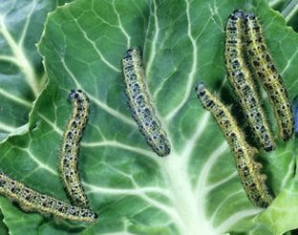

A. Spraying chemical pesticide B. Spraying organic pesticide
C. Burning the plants D. Adding chemical fertilizer
- A teacher displays two bowls: one with thin batter and another with soft dough. Which correct matching is TRUE?
A. Thin batter – Mandazi, Soft dough – Pancake
B. Thin batter – Chapati, Soft dough – Bhajia
C. Thin batter – Pancake, Soft dough – Chapati
D. Thin batter – Doughnut, Soft dough – Sauce
- What type of graft is shown in the diagram below?
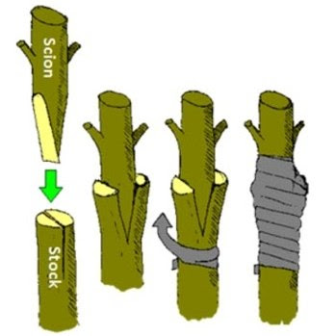

A. Cleft graft
B. Whip graft
C. Side graft
D. Bud graft

SECTION B: STRUCTURED QUESTIONS (50 Marks)

PART 1: AGRICULTURE (25 Marks)
- Susan knitted the following item.

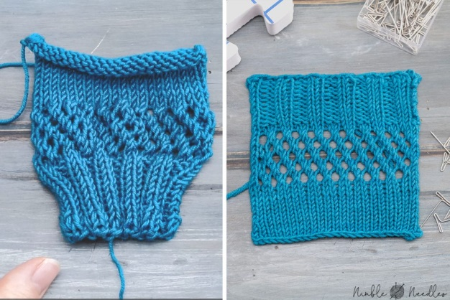

Identify the knitting technique used

____________________________________________________________________________________________________________

- A learner is using a sharp knife to prepare vegetables for roasting.



What two safety precautions should they follow?

i. ____________________________________________________________________________________________________________________
ii. ___________________________________________________________________________________________________________________
- Why is it important to preserve food nutrients?

i. ____________________________________________________________________________________________________________________
ii. ___________________________________________________________________________________________________________________
34. (a) Name two methods of improving soil fertility without using inorganic fertilizers. (2 marks)
i. ____________________________________________________________________________________________________________________
ii. ___________________________________________________________________________________________________________________
(b) Explain two advantages of crop rotation to a farmer. (4 marks)
i. ____________________________________________________________________________________________________________________
ii. ___________________________________________________________________________________________________________________
(c) Give two advantages of keeping poultry in a fold. (4 marks)
i. ____________________________________________________________________________________________________________________
ii. ___________________________________________________________________________________________________________________
35. (a) State two examples of field pests that attack crops. (2 marks)
i. ____________________________________________________________________________________________________________________
ii. ___________________________________________________________________________________________________________________
(b) Explain two reasons why a farmer may choose to make silage instead of hay. (4 marks)
i. ____________________________________________________________________________________________________________________
ii. ___________________________________________________________________________________________________________________
(c) Name two causes of soil pollution. (2 marks)
i. ____________________________________________________________________________________________________________________
ii. ___________________________________________________________________________________________________________________
(d) List two signs of a diseased crop. (2 marks)
i. ____________________________________________________________________________________________________________________
ii. ___________________________________________________________________________________________________________________

36. (a) State three advantages of agroforestry to smallholder farmers. (3 marks)
i. ____________________________________________________________________________________________________________________
ii. ___________________________________________________________________________________________________________________
iii. __________________________________________________________________________________________________________________
(b) Identify two ways of harvesting water in the farm. (2 marks)
i. ____________________________________________________________________________________________________________________
ii. ___________________________________________________________________________________________________________________
(c) State three control measures a farmer can use against storage pests in maize. (2 marks)
i. ____________________________________________________________________________________________________________________
ii. ___________________________________________________________________________________________________________________
37.Study the grafting technique below.

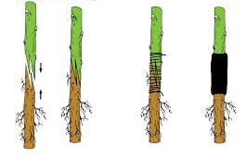

a) Identify the grafting method shown in the diagram. (1 Mark)
i. ____________________________________________________________________________________________________________________
b) Why must the cambium layers of the scion and rootstock be in contact? (2 Marks)
i. ____________________________________________________________________________________________________________________
ii. ___________________________________________________________________________________________________________________
c) Give three purposes of grafting and provide an example for each. (3 Marks)
i. ____________________________________________________________________________________________________________________
ii. ___________________________________________________________________________________________________________________
iii. ____________________________________________________________________________________________________________________
d) State one reason why safety is important when using sharp grafting tools. (1 Mark)

i. ____________________________________________________________________________________________________________________
ii. ___________________________________________________________________________________________________________________

PART 2: NUTRITION (25 Marks)
37. (a) Define food preservation. (2 marks)
____________________________________________________________________________________________________________________
_____________________________________________________________________________________________________________________
(b) State two reasons why food preservation is important. (2 marks)
i. _____________________________________________________________________________________________________________________
ii. ____________________________________________________________________________________________________________________
(c) List two modern methods of food preservation. (2 marks)
i. _____________________________________________________________________________________________________________________
ii. _____________________________________________________________________________________________________________________
(d) Explain two disadvantages of consuming stale food. (4 marks)
i. ____________________________________________________________________________________________________________________
ii. ___________________________________________________________________________________________________________________
38. (a) State three characteristics of a balanced diet. (3 marks)
i. _____________________________________________________________________________________________________________________
ii. ____________________________________________________________________________________________________________________
iii. ____________________________________________________________________________________________________________________
(b) Give two examples of deficiency diseases caused by lack of vitamins. (2 marks)
i. ___________________________________________________________________________________________________________________
ii. _____________________________________________________________________________________________________________________
(c) Outline two rules of table etiquette. (2 marks)
i. _____________________________________________________________________________________________________________________
ii. ____________________________________________________________________________________________________________________
(d) State three personal hygiene practices that should be observed during food preparation. (3 marks)
i. _____________________________________________________________________________________________________________________
ii. ____________________________________________________________________________________________________________________
iii. ____________________________________________________________________________________________________________________
39. (a) Name one temporary and one permanent stitch used in sewing. (2 marks)
Temporary: __________________________
Permanent: __________________________
(b) Give two reasons why it is important to disinfect clothes during laundry. (2 marks)
i. _____________________________________________________________________________________________________________________
ii. ____________________________________________________________________________________________________________________
(c) List three qualities of a good seam. (3 marks)
i. _____________________________________________________________________________________________________________________
ii. ____________________________________________________________________________________________________________________
iii. ____________________________________________________________________________________________________________________

- The diagram below shows a simple cabinet-type homemade sun dryer with a transparent cover, mesh trays, and ventilation holes.

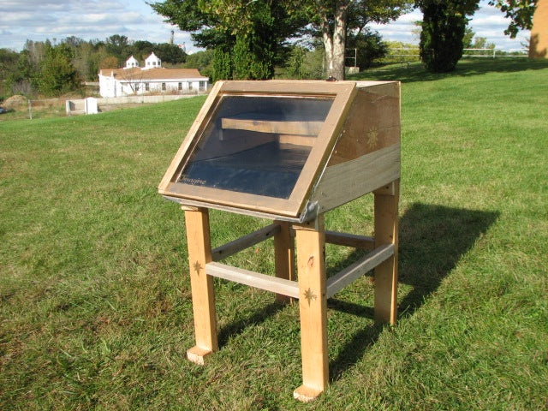

a) What type of energy is mainly used in this dryer? (1 Mark)
i. _____________________________________________________________________________________________________________________
b) Explain three ways the features shown in the diagram help vegetables dry faster. (3 Marks)
i. _____________________________________________________________________________________________________________________
ii. ____________________________________________________________________________________________________________________
iii. ___________________________________________________________________________________________________________________
c) List three preparation steps done on vegetables like sukuma wiki before drying. (3 Marks)
i. _____________________________________________________________________________________________________________________
ii. ____________________________________________________________________________________________________________________
iii. ____________________________________________________________________________________________________________________

This is the last printed page

Marking scheme
SECTION A: MULTIPLE CHOICE QUESTIONS (30 Marks)
Q.No | Answer | Explanation
1 | B | Leguminous crops fix atmospheric nitrogen into the soil through root nodules, improving soil fertility for cereals.
2 | C | Coffee is a perennial crop as it grows and yields over many years.
3 | D | Drip irrigation is most water-efficient as water is delivered directly to the plant roots.
4 | C | Zero grazing allows easier feed and disease management as cows are confined and monitored.
5 | B | Wilting due to drought is a water deficiency, not a nutrient deficiency.
6 | C | Carbohydrates provide the body with energy.
7 | D | Hand fork is suitable for light weeding without damaging plants.
8 | B | Pasteurization kills harmful bacteria and prevents milk spoilage.
9 | A | Grafting is an artificial method of vegetative propagation.
10 | B | Correct sequence: Soaking → Washing → Rinsing → Drying → Ironing.
11 | B | Nitrogen is a macronutrient required in large quantities by plants.
12 | C | A balanced diet contains all nutrients in correct proportions.
13 | D | Lack of iron in the diet causes iron deficiency anemia.
14 | B | Terraces reduce soil erosion by slowing water flow on slopes.
15 | C | Freezing preserves leafy vegetables for a long time without nutrient loss.
16 | A | Warp is the horizontal thread in weaving.
17 | A | Arrow roots and potatoes are suitable for value addition (e.g., flour, chips).
18 | C | Teaspoon allows accurate measurement of small quantities of liquids.
19 | B | Crop rotation improves soil fertility and helps control pests.
20 | C | Cotton is a natural fibre; the others are synthetic.
21 | D | Biological pest control uses predators to reduce pests naturally.
22 | D | Milk is a by-product of dairy cattle; beef is meat.
23 | C | Baking uses dry heat in an oven.
24 | B | Kitchen gardens provide fresh vegetables for household consumption.
25 | C | Gabions (stone barriers) are used to prevent soil erosion on slopes.
26 | B | Steaming lightly preserves vitamin C better than boiling in excess water.
27 | D | Proper hand washing prevents contamination and food poisoning.
28 | B | Organic pesticides can control pests in organic gardening.
29 | C | Pancakes are thin batter; Chapati is soft dough.
30 | A | The diagram shows a cleft graft, where the scion is inserted into a split rootstock.
SECTION B: STRUCTURED QUESTIONS (50 Marks)
PART 1: AGRICULTURE (25 Marks)
31. Identify the knitting technique used
- Answer: i. Circular knitting
- Explanation: The item shows loops interlocked, typical of knitting.
32. Two safety precautions when using a sharp knife
i. Always cut away from the body.
ii. Keep fingers away from the blade.
Other possible answers (up to 10):
- Use a stable cutting surface.
- Ensure the knife is sharp to avoid slipping.
- Do not leave the knife unattended.
- Wear protective gloves if necessary.
- Keep knife handles dry.
- Clean knife carefully after use.
- Store knife safely in a holder.
- Cut slowly and carefully.
- Keep the cutting area well-lit.
- Avoid distractions while cutting.
33. Importance of preserving food nutrients
i. To maintain health and proper body growth.
ii. To prevent nutrient loss during storage and cooking.
Other possible answers (up to 10):
- To prevent deficiency diseases.
- To maintain the taste and quality of food.
- To enhance shelf-life of foods.
- To provide balanced diet.
- To retain color, flavor, and texture.
- To avoid food wastage.
- To ensure food safety.
- To maximize the economic value of food.
- To improve digestibility.
34(a). Two methods of improving soil fertility without inorganic fertilizers
i. Use of compost/manure
ii. Growing leguminous crops (nitrogen fixation)
34(b). Two advantages of crop rotation
i. Improves soil fertility
ii. Reduces pest and disease buildup
34(c). Two advantages of keeping poultry in a fold
i. Easier management and feeding
ii. Protection from predators
35(a). Two examples of field pests
i. Aphids
ii. Armyworms
Other possible answers:
- Cutworms, Beetles, Mites, Locusts, Grasshoppers, Leaf miners, Weevils, Borers, Thrips
35(b). Two reasons for making silage instead of hay
i. Can be stored wet and retains more nutrients
ii. Allows feeding during rainy season
35(c). Two causes of soil pollution
i. Use of chemical pesticides
ii. Industrial waste
Other possible:
- Oil spills, dumping plastics, deforestation, mining waste, overuse of fertilizers, sewage disposal, agrochemical runoff, heavy metals
35(d). Two signs of diseased crops
i. Yellowing of leaves
ii. Stunted growth
Other possible:
- Leaf spots, Wilting, Blight, Root rot, Powdery mildew, Rust, Discoloration, Deformed fruits, Galls, Defoliation
36(a). Three advantages of agroforestry
i. Provides timber and fuelwood
ii. Improves soil fertility
iii. Provides shade and windbreak
36(b). Two ways of harvesting water on a farm
i. Rainwater harvesting tanks
ii. Pans/ponds/dams
36(c). Three control measures for storage pests in maize
i. Use of airtight containers
ii. Fumigation
iii. Sun drying
37(a). Identify grafting method
i. Cleft graft
37(b). Why cambium layers must be in contact
i. To allow fusion of tissues and successful growth
ii. For nutrient and water transport between scion and rootstock
37(c). Three purposes of grafting with examples
i. To improve yield – e.g., grafting mango for higher fruit yield
ii. To change variety – e.g., citrus grafting for disease-resistant variety
iii. To repair damaged plants – e.g., cleft grafting on broken trees
37(d). Reason why safety is important when using sharp grafting tools
i. To prevent injuries/cuts
PART 2: NUTRITION (25 Marks)
38(a). Define food preservation
- Answer: Process of treating and handling food to prevent spoilage and extend shelf-life.
(b). Two reasons why food preservation is important
i. Prevents food spoilage
ii. Reduces wastage
Other possible answers:
- Maintains nutrients, flavor, and texture
- Ensures food safety
- Allows long-term storage
- Facilitates transport and trade
- Prevents microbial growth
(c). Two modern methods of food preservation
i. Freezing
ii. Canning
Other possible answers:
- Vacuum packing, Refrigeration, Pasteurization, Dehydration, Irradiation, Modified atmosphere packaging, Cold storage, Microwave preservation
(d). Two disadvantages of consuming stale food
i. Causes food poisoning
ii. Loss of nutrients
Other answers:
- Unpleasant taste, Odor, Increased risk of diarrhea, Vomiting, Weakens immunity, Can cause mold-related diseases, Digestive discomfort, May lead to chronic illness
39(a). Three characteristics of a balanced diet
i. Provides energy
ii. Contains all nutrients in correct proportions
iii. Includes variety of foods
Other answers:
- Supports growth, Maintains body functions, Prevents deficiency diseases, Easy to digest, Safe and hygienic, Suitable for age and activity, Affordable
(b). Two deficiency diseases caused by lack of vitamins
i. Scurvy – lack of Vitamin C
ii. Night blindness – lack of Vitamin A
Other examples:
- Beriberi (B1), Pellagra (B3), Rickets (D), Anemia (B12), Osteomalacia (D), Neural tube defects (Folic acid), Goiter (Iodine)
(c). Two rules of table etiquette
i. Wash hands before eating
ii. Do not talk with a full mouth
Other possible answers:
- Chew with mouth closed, Use utensils properly, Do not reach across the table, Wait for everyone to be served, Eat politely, Avoid making noise, Offer food to others first
(d). Three personal hygiene practices during food preparation
i. Wash hands thoroughly
ii. Tie hair / use hairnet
iii. Keep nails short and clean
Other possible answers:
- Use clean utensils, Avoid wearing jewelry, Wear clean apron, Cover cuts with bandages, Wash vegetables and fruits, Disinfect work surfaces, Avoid touching face while cooking, Keep kitchen clean
40(a). Temporary and permanent stitches in sewing
- Temporary: Basting stitch
- Permanent: Running stitch / Back stitch
(b). Two reasons to disinfect clothes during laundry
i. Kill germs and bacteria
ii. Prevent disease transmission
Other answers:
- Remove odor, Maintain hygiene, Protect skin health, Improve fabric longevity
(c). Three qualities of a good seam
i. Strong and durable
ii. Neat and even
iii. Does not unravel easily
Other answers:
- Flexible, Matches fabric type, Correct tension, Resistant to washing, Proper alignment, Smooth finish, Economical use of thread
40(a). Type of energy used in the sun dryer
- Solar energy
(b). Three ways features help vegetables dry faster
i. Transparent cover allows sunlight to enter and trap heat
ii. Mesh trays allow air circulation
iii. Ventilation holes remove moisture
(c). Three preparation steps for vegetables before drying
i. Wash thoroughly
ii. Cut into uniform sizes
iii. Blanch briefly (if necessary)

