
MARANDA HIGH SCHOOL
Kenya Certificate of Secondary Education
POST MOCK 2 EXAMINATIONS, 2025

312/2 Geography Paper 2
September, 2025 Time: 2½ Hours

Name: ………………………………………….….…… Adm No: ………………
Class: ………………Candidate’s Signature: ………..……..Date:………………..
Instructions to candidates
- Write your name, admission number and class in the spaces provided above.
- This paper has two sections A and B
- Answer all the questions in SECTION A.
- Answer question 6 and any other two questions from SECTION B.
- All answers must be written in English.
- This paper consists of 16 printed pages.
- Candidates should check the question paper to ascertain that all the pages are printed as indicated and that no questions are missing.
For Examiner’s Use Only

Questions | Candidate’s  Score | Maximum  Score
1 -5 |  | 25
6 |  | 25
 |  | 25
 |  | 25
Total Score |  | 100

SECTION A
Answer all questions in this section
- (a) What is environmental conservation? (2 marks)
- Environmental conservation is the sustainable management and protection of the natural environment and its resources.
(b) Give three effects of air pollution. (3 marks)
- Causes respiratory and cardiovascular diseases such as asthma, bronchitis, and heart problems.
- Leads to acid rain damaging crops, forests, and aquatic ecosystems.
- Contributes to global warming by increasing greenhouse gases like carbon dioxide and methane.
- Smog/smoke reduces visibility/ causes road accidents
- (a) Name two indigenous softwood species in Kenya. (2 marks)
- Bamboo
- African pencil
- Podocarpus
- cedar
(b) State three problems associated with Forestry in Kenya. (3 marks)
- Illegal logging leading to deforestation and biodiversity loss.
- Forest fires caused by natural factors and human negligence.
- Encroachment of forest land for farming and settlement due to population pressure.
- Pests and diseases affecting forest health.
- Poor forest management and enforcement of laws.
- (a) Differentiate between land reclamation and land rehabilitation. (2 marks)
- Land reclamation is creating new land from water bodies such as wetlands or seas while land rehabilitation is restoring degraded land to productivity
(b) State three problems facing the Perkerra irrigation scheme. (3 marks)
- Stagnant waters in the plots and canals encourage the breeding of snails and mosquitoes that spread diseases (bilharzia and malaria) that weaken the farmers hence causing low output
- The schemes is located in sparsely populated areas/far from urban centres limiting market
- Crops planted in the schemes are often attacked by pests and diseases e.g. Quelea birds, root rot, etc. destroy the crops in the fields thus lowering their quality
- Inadequate capital to hire labour for planting, weeding and harvesting/purchase equipment/meet operational costs
- Siltation of the canals requiring frequent dredging; expensive thus reducing the price margins and reduces the capacities of the dams

- (a) Name two major tourist attractions in Switzerland. (2 marks)
- The alps/jura mountains
- Lake Geneva/zurich
- The rhine falls
- UN offices
- Zurich cultural festival
- Aletch glacier
- Chillon Castle
(b) State three benefits of tourism to the economy of Switzerland. (3 marks)
- Generates foreign exchange earnings.
- Generates government revenue through taxes
- Market for industrial goods
- Creates employment in hotels, transport, and services.
- Encourages infrastructural development.
- Promotes cultural exchange.
- Use the map of East Africa provided below to answer (a)
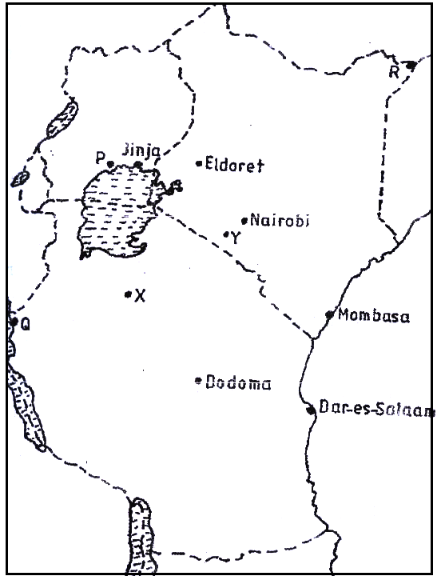
(a) Name the towns marked P and X. (2 marks)
- P: Kampala
X: Mombasa
(b) State three factors that have contributed to the growth of the town marked Y. (3 marks)
- Mogadi-nairobi road easy movement
- Availability of gently sloping land for settlemet
- Schools like/attract more residents
- Mining of soda has created jobs attracting many people

SECTION B
Answer question 6 and any other two questions from this section.
- (a) The table below shows industrial production of selected commodities in Kenya from 2019 to 2022 in ‘000 tonnes
COMMODITY/YEAR | 2019 | 2020 | 2021 | 2022
Industrial Steel | 493 | 544 | 640 | 689
Cement | 6122 | 7575 | 9230 | 9880
Processed Tea | 459 | 570 | 438 | 535
Processed Sugar | 441 | 604 | 700 | 765

- (i) Using a scale of 1 cm to represent 1,000 tonnes, draw a multiple line graph to represent the above data. (8 marks)
(ii) Give two reasons for the trend shown by cement production. (2 marks)
(b) State four characteristics of Jua Kali industries in Kenya. (4 marks)
(d) State three negative effects of industrialization to the environment. (3 marks)
(d) Explain four ways in which inadequate capital has hindered development of industries in Kenya. (8 marks)
- Inadequate capital prevents entrepreneurs and the government from setting up large-scale industries, so many remain small and underdeveloped.
- Since local investors cannot raise enough capital, Kenya relies heavily on foreign investors, who often repatriate profits abroad, slowing local growth.
- Industries require modern, expensive machinery and technology, but inadequate capital forces many to use outdated equipment, leading to low productivity.
- Without enough funds, industries struggle to import raw materials/ to fully exploit local resources limiting industrial expansion
- Inadequate capital limits research and innovation hindering industrial expansion
- Insufficient capital means industries cannot attract or retain highly skilled workers. Training and employing skilled manpower is costly.
- Inadequate capital hampers development of supporting /roads, power supply, water, communication) requires huge investments. making industries inefficient.
- Industries operate on a small scale due to financial constraints, leading to low output and inability to compete globally.
- (a) Name two counties in rift valley highlands of Kenya where wheat is grown in large
scale. (2 marks)
(b) State how the following factors favour wheat growing in Kenya
- Climate (2 marks)
- Land (3 marks)
- Availability extensive nd gently sloping areas in regions like the Uasin Gishu, Trans Nzoia, and Narok plains provide enough space for mechanized wheat farming

2. Well-Drained Soils
- Wheat thrives in light, well-drained soils such as volcanic soils in the Rift Valley. These soils are fertile and suitable for root development.

3. Flat / Gently Sloping Land
- Wide plains and gentle slopes favour the use of machines (tractors and harvesters), which are essential for commercial wheat farming.

4. Relatively Fertile Soils
- Areas like the Rift Valley highlands have volcanic soils rich in minerals, which reduce the need for heavy fertiliser use.

5. Large-Scale Commercial Farms
- The availability of land in some regions has allowed establishment of large wheat estates, supporting both subsistence and commercial production

- Describe the processing of wheat from the time it is ready for harvesting upto packaging. (6 marks)

- Explain three reasons for the decline in wheat production in Kenya in the recent years. (6 marks)
(e) Compare wheat farming in Kenya and Canada under the following sub headings
      - Marketing of wheat (2 marks)
      - Transportation (4 marks)
- (a) (i) Define the terms;
      - Population size. (2 marks)
      - Ageing population. (2 marks)
(ii) State three advantages of ageing population. (3 marks)
(b) Explain how topography influences population distribution in Kenya. (6 marks)
(c) State three ways in which cultural beliefs have led to large population growth rate in
Kenya. (3 marks)
(d) State three effects of rural to rural migration to receiving areas. (3 marks)
(e) Explain three differences between population trends in Kenya and Sweden. (6 marks)

- (a) State differences between bilateral and multilateral trade. (2 marks)
(b) Explain how the following factors influence Kenya’s international trade.
    - Transport networks. (4 marks)
    - Global demand of goods (4 marks)
(c) State three objectives of Economic community of West African States (ECOWAS). (3 marks)
(d) Explain how the following is affecting Regional trading blocs
  - Tariffs (2 marks)
  - Production of similar goods (2 marks)
  - Level of industrialization (2 marks)
(e) Maranda high school students carried out a field study in a supermarket in Kisumu town.
(i) List two types of hypothesis they may have formulated. (2marks)
(ii) State two problems they might have encountered (2 marks)
(ii) Give two justifications why they may have preferred observation method to conducting interviews in collecting their data. (2 marks)

- (a) (i) Differentiate between transport and communication. (2 marks)
(b) (i) Give three main means of air transport in Kenya. (3 marks)
(ii) State four challenges facing air transport in Kenya. (4 marks)
(c) Explain three measures the government is taking to prevent cybercrimes. (6 marks)
(d) Study the map of the Great Lakes and the St. Lawrence Sea way below use it to answer question d(i) and (ii)
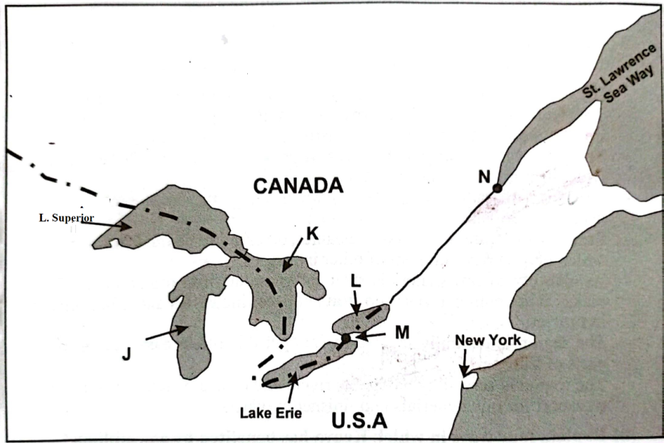
(i) Name the lakes marked K and J (2 marks)
(ii) Name the canal marked M (1 mark)
(iii) Name the port marked N (1 mark)
(d) Explain three ways in which the Great Lakes and St. Lawrence Sea way route is of benefit to the residence of Toronto. (6 marks)




