NYAGA SECONDARY SCHOOL
MOCK EXAMINATION 2025
FORM FOUR
GEOGRAPHY - PAPER 1
END TERM 2 2025
MARKING SCHEME

SECTION A
1. (a) State three effects of the rotation of the earth on its axis. (3 marks)
- It causes the occurrence of day and night/apparent movement of the sun from East to West.
- It results in high and low tides/rising and falling of ocean tides/occurrence tides.
- It causes deflection of winds and ocean currents.
- It causes variation of atmospheric pressure over the earth’s surface/pressure difference on earth surface/variation in the
- speed of air masses on earth’s surface.
(b) Give two proofs that the earth is spherical. (2 marks)
- During sunrise,people living in the east see sunrise earlier than those in the west due to earth’s rotation.
- Movement on the surface of the earth along a straight path while maintaining one direction will bring one back to the
- same starting point from the opposite direction.
- All planets in the solar system are spherical, the earth being one of the planets has a similar shape.
- Satellites photographs of the earth taken from the outer space at great distances from the earth all show that the earth is spherical.
- When a ship is approaching land from a distance at sea, smoke is seen first at horizon and then the rest of the ship will appear gradually.
- The earth’s horizon appears circular/curved when observed from a very high point like tower.
2. (a) State three factors that influence how the wind blow. (3 marks)
- Pressure gradient/difference/barometric gradient.
- Friction force on the earth’s surface.
- Rotation of the earth.
- Temperature of a place.
(b) Identify two types of local winds. (2 marks)
- Land and sea breezes
- Katabatic winds.
- Sirocco/khamsin/berg
- Anabatic winds
- Harmattan
- Fohn winds/Chinook.
3.(a) Define the term folding. (2 marks)
- Folding is the process through which crustal rocks/sedimentary rocks bend upwards or downwards due to compressional forces/earth movements.
(b) Name three fold mountains formed during the hercynian orogeny. (3 marks)
- Cape Ranges
- Ural mountains
- Appalachians

4. (a) The diagram below shows the occurrence of an earthquake. Name the parts marked A, B, and C. (3 marks)

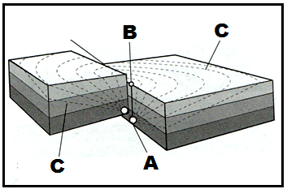
(b) State two differences between the intensity and magnitude of an earthquake. (2 marks)
- Intensity is the measure of how hard an earthquake shakes the ground whereas magnitude is the measure of the amount of energy released during an earthquake.
- Intensity is measured using a mercalli scale while magnitude is measured using a Richter scale/a moment magnitude scale.
- Intensity decreases from the epicenter outwards while magnitude remains constant from the epicenter outwards.

5. (a) State three characteristics of Savanna vegetation. (3 marks)
- Most of trees shed their leaves/deciduous.
- Trees leaves are modified to thorns.
- The grass is hardy/tufted.
- Trees are umbrella shaped.
- Trees are scattered.
- Grass dominates the area.
- Trees barely grow to a height of 5 meters.
- Grass grows rapidly to maturity during short rains.
- Trees have deep taproots.
(b) Give two uses of Savanna vegetation to man. (2 marks)
- Trees are sources of fuel/charcoal
- Some plants have medicinal value.
- The vegetation provides beauty/aesthetic value.
- Habitat for wild animals.
- Trees provide timber.
- Source of food for human consumption and animals.
SECTION B
Answer question 6 and any other two questions from this section.
6. Study the map of TAMBACH 1:50,000 (sheet 90/3) provided to answer the following questions.
(a) (i) Identify two relief features found in the area covered by the map. (2 marks)
- Escarpment
- Valley
- River valleys
- Hill
(ii) Give the latitudinal extent of the area covered by the map. (2 marks)
- 0⁰30’N-0045’N
(iii) Give the six figure grid reference of the cattle dip at Singore (to the north western side of the area covered by the map). (2 marks)
- 795794
(b) (i) Calculate the approximate area of Kaptagat forest. (2 marks)
- Incomplete squares =9
- Complete squares=0
Area= 9/2=4.5km² ± 0.5km²

(ii) Measure the distance of road C51 from the junction at the mining camp to Kabarnet. Give your answer in kilometres. (2 marks)
- 5.4km ± 0.5km
(iii) Calculate the bearing air photo principal point 039 (at grid reference 9478), from the photo principal point 038 (at grid reference 9481). (2 marks)
- 180⁰S
(c) Describe the characteristics of the long profile of R. Kerio. (5 marks)
- It is a permanent river
- It flows from south to north
- It is the main river in the area covered by the map.
- It has several tributaries
- It highly meanders towards the northern side.
- Trellis is the dominant drainage pattern formed by R. kerio and its ributaries.
(d) Citing evidence from the map, state four social functions of Tambach. (8 marks)
- A religious center as evidenced by the presence of churches
- An educational center as evidenced by the presence of schools such as kabore school……
- An administrative center as evidenced by the presence of ,D.O/DC/chif’s office……
- A health center as evidenced by the presence of dispensaries,health centers, district hospital…..
- A recreational center as evidenced by the presence of district stadium.

7. (a) Give three ways in which rocks are classified. (3 marks)
- According to their mode of formation
- According to their chemical composition.
- According to their age.

(b) Describe how the following rocks are formed. (i) Igneous rocks. (6 marks)
- Very high temperatures in the interior of the earth causes materials to be in molten form (magma)
- Intense pressure underneath pushes the molten magma through lines of weakness such as faults and vents
- If the pressure is low, magma fails to reach the earth’s surface.
- Such magma cools and solidifies below the surface forming intrusive igneous rocks.
- If the pressure acting on the magma is high, the magma reaches the surface as lava.
- The lava cools and solidifies forming extrusive igneous rocks/volcanic rocks.

(ii) Chemically formed sedimentary rocks. (6 marks)
- Mineral particles are dissolved by rain water from pre-existing rocks mainly volcanic on land.
- The dissolved minerals are transported by water in solution and drained in large water bodies such as seas and lakes.
- Mixing of water with different mineral solutions results in chemical reactions.
- The resultant chemical reactions leads to precipitation/deposition of solid particles.
- Solid particles can also be directly deposited through evaporation of the mineral solutions.
- The deposited particles accumulate on the lake or sea bed forming layers. The layers may be covered by other sediments.
- Weight of overlying materials compress and compact the bottom layers into a rock.(Chemically formed sedimentary rocks)

(c) Explain two reasons why sedimentary rocks are widespread at the coast of Kenya. (4 marks)
- The coastal plain is a lowland which facilitated deposition of sediments by rivers from the highlands and by waves from the sea.
- The shallow continental shelf and warm sea water favoured the survival of polyps thus leading to the formation of coral reefs and rocks.
- Some sections of the Kenyan coast have emerged from the sea thus exposing large sections that were initially under water where deposition occurred.

(d) Explain three economic importance of sedimentary rocks to Kenya. (6 marks)
- Some sedimentary rocks are ores that contain valuable minerals such and soda ash which are exploited and sold thus generating income and foreign exchange.
- Some sedimentary rocks provides raw materials to some industries. Example limestone for cement industries.
- Some sedimentary rocks such as sandstones and limestone are used for building houses and road construction.
- Some sedimentary rocks such as soapstone are carved and sold thus generating income to some people.
- Some salts obtained from some sedimentary rocks are used for domestic and industrial purposes e.g. soda ash from trona in glass and bottle industry.
- Some sedimentary rocks undergo weathering over long periods of time to form very rich and fertile soils that support a wide variety of crops.
- Some permeable sedimentary rocks where underlain by impermeable rocks hold and store ground .water as aquifers. Such water forms vital springs or is drawn through boreholes for domestic, industrial or irrigation purposes.

8. (a) (i) Identify three processes through which waves erode the coastline. (3 marks)
- Hydraulic action
- Abrasion
- Solution
(ii) Apart from blowholes, list three features that are produced by wave erosion along the coast. (3 marks)
- Headlands and bays
- Cliffs,Wave-cut platforms
- Caves
- Geo
- Arch
- Stump/stack.
(b) With aid of well-labeled diagrams, describe how a blowhole is formed. (8 marks)
- Wave erosion through abrasion and hydraulic action act on joints or lines of weakness at the base of the cliff.
- Wave erosion acts lead to the formation of a notch, which is enlarged to form a cave.
- Wave erosion acts on lines of weakness on the cave’s roof.
- Weathering through solution acts on the rocks on the surface removing them.
- Eventually the surface is connected to the cave forming a vertical shaft called a blowhole.
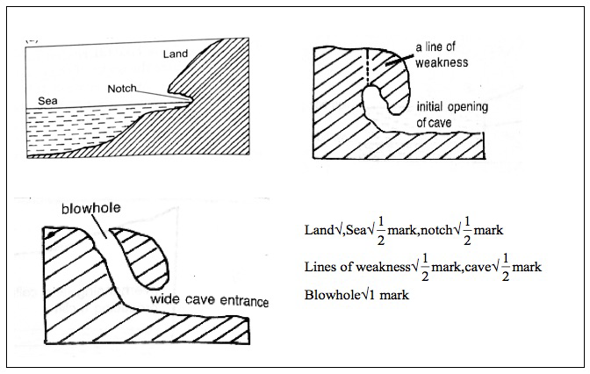
(c) Describe how a spit is formed. (4 marks)
- It forms on a shallow shore where there is change in the angle of the coastline.
- Sand and shingle are deposited from the headland seawards by long shore drift.
- Continued deposition extends the accumulation of materials seawards.
- With time an elongated ridge of sand deposits attached to the mainland called a spit is formed.
(d) Bidii Boys students conducted a field study on coastal features along the Kenyan coast.
(i) List three features of coastal emergence they are likely to have studied. (3 marks)
- Raised beaches
- Raised wave-cut platforms.
- Raised cliffs.
- Raised mudflats.
- Exposed coral rocks.
(ii) State four ways in which features resulting from coastal emergence are of significance to Kenya.
(4 marks)
- Some features such as wave cut platforms attract tourist earning the country foreign exchange.
- Exposed coral provide raw materials for cement making.
- Coral rock is cut into blocks for use in building and construction.
- Coastal emergence features are used for education and research purposes.

9. (a) (i)Name two types of hot desert landscape. (2 marks)
- Sandy /erg /koum
- Stony/reg/serrir
- Rocky/hamada.
- Badlands.
  - (Any first 2×1=2 marks)
ii)State two reasons why wind erosion is very effective in hot deserts. (2 marks)
- Presence of loose unconsolidated dry matter /sand /gravel.
- Occurrence of strong tropical storms.
- Absence of vegetation leading to high wind velocity due to little frictional force.
  - (Any 2×1=2 marks)

b i) ) Apart from Yardangs name three features that results from wind action in deserts.
(3 marks)
- Rock pedestals
- Mushroom blocks
- Zeugens
- deflation hollows/depressions.
- Ventifacts. (any 3×1=3 marks)
- Using well labelled diagrams,describe how Yardangs are formed.(7 marks)
- Rocks made up of vertical alternating layers of hard and soft rocks lie parallel to the prevailing winds in desert.
- Wind abrasion erodes the soft rocks and the particles are removed by deflation leading to formation of large furrows .the layers of hard resistant rocks are left standing as ridges.
- The ridges that are left standing in between furrows are called Yardangs.

- Explain how the following processes of wind erosion occur in the desert areas .
- Saltation. (2 marks)
Medium sized particles are carried by a series of jumps and hops. Materials are rolled along the ground, collide with each other and bounce off into the air and transported for short distances.

- Surface creep. (2 marks)
Wind transport heavy materials e.g. gravel, pebbles by pushing them along the desert.
They are never lifted and move for a short distance due to their weight.
- You intend to carry out a field study in an arid area near your school.
- State two reasons for carrying out a pre-visit. (2 marks)
- It assists the researcher to be familiar with the area of study.
- It assists in preparation of the budget.
- It helps the researcher in identifying possible problems that are likely to be experienced during the study.
- It helps the researcher in developing a work schedule.
- State four positive effects of desert features to man that you are likely to identify. (4 marks)
- Vast open ground s of deserts are used for testing bombs / films development.
- Loess deposited in wetter areas have rich soils for agriculture.
- Oasis provide water used for domestic use by the desert communities.
- Playas / Salinas may contain salts that may be exploited for income generation.
- Strong winds in the desert areas may be tapped for energy / hot sun for solar energy.
- Rock pedestals, yardangs and zeugens may be attractive features for tourist attraction.
- Seasonal streams can be dammed to supply water to the surroundings e.g Kigombo dam in Mbololo area of Taita Taveta.
( Any 4×1=4 marks)
10. (a) State four factors that determine the amount of surface run-off. (4 marks)
- High rainfall/high amount/high rainfall intensity/amount of precipitation
- The rate of evaporation.
- The nature of the slope/gradient of the land.
- The nature of the underlying rocks.
- The amount of vegetation.
- Human activities.
- The nature of the soil/the level of saturation.
(b) Describe three ways in which a river transport its load. (6 marks)
- Solution;It occurs if the rocks in the river bed is soluble.The soluble materials are dissolved in water and carried away in solution form. (1 x 2 = 2 marks)
- Suspension;Is the movement of light/fine insoluble materials/silt/mud/clay.The materials float on water and are transported.
- Traction;Is the movement of large and heavy materials.The debris is rolled and dragged along the river bed.
- Saltation;Is the movement of fairly heavy materials by bouncing along the river bed.The materials leaps and jumps and is momentarily lifted by the water turbulence then dropped out the river bed again.
(c) Using diagrams,describe the following drainage patterns:
(i) Dendritic; (2 marks)
- It is shaped like a tree trunk and its tributaries.The tributaries join the main river at acute angles.
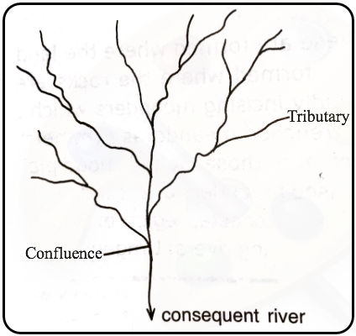
(ii) Trellis; (2 marks)
- Occurs in areas with alternate hard/soft rocks.The tributaries joins the main river at right angles.
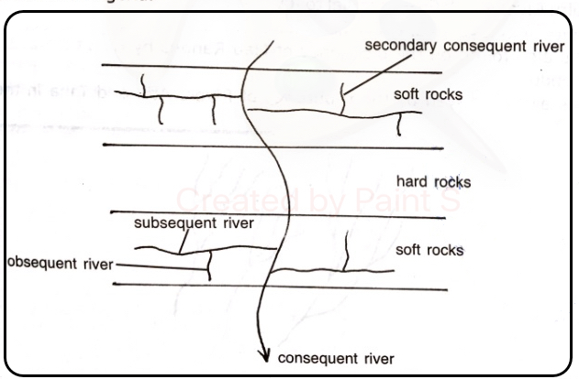
(iii) Centripetal. (2 marks)
- The rivers flow from all direction and converge at a central basin/lake/swamp.
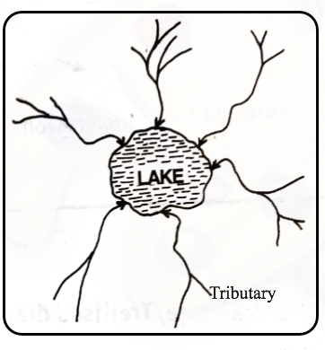
(d) (i) What is a delta? (2 marks)
- It is a low-lying accumulation or plain of silt/tract of alluvial deposits deposited by a river at its mouth.
(ii) State three ideal conditions under which a delta may be formed. (3 marks)
- Large quantities of silt/sediments are carried/deposited at the river mouth.
- Low velocity of the river at the mouth/gentle slope at the river mouth.
- Weak sea waves/weak tidal currents at the coast/in the sea/at the river mouth.
- A shallow continent/shelf/shore/around the river mouth.
- High rate of deposition than the rate of removal of silt at the river mouth.
(iii) State four factors that lead to river deposition. (4 marks)
- Reduction in river gradient which decreases the velocity of water hence deposition of some load.
- Freezing of river water leads to embedment of the load in the ice being deposited.
- River entering large water body reduces the speed of the river flow.
- Presence of obstacles on the river course which blocks some of its load.
- Reduction in river volume which reduces the strength of the river.
- Increase in width of the channel makes to spread over wide area.
- Increase in the amount of load/size of the load.

