233/3
CHEMISTRY
PAPER 3 MARKING SCHEME

NYAGA SECONDARY SCHOOL
MOCK EXAMINATION 2025
MARKING SCHEME
FORM 4
Kenya Certificate of Secondary Education (K.C.S.E)
QUESTION 1
Table 1
Award a total of 4 marks as follows
- Complete table ……………………………………………….1 mk
- Used of chemicals ……………………………………………….1 mk
- Accuracy ……………………………………………….1 mk
- Trend ……………………………………………….1 mk
Graph
Award a total of three marks as follows
- Labelling of axes……………………………………………...... ½ mk
- Scale ……………………………………………...... ½ mk
- Plotting ……………………………………………...... ½ mk
- Shape ……………………………………………...... ½ mk
ii) Showing on the graph ……………………………………………...... ½ mk
Correct reading ……………………………………………...... ½ mk (ANS 1)
iii) ∆H = 20 × 4.2 Ans1 = ANS 2 ……………………………………...... ½ mk
Molar enthalpy of solution = $\frac{ 101 ×Ans2}{2.0}= +Ans 3$……...... ½ mk
Table 2
Award 5 marks as follows;
- Complete table……………………………………………….1 mk
- Use of decimals………………………………………………1 mk
- Accuracy………………………………………………….….1 mk
- Principles of averaging……………………………………….1 mk
- Final accuracy………………………………………….…….1 mk
b) i) Moles = $\frac{2 ×25}{1000}=0.05$
ii) Moles = $\frac{0.05}{10}=0.005$
c) i) Mole ratio = 1:1
Moles of NaOH = 0.005
ii) Mass = 0.005 × 40 = 0.2g
iii) Percentage Purity = $\frac{0.2 ×1000 ×100}{12 ×20.0\left(average volume\right)}(1mk)=correct ANS(1mk)$

QUESTION 2
a)
- Observations | Inference
Blue precipitate  Deep blue solution  In excess  (1mark) | Cu²⁺ _{(aq)}  (1mark)

b)
- Observations | Inference
Brown solid / residue  Temperature rises  Blue colour of solution fades  Pale green filtrate  (any two correct) (1mark) | Q is more reactive than copper  (1mark)
i)
- Observations | Inference
White precipitate  (1mark) | SO²₋₄ , SO²₋₃ , CO²₋₃ , Cl⁻  4 ions – 1 mark  3 ions – ½ mark  2 ions - 0  (1mark)
ii)
- Observations | Inference
White precipitate , insoluble  (1mark) | SO²₋₄ Present  (1mark)

iii)
- Observations | Inference
Green precipitate,  Insoluble  (1mark) | Fe²⁺ present  (1mark)
iv)
- Observations | Inference
Pale green solution changes to brown  (1mark) | Fe²⁺ oxidized to Fe³⁺  (1mark)
QUESTION 3
i)
- Observations | Inference
pH 4  (1mark) | Weakly acidic  (1mark)
ii)
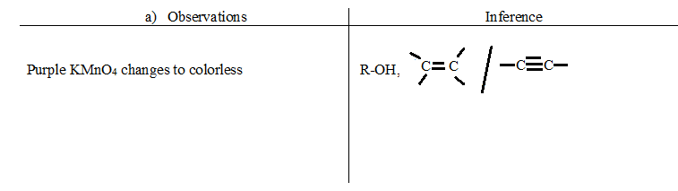
iii)
- Observations | Inference
Orange K₂Cr₂O₇ changes to green  (1mark) | R – OH present  (1mark)

