Name: _____________________________________________ Adm No: ____________Class:_____
Candidate’s Signature: ________________________ Date: __________________________
233/2
CHEMISTRY
Paper 2
JULY/AUGUST 2025
Time: 2 HOURS

NYAGA SECONDARY SCHOOL
MOCK EXAMINATION 2025
Kenya Certificate of Secondary Education

INSTRUCTIONS TO CANDIDATES
- Write your name and index no in the spaces provided above.
- Sign and write the date of exam in the spaces provided above.
- Answer all the questions in the spaces provided after each.
- Mathematical tables and silent electronic calculators may be used.
- All working must be clearly shown where necessary.
- This paper consists of 13 printed pages. Candidates should check to ensure that all pages are printed as indicated and that no questions are missing.
- All answers should be written in English.

FOR EXAMINER’S USE ONLY

Question | Maximum score | Candidate’s score
1 | 10
2 | 10
3 | 13
4 | 10
5 | 14
6 | 10
7 | 09
8 | 14
Total | 80

1. Study the information in the table below and answer the questions that follow.

The letters do not represent the actual symbols of the elements.

Elements | Electronic configuration | Ionization energy kJmol⁻¹
P | 2:1 | 519
C | 2:8:1 | 494
R | 2:8:8:1 | 418

- What is the general name given to the group which elements P, C and R belong? (1mark)

………………………………………………………………………………………

- What is meant by ionization energy? (2marks)

……………………………………………………………………………………………………

- Explain why element P has the highest ionization energy. (2marks)

………………………………………………………………………………………………………

- (a) When a piece of element “C” is placed on water, it melts and hissing sound is produced as it moves on the surface of the water. Explain these observations. (2marks)

…………………………………………………………………………………………………………………….………………………………………………………………………………………………………………………………………………………………………………………………
(b) Distinguish between a strong and a weak base. Give an example of each. (3marks)

…………………………………………………………………………………………………………………….……………………………………………………………………………………………………………………………………………………………………………………………..
2. The flow chart below shows some reactions starting with copper (II) nitrate. Study it and answer questions that follow.

a) State the condition necessary in step 1. (1mark)

. .........................................................................................................................................................
- Identify (1mark)
Reagent M
.........................................................................................................................................................
Gas S (1mark)
........................................................................................................................................................
Acidic products (2marks)

T......................................................................................................................................................

V.....................................................................................................................................................

- Write the formula of the complex ion formed in step 3. (1mark)

.........................................................................................................................................................
iii. Write the equations for the reaction in, (2marks)
Step 1
.........................................................................................................................................................
Step 2
.........................................................................................................................................................
- Write an ionic equation for that occurs in step 5. (1mark)
.........................................................................................................................................................
- State any one observation made in STEP 1, (1mark)
………..........................................................................................................................................
3. a) State two types of polymerization. (2marks)
......................................................................................................................................................... .........................................................................................................................................................
b) Name the compound with the formula below:
CH₃CH₂CH₂ONa (1mark)
.........................................................................................................................................................
c) Study the scheme below and use it to answer the questions that follow:-
n
P

CH₃CH₂CH₃

Step J

V

CH₃CH = CH₂

Step

W

CH₃CH₂CH₂OH
CH₃CH₂COOH
Step R

Gas F
CH₃CH₂COONa
NaOH
Step J

K₂CO₃

Step X

NaOH
Heat

CH₃CH₂COOCH₃
G
Product T
+ Na₂CO₃
C - C
H H
CH₃ - H
K

- Name the following compounds:- (2marks)
I. Product T ………………………………. II. K …………………………………….
- State one common physical property of substance G. (1mark)
.........................................................................................................................................................
- State the type of reaction that occurred in step J. (1mark)
.........................................................................................................................................................
- Give one use of substance K. (1mark)
...........................................................................................................................................................
- Write an equation for the combustion of compound P. (1mark)
.........................................................................................................................................................
- Describe how compounds CH₃CH₂COOH and CH₃CH₂CH₂OH can be distinguished chemically. (2marks)
..................................................................................................................................................................................................................................................................................................................
...........................................................................................................................................................................................................................................................................................................................................................................................................................................................................
- If a polymer K has relative molecular mass of 12,600, calculate the value of n (H=1 C =12)
(2marks)
......................................................................................................................................................... ......................................................................................................................................................... .........................................................................................................................................................
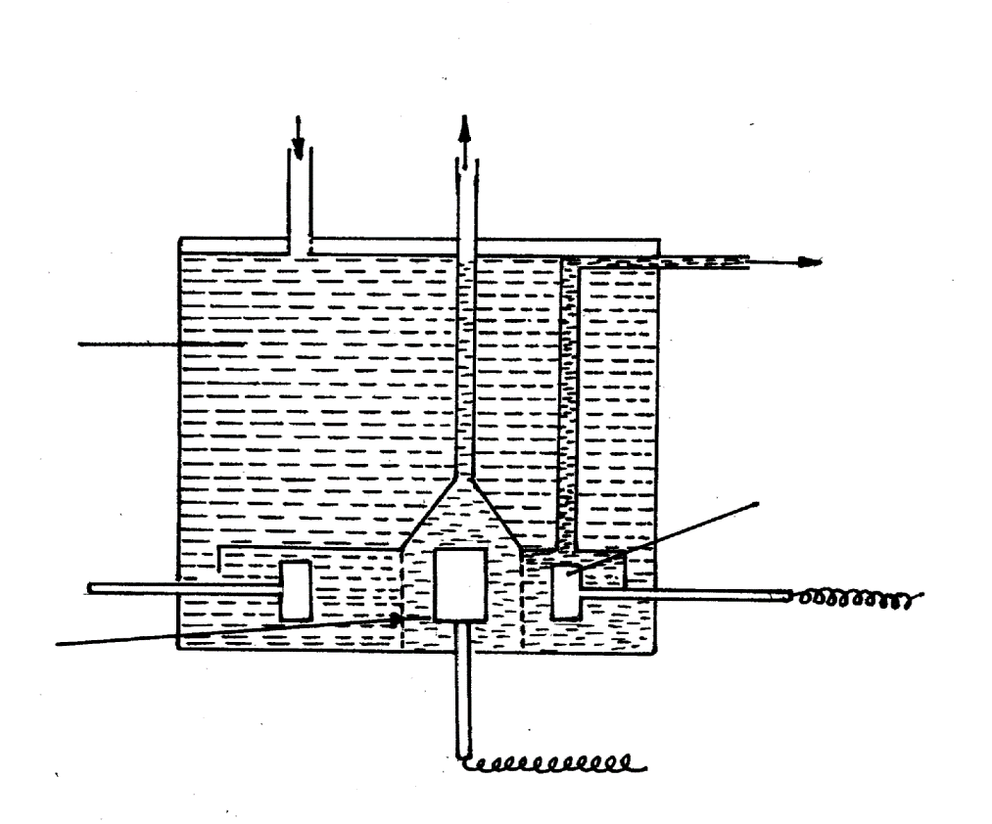
4. The diagram below shows the extraction of sodium metal using the downs cell. Study it answer the questions that follow.

Sodium chloride
Molten sodium
Molten sodium Chloride and calcium chloride
Steel cathode

teel gauze cylinder
Graphite anode
-ve
Gas

i Explain why in this process the sodium chloride is mixed with calcium chloride. (2marks)
…………………………………………………………………………………………………
…………………………………………………………………………………………………
ii Why is the anode made of graphite and not steel? (1mark) ………………………………..………………………………………………………………………..…………………………………………………………………………………………………
iii. State two properties of sodium metal that make it possible for it to be collected as shown in the diagram. (2marks) ………………………………..………………………………………………………………………..………………………………………………………………………………………………..
iv) What is the function of the steel gauze cylinder? (1mark) ………………………………..………………………………………………………………………..…………………………………………………………………………………………………
v). Write ionic equations for the reactions which take place at: (2mks)
Cathode……………………………………………………………… ………………
Anode…………………………………………………………………………………
vi). Give one industrial use of sodium metal. (1mark) ………………………………..……………………………………………………………………………………………………………………………………………………………………………
b) Explain why the sodium metal is kept stored under kerosene. (1mark)
………………………………..……………………………………………………………………
………………………………………………………………………………………………………

5. Below is a simplified diagram for the manufacture of sulphuric (VI) acid in large scale.
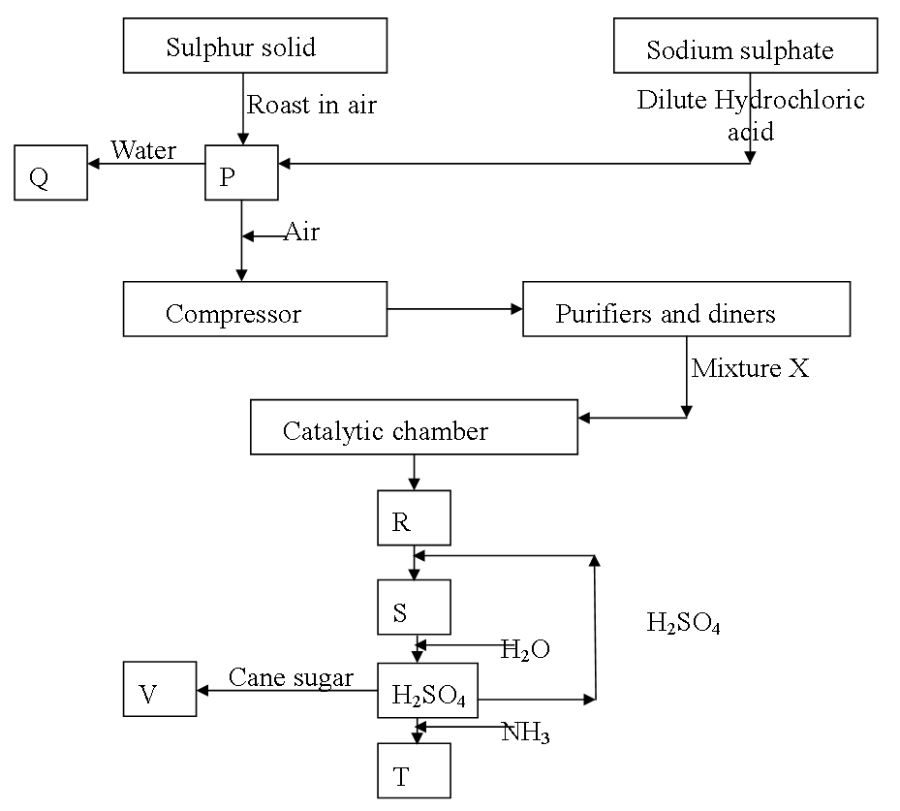

- Name the substances P, Q, R, S, T and V (3marks)
P……………………………………………... S ……………………………………
Q…………………………………………… T……………………………………...
R…………………………………………….. V………………………………………

- What is the use of the compressor? (1mark)
……………………………………………………………………………………………………….…………………………………………………………………………………………..……

- Name two impurities removed in purification chamber? (1mark)
……………………………………………………………………………………………………….…………………………………………………………………………………

- State two conditions for the formation of R other than the catalyst. (1mark)
……………………………………………………………………………………………………….……………………………………………………………………………
- Write the chemical formula of the commonly used catalyst in the catalytic chamber. (1mark)
..........................................................................................................................................
- Write an equation for the reaction in the catalytic chamber. (1mark)
………………………………………………………………………………………
- Describe a chemical test to confirm the presence of P. (1mark)
……………………………………………………………………………………………………….………………………………………………………………………………………………………………………………………………………………………………………………
- One of the uses of sulphuric (VI) acid is ‘pickling’ metals. What does the term ‘pickling’ mean? (1mark)
……………………………………………………………………………………………………….……………………………………………………………………………………………
- The following diagram represents the method of preparing sulphur (1V) oxide solution.
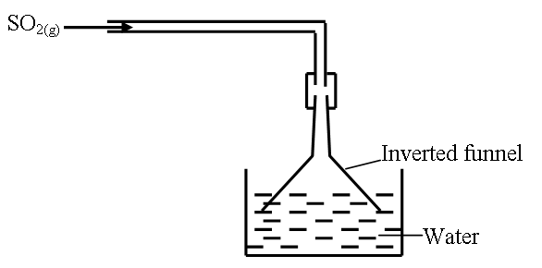
- Why is an inverted funnel used? (1mark)
……………………………………………………………………………………………………….……………………………………………………………………………………………
- Explain the observation made when moist litmus paper is dipped in a gas jar containing sulphur (IV) oxide gas. (1mark) ……………………………………………………………………………………………………….……………………………………………………………………………………………………………………………………………………………………….
- State and explain what would be observed if concentrated sulphuric (VI) acid is added to cane sugar leading to formation of substance Q. (2marks)
………………………………………………………………………………………………………
………………………………………………………………………………………………………
………………………………………………………………………………………………………
6. The following results were obtained in an experiment to determine the heat of neutralization of 50cm³ of 2M HCl and 50cm³ of 2M NaOH.
Mass of plastic cup = 45.1g
Initial temperature of acid = 27.0ºC
Initial temperature of Alkali = 23.0ºC
Mass of Plastic cup + NaOH + HCl = 145.1g
Temp. of the mixture of HCl + NaOH = 38.5ºC.
- Define molar heat of neutralisation. (1mark)
……………………………………………………………………………………………………….…………………………………………………………………………………………………
- Write an ionic equation for the neutralisation of HCl and NaOH. (1mark)
……………………………………………………………………………………………………….…………………………………………………………………………………………………
- Calculate:
- The amount of heat produced during the experiment. (Specific heat capacity of solution = 4.2kJ/kg/K and density of solution = 1g/cm³). (2marks)

……………………………………………………………………………………………………….……………………………………………………………………………………………………………………………………………………………………………………………………………………………………………………………………………………………………………
- The molar heat of neutralisation for this reaction. (2marks)
……………………………………………………………………………………………………….…………………………………………………………………………………………………………………..………………………………………………………………………………………………..………………………………………………………………………………………………………………………………………………………………………………………………
- Explain why the molar heat of neutralisation of sodium hydroxide and ethanoic acid of equal volume and molarity would be less than the value obtained in c (ii) above. (2 marks)
…………………………………………………………………………………………………….…………………………………………………………………………………………………………………………………………………………………………………………………………………..…………………….……………………………………………………………………………………………………………………………………………………………………………………..
e) Draw an energy level diagram for the neutralisation reaction in (c) above. (2 marks)

7. The figure below shows parts of Le’Clanche cell (dry cell).
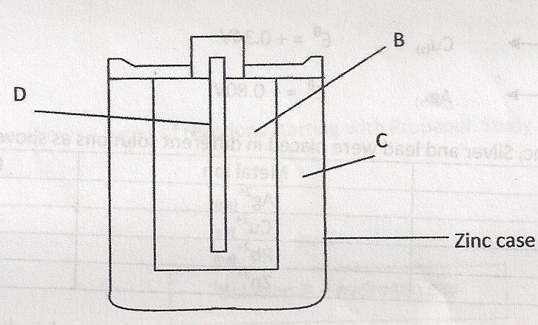
  - Name:
- Substance D (1mark)
………………………………………………………………………………………….
- Mixture B (1mark)
………………………………………………………………………………………….
- Electrolyte C (1mark)
………………………………………………………………………………………….
  - In the cell, the electrolyte is a paste. Explain. (1mark)
………………………………………………………………………………………………………
……………………………………………………………………………………………………………………………………………………………………………………………………………..
  - The following reaction occurs when the cell is in use.
MnO₂
Zn_{(s)} + 2NH₄⁺_{(aq)} Zn²⁺_{(aq)} + 2NH_{3(aq)} + H₂O_{(l)}

Given that:
Zn²⁺_{(aq)} + 2e⁻ Zn(s) E^{Ф} = -0.76V
MnO₂

2NH₄⁺_{(aq)} + 2e⁻ 2NH_{3(g)} + H₂O_{(l)} E^{Ф} = +0.74V

Calculate the e.m.f. of the cell. (1mark)

(d) Use the standard electrode potentials given below to answer the questions that follow.

Half reactions Electrode potential, E^{θ} (V)
D⁺ _{(aq)} + e⁻ D _{(s)} + 0.80
E²⁺ _{(aq)} + 2e⁻ E _{(s)} + 0.34
F ²⁺ _{(aq)} + 2e⁻ F _{(s)} -0.13
G ²⁺ _{(aq)} + 2e⁻ G _{(s)} -0.76

(i) Construct an electrochemical cell that will produce the lowest emf. (3 marks )

(ii) Calculate the emf of the cell constructed in (i) above. (1 mark)

8. A conical flask was connected to a gas syringe by means of a stopper and a delivery tube. 30cm³ of water and 0.5g of Manganese (IV) Oxide were placed in the flask and the 5cm³ of Hydrogen Peroxide were added. The flask was quickly stoppered and the readings of volume of gas in syringe were recorded after every 10 seconds. The results obtained were recorded in the table below

Time (sec) | 0 | 10 | 20 | 30 | 40 | 50 | 60 | 70 | 80
Volume (cm³) | 0 | 18 | 30 | 40 | 48 | 53 | 57 | 58 | 58

  - (i) Draw a set-up used to carry out the above experiment. (3mks)

(ii) Name the gas evolved in this reaction. (1mk)
…………………………………………………………………………………………….
  - (i) Plot a graph of volume (cm³) shown in the syringe against time (sec). (3mks)



(ii) Without emptying the flask another 10cm³ of water and 5cm³ of Hydrogen peroxide were added and the experiment repeated exactly as above. Using the same axes as in (b) (i) above, sketch a second curve to show how volume of gas collected would vary with time. In this second experiment label the curve B. (1mk)
(iii) Calculate the rate of the reaction at the 30th second. (2mks)
………………………………………………………………………………………………………………………………………………………………………………………………………………………………
  - At the end of the experiment Manganese (iv) oxide were removed from the flask, dried and re-weighed. State the observation in the change in mass. (1mk)
………………………………………………………………………………………………………………………………………………………………………………………………………………………………
  - Nitrogen (iv) Oxide (NO₂) was collected in a transparent glass jar at room temperature. The gas jar was sealed. A chemical equilibrium established in the gas jar as represented by the chemical equation below:
2NO_{2(g)} N₂O_{4(g)} ∆H^{ø}_{ƒ} = +9.7kJmol⁻¹
Red/Brown (Yellow)
State and explain the observation made when the sealed glass jar is lowered in a trough of ice cold water. (2mks)

