MARKING SCHEME
233/2
CHEMISTRY
Paper 2
JULY/AUGUST 2025
Time: 2 HOURS

NYAGA SECONDARY SCHOOL
MOCK EXAMINATION 2025
Kenya Certificate of Secondary Education

1. Study the information in the table below and answer the questions that follow.

The letters do not represent the actual symbols of the elements.

Elements | Electronic configuration | Ionization energy kJmol⁻¹
P | 2:1 | 519
C | 2:8:1 | 494
R | 2:8:8:1 | 418

- What is the general name given to the group which elements P, C and R belong? (1mark)
Alkali metals
- What is meant by ionization energy? (2marks)
Energy required to remove an electron from an atom of an element in its gaseous state.
- Explain why element P has the highest ionization energy. (2marks)
P” has the smallest ionic radius therefore, the outermost electrons are most strongly attracted to the nucleus, hence more energy is required to remove this electron
(a) When a piece of element “C” is placed on water, it melts and hissing sound is produced as it moves on the surface of the water. Explain these observations. (2marks)
Melts because the reaction is exothermic. Hissing sound because of the production of hydrogen gas. Float because it is less dense than water. Moves about due to propelling effect of escaping hydrogen.
(b) Distinguish between a strong and a weak base. Give an example of each. (3marks)
A strong base ionizes completely in water producing more OH⁻ ions e.g. KOH and NaOH. A weak base ionizes slightly producing few OH ions e.g. NH₄OH, Ca(OH)₂ and Mg(OH)₂.
2. The flow chart below shows some reactions starting with copper (II) nitrate. Study it and answer questions that follow.

a) State the condition necessary in step 1. (1mark)
Heating
- Identify (1mark)
Reagent M sodium carbonate/ potassium carbonate
Gas S – oxygen (1mark)
Acidic products (2marks)
T – nitric (v) acid
V – nitric (III) acid
- Write the formula of the complex ion formed in step 3. (1mark)
[CU(NH₃)₄]²⁺
iii. Write the equations for the reaction in, (2marks)
Step 1
2CU(NO₃)_{2(s)}→ 2CUO_{(s)} + 4NO_{2(g)} + O₂
Step 2
NO_{2(g)} + H₂O(l) →HNO_{2(aq)} + HNO_{3(aq)}
- Write an ionic equation for that occurs in step 5. (1mark)
Cu²⁺_{(aq)} + CO₃²⁺$-> CuCO$_{3(s)}
- State any one observation made in STEP 1, (1mark)
-Brown gas formed // Black solid formed

3. a) State two types of polymerization. (2marks)
addition polymerization and condensation polymerization
b) Name the compound with the formula below:
CH₃CH₂CH₂ONa (1mark)
Sodium propoxide
c) Study the scheme below and use it to answer the questions that follow:-
n
P

CH₃CH₂CH₃

Step J

V

CH₃CH = CH₂

Step

W

CH₃CH₂CH₂OH
CH₃CH₂COOH
Step R

Gas F
CH₃CH₂COONa
NaOH
Step J

K₂CO₃

Step X

NaOH
Heat

CH₃CH₂COOCH₃
G
Product T
+ Na₂CO₃
C - C
H H
CH₃ - H
K

i. Name the following compounds:- (2marks)
I. Product T T is ethane II. K is polypropene
ii. State one common physical property of substance G. (1mark)
has a fruity smell
- State the type of reaction that occurred in step J. (1mark)
Neutralization
- Give one use of substance K. (1mark)
- Used to make ropes √ 1 mark
- Used to make crates of bottles
- Used as surface for all weather football and hockey pitches (Any correct use)
- Write an equation for the combustion of compound P. (1mark)
- CH₃CH₂CH₃ + SO₂ _______ 3CO₂ + 4H₂O (N.B ignore state symbols)
- Describe how compounds CH₃CH₂COOH and CH₃CH₂CH₂OH can be distinguished chemically. (2marks)
React a small sample of each of the two substances with sodium carbonate separately. Bubbles// effervescence are observed with CH₃CH₂COOH and no reaction with CH₃CH₂CH₂OH
- If a polymer K has relative molecular mass of 12,600, calculate the value of n (H=1 C =12) (2marks)
RMM of monomer = 42 √ ½
42n = 12600
N = 12600 = 300√ ½
42

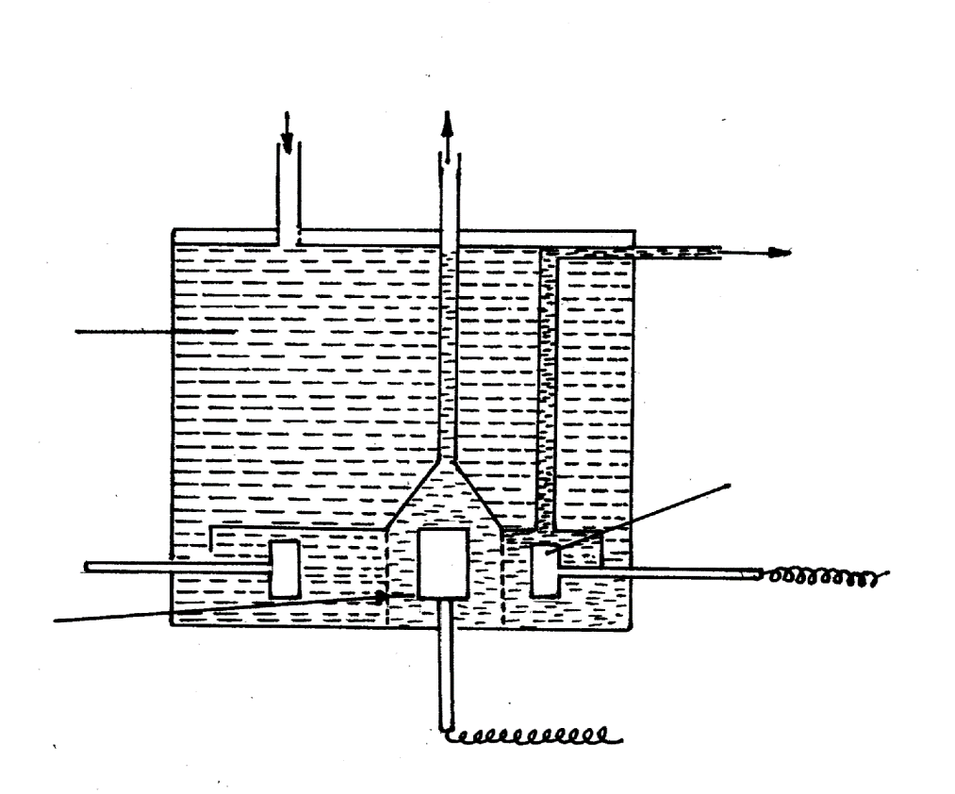
4. The diagram below shows the extraction of sodium metal using the downs cell. Study it answer the questions that follow.

Sodium chloride
Molten sodium
Molten sodium Chloride and calcium chloride
Steel cathode

teel gauze cylinder
Graphite anode
-ve
Gas

i Explain why in this process the sodium chloride is mixed with calcium chloride. (2marks)
To lower M.P of NaCl from 800º-600ºC hence reducing the cost of production of Na
ii Why is the anode made of graphite and not steel? (1mark)
Steel would react chlorine while graphite will not.
iii. State two properties of sodium metal that make it possible for it to be collected as shown in the diagram. (2marks)
M.P lower than that of the electrolyte
-Less dense than that of the electrolyte
iv) What is the function of the steel gauze cylinder? (1mark)
To prevent the chlorine and sodium from mixing / coming into conduct / prevent products from mixing.
v). Write ionic equations for the reactions which take place at: (2mks)
Cathode Na+ + e- -------- Na(l)
Anode 2Cl-(l) -------- Cl_{2(g)} + 2e-
vi). Give one industrial use of sodium metal. (1mark)
Manufacture of Na₂O₂, NaCN / alloy of Na⁺ Pb to make T.E.L/liquid Na- coolant in nuclear reactors / Na vapour used in extraction of titanium.
b) Explain why the sodium metal is kept stored under kerosene. (1mark)
To prevent from reacting with air and water
5. Below is a simplified diagram for the manufacture of sulphuric (VI) acid in large scale.
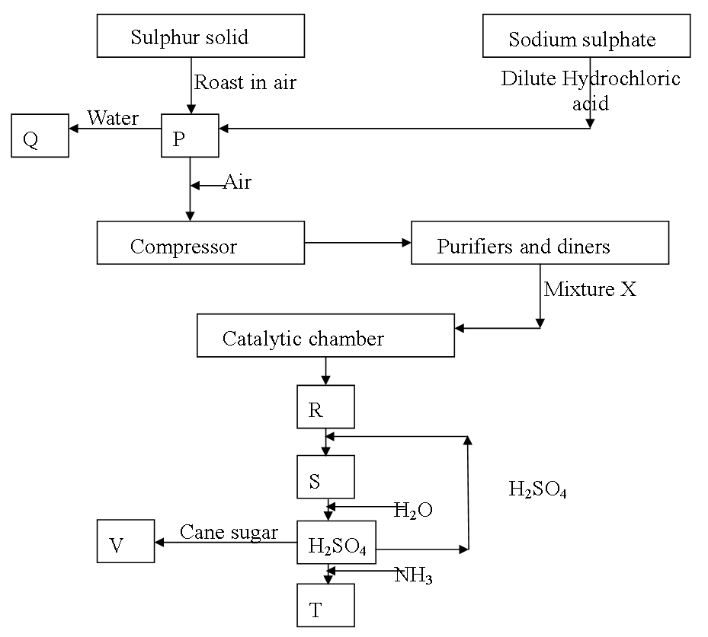

- Name the substances P, Q, R, S, T and V (3marks)
P Sulphur IV oxide S - Oleum
Q Sulphuric (IV) acid/Sulphurous acid. T - Ammonium sulphate
R - Sulphur (IV) oxide V – Carbon.

- What is the use of the compressor? (1mark)
To increase the pressure of the gaseous mixture.

- Name two impurities removed in purification chamber? (1mark)
Dust particles
Water vapour
Arsenic compounds

- State two conditions for the formation of R other than the catalyst. (1mark)
- High pressure of 1-2 atmospheres.
Low temperatures of 400-450°C
- Write the chemical formula of the commonly used catalyst in the catalytic chamber. (1mark)
V₂O₅
- Write an equation for the reaction in the catalytic chamber. (1mark)
2SO_{2(g)} + O_{2(g)} $→$ 2SO_{3(g)}
- Describe a chemical test to confirm the presence of P. (1mark)
- K₂Cr₂O₇ which changes from orange to green.
- One of the uses of sulphuric (VI) acid is ‘pickling’ metals. What does the term ‘pickling’ mean? (1mark)
Removing/ cleaning off the oxide layer on metal surfaces.
- The following diagram represents the method of preparing sulphur (1V) oxide solution.
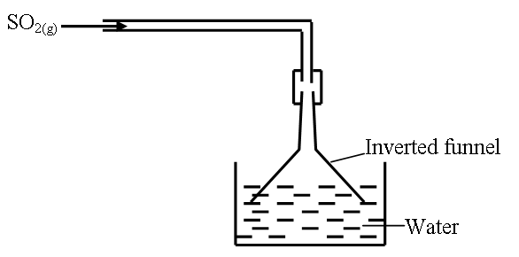
- Why is an inverted funnel used? (1mark)
To increase the surface area for absorption

Explain the observation made when moist litmus paper is dipped in a gas jar containing sulphur (IV) oxide gas. (1mark)
Sulphur (IV) oxide is an acidic gas and also bleaches.

- State and explain what would be observed if concentrated sulphuric (VI) acid is added to cane sugar leading to formation of substance Q. (2marks)
A black solid is formed. Conc sulphuric (VI) acid is a dehydrating agent.
6. The following results were obtained in an experiment to determine the heat of neutralization of 50cm³ of 2M HCl and 50cm³ of 2M NaOH.
Mass of plastic cup = 45.1g
Initial temperature of acid = 27.0ºC
Initial temperature of Alkali = 23.0ºC
Mass of Plastic cup + NaOH + HCl = 145.1g
Temp. of the mixture of HCl + NaOH = 38.5ºC.
- Define molar heat of neutralisation. (1mark)
Enthalpy change that occurs when one mole of water is formed when an acid reacts with an alkali.
- Write an ionic equation for the neutralisation of HCl and NaOH. (1mark)
H⁺_{(aq)} +OH⁻_{(aq)} H₂O(l)
- Calculate:
- The amount of heat produced during the experiment. (Specific heat capacity of solution = 4.2kJ/kg/K and density of solution = 1g/cm³). (2marks)
. $∆H=MC∆T$
=$\frac{100}{1000}X 4.2X13.5=5.67KJ$
- The molar heat of neutralisation for this reaction. (2marks)
Moles of alkali $=\frac{50x2}{100}=0.1 moles, if 0.1mole→5.6KJ$
$1mole→\frac{1X5.67}{0.1}=56.7=-56.\frac{7KJ}{mol}$

- Explain why the molar heat of neutralisation of sodium hydroxide and ethanoic acid of equal volume and molarity would be less than the value obtained in c (ii) above. (2 marks)
Ethanoic acid is a weak acid which partially ionizes and some of the heat energy is used to ionize the undissociated molecules.
e) Draw an energy level diagram for the neutralisation reaction in (c) above. (2 marks)
NaOH _{(aq)} +HCl _{(aq)}
NaCl _{(aq)} +H₂O _{(aq)}
Energy KJ
Reaction path

s
7. The figure below shows parts of Le’Clanche cell (dry cell).
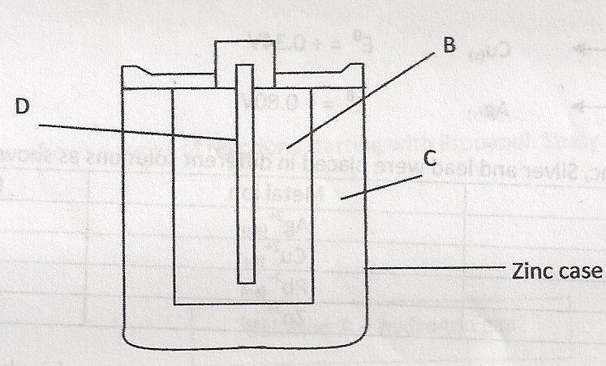
  - Name:
- Substance D (1mark)
Carbon rod
- Mixture B (1mark)
Mixture of Carbon and Manganese (iv) oxide.
- Electrolyte C (1mark)
Ammonia chloride
  - In the cell, the electrolyte is a paste. Explain. (1mark)
To allow movement of ions

  - The following reaction occurs when the cell is in use.
MnO₂
Zn_{(s)} + 2NH₄⁺_{(aq)} Zn²⁺_{(aq)} + 2NH_{3(aq)} + H₂O_{(l)}

Given that:
Zn²⁺_{(aq)} + 2e⁻ Zn(s) E^{Ф} = -0.76V
MnO₂

2NH₄⁺_{(aq)} + 2e⁻ 2NH_{3(g)} + H₂O_{(l)} E^{Ф} = +0.74V

Calculate the e.m.f. of the cell. (1mark)
- E⁰_{cell} = E⁰_{reduced} - E⁰_{oxidised}
= 0.74V – -0.76V
= 1.50V

(d) Use the standard electrode potentials given below to answer the questions that follow.

Half reactions Electrode potential, E^{θ} (V)
D⁺ _{(aq)} + e⁻ D _{(s)} + 0.80
E²⁺ _{(aq)} + 2e⁻ E _{(s)} + 0.34
F ²⁺ _{(aq)} + 2e⁻ F _{(s)} -0.13
G ²⁺ _{(aq)} + 2e⁻ G _{(s)} -0.76

(i) Construct an electrochemical cell that will produce the lowest emf. (3 marks )

(ii) Calculate the emf of the cell constructed in (i) above. (1 mark)

Emf of cell = 0 - 0.13 – ( -0.76)
= -0.13 + 0.76 √ ½
= + 0.63V √ ½

THIS IS THE LAST PRINTED PAGE.

