Name: _____________________________________________ Adm No: ____________Class:_____
Candidate’s Signature: ________________________ Date: __________________________
233/1
CHEMISTRY
Paper 1
JULY/AUGUST 2025
Time: 2 HOURS

NYAGA SECONDARY SCHOOL
MOCK EXAMINATION 2025
Kenya Certificate of Secondary Education

INSTRUCTIONS TO CANDIDATES

- Write your name and index number in the spaces provided.
- Answer all questions in the spaces provided
- KNEC mathematical tables and silent electronic calculators may be used for calculations.
- All workings must be clearly shown where necessary.
- Candidates should check the question paper to ascertain all the pages are printed as indicated and no questions are missing.

For Examiners Use Only

Questions | Maximum Score | Students Score
1-29 | 80

This paper consists of 11 printed pages. Candidates should check the question paper to ascertain that all pages are printed as indicated and that no pages are missing.

1. A student lowered burning magnesium ribbon into a gas jar full of sulphur (IV) oxide gas.
(i) Explain why magnesium continued to burn while sulphur (IV) oxide gas does not support burning. (2 marks)
………………………………………………………………………………………………
……………….………………………………………………………………………………
……………………..……………………………...................................................................
(ii) Write an equation for the reaction that took place. (1 mark)
……….……………………………………………………………………………………..
2. (a) Identify the acid and base in the forward reaction given by the equation below:
${ HSO}_{4 (aq)}^{-} + H_{2}O_{(l)} ⇋ H_{2}{SO}_{4 (aq)} + {OH}_{(aq)}^{-}$ (1mark)

Acid …………………………..………….….

Base ………………………………………..

- Using the above equation and your answer in (a) above, define the term acid.
………………………………………………………….…………………….
………………………………………………………………………………. (1mark)
3. The table below gives the solubility of potassium bromide and potassium sulphate at 0ºC and 40ºC.
Substance | Solubility g/100g of water
Substance | 0ºC | 40ºC
Potassium bromide | 55 | 75
Potassium sulphate | 10 | 12
When an aqueous mixture containing 58g potassium bromide and 8g of potassium sulphate in 100g of water at 40ºC was cooled to 0ºC, some crystals were formed.
i) Identify the crystals. (1mark)
………………………………………………………….…………………
ii) Determine the mass of the crystals formed. (1mark)

………………………………………………………….…………………
iii) Name the method used to obtain the crystals. (1mark)

………………………………………………………….…………………

4. The diagram below shows a charcoalstove in a well-ventilated room.Study it and answer the questions that follow.

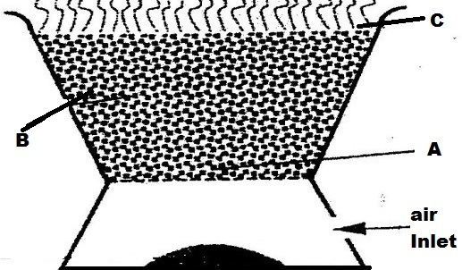

- Write the chemical equation for the reaction that takes place at
- Region B (1mark)

...........................................................................................................................
- If the above stove is used in a poorly ventilated room, carbon (ii) oxide gas would be formed due to incomplete combustion of charcoal. State two reasons why the gas is also termed as ‘silent killer’ (2 marks)
...................................................................................................................................
...................................................................................................................................
5. Starting with lead (II) nitrate solution, sodium sulphate solution and water, describe how a solid sample of lead (II) sulphate can be prepared in the laboratory. (3mks)
……………………………………………………………………………………………..
………….………………………………………………………………………………….
…………………….……………………………………………………………………
6(a) State the graham’s law of diffusion (1mk)
………………………………………………………………………………………………
……………………………….………………………………………………………………
(b) Calculate the relative formula mass of gas X given that the time taken by equal volume of nitrogen gas and gas X to diffuse through the same hole is 10 seconds and 20 seconds respectively. N=14 (2mks)
………………………………………………………………………………………………
……………………………….………………………………………………………………
……………………………………………….………………………………………………
………………………………………………………………………………………………
……………………...……………………………….……………………………………...
7. Name the following processes;
- When anhydrous calcium chloride is left in an open beaker overnight a solution was formed. (1mark)

…………………………………………………….…………………………………..
- When sodium carbonate decahydrate crystals are left in an open beaker for some days it turned into a powder. (1mark)

…………………………………………………….…………………………………..
8. The grid below represents part of the periodic table. Study it and answer the questions that follow. The letters are not the actual symbols of the elements.

F |  |  |  |  | B |  | K
 | Y |  |  | V |  | M |  | T
H |  |  |  |  |  |  | P

a) Select an element that cannot form an ion. (1/2mark)

……………………………………………….………………………………………………

b) Which group (I) element has the highest first ionization energy? (1/2mark)

c) Compare the atomic radius of Y and V (2marks)
……………………………………………….………………………………………………
………………………………………………………………………………………………
……………………………………………….………………………………………………
9. In an experiment to investigate the percentage of oxygen in air, 200cm³ of air was passed over heated copper turning repeatedly until a constant volume of air remained. 160cm³ of air remained at the end of the experiment.
i) State the major gas that comprises the 160cm³ of air remained at the end of the experiment.

……………………………………………….……………………………………(1mark)
ii) Determine the percentage of air used up during the experiment. (2marks)
………………………………………………………….……………………………………
……………………………………….………………………………………………………
…………………….…………………………………………………………………………
10. The table below gives bond energies of some covalent compound
Bond | Bond energy KJ mol⁻¹
C – H | 413
C – C | 343
O=O | 497
C=O | 804
H-O | 464

Calculate the enthalpy change for the combustion of methane in excess oxygen gas. (3marks)
……………………………………………………..….……………………………………………………………………..……………………………………………………..….……………………………..……………………………………………………..….………………………………………………………….……………………………………………………………………………………………………………………………………………………………………………………………………………………………………………
11. a) State the reason why potassium carbonate cannot be prepared using Solvay Process.
(1mark)
……………….……………………………………………………………………
…………………….…………………………………………………………………………
b) State two use of sodium carbonate (1 mark)
……………….…………………………………………………………………………..
……………….…………………………………………………………………………..
…………………….……………………………………………………………………...
12. Concentrated hydrochloric acid that is 35% pure has a density of 1.18g/cm³. Calculate its concentration in moles per litre. (H=1.0 Cl=35.5) (3marks)
…………………….…………………………………………………………………………
…………………….…………………………………………………………………………
…………………….…………………………………………………………………………
…………………….…………………………………………………………………………
13. Identify and state the use of the apparatus represented below. (2 marks)

Name……………………………………………………………………

Use………………………………………………………………………
14. Give the systematic name of each of the compounds represented by the formulae below.
(2 marks)
(a) CH₃CH₂CH₃

……………………………………………………………………………………………..

(b) CH₃CH=CHCH₃
……………………………………………………………………………………………..
15. The diagram below represents a set up for large scale manufacture of hydrochloric acid. Study it and answer the questions that follow.
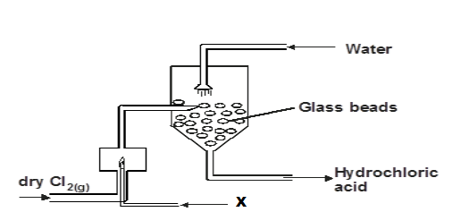

a) Name substance X. (1 mark)

………………………………………………………………………………..

b) What is the purpose of the glass beads? (1 mark)
...............................................................................................................................
c) Give two uses of hydrochloric acid. (1 mark)
.................................................................................................................................................
.................................................................................................................................................
……………………………………………………………………………………………….

16. 30cm³ of 0.5M hydrochloric acid was used to neutralize 25cm³ of sodium hydroxide solution. Determine the concentration of sodium hydroxide in grams per litre. (3 marks)
(H=1, O=16, Na= 23)

17. a) What role do the following parts play during fractional distillation of water and ethanol?

    - The fractionating column. (1mark)
…………………………………………………………………………………………
…………………………………………………………………………………………
    - The glass beads (1mark)
…………………………………………………………………………………………
…………………………………………………………………………………………
iii) State one application of fractional distillation. (1mark)
……………………………………………………………………………………………
……………………………………………………………………………………………
18. Study the table below and answer the questions that follow. The letters do not show the actual symbol:-
Ion | Electron Arrangement
R²⁺ | 2.8.8
S²⁻ | 2.8

  - Write the electron arrangement of each atom.
R ………………………………………………………..…………. (½ mark)

S …………………………………………………………………… (½ mark)
  - Write the formula of the oxide of R and Chloride of S
Oxide of R …………………………………………………….……. (1mark)
Chloride of S ……………………………………………………….. (1mark)

19 Oxygen gas can be prepared in the laboratory by decomposition of hydrogen peroxide
- Write an equation to show the decomposition of hydrogen peroxide to produce oxygen gas.
……………………………………………………………………………… (1mark)
b) Name the catalyst used in the above reaction. (1mark)
…………………………………………………………………………………………
c) Explain why oxygen gas is collected over water (1mark)
…………………………………………………………………….……………………
20. When a few drops of aqueous ammonia were added to a colourless solution of zinc (II) sulphate, a white precipitate was formed. On addition of more aqueous ammonia, the white precipitate dissolved to a colourless solution Q
(a) Name the white precipitate formed (1mark)
……………………………………………………………………………………
(b) Write formula of the complex ion present in the colourless solution ………………………………………………….…………………… (1mark)
(c) Write an ionic equation for the formation of the white precipitate
………………………………………………………….…………… (1mark)

21. A mass of 0.92g of ethanol were found to burn in excess air producing a temperature
rise of 32.5ºC in 200cm³ of water.(C=12.0 H=1.0 O=16.0)
(Density of water 1g/cm³, Specific heat capacity of water 4.2kJ kg⁻¹k⁻¹)
a) Write the equation for combustion of ethanol (1mark)

……..……………………………………………………………………
b) Determine the molar heat of combustion of ethanol (2 marks)

22. Polymerization of ethene takes place as shown in the equation below

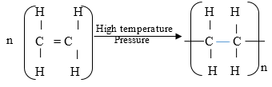

a) Name the type of polymerization undergone by ethene in the reaction above(1mark)

……..……………………………………………………………………………………

b) Name the polymer formed above (1mark)
……..…………………………………………………………………………………….
23. Sulphur occurs naturally in two different forms called allotropes;
a) What are allotropes? (1 mark) ……..…………………………………………………………………….……

b) The two allotropes of sulphur are stable at different temperatures, as shown in the
equations below.
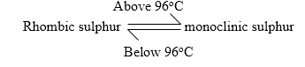
What name do we call the 96ºc temperature?
……..…………………………………………………………………….…… (1mark)
24. A sample of water from a village in Rift Valley was divided into equal portions
and each mixed with equal volume of soap solution.

Sample of water | Treatment before adding soap | Observations made on shaking with soap
I | Boiled | Lather form immediately
II | No treatment | Slight lather form slowly
III | Treatment with washing soda | Lather formed immediately

(a) What type of hardness is present in water from the village? Explain (1mark)
……..…………………………………………………………………….……
……..…………………………………………………………………….……
(b) State two advantage of hard water (2mark)
……..…………………………………………………………………….………
…….…..…………………………………………………………………….……
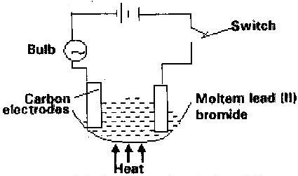
25. Study the set up below and answer the questions that flows

State all the observations that would be made when the circuit is completed (3marks)

……..…………………………………………………………………….…………….
……..…………………………………………………………………….…………….
……..…………………………………………………………………….…………….
……..…………………………………………………………………….…………….
26. Explain the following observations:-
(i) Sodium chloride allows electric current to pass through it only when in molten state

……..…………………………………………………………………….……… (1mark)
……………………………………………………………………………………..
(ii) Graphite is a non-metal yet it is a conductor of electricity (1mak)
……..…………………………………………………………………….…………
……………………………………………………………………………………..
27. The diagram below illustrates an experiment in which two plain papers (a) and (b) were passed through a Bunsen burner flame.

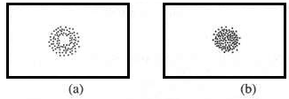
(i) State the aim of the experiment. (1mark)
……..…………………………………………………………………….………
……..…………………………………………………………………….………
(ii) Name the type of flame that was used (1 mark)

……..…………………………………………………………………….………

(iii) Bunsen burner is the main source of heat in a chemistry laboratory. State any other two sources of heat that can also be used in a school laboratory. (2mark)
……..…………………………………………………………………….………
……..…………………………………………………………………….………

28. 10 cm³ of concentrated sulphuric (VI) acid was diluted to 100cm³. 15 cm³ of the resulting solution was neutralized by 25cm³ of 0.1M sodium hydroxide solution. Determine the molarity of the concentrated acid sulphuric (VI) acid. (S=32, H=1, O= 16) (3marks)

29. (a) State why it’s not advised to prepare hydrogen gas in the laboratory using dilute hydrochloric acid and lead metal. (1mark)
……..……………………………………………………………………………..
……………………………………………………………………………………
b) Give two reasons why hydrogen gas is not commonly used as a fuel. (2marks)
……..…………………………………………………………………….………
……..…………………………………………………………………….………

THIS IS THE LAST PRINTED PAGE

