MARKING SCHEME
233/1
CHEMISTRY
Paper 1
JULY/AUGUST 2025
Time: 2 HOURS
NYAGA SECONDARY SCHOOL
MOCK EXAMINATION 2025

1. A student lowered burning magnesium ribbon into a gas jar full of sulphur (IV) oxide gas.
(i) Explain why magnesium continued to burn while sulphur (IV) oxide gas does not support burning. (2 marks)
Magnesium produce a lot of heat that decompose sulphur (IV) oxide to sulphur and oxygen gas ¹. Oxygen gas produced supports burning hence magnesium continues to burn¹
(ii) Write an equation for the reaction that took place. (1 mark)
.
2. (a) Identify the acid and base in the forward reaction given by the equation below:
${ HSO}_{4 (aq)}^{-} + H_{2}O_{(l)} ⇋ H_{2}{SO}_{4 (aq)} + {OH}_{(aq)}^{-}$ (1mark)

Acid …$H_{2}O_{\left(l\right)}$¹/₂
Base${ HSO}_{4 (aq)}^{-}$
- Using the above equation and your answer in (a) above, define the term acid.
An acid is a proton donor ¹
3. The table below gives the solubility of potassium bromide and potassium sulphate at 0ºC and 40ºC.
Substance | Solubility g/100g of water
Substance | 0ºC | 40ºC
Potassium bromide | 55 | 75
Potassium sulphate | 10 | 12
When an aqueous mixture containing 58g potassium bromide and 8g of potassium sulphate in 100g of water at 40ºC was cooled to 0ºC, some crystals were formed.
i) Identify the crystals. (1mark)
Potassium bromide ¹
ii) Determine the mass of the crystals formed. (1mark)
58-55 = 3g ¹

iii) Name the method used to obtain the crystals. (1mark)
Fractional crystallization ¹
4. The diagram below shows a charcoal stove in a well-ventilated room. Study it and answer the questions that follow.

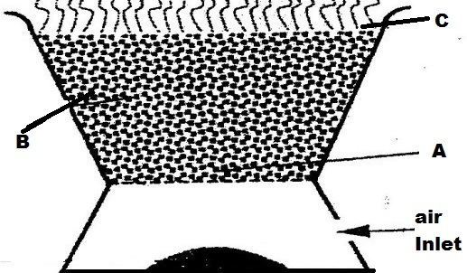

- Write the chemical equation for the reaction that takes place at
- Region B (1mark)
- If the above stove is used in a poorly ventilated room, carbon (ii) oxide gas would be formed due to incomplete combustion of charcoal. State two reasons why the gas is also termed as ‘silent killer’ (2 marks)
The gas is colourless ¹
Its odorless ¹
5. Starting with lead (II) nitrate solution, sodium sulphate solution and water, describe how a solid sample of lead (II) sulphate can be prepared in the laboratory. (3mks)
-Add lead (II) nitrate solution into a beaker containing sodium sulphate solution. ¹
- Stir then filter to obtain lead (II) sulphate as the residue ¹
-Wash the residue with distilled water and dry between filter papers ¹to obtain solid sample of lead (II) sulphate
6(a) State the graham’s law of diffusion (1mk)
The rate of diffusion of any gas is inversely proportional to the square root of its density at constants conditions of temperature and pressure. ¹
(b) Calculate the relative formula mass of gas X given that the time taken by equal volume of nitrogen gas and gas X to diffuse through the same hole is 10 seconds and 20 seconds respectively. N=14 (2mks)

$\frac{Tx}{TN2}$=$\frac{Mx}{N2}\frac{Mx}{28}$ =$\frac{20}{10}$¹ Mx=$\frac{20x20x28}{10X10}$¹
=112 sec¹
7. Name the following processes;
- When anhydrous calcium chloride is left in an open beaker overnight a solution was formed. (1mark)
Deliquescence¹
- When sodium carbonate decahydrate crystals are left in an open beaker for some days it turned into a powder. (1mark)
Efflorescence¹
8. The grid below represents part of the periodic table. Study it and answer the questions that follow. The letters are not the actual symbols of the elements.

F |  |  |  |  | B |  | K
 | Y |  |  | V |  | M |  | T
H |  |  |  |  |  |  | P

a) Select an element that cannot form an ion. (1/2mark)
T ¹/₂
b) Which group (I) element has the highest first ionization energy? (1/2mark)
F ¹/₂
c) Compare the atomic radius of Y and V (2marks)
Y has a larger atomic radius than V/ V has a smaller atomic radius than Y1
There is increase in number of protons and electrons across the period that increase nuclear charge hence Y has a weaker nuclear charge attraction
than V
9. In an experiment to investigate the percentage of oxygen in air, 200cm³ of air was passed over heated copper turning repeatedly until a constant volume of air remained. 160cm³ of air remained at the end of the experiment.
i) State the major gas that comprises the 160cm³ of air remained at the end of the experiment. (1mark)
Nitrogen gas
ii) Determine the percentage of air used up during the experiment. (2marks)
200-160 = 40 cm³
40/200 X 100
= 20 %
10. The table below gives bond energies of some covalent compound
Bond | Bond energy KJ mol⁻¹
C – H | 413
C – C | 343
O=O | 497
C=O | 804
H-O | 464

Calculate the enthalpy change for the combustion of methane in excess oxygen gas. (3marks)
Bond Broken Bond Formed
4 (C – H) + 2(O=O) 2(C=O) + 2 (2 X H-O)
4x 413 + 2(497) =+ 2646$kJ$2X (804) +2 (2X464) = -3464$kJ$
$∆H=$+ 2646 + (-3464)
= - 818 $kJ$
11. a) State the reason why potassium carbonate cannot be prepared using Solvay Process.
(1mark)
Potassium carbonate has high solubility in water and does not precipitate out.
b) State two use of sodium carbonate (1 mark)
-Softening hard water
- Manufacture of detergents * Any two correct
- Used in making glass
- Used in paper industry
12. Concentrated hydrochloric acid that is 35% pure has a density of 1.18g/cm³. Calculate its concentration in moles per litre. (H=1.0 Cl=35.5) (3marks)
Consider 1000cm³ of the solution
Mass = 1000 x 1.18
= 1180g ¹/₂
% acid = 35/100 X 1180¹/₂
= 413g of acid in 1000cm³
Molarity= 413/36.5
= 11.32M
13. Identify and state the use of the apparatus represented below. (2 marks)
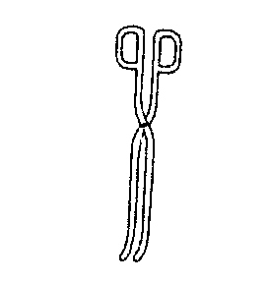
Name Tongs¹/₂
Use Holding hot/corrosive substances ¹/₂
14. Give the systematic name of each of the compounds represented by the formulae below.
(2 marks)
(a) CH₃CH₂CH₃
Propane
(b) CH₃CH=CHCH₃
But-2-ene
15. The diagram below represents a set up for large scale manufacture of hydrochloric acid. Study it and answer the questions that follow.
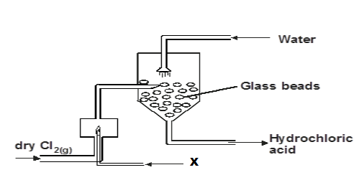

a) Name substance X. (1 mark)
Hydrogen gas
b) What is the purpose of the glass beads? (1 mark)
To increase the surface area for the gas to dissolve in water.
c) Give two uses of hydrochloric acid. (1 mark)
- Cleaning metal before electroplating (de-scaling)
- Used in water treatment (Chlorination) * Any two correct ¹/₂ ¹/₂
- Making dyes and drugs
16. 30cm³ of 0.5M hydrochloric acid was used to neutralize 25cm³ of sodium hydroxide solution. Determine the concentration of sodium hydroxide in grams per litre. (3 marks)
(H=1, O=16, Na= 23)
. Moles of HCl used = 30X0.5/1000
0.015moles ¹/₂
NaOH: HCl
1 : 1 Equation or Mole ration¹/₂
0.015moles: 0.015moles¹/₂
Moles of NaOH used = 0.015moles¹/₂
Molarity of NaOH = 0.5X1000/25¹/₂
=0.6M ¹/₂
17. a) What role do the following parts play during fractional distillation of water and ethanol?

i) The fractionating column. (1mark)
Allows water vapour to condense back into liquid and flow back into flask before the boiling point of water is reached.
ii) The glass beads (1mark)
It increases the surface area for condensation
iii) State one application of fractional distillation. (1mark)

18. Study the table below and answer the questions that follow. The letters do not show the actual symbol:-
Ion | Electron Arrangement
R²⁺ | 2.8.8
S²⁻ | 2.8

  - Write the electron arrangement of each atom.
R 2.8.8.8.2¹/₂ (½ mark)
S 2.6¹/₂ (½ mark)
  - Write the formula of the oxide of R and Chloride of S
Oxide of R – RCl₂ (1mark)
Chloride of S –Cl₂S₇ (1mark)
19 Oxygen gas can be prepared in the laboratory by decomposition of hydrogen peroxide
- Write an equation to show the decomposition of hydrogen peroxide to produce oxygen gas. (1mark)
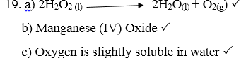
b) Name the catalyst used in the above reaction. (1mark)
Mangenese (iv) Oxide
c) Explain why oxygen gas is collected over water (1mark)
Oxygen is slightly soluble in water
20. When a few drops of aqueous ammonia were added to a colourless solution of zinc (II) sulphate, a white precipitate was formed. On addition of more aqueous ammonia, the white precipitate dissolved to a colourless solution Q
(a) Name the white precipitate formed (1mark) Zinc hydroxide
(b) Write formula of the complex ion present in the colourless solution (1mark)
Zn (NH₃)₄²⁺
(c) Write an ionic equation for the formation of the white precipitate
(1mark)
21. A mass of 0.92g of ethanol were found to burn in excess air producing a temperature
rise of 32.5ºC in 200cm³ of water.(C=12.0 H=1.0 O=16.0)
(Density of water 1g/cm³, Specific heat capacity of water 4.2kJ kg⁻¹k⁻¹)
a) Write the equation for combustion of ethanol (1mark)
b) Determine the molar heat of combustion of ethanol (2 marks)
$∆H=mco$
Mass of water heated = volume X density
200 X1 =200g or 0.2kg¹/₂
$∆H=0.2$x 4.2x32.5 ¹/₂
= -27.3kJ¹/₂
Moles of ethanol burnt= 0.92/46
= 0.02 Moles¹/₂
Molar Heat of combustion of ethanol = 27.3X1/0.02
1365kJmol⁻
22. Polymerization of ethene takes place as shown in the equation below

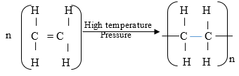

a) Name the type of polymerization undergone by ethene in the reaction above (1mark)
Additional polymerisation
b) Name the polymer formed above (1mark)
Polyethene
23. Sulphur occurs naturally in two different forms called allotropes;
a) What are allotropes? (1 mark)
Allotropes are different forms of an element at the same physical state.
b) The two allotropes of sulphur are stable at different temperatures, as shown in the
equations below.
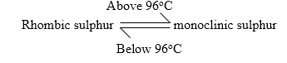
What name do we call the 96ºc temperature?
Transitional temperature (1mark)
24. A sample of water from a village in Rift Valley was divided into equal portions
and each mixed with equal volume of soap solution.

Sample of water | Treatment before adding soap | Observations made on shaking with soap
I | Boiled | Lather form immediately
II | No treatment | Slight lather form slowly
III | Treatment with washing soda | Lather formed immediately

(a) What type of hardness is present in water from the village? Explain (1mark)
Temporary water hardness
Water softened after boiling / the hardness removed by boiling
(b) State two advantage of hard water (2mark)
- Hard water contains calcium that is essential for bone formation
- Its suitable for beer brewing because the taste can be enhanced easily
- Hard water prevents lead from coming into contact with drinking water due to deposition of insoluble coating.
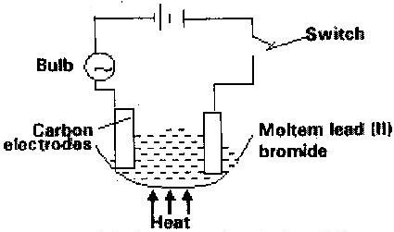
25. Study the set up below and answer the questions that flows

State all the observations that would be made when the circuit is completed (3marks)
-The bulb lights
- Grey solid deposits at the cathode
- Brown gas bubbles produced at the anode
26. Explain the following observations:-
(i) Sodium chloride allows electric current to pass through it only when in molten state
(1mark)
(i) In molten state, the ions in sodium chloride become mobile hence allows the electric current flow through them
(ii) Graphite is a non-metal yet it is a conductor of electricity (1mak)
Graphite has a delocalised electron because it only uses three electrons in bonding and one electron remains delocalised
27. The diagram below illustrates an experiment in which two plain papers (a) and (b) were passed through a Bunsen burner flame.

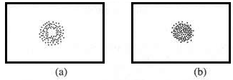
(i) State the aim of the experiment. (1mark)
To determine the hottest part of the non-luminous flame
(ii) Name the type of flame that was used (1 mark)
Non-luminous flame
(iii) Bunsen burner is the main source of heat in a chemistry laboratory. State any other two sources of heat that can also be used in a school laboratory. (2mark)
-Electric heaters
- Candles
- Paraffin stoves * Any two correct ¹¹
28. 10 cm³ of concentrated sulphuric (VI) acid was diluted to 100cm³. 15 cm³ of the resulting solution was neutralized by 25cm³ of 0.1M sodium hydroxide solution. Determine the molarity of the concentrated acid sulphuric (VI) acid. (S=32, H=1, O= 16) (3marks)
NaOH: H₂SO₄
2: 1 ¹/_{2 *}accept equation
Moles of NaOH 25x0.1/1000
= 0.0025moles¹/₂
Moles of H₂SO₄0.0025/2 = 0.00125 moles¹/₂
Moles of HCl in 100cm3 0.00125x100/15 = 0.00833 moles ¹/₂
Molarity of HCl 0.00833x1000/100 = 0.833M
29. (a) State why it’s not advised to prepare hydrogen gas in the laboratory using dilute hydrochloric acid and lead metal. (1mark)
Hydrochloric acid react with lead metal to form insoluble lead (II) chloride which prevents further reaction
b) Give two reasons why hydrogen gas is not commonly used as a fuel. (2marks)
- Highly flammable
- Expensive

……...THIS IS THE LAST PRINTED PAGE..…

